CMPU4064 Systems Analysis and Design

Practical Class Week 5

Contents

Exercise 1: Git and GitHub 1

Step ONE – Signup for GitHub and install Git. 1

Step Two – Create a Local Repository 2

Step 3: Stage a file 3

Step 4: Make a change to the file and then restore it 3

Step 5: Commit your changes 3

Step 6: Sync with GitHub 4

Exercise 2 – Non-Functional Requirements 6

# Exercise 1: Git and GitHub

## Step ONE – Signup for GitHub and install Git.

* Signup for GitHub
  + Use your TUDublin email address:

* Download and install Git
  + Windows <https://gitforwindows.org/>
  + MacOS <https://git-scm.com/download/mac>
  + Linux <https://git-scm.com/download/linux>
* Open a Command Prompt/Terminal
* To verify successful installation
  + Enter:

git –version

* + You should see the details of the version of git installed.
* You need to let Git know your credentials:
  + Use the username you created for GitHub

git config --global user.name yourusername

git config --global user.email youremailaddress

## Step Two – Create a Local Repository

* Make a new directory/folder, move into it and create a repository by calling git init

mkdir CMPU4064Week5

cd your CMPU4064Week5

git init

* Check the status of the repository:

git status

It will show that you are currently on the master branch, that you haven’t committed anything (i.e. saved anything to the repository) and that there are currently no files that git is tracking changes to.

* Add a file to your repository:
  + E.g. Download the lab instructions for this week rename them to something simple (e.g. CMPU4064InsWeek5.docx) and copy them to the project folder.
* Check the status of the repository:
  + You should now see that git has detected but that it is not being tracked by git.

* + You should now see that git has detected but that it is not being tracked by git.
  + Open the file and make a change – you should see that git has not recorded any information about that change.

## Step 3: Stage a file

* Add your instructions file to staging

git add CMPU4064InsWeek5.docx

git status

* When you look at the status you will see that changes are now being tracked:

## Step 4: Make a change to the file and then restore it

* Experiment by making a change to the file
  + Check the status
* Restore to the file :

git restore CMPU4064InsWeek5.docx

* Check the status of the repository.
* Check the contents of the file.

## Step 5: Commit your changes

* Issue a commit command with a companion message:

git commit -m "Committing to the repository for the first time"

## Step 6: Sync with GitHub

* Create a New repository in GitHub:

* Add a readme.md file as part of the create.
* Locate the URL for the repository:

* From the command prompt:
  + Create a connection between your local repository and this remote repository

git remote add origin <https://github.com/your-username/repository-name.git>

* Push your local repository to the remote repository

git push -u origin master

* In GitHub in your repository, you should now have two branches main and master:

* Switch to the master branch and you can see the files from your local repository.

# Exercise 2 – Non-Functional Requirements

Review the following description of a proposed application:

LuxLimo is a limousine hire company who wishes to put in place a software application to help them manage their operations. Before someone becomes a client of LuxLimo they must apply and pass a credit check. Once an applicant is approved they become a customer, and the customer relationship manager creates a login for them which they sent to the customer in writing. The diagram below represents a first draft of the use case diagram derived from initial analysis of requirements.

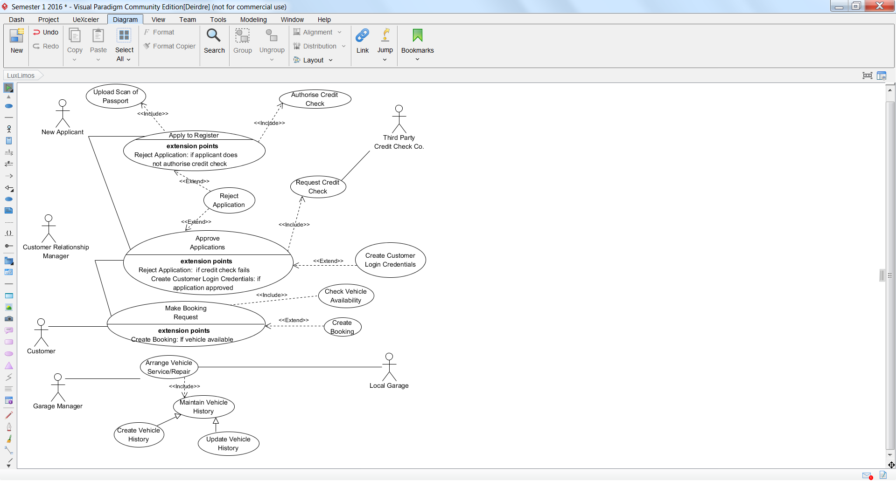

* LuxLimo have commissioned an external company to develop their software application.
* The application will store customers’ personal details including the scan of their passport and result of the credit check as well as storing details of customers’ bookings which will include dates, times, origins, destinations and details of passengers and payments. Similarly details of local garages, contacts in those garages, addresses and other details are stored as well as details of transactions between LuxLimo and the garages.
* LuxLimo has no formal documentation of their business practices. Only the managing director has a detailed understanding of all aspects of the business. However, his availability during the time period identified for the application development is limited.
* The customer relationship manager and the garage manager have a detailed understanding of the areas of the business for which they are responsible. Both managers are keen to ensure that the application be available using a range of mobile devices in addition to a web interface and that it be hosted in the cloud. The managing director is not convinced of the need for this.
* The external company commissioned has no previous experience of developing applications hosted in the cloud.
* The budget and timescale for the project have been agreed with the external company.

There is no flexibility in these, and the external company needs to complete the project as soon as possible so that they can start work on another project.

* The customer relationship manager is the data controller for LuxLimo and has access to all data.
* The garage manager has access to manage all information related to vehicles but also to view information relating to driver journeys, including driver names but no other personal information about drivers.
* The garage manager will work primarily work in the company garage where cars are stored and cleaned. Valeting staff and drivers are constant visitors to the garage manager’s office.
* **Identify a range of non-functional requirements you think could be considered for this development project and the resulting application. Justify your answers.**