A



Project REPORT ON

" Smart Dustbin "

SUBMITTED TO THE SAVITRIBAI PHULE PUNE UNIVERSITY, PUNE FOR THE PARTIAL FULFILLMENT FOR THE AWARD OF THE DEGREE

OF

BACHELOR OF ENGINEERING IN

INFORMATION TECHNOLOGY BY

Abhishek Sabane Roll No: 23167

Yash Sarpate Roll No: 23170

Rishabh Sharma Roll No: 23173

Under guidance form

Ms. Rashmi Chhattani Signature

DEPARTMENT OF INFORMATION TECHNOLOGY

PUNE INSTITUTE OF COMPUTER TECHNOLOGY , PUNE

Sr. No. 27, Trimurti Chowk, Dhankawadi, Pune-43

AY -2024-25

### Abstract



The **Smart Dustbin using Arduino Uno** is an efficient, low-cost, and user-friendly waste management system designed to promote hygiene and automation in public and private spaces. At the core of the system is an Arduino Uno microcontroller that processes input from a PIR motion sensor and an ultrasonic distance sensor. When motion is detected near the dustbin, the system automatically opens the lid using a servo motor, allowing touchless waste disposal.

An ultrasonic sensor is used to measure the level of garbage inside the bin. The current fill percentage is displayed in real time on a 16x2 LCD screen, providing visual feedback about when the bin needs to be emptied. The use of a servo motor for lid control ensures smooth operation, while the PIR sensor helps maintain a hands-free experience, reducing the risk of contamination.

The entire setup is compact, reliable, and can be powered by a battery or external power source, making it suitable for homes, offices, hospitals, and public places. This smart dustbin enhances cleanliness and convenience while encouraging responsible waste disposal practices through automation.

### Acknowledgment



I sincerely express my gratitude to all those who have contributed to the successful completion of this report on the **Smart Dustbin using Arduino Uno**. I extend my heartfelt thanks to my mentors, professors, and institution for their valuable guidance, encouragement, and continuous support throughout the development of this project. Their insights and suggestions have played a crucial role in shaping the outcome of this work.

I would also like to acknowledge the various sources of information, including reference books, research articles, and online platforms, which have deepened my understanding and assisted me in implementing this project effectively.

Lastly, I am deeply thankful to my peers, friends, and family for their constant support and motivation, which kept me focused and inspired throughout this journey.

Without the collective support and shared knowledge of these individuals, the successful completion of this report would not have been possible.

INDEX



|  |  |  |
| --- | --- | --- |
| SR. NO. | Title | Page No. |
| 1 | Introduction | 5 |
| 2 | Previous work | 6 |
| 3 | Components Used | 8 |
| 4 | Code | 13 |
| 5 | Working | 15 |
| 6 | Future scope | 16 |
| 7 | Conclusion | 18 |
| 8 | References | 19 |

## Introduction



Waste management and hygiene are becoming increasingly important in today’s world, especially in urban areas where cleanliness plays a vital role in public health and environmental sustainability. Traditional dustbins require physical contact, which can lead to the spread of germs and discourage proper usage. With the growing emphasis on automation and smart solutions, there is a clear shift toward systems that enhance both convenience and hygiene.

This project, titled **“Smart Dustbin using Arduino Uno,”** is designed to provide an automatic and efficient waste disposal solution. It eliminates the need for manual lid operation by using sensors to detect nearby motion and the fill level of the dustbin, thereby ensuring a hands-free and informative user experience.

The core of the system is the **Arduino Uno microcontroller**, which processes input from a **PIR motion sensor** and an **ultrasonic distance sensor**. When motion is detected near the bin, the system automatically opens the lid using a **servo motor**, allowing users to dispose of waste without touching the bin. Simultaneously, the ultrasonic sensor monitors the garbage level, which is displayed in real-time on a **16x2 LCD screen**.

This smart dustbin is ideal for homes, schools, offices, hospitals, and public places, promoting better hygiene and reducing human contact. The components used are cost-effective, easy to assemble, and perfect for both DIY and educational projects. The system can also be scaled or upgraded with features like IoT-based level alerts or solar-powered operation.

By combining fundamental electronics with embedded programming, this project demonstrates a practical application of automation and microcontroller technology in solving everyday problems.

## Previous work



### Background and Related Work – Smart Dustbin using Arduino Uno

In recent years, the integration of automation and smart technology into waste management has gained momentum, especially in efforts to promote hygiene and improve public sanitation. Several projects and research initiatives have been developed to enhance how garbage is collected, monitored, and handled using sensor-based and microcontroller-driven systems.

#### Traditional Dustbins and Manual Waste Disposal

Conventional dustbins require users to lift or touch the lid manually, which increases the risk of contamination, especially in hospitals, public restrooms, and crowded urban areas. Though simple and inexpensive, they offer no real-time feedback about the garbage level, often leading to overflows or underutilization due to irregular cleaning schedules.

#### Sensor-Based Semi-Automatic Systems

Early advancements involved integrating IR or ultrasonic sensors to detect hand movements and open the lid via simple actuators like motors. Some academic projects used PIR sensors to detect presence and servo motors to automate lid movement. However, these designs were often limited by a lack of garbage level monitoring and user feedback, making them less informative and less efficient in practical deployment.

For example:

* + A college-level project from Mumbai University used an Arduino Uno with a PIR sensor to automatically open a dustbin lid. However, it lacked fill-level detection and did not display any user feedback.
  + A prototype developed by students at VIT integrated ultrasonic sensors to detect hand presence but did not include any mechanism to track how full the bin was or notify cleaning personnel.

#### IoT and Smart City Integration

With the emergence of IoT, some projects have introduced cloud-connected smart bins that report garbage levels in real time, allowing municipal systems to optimize collection routes. These systems typically use GSM/Wi-Fi modules, GPS tracking, and cloud dashboards. While powerful, they are complex and expensive to build and maintain, making them impractical for small-scale use or learning-level projects.

For example: An IoT-based smart bin system published in the International Journal of Scientific & Engineering Research used NodeMCU for Wi-Fi connectivity and cloud

monitoring. Though impressive, it required internet access, stable power, and data storage infrastructure.

* + A government pilot project in Pune deployed GPS-tracked smart bins across key city zones. These bins, equipped with sensors and cellular modules, automatically reported their fill levels but had high setup and maintenance costs.

### Project Focus – Smart Dustbin Using Arduino Uno

This project focuses on building a **simple, cost-effective, and user-friendly Smart Dustbin** using an **Arduino Uno**, **PIR sensor**, **ultrasonic sensor**, **servo motor**, and **16x2 LCD display**. The system automatically opens the lid when motion is detected, allowing users to dispose of waste without touching the bin — enhancing hygiene and convenience. Simultaneously, an ultrasonic sensor measures the garbage level, which is displayed in real time on the LCD screen, helping users or cleaning staff know when the bin is full.

Designed for homes, offices, schools, and hospitals, the project operates on basic components without needing internet connectivity or high-power requirements. It is especially suited for DIY enthusiasts, school/college students, and low-budget implementation, while also offering scope for future expansion into IoT or solar-powered versions.

1. **Components Used**

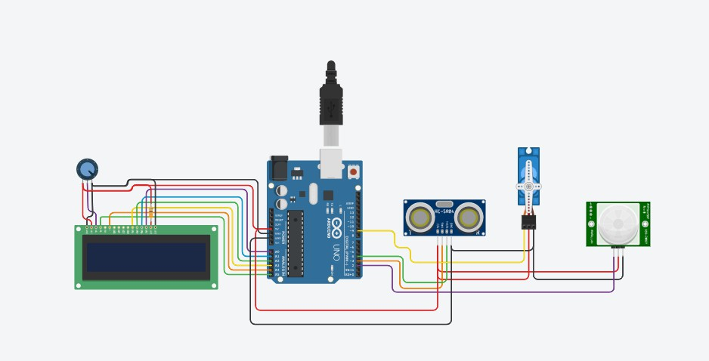

### Arduino Uno Introduction:

The **Arduino Uno** is an open-source microcontroller board based on the **ATmega328P**. It is highly popular in the fields of embedded systems, automation, and electronics prototyping due to its ease of use, wide availability, and strong community support.

### Function:

In the **Smart Dustbin System**, the Arduino Uno functions as the **central controller**. It receives input signals from the **PIR motion sensor** and the **ultrasonic distance sensor**, processes these inputs, and controls the **servo motor** to open or close the lid. It also sends real-time garbage level data to the **LCD display**, enhancing user interaction and awareness.

### Benefits:

The Arduino Uno is easy to program, affordable, and highly versatile. It features multiple **digital and analog I/O pins**, which makes it simple to interface with sensors, actuators, and displays. Its reliability and portability make it ideal for low-power, standalone projects like the smart dustbin.

### Applications:



Used in hygiene-focused automation systems, smart homes, public sanitation projects, and educational embedded system prototypes.

### Why It Is Used in This Project:

The Arduino Uno serves as the **"brain"** of the system, making real-time decisions based on motion detection and garbage level inputs, while controlling the lid mechanism and displaying the current status effectively.

### PIR Sensor Introduction:

A PIR (Passive Infrared) sensor is a motion-detecting device that senses infrared radiation emitted by nearby objects like human bodies.

### Function:

In this project, the PIR sensor detects when someone approaches the dustbin. Upon detection, the Arduino triggers the lid to open automatically using a servo motor.

### Benefits:

Non-contact detection, low power consumption, and quick response time make it ideal for hygiene-based automation.

### Applications:

Used in automatic lighting systems, intrusion alarms, and contactless device control.

### Why It Is Used in This Project:

To enable **touch-free** lid opening, promoting better hygiene and making waste disposal more convenient.

### Ultrasonic Sensor

**Introduction:**



An ultrasonic sensor measures the distance to an object by emitting sound waves and measuring their echo.

### Function:

In this project, the ultrasonic sensor continuously monitors the garbage level inside the dustbin. It helps calculate how full the bin is and sends this data to the LCD for display.

### Benefits:

Accurate, reliable, and non-contact measurement. Works well in dusty or moist environments.

### Applications:

Used in level sensing, object detection, and robot navigation.

### Why It Is Used in This Project:

To determine the **fill level** of the bin and prevent overflow by informing users when it’s full..

### Servo Motor Introduction:

A servo motor is an actuator capable of precise angular movement, controlled via PWM signals.

### Function:

It operates the dustbin lid. When motion is detected, the Arduino sends a signal to the servo to rotate and open the lid, and later return it to the closed position.

### Benefits:

Precise, low-power, compact, and easy to control — ideal for repeated small movements like opening a lid.

### Applications:



Used in robotics, automation, and mechanical control systems.

### Why It Is Used in This Project:

To **open and close** the dustbin lid automatically based on motion detection, simulating a smart, touch-free operation.

### 16x2 LCD

**Introduction:**

The 16x2 LCD is a character display module capable of showing 16 characters across two lines.

### Function:

Displays real-time messages such as **"Welcome"**, **"Lid Opening"**, and **"Garbage Level: 70%"**, enhancing user experience and system transparency.

### Benefits:

Low-cost, widely supported, and easy to use with microcontrollers.

### Applications:

Used in embedded projects for display output, vending machines, and status displays.

### Why It Is Used in This Project:

To provide clear, **visual feedback** about system status and garbage level, making the bin more interactive

### Power Supply (Battery or USB) Introduction:

The system can be powered either through a USB connection or an external 9V battery.

### Function:

Provides power to the Arduino and all connected components such as sensors, servo, and LCD.

### Benefits:



Offers flexible powering options, allowing for both stationary and portable use.

### Applications:

Used in all embedded systems, especially portable or remote setups.

### Why It Is Used in This Project:

To ensure reliable operation in both indoor and outdoor environments without dependency on wall outlets.

### System Block Diagram (Verbal Description):

* **Input:** PIR Sensor (Motion Detection), Ultrasonic Sensor (Garbage Level Detection)
* **Controller:** Arduino Uno
* **Output Devices:** Servo Motor (Lid Control), LCD Display (Garbage Level), Buzzer (Optional Alert)
* **Power:** Battery or USB
* Process Flow: PIR detects motion → Arduino opens lid via servo → Ultrasonic sensor measures garbage level → LCD displays fill percentage

1. Code

#include <LiquidCrystal.h> #include <Servo.h>

// Pin Definitions

const int pirSensorPin = 2; const int ultrasonicTrigPin = 3; const int ultrasonicEchoPin = 4; const int servoPin = 9;

// LCD: RS, E, D4, D5, D6, D7

LiquidCrystal lcd(A5, A4, A3, A2, A1, A0);

Servo lidServo;

// Constants

const int maxDistance = 200; // Max garbage depth in cm const int maxGarbageCapacity

= 100;

bool isLidOpen = false;

// Setup

void setup() { pinMode(pirSensorPin, INPUT);

pinMode(ultrasonicTrigPin, OUTPUT);

pinMode(ultrasonicEchoPin, INPUT);

lidServo.attach(servoPin);

lidServo.write(0); // Start with lid closed

lcd.begin(16, 2); lcd.print("Smart Dustbin"); delay(2000);

lcd.clear();

}

// Loop

void loop() { int pirValue =

digitalRead(pirSensorPin);

long distance = getUltrasonicDistance();

// Calculate garbage level int garbageLevel = 0;

if (distance < maxDistance) { garbageLevel =

map(distance, maxDistance, 0,

0, maxGarbageCapacity);

}

int percentage = map(garbageLevel, 0,

maxGarbageCapacity, 0, 100);

// Display on LCD lcd.setCursor(0, 0); lcd.print("Garbage: "); lcd.print(percentage); lcd.print("% ");

// Lid control

if (pirValue == HIGH &&

!isLidOpen) { openLid();

delay(5000); // Lid open duration

closeLid();

}

delay(1000); // Small delay to avoid flickering

}

// Measure distance using ultrasonic sensor

long getUltrasonicDistance() { digitalWrite(ultrasonicTrigPin, LOW);

delayMicroseconds(2); digitalWrite(ultrasonicTrigPin, HIGH);

delayMicroseconds(10); digitalWrite(ultrasonicTrigPin, LOW);

long duration = pulseIn(ultrasonicEchoPin, HIGH);

long distance = duration *

0.034 / 2; // Convert to cm return distance;

}

// Lid functions void openLid() {

lidServo.write(90); // Adjust as needed

isLidOpen = true;

}

void closeLid() { lidServo.write(0); isLidOpen = false;

}

1. **Working**

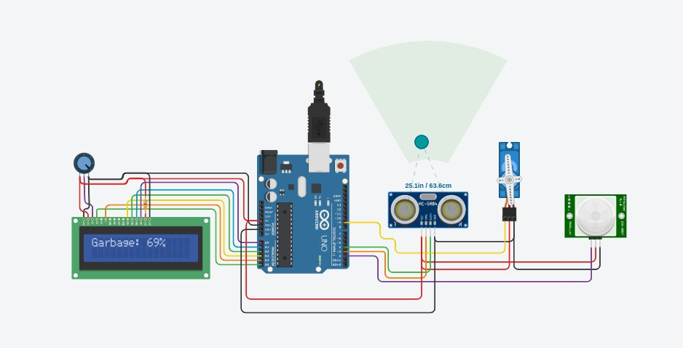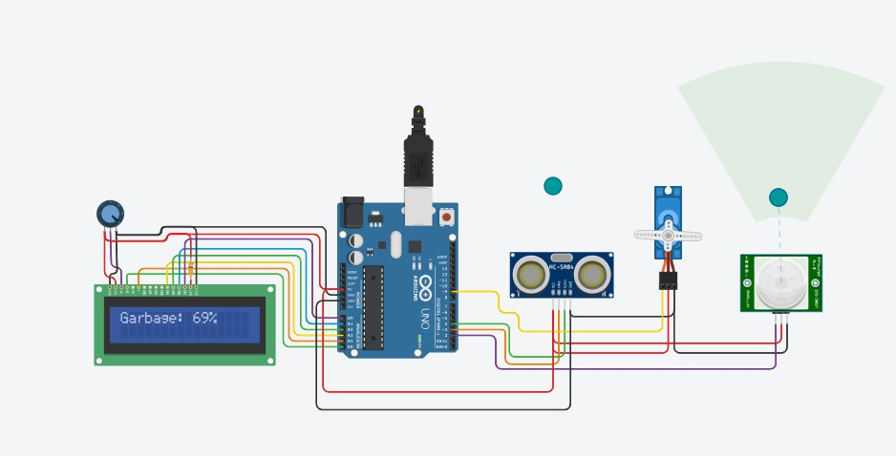

The **Smart Dustbin System** operates by detecting nearby motion using a **PIR sensor**. When a person approaches, the sensor sends a signal to the **Arduino Uno**, which then activates a **servo motor** to automatically open the lid. Simultaneously, an **ultrasonic sensor** measures the garbage level inside the bin. This data is displayed in real time on a **16x2 LCD screen**, showing the fill percentage to inform users when the bin is nearly full. After a short delay, the lid closes automatically. This system promotes hygiene by offering **touch-free operation** and improves efficiency through **garbage level monitoring**, making waste management smarter and more convenient.

# Future scope



The **Smart Dustbin System** developed in this project showcases an efficient and hygienic solution for modern waste management using microcontroller-based automation. While the current version offers features such as **automatic lid opening** and **real-time garbage level monitoring**, there is considerable scope for further development and technological integration. Future enhancements may include:

#### IoT-Based Monitoring and Alerts:

The system can be upgraded using Wi-Fi (ESP8266/ESP32) or GSM modules to send real-time updates about garbage levels to a mobile app or cloud dashboard. This enables remote monitoring, overflow alerts, and smart collection scheduling, which are particularly useful for public or commercial installations.

#### Solar Power Integration:

By incorporating a **solar-powered power supply**, the smart dustbin can be made **energy-independent**, reducing reliance on conventional power sources. This is especially beneficial for outdoor or rural applications where electricity is limited or unreliable.

#### Mobile App Integration::

A dedicated **smartphone application** could allow users or waste management personnel to check fill levels, receive alerts, and configure system settings remotely. This would make the system more interactive and user-friendly.

#### Real-Time Intrusion Alerts:

The system can be upgraded to detect multiple incorrect attempts and send instant alerts via SMS, email, or app notifications. A camera module can also be added to capture images of unauthorized users.

#### Battery Backup and Power Optimization:

Incorporating rechargeable batteries and low-power components will ensure the system continues to operate during power failures. Solar charging can also be explored for energy independence in remote or outdoor setups.

#### User Management System:

A future version could support multiple user profiles with unique PINs, allowing access

logs to be maintained and individual user permissions to be granted or revoked.

#### Mobile App Development:



A dedicated app could provide features like virtual keypad access, temporary password generation for guests, lock/unlock history tracking, and customizable settings for alerts and access control.

#### Scalability for Commercial Use:

The system can be expanded for use in commercial buildings, hostels, or office spaces where centralized access control is required. Integration with access databases, card swipes, or employee login systems can make it suitable for enterprise-level deployment.

This project sets the foundation for a secure, programmable, and scalable digital locking solution that can evolve into a complete smart access control platform with the help of modern technologies.

# Conclusion



The **Smart Dustbin System using Arduino Uno** offers a hygienic, cost-effective, and intelligent solution to one of the most pressing needs in modern waste management— efficient garbage disposal and real-time monitoring of bin fill levels. By integrating fundamental electronic components such as the **Arduino Uno**, **PIR sensor**, **ultrasonic sensor**, **servo motor**, and **16x2 LCD display**, this project successfully implements an automated, sensor-driven waste disposal mechanism that significantly improves both usability and sanitation.

The system ensures a **touch-free disposal experience** by opening the lid automatically when motion is detected and accurately measuring the garbage level inside the bin. This design eliminates the risks of contamination associated with manual lid operation and provides real-time visual feedback on the bin’s status, enabling timely collection and maintenance.

This project serves as a practical model for smart waste management solutions in a variety of settings, including homes, offices, schools, and public spaces. It demonstrates how integrating basic hardware components with logical control can effectively address real-world challenges in sanitation and efficiency, ensuring that the bin is emptied before overflow occurs.

In conclusion, the project successfully achieves its goal of creating an automated smart dustbin system that enhances hygiene and operational efficiency. It showcases the potential of embedded systems to improve everyday waste management practices in a simple and affordable way. With future enhancements such as IoT connectivity for remote monitoring, solar power integration for energy independence, and advanced sorting or segregation features, this system can evolve into a comprehensive smart waste management solution for urban and rural applications alike.

.



# References

* 1. ** "Smart Dustbin Using Arduino and Ultrasonic Sensor" Author: K. Ramya, B. Palaniappan https://**[**www.ijraset.com/fileserve.php?FID=15963**](http://www.ijraset.com/fileserve.php?FID=15963)
  2. ** "Smart Dustbin with Arduino and Servo Motor | DIY Project" Channel: Creativity Buzz** [**https://youtu.be/z8s1LBl9LkE?si=JVE1o1sJ3PVq-N9E**](https://youtu.be/z8s1LBl9LkE?si=JVE1o1sJ3PVq-N9E)

