About the Report
ShopNest is a fictional sales outsourcing firm that operates transactions of 15 store chains in Nigeria. They handle sales of billions of Nigerian Naira every month. Their employees manage both online and regular transactions.
This report aims to provide powerful insight on their performance between January 2024 and October 2024. Summarized sales analysis based on multiple factors like store, city, payment type etc. can be found on page 1. But since these types of companies also have strong influence over how your brand is represented, it is also practical to know what kind of customers they’ve managed to successfully negotiate with, so page 2 a detailed breakdown of the firm’s clients.

NOTE: 1 USD is currently valued at 1352 Nigerian Naira, so the numbers are greatly inflated.

Get data from our warehouse
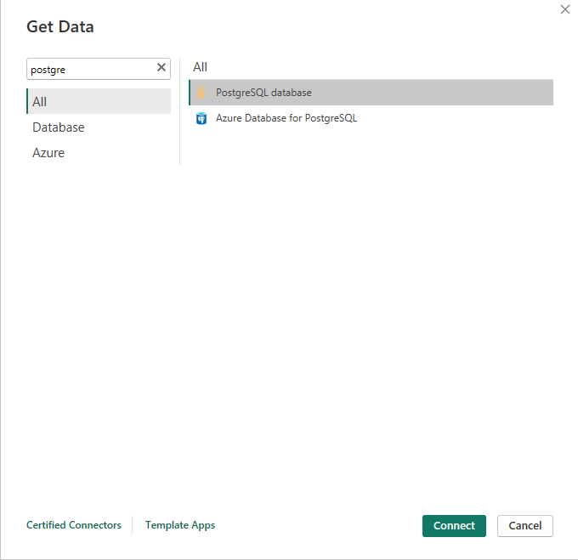
Choose import so we can work with data
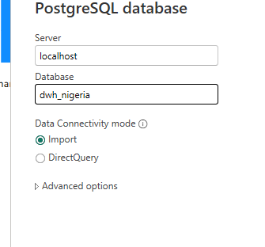
In the fact table, let’s add custom column that spells out the channel using which the sale was made
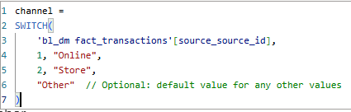
Also add custom column in date table to spell out weekday name
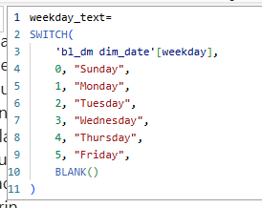
Add custom column in customer table to spell out income level
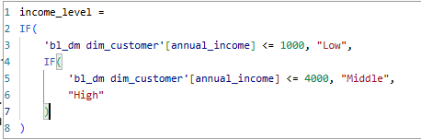

Merge first_name and last_name to get full names of customers and employees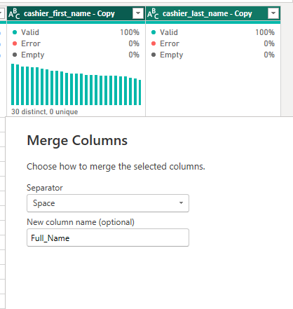

In our “sales by store” visual, add conditional colors to point out which store chains generated 10bn.
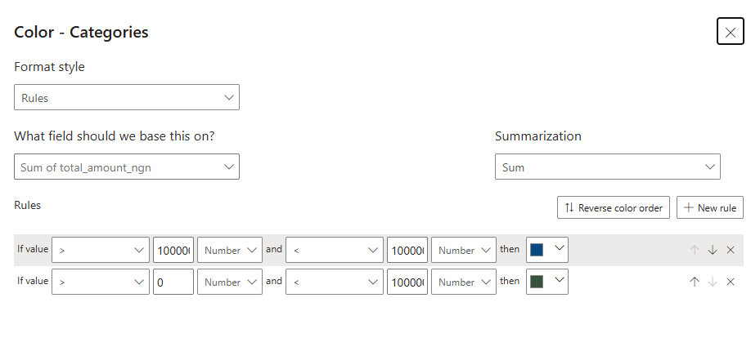
Create total sales measures to see top spending customers
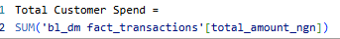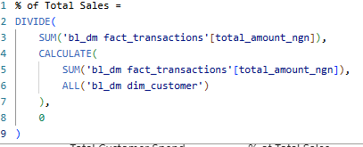
Create measure to see their last order date
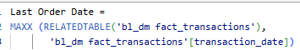
Add calculated column to find out customer age
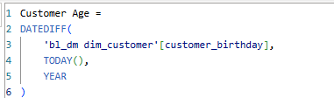

Allow using 1st page as tooltip
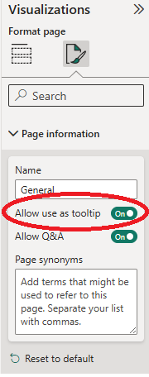
And add it as a tooltip to our top 5 customers on page 2
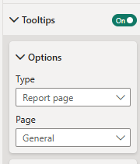

Create measure which will dynamically change based on which bar we click on in the “sales by gender” visual.
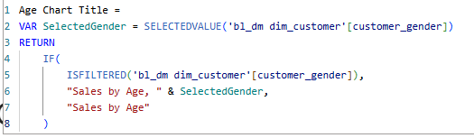

Published:
