Connect to redshift
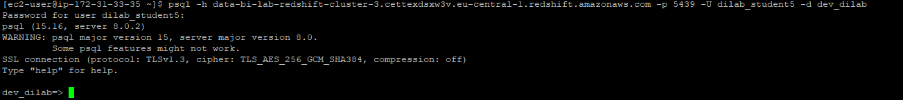
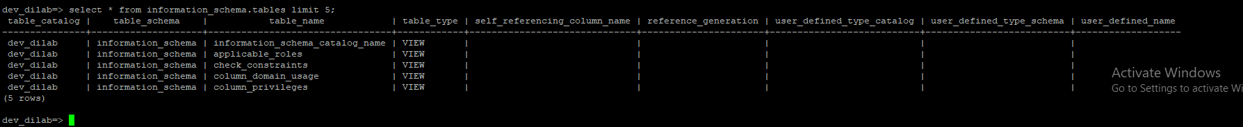
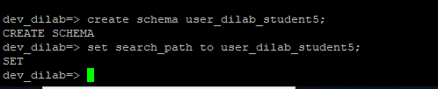
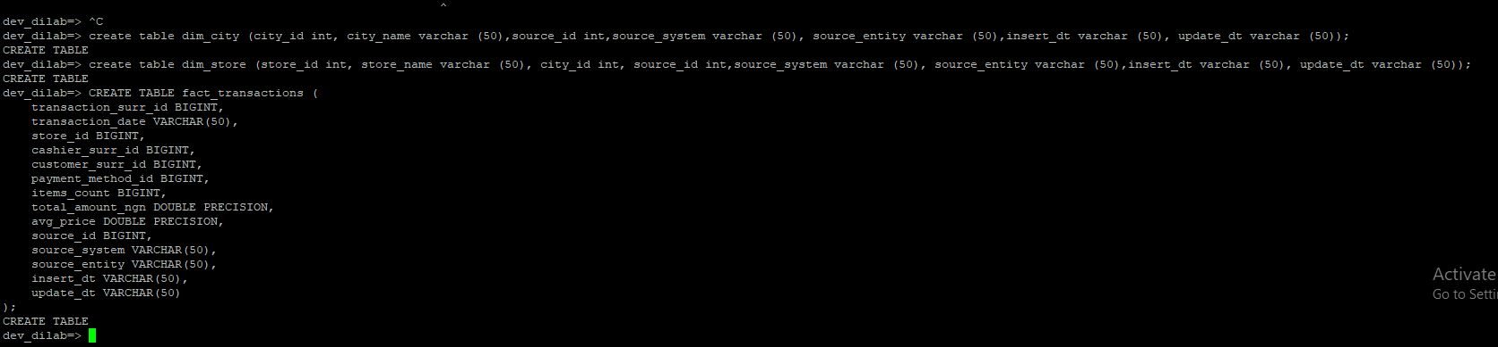
Load data
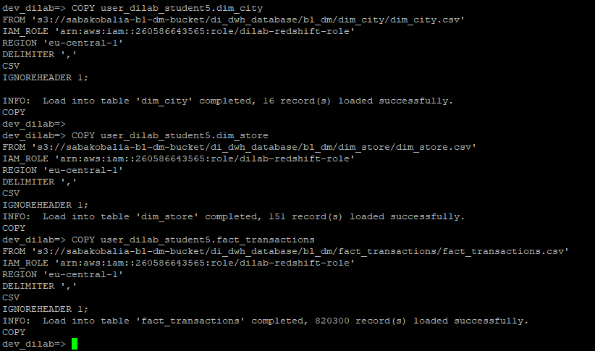
With these tables we can run performance analytics on each store
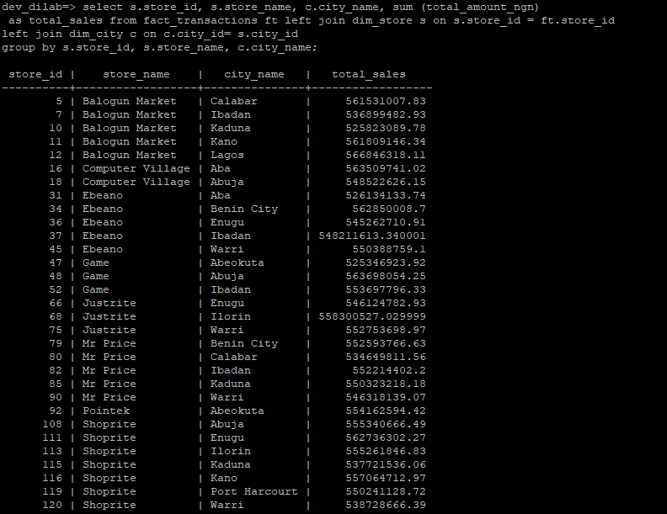
Check Table Info (size, rows, distribution)
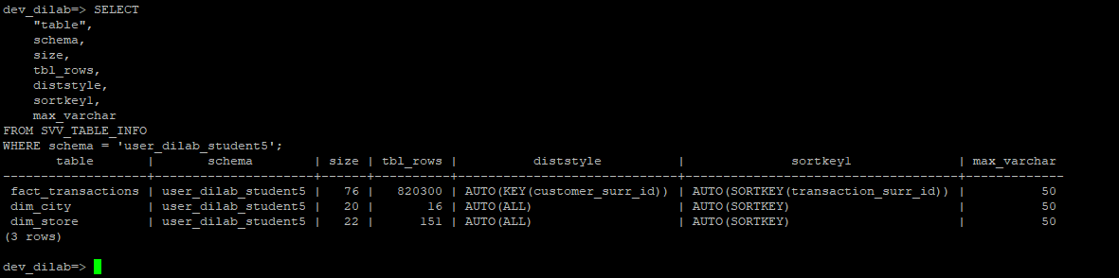

Check Column Compression
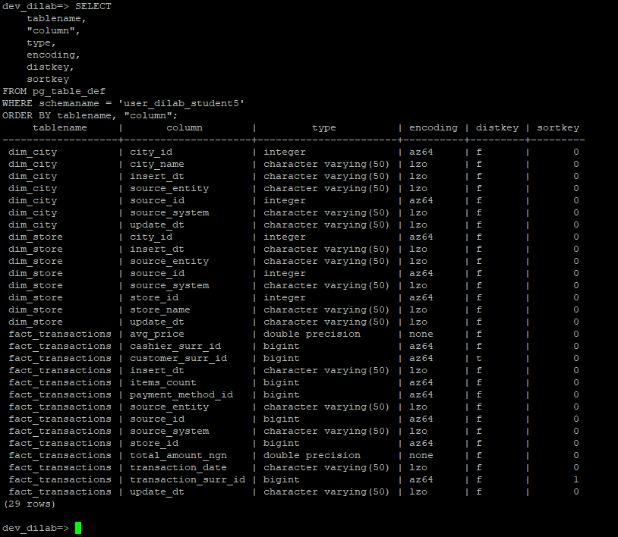
The fact table fact_transactions is distributed by customer_surr_id and has transaction_surr_id as a sort key. The dimension tables dim_city and dim_store are copied to all nodes and do not have any sort keys. Most number columns use AZ64 compression and text columns use LZO, but some columns like avg_price and total_amount_ngn do not have compression.The tables work and can be queried, but they are not fully optimized. Some important columns are not compressed and the sort keys are missing on some tables. To improve query speed, we need to set proper distribution keys, sort keys, and compression for the columns.

Create new table without compression and copy same data
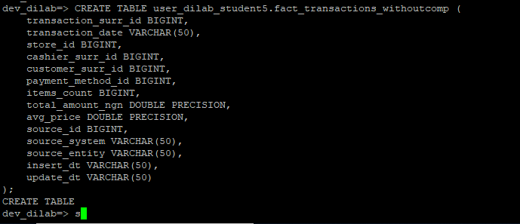
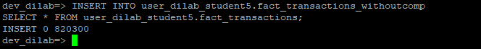
Let’s see what ANALYZE COMPRESSION tells us
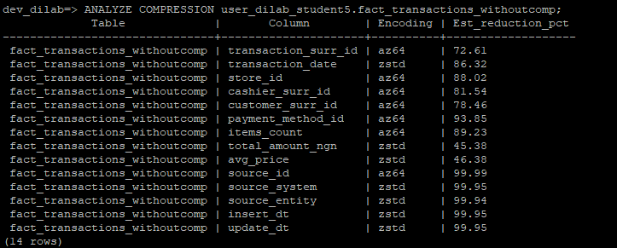

Create new table with suggested encodings and load data
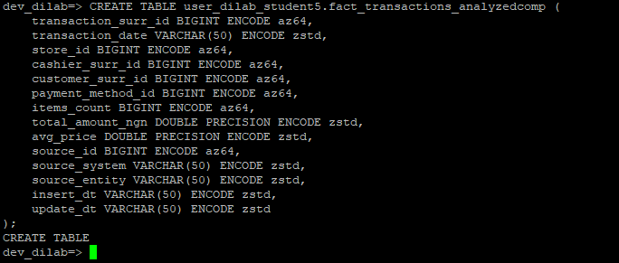
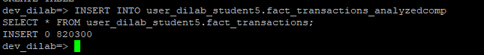
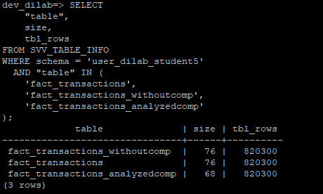
The uncompressed version used 76 MB storage, which is the same as the original table with default compression because Redshift had already applied some automatic encoding. After applying the encodings suggested by ANALYZE COMPRESSION and creating the table fact_transactions_analyzedcomp, the size dropped to 68 MB. This shows that using the recommended compression can save storage and improve performance, especially for large tables.

Create a simple procedure
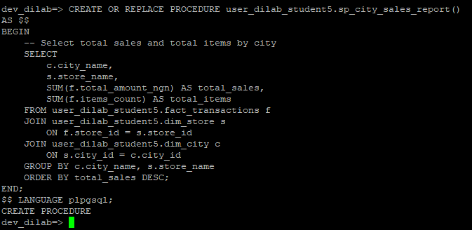
Run the SELECT manually before optimization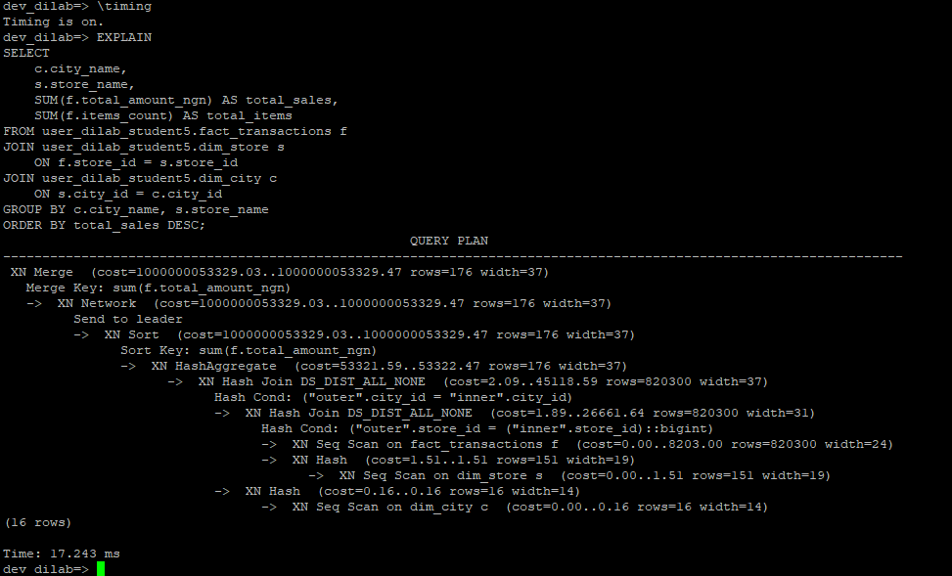
Run the actual query to log time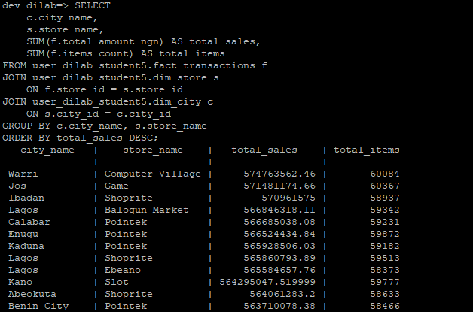
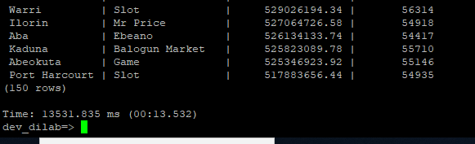
The execution plan shows that Redshift used hash joins to combine the tables, and it performed sequential scans on the large fact table. Both dimension tables are small, so they were copied to all nodes for the joins. The query took about 13.5 seconds to run.
Before optimization, the fact table’s distribution and sort keys were not aligned with the join columns, which means a lot of data had to be moved between nodes during execution. This explains why the query was slower.
The first execution of the query used the current table settings, where the distribution key of the fact table) does not match the join column (store_id). This caused Redshift to shuffle large amounts of data between nodes during the hash joins. Also, the sort key (transaction_surr_id) is unrelated to the columns used in aggregation (store_id and city_id).
Existing distribution style and sort keys:
fact_transactions: Distribution key = customer_surr_id, Sort key = transaction_surr_id
dim_store, dim_city: Distribution style = ALL (copied to all nodes), no sort key defined
The fact table is distributed by a column not used in the join. This forces Redshift to redistribute data during the query.
Dimension tables are small and fully copied to all nodes, which is fine.
Only transaction_surr_id in the fact table is sorted, but it is not used in the query. sorting does not help here.
5.
Create optimized table and copy data into it
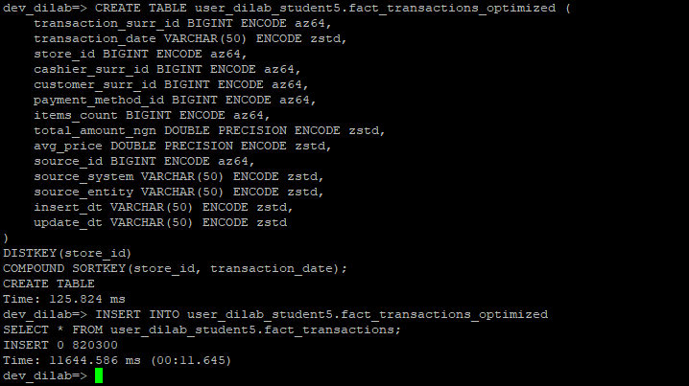

Run the query and log execution plan
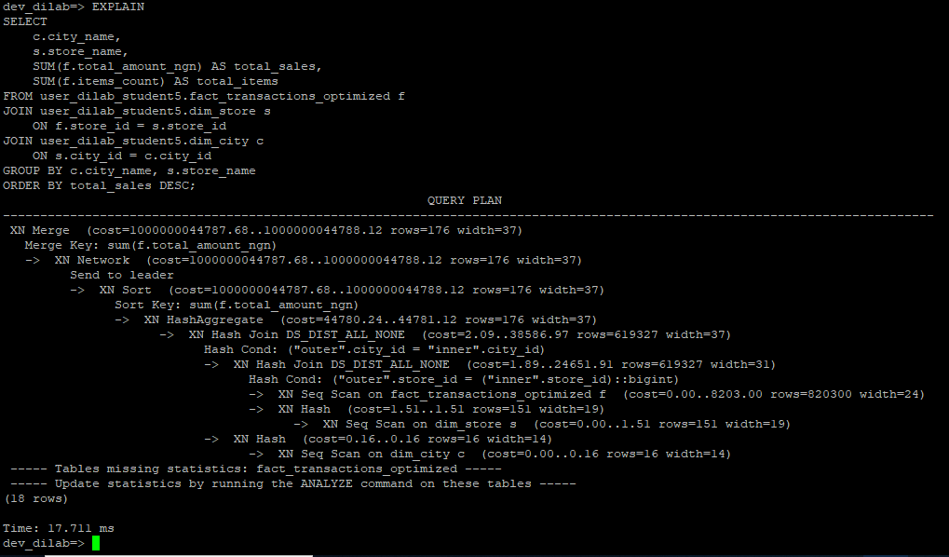
Run actual query to log execution time
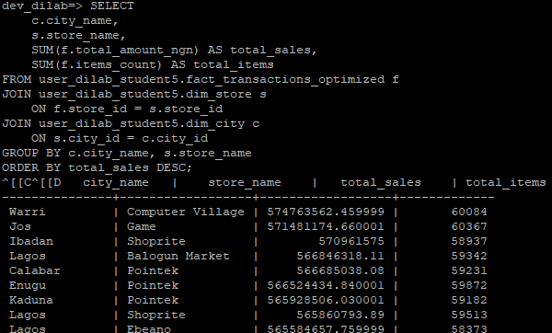
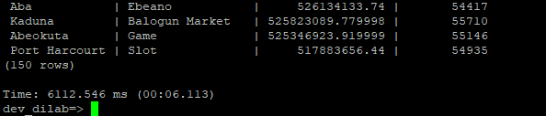
I chose KEY distribution on store_id because our query joins the fact table with dim_store using this column. Since this join is used frequently and not shared with many other tables, distributing data by store_id ensures that all rows for the same store are on the same node, reducing the need for data redistribution during the join.
I also used a compound sort key on (store_id, transaction_date). This helps Redshift scan the data more efficiently for the join and improve query performance when filtering or aggregating by date.
After optimization, EXPLAIN shows that the hash joins still occur, but because the fact table is distributed by store_id, no large data shuffle is needed across nodes. The query can now process joins mostly locally, which is more efficient.
When running the actual query, the execution time decreased to 6.1 seconds, compared to 13.5 seconds before optimization. This is a performance improvement of more than 50%.

6.
Create a report table
