1.
Add 3 roles based on what part of the world user is from. Only let them view the data for that region.
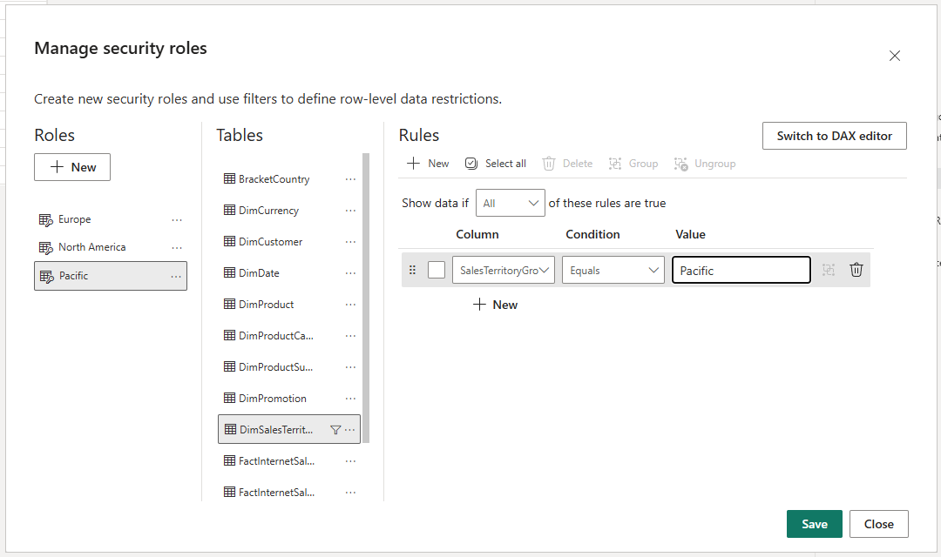
This helps improve data security and privacy. It also makes reports more focused and easier to analyze by removing unnecessary global data.
2. add bookmark and name it ‘Map’
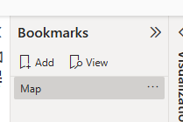
copy the map visual and place the copy on top of the original
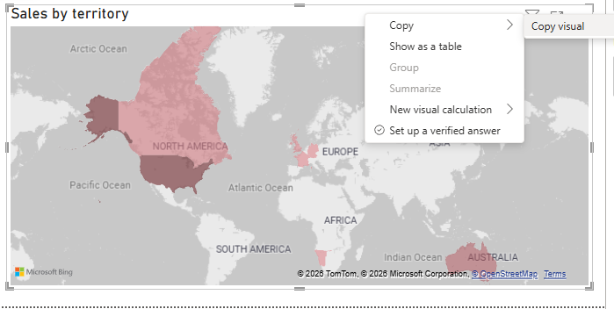

make the copy a bar chart and disable view for map visual. Bookmark this state and name it “Chart view”
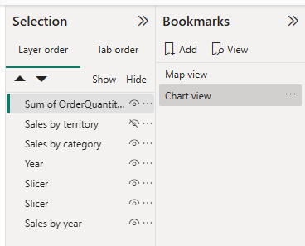
do the same for Map visual
Insert buttons and assign the two bookmarks to them
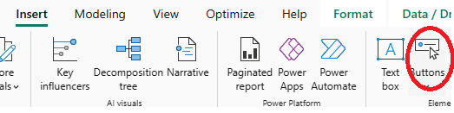
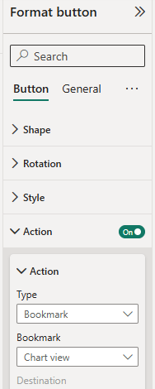
3. create new measures : previous month/quarter quantity/SalesAmount
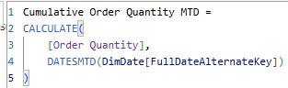
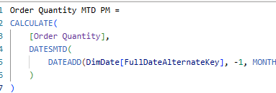
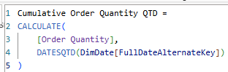
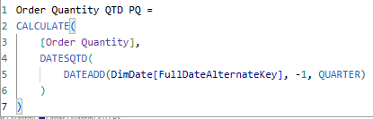
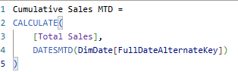
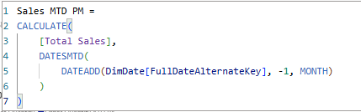
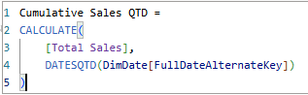
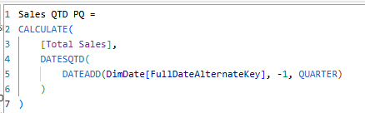

Before changing visuals current state create bookmark and name it Year view
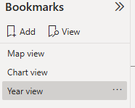
Recreate the two graphs on the page “Task 3 (2)” but with month measures instead of year. Bookmark it and name it Month view. Same procedure for Quarter view.
Add buttons for each bookmark
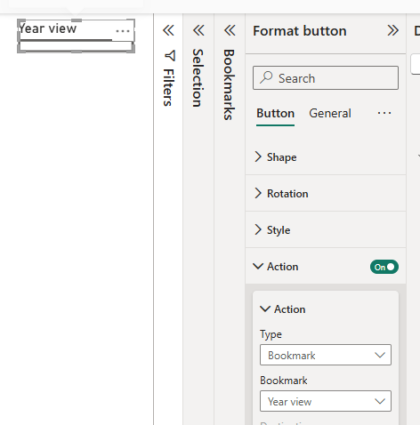
4. add a decomposition tree visual
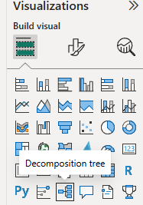
Let’s explain total sales by category, country and color.
Drag measure “Total Sales” to “Analyze” field.
The three explanatory fields to “Explain by”
This allows breaking down the main metric into contributing factors and identifying key drivers of sales. The visual provides an interactive way to understand how different variables impact overall performance.

5. go to page “Lab Report (1)” and allow use as tooltip
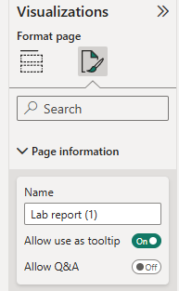
Go back to decomposition tree and add tooltip
