Business Template

Subject areas
Logo / Image

Contents
1 Business Description 3
1.1 Business background 3
1.2 Problems. Current Situation 3
1.3 The benefits of implementing a database. Project Vision 3
2 Model description 3
2.1 Definitions & Acronyms 3
2.2 Logical Scheme 3
2.3 Objects 3

Business Description

Business background
A museum that owns a large building with several floors, multiple storages and many art pieces. It has employees that manage these assets, hold exhibitons and sell tickets.

Problems. Current Situation
Hard to track items,exhibitions and visitors. Maintenance and infrastructure history are easy to lose. Creating reports and analyzing travel and sales is extremely time-consuming.

the Benefits of implementing a database. Project Vision
The database helps the museum keep all its information organized in one place, making it easy to find and update. It improves accuracy by enforcing rules, so data like items, exhibitions, and tickets stays consistent. Staff can quickly track where items are, which exhibitions are running, and who planned them. It also makes reporting and planning more efficient. Overall, it supports smoother daily operations and future digital systems like online ticketing.

Model description

Definitions & Acronyms
PK (Primary Key): A unique identifier for each record in a table. Denoted as the key symbol in this case. Indicated by the key symbol.
FK (Foreign Key): A field that links one table to another.
“INT” data type – integer
“Text”, “decimal”, “date” and “time” are also data types.

Logical Scheme
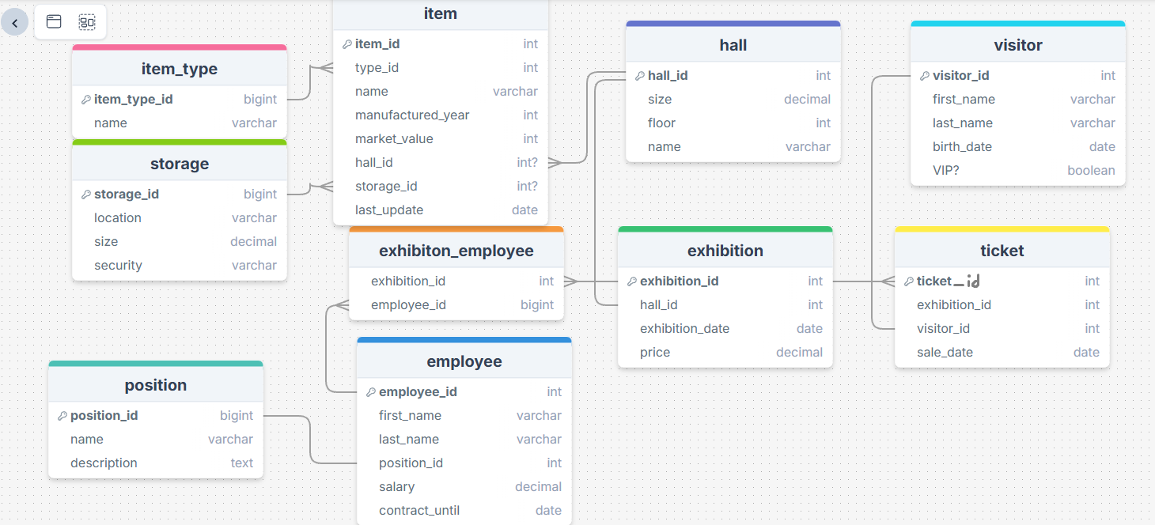

Objects

Item type | Field name | Field Description | Data Type
Table 1 | Item_type_id | PK | Int
 | name |  | varchar
Keeps info about every type of item we might have in inventory.
Example with data:

Item_type_id | name
5 | Painting

Hall | Field name | Field Description | Data Type
Table 2 | Hall id | PK | Int
 | Size | Sq meters | decimal
 | Floor | Which floor is it on | Int
 | name |  | Varchar
Keeps info about every hall in our building
Example with data
Hall id | Size | Floor | name
1 | 75.2 | 2 | The Italian hall

storage | Field name | Field Description | Data Type
Table 3 | Storage id | PK | Int
 | location |  | varchar
 | security | level of security | varchar
 | size | Sq meters | dec
Info about every storage we have.
Example with data:
Storage id | location | size | security
1 | Beliashvili ave. 6 | 100.1 | Medium

Item | Field name | Field Description | Data Type
Table 4 | Item id | PK | Int
 | Type_id | What kind of item is it? (FK from table 1, ‘item type’) | Int
 | Name |  | varchar
 | Manufactured year | Exact or estimated manufacture year | int
 | Market value | Exact or estimated value | int
 | Hall id | Which hall is it in? if at all. Nullable. FK from table 2 ‘hall’ | int
 | Storage_id | Which storage is it in? if at all. Nullable. FK from table 3 ‘storage’ | int
 | Last_update |  | date
Keeps info about every item in our possession.

Example with data:
Item id | Type_id | Manufactured year | Market value | Hall id | Storage id | Last update
1 | 1 | 1850 | 52000 | 1 | NULL | 2025-12-01

Position | Field name | Field Description | Data Type
Table 5 | Position id | PK | Int
 | Name |  | Varchar
 | description |  | text
Keeps info about every possible position an employee might have.
Example with data:
Position id | Name | description
1 | Security guard | Guards items

Employee | Field name | Field Description | Data Type
Table 6 | Employee ID | PK | Int
 | First name |  | text
 | Last name |  | text
 | position | FK from table 5 | text
 | salary |  | decimal
 | Contract until |  | date
Keeps track of every museum employee.
Example with data:

Employee ID | Name | Last name | Position_id | Salary | Contract until
1245 | Giorgi | Giorgadze | 3 | 3,000 | 2026-12-31

Exhibition | Field name | Field Description | Data Type
Table 7 | Exhibition id | PK | int
 | Hall id | Fk from table 2 -hall | int
 | Exhibition date | When we’re hosting it | date
 | price | How much to attend | decimal
Tells us about every exhibition we have ever held/plan to hold.
Example with data:

Exhibition id | Hall id | Exhibition date | price
124 | 5 | 20.12.2025 | 50.5

Exhibition employee | Field name | Field Description | Data Type
Table 8 | Exhibition id | Fk from table 7-exhibition | int
 | Employee id | Fk from table 6-employee | int
Tells us which employees were assigned to plan/manage which exhibition. Exhibition ID and Employee ID have a many-to-many relationship, as one event can have many planners and one employee can plan many exhibitions throughout their time working with us.
Example with data:
Exhibition id | employee id
124 | 50

visitor | Field name | Field Description | Data Type
Table 9 | visitor ID | PK | int
 | First name |  | int
 | Last name |  | int
 | Birth date |  | date
 | VIP? | Are we trying to secure funding or other favors from them? | boolean
Keeps track of every visitor that has ever come to our exhibitions
Example with data:

visitor ID | First name | Last name | Birth date | VIP?
2035 | Alexander | Cintron | 01.09.1980 | FALSE

ticket | Field name | Field Description | Data Type
Table 10 | Ticket id | PK | int
 | Exhibition id | Which event was the ticket for, fk from table 7 –‘exhibition’ | int
 | Visitor_id | Who bought it. Fk from table 9-‘visitor’ | int
 | Sale date |  | date
Keeps track of every event ticket we’ve sold.
Example with data:
Ticket id | Exhibition id | Visitor_id | Sale date
3900 | 120 | 699 | 05.05.2025

