4.2.2 : We merge the copied “FirstName” and “LastName” columns using space as a separator and name it “Full Name”.
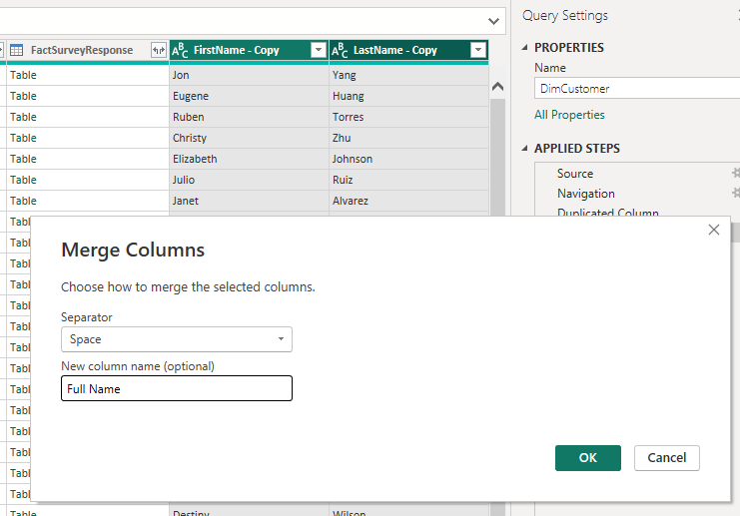

4.2.3: We change the type of DiscountPct to percentage.
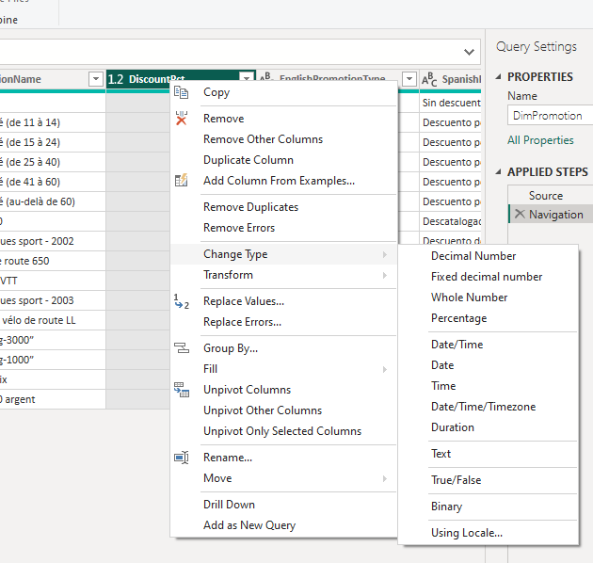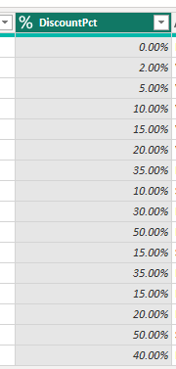

4.2.4: Add column that returns number of days from difference of two columns.
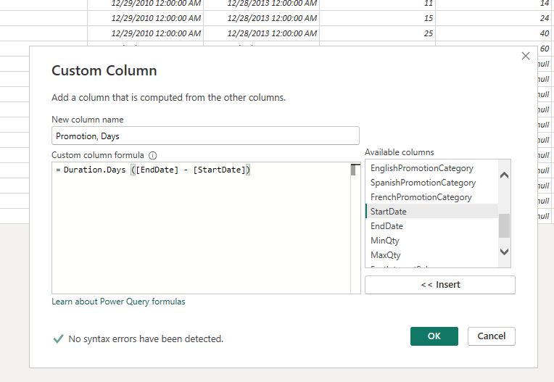
4.3 connect to the server again and import ‘DimProductSubcategory’ and ‘DimProductCategory’ tables.
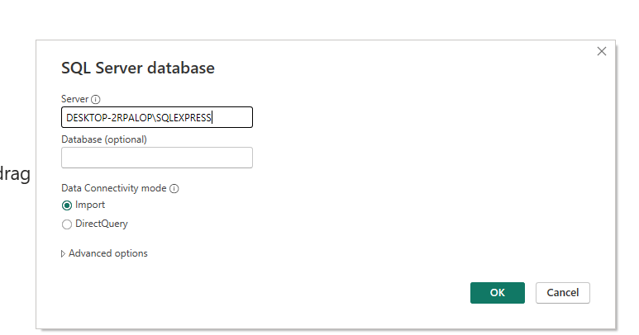
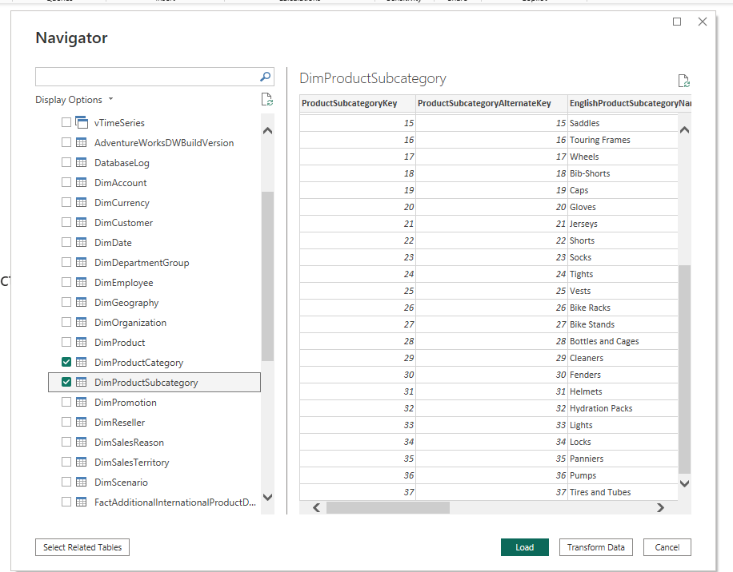
4.4
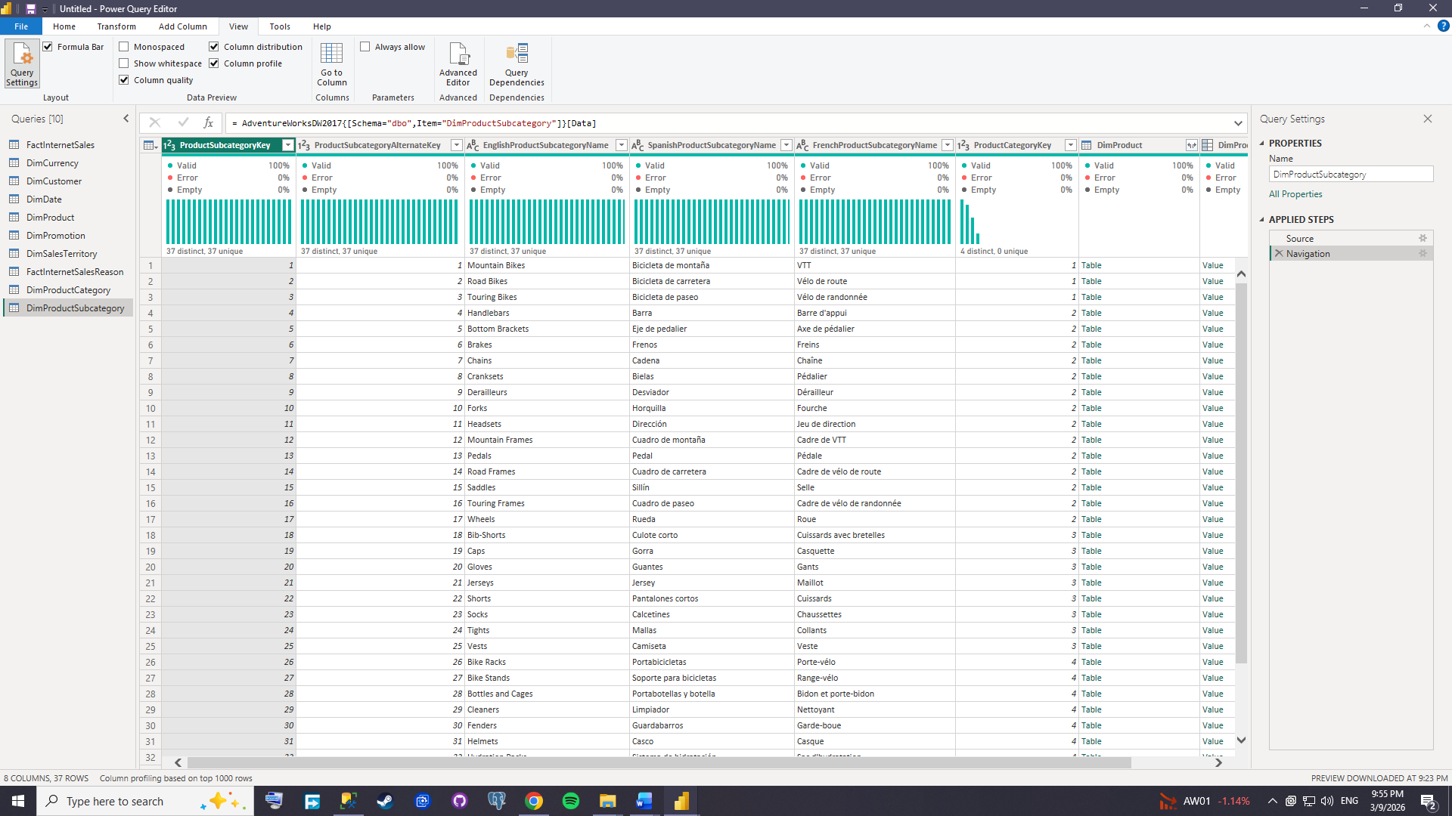
4.5.1 We create a column that stores what year the order was made.
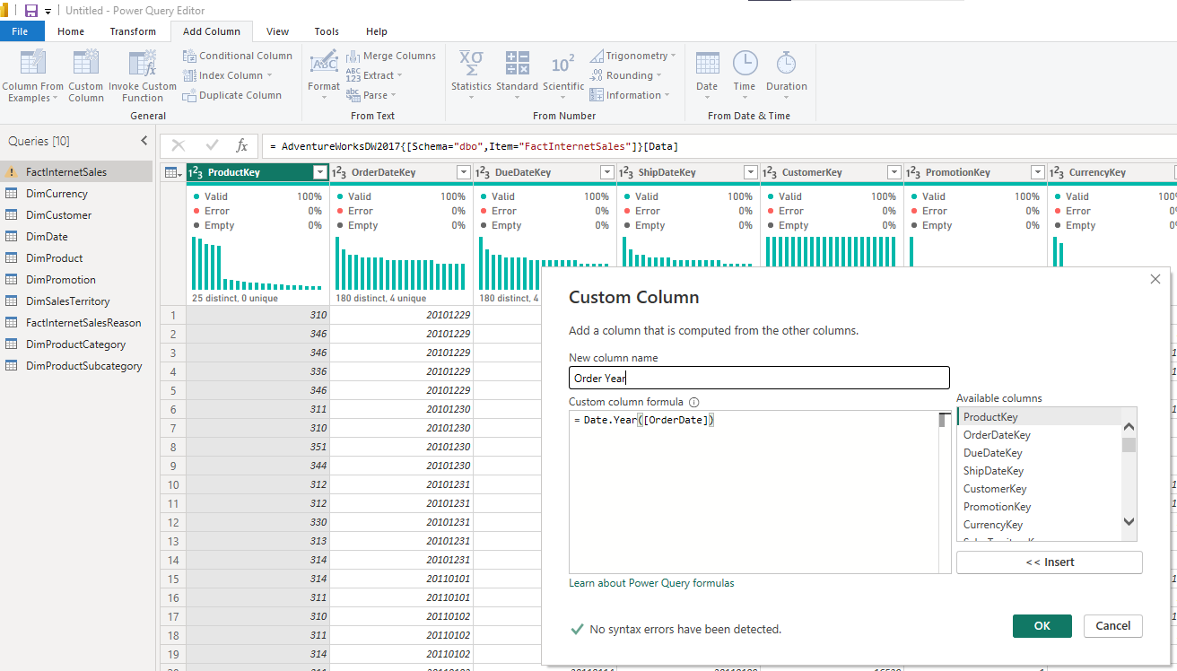

4.5.2: Keep only the desired columns from the copied table.
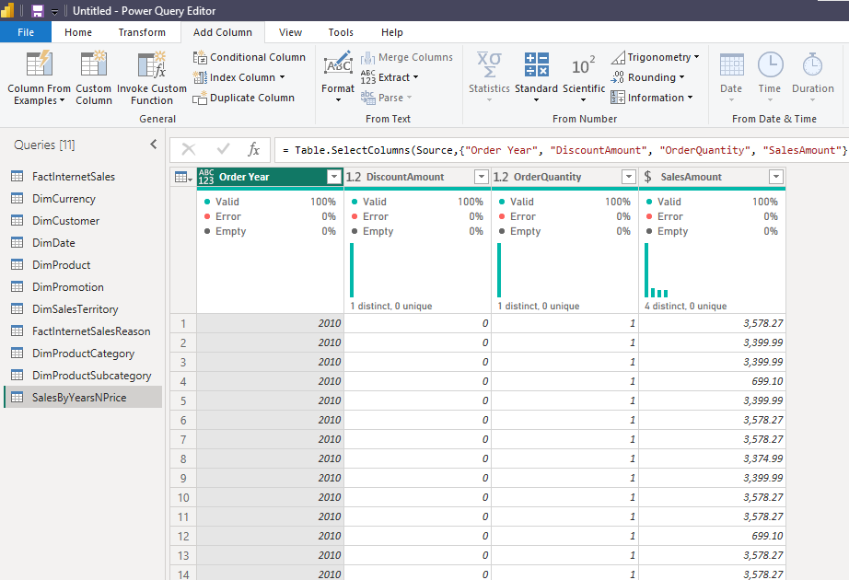
4.5.3 Pivot column ‘OrderYear’ to see the aggregate sales value for each year.
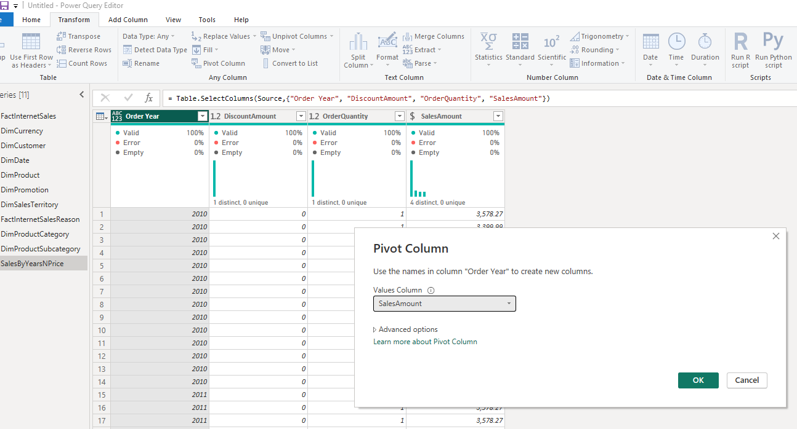
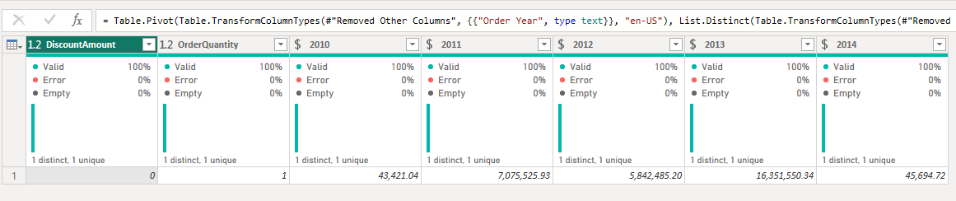4.6: Keep only the desired column from copied tables
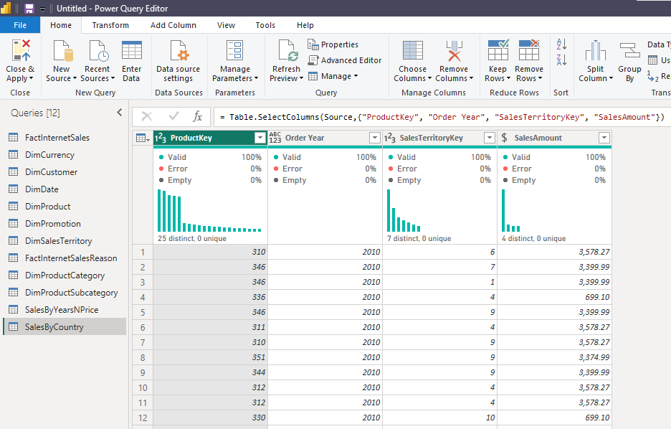
Merge with sales territory table:
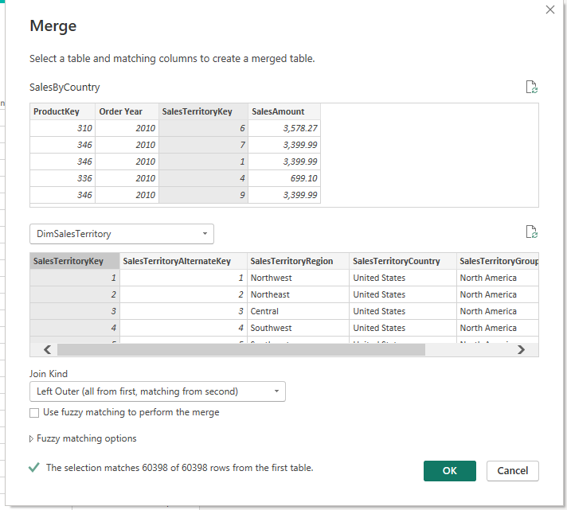

Merge with DimProduct
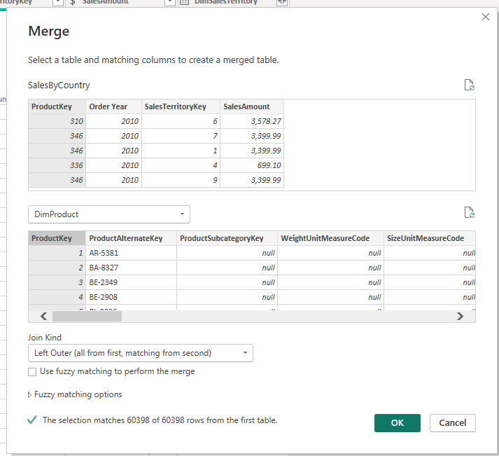
Only expand Subcategory key from this table
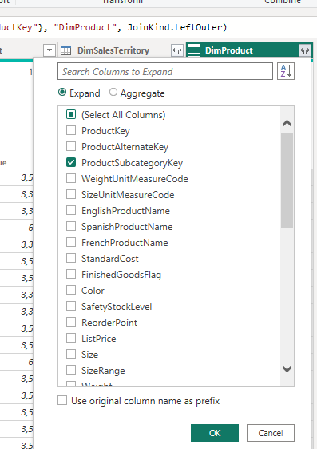
Merge with Product subcategory:
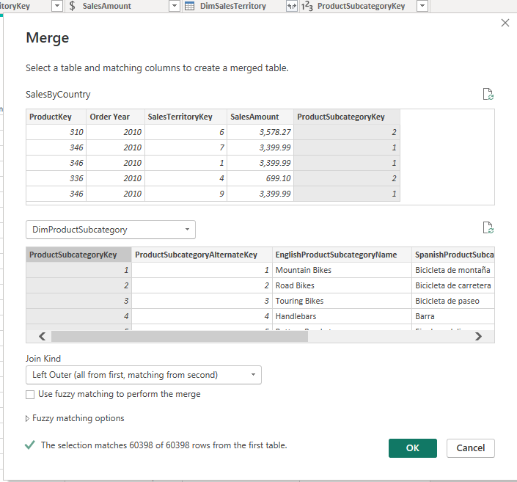
Only expand category key from this table
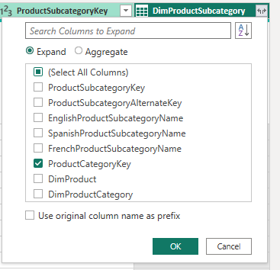
Finally merge with product category
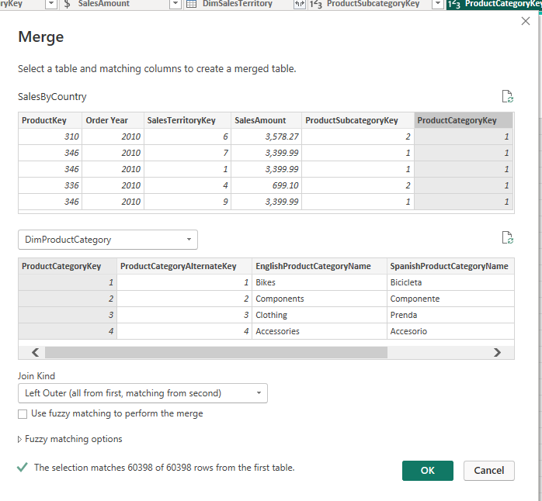
Only expand English category name
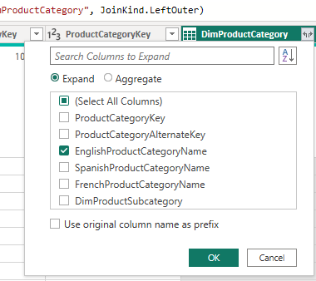
Expand country from Dim territory
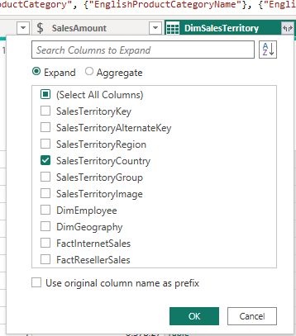
Final result
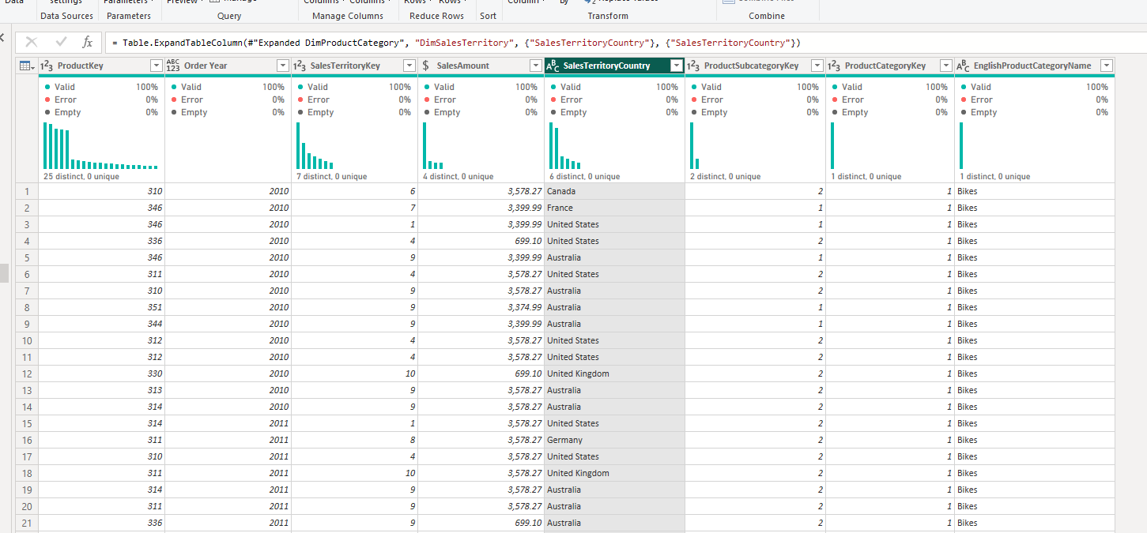

4.7 With this step we see sales amount grouped by year + country + category.
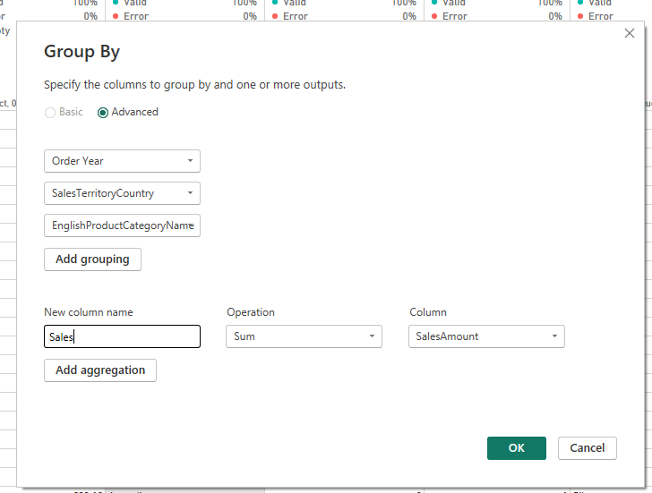
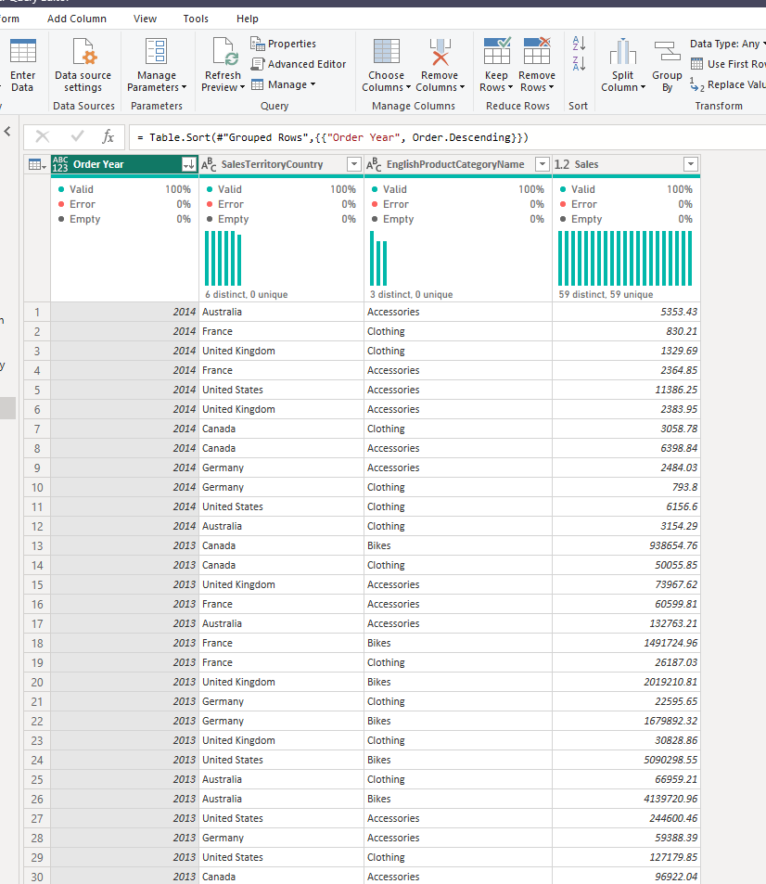
For example, we see that in 2013 company sold 26,187.03 worth of clothing in France.
4.9
Import and DirectQuery connect to Microsoft SQL Server in different ways. Import loads the selected tables and their data directly into the Power BI file, so queries run inside Power BI and performance is usually faster. DirectQuery does not store the data locally and instead sends queries to SQL Server every time a visual is used. For example, when selecting FactInternetSales and clicking “mark related tables,” Import also includes DimProductSubcategory and DimProductCategory because they are indirectly related through DimProduct. In DirectQuery, those two tables are not automatically selected because they are not directly related to FactInternetSales, but only connected through another table.
