Business Template

Retail Sales Transactions Analysis
Logo / Image

Contents
1 Business Description 3
1.1 Business background 3
1.2 Problems because of poor data management 3
1.3 Benefits from implementing a Data Warehouse 3
1.4 DATASETS DESCRIPTION 3
1.5 GRAIN / DIM / FACT 4
2 Business Layer 3NF 4
3 Business Layer Dimensional Model 4
4 Logical Scheme 4
5 Data Flow 4
6 Fact Table Partitioning Strategy 4

Business Description

Business background
For this project, the focus is on retail sales across multiple store locations in Nigeria, covering both physical stores and online channels. The business collects transactional data at the point of sale, capturing details such as the products purchased, quantities, payment methods, and customer interactions. By analyzing this data, the company can gain insights into sales patterns, customer preferences, and operational efficiency. The goal is to consolidate all transactional data from different sources into a single, well-organized data warehouse that will allow for better decision-making and business planning.

Problems because of poor data managemenT
Without proper data management, it is difficult to understand the overall performance of the business. For instance, if sales data is scattered across multiple stores or systems, it becomes almost impossible to answer questions like which products are selling best, which locations are underperforming, or how online and offline sales compare. Similarly, tracking customer loyalty points, discounts, and payment trends is cumbersome when the data is not integrated. Poorly managed data also makes it difficult to identify trends over time or plan inventory efficiently, which can lead to missed opportunities, stock shortages, or excess inventory. Ultimately, this limits the company’s ability to make informed strategic decisions and remain competitive in the retail market.

Benefits from implementing a Data Warehouse
Implementing a data warehouse allows the business to integrate, organize, and analyze all transactional data from both offline and online sales. By consolidating these datasets, it becomes possible to identify trends in customer purchases, track product performance across stores, and evaluate the effectiveness of promotions and loyalty programs. The data warehouse will also support comparing sales channels, such as brick-and-mortar stores versus online platforms, helping the company understand customer behavior in different contexts. With a structured warehouse, managers will be able to answer complex questions about sales patterns, product performance, and operational efficiency, enabling them to make better decisions, optimize inventory, and improve overall business strategy.

DATASETS DESCRIPTION
The first dataset contains the following information:

Sale information:
Date: when was the transaction made
Transaction price: The dollar amount the business acquired
Discount: was it applied or not.
Amount: how many items were sold

Cashier information:
Gender: male or female
Birthday: age of our employees

Store information:
Name: which chain the store belongs to
City: which city is it located in

City information:
Name: the cities in which we are recording sales.
Region: which part of Nigeria is the city

Customer information:
Gender: male or female
Birthday: age of our customers.

The hierarchy we have in this dataset is one of location. Each store belongs to a city, and each city belongs to a region.

GRAIN / DIM / FACT
The business process represented in the dataset is retail sales transactions generated through both physical stores and online sales channels. Each record captures a completed purchase made by a customer, including information about where and when the transaction occurred, how it was paid for, and the overall value of the sale.
The grain of the data is defined at the level of a single sales transaction. Each row in the dataset represents one completed transaction that took place at a specific store or online channel, on a specific date and time. This means that every record corresponds to one purchase event, regardless of the number of items included in that transaction.
At this level of detail, each transaction is fully described by its associated dimensions, including the date and time of the sale, the store and city where it occurred, the cashier who processed the transaction, the payment method used, and whether any discounts or loyalty points were applied. These dimensions together provide complete contextual information for analyzing each individual sale.
This grain was chosen because it reflects the most detailed and accurate level at which the data is captured in the source systems. Using transaction-level granularity allows the business to analyze sales performance flexibly across different dimensions such as time, location, sales channel, and payment method, while still supporting aggregation to higher levels for reporting and strategic analysis.
FACT_SALES
Column name | Description | Data Type
Sale_id | Surrogate key | Int
Transaction_id | Transaction identifier from source | varchar
Date_id | Fk to dim_date | int
Store_id | FK to dim_store | int
Cashier_id | Fk to dim_cashier | Int
Payment_method_id | Fk to dim_payment_method | int
Items_count | Number of items bought | Int
Total_amount_ngn | Dollar amount payed | Decimnal
Loyalty_points_earned | Loyalty points earned | Int
Discount_applied | Was the price discounted or not | Boolean
Source_system | Offline or online source | varchar

Example with filled data

Sale_id | Transaction_id | Date_id | Store_id | Cashier_id | Payment_method_id
1 | POS00000000 | 1 | 1 | 1 | 1

Items_count | Total_amount_ngn | Discount_applied | Loyalty_points_earned | receipt_number | Source_system
13 | 33837.28 | FALSE | 662 | RCP0000000000 | Source 1

DIM DATE
Column name | Description | Data Type
Date_id | PK | Int
Full_date |  | date
day | Day of month | int
month | 1 through 12 | int
year |  | int
weekday |  | varchar

Example with data:
date_id | Full_date | day | month | year | weekday
1 | 2024-08-03 | 3 | 8 | 2024 | saturday

DIM_STORE
Column name | Description | Data Type
Store_id | PK | Int
Store_name |  | varchar
city |  | varchar
Store_src_id | Stores’ source id | varchar
Example with data:
Store_id | Store_src_id | Store_name | city
1 | BAL001 | Balogun Market | Kano
DIM CASHIER
Column name | Description | Data Type
Cashier_id | PK | Int
Cashier_src_id | Cashiers’ source id | varchar

Example with data:
Cashier_id | Cashier_src_id
1 | CASH990
DIM_PAYMENT_METHOD

Column name | Description | Data Type
Payment_method_id | PK | Int
Payment_method | Name of method | varchar

Example with data:
Payment_method_id | Payment_method
1 | cash

DIM_SOURCE_SYSTEM
Column name | Description | Data Type
Source_id | PK | Int
Source_name |  | varchar
Example with data:
Source_id | Source_name
1 | Source 1

Business Layer 3NF
SCD is a concept that describes keeping old data and keeping track of what data is old and what is new. Type 2 (SCD2) is a method where we add a new column that tells us whether this data is current or expired.
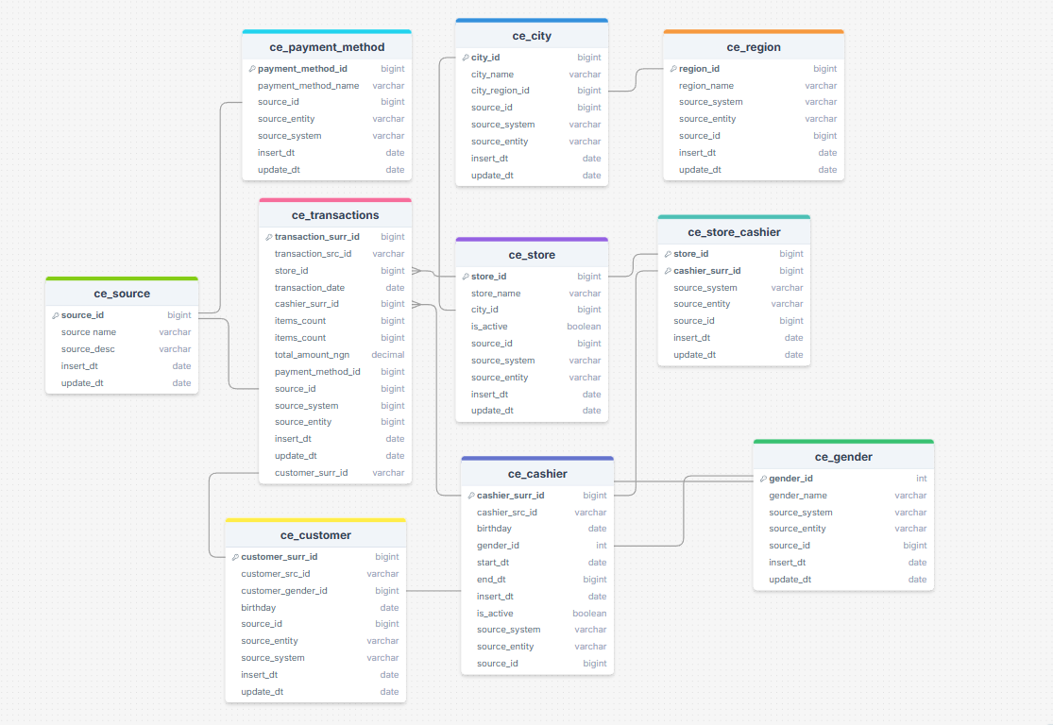
In our model each table has a source_id, to tell us whether it came from source 1 or 2.
Table ‘ce_cashier’ (SCD2) has columns ‘start_date’ and ‘end_date’ to tell us when this employee was assigned and until when to a particular store. It also has a Boolean column ‘is_active’ to make filtering active/inactive assignements easier. All other tables have SCD1.

Business Layer Dimensional Model

Logical Scheme

Data Flow

Fact Table Partitioning Strategy

