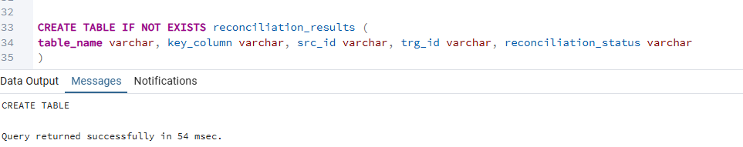
Insert problematic rows
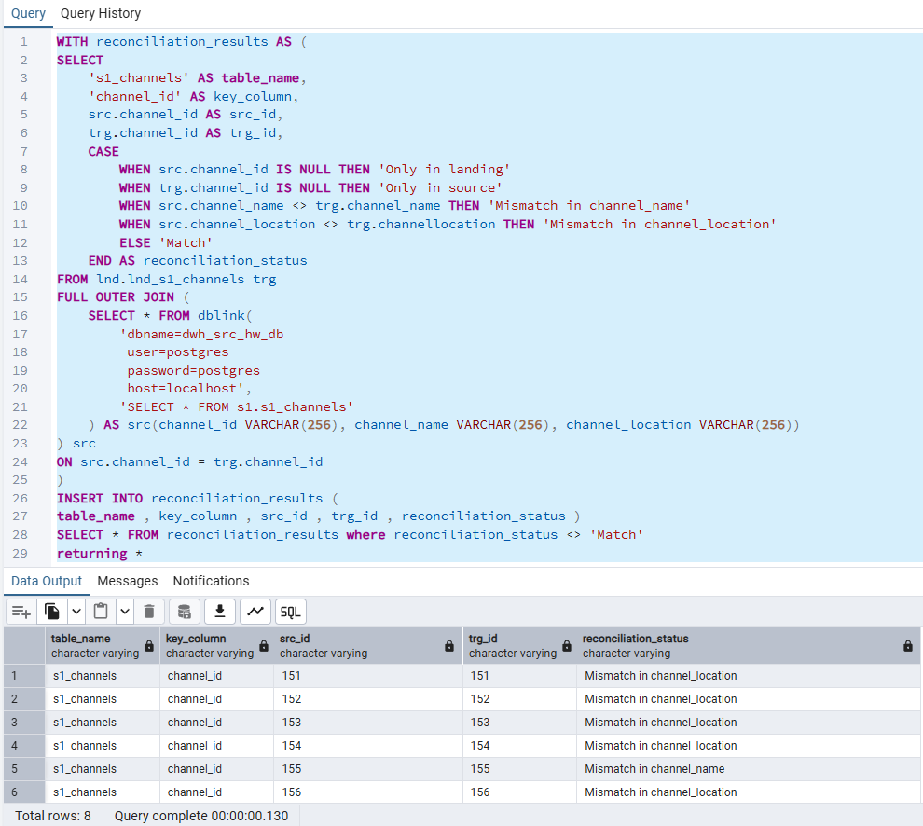
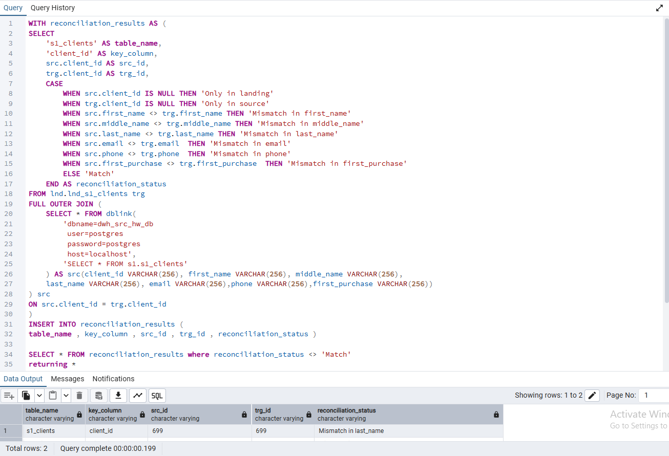
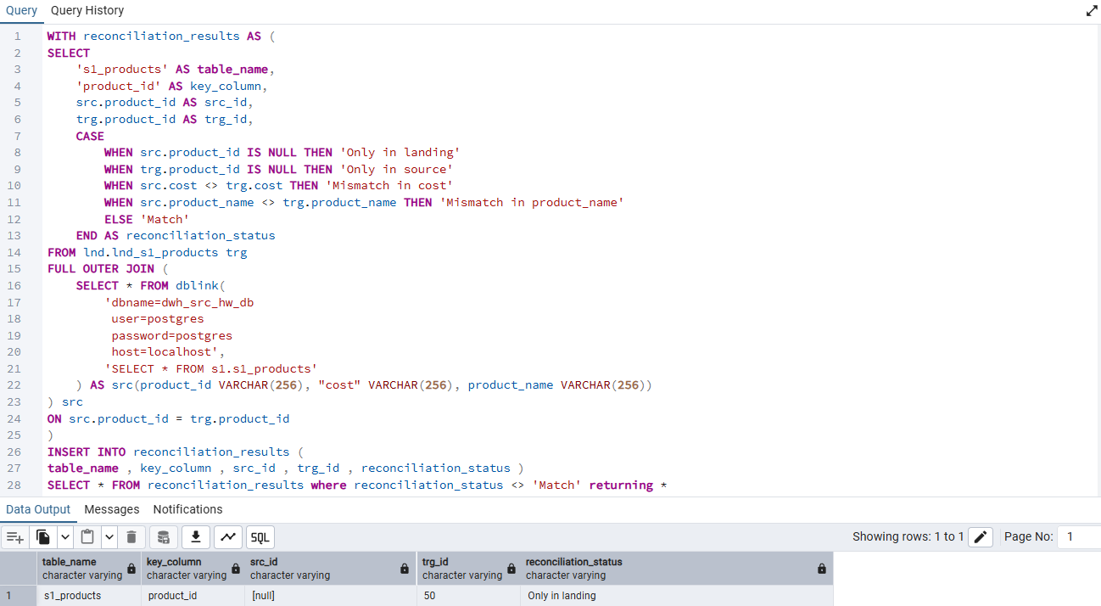

S1_sales doesn’t have a primary key, so we need to validate that at least a composite key exists naturally (combination of n number columns is unique for each row; in this case n=4)
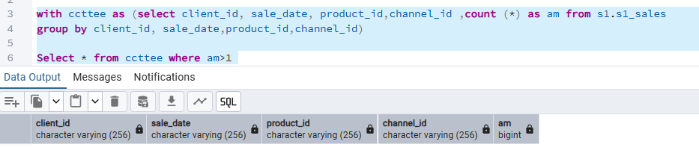
Then insert
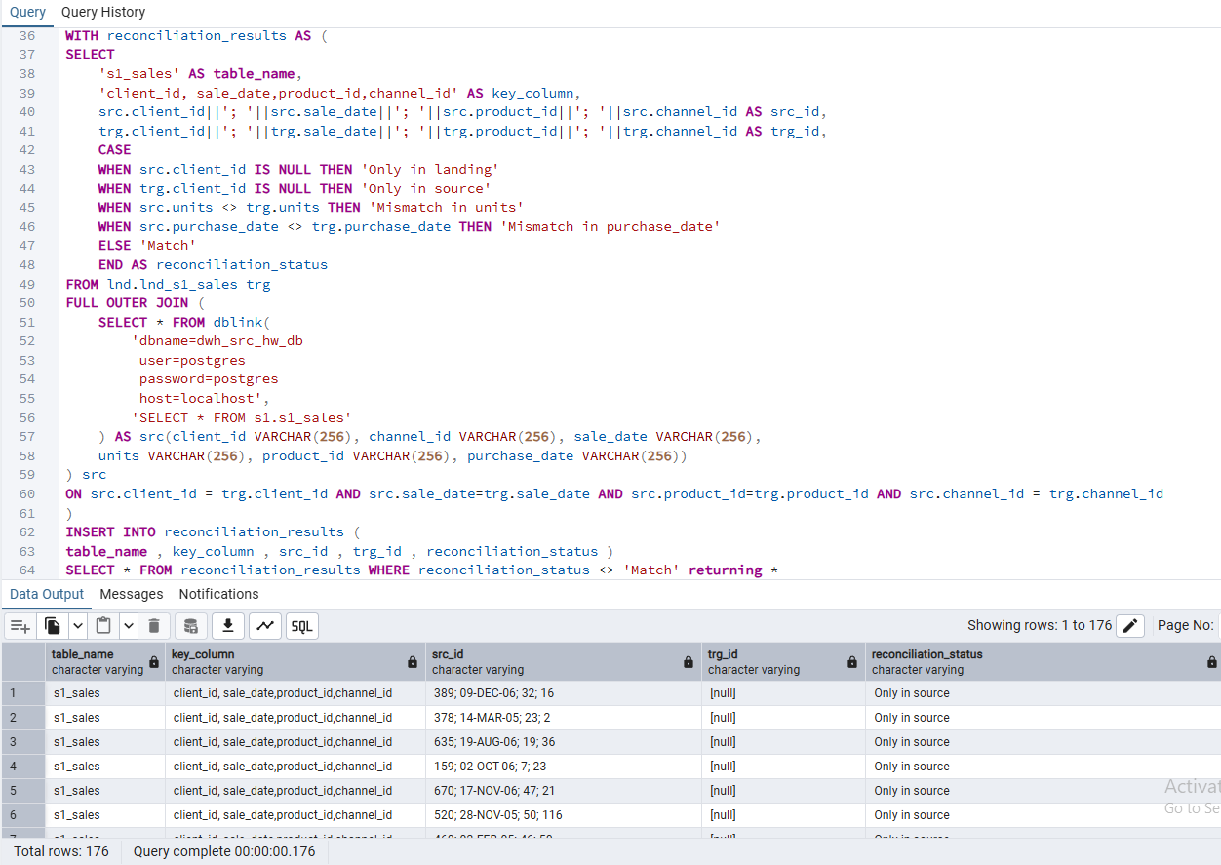

S2_channels has no problems, so we insert nothing
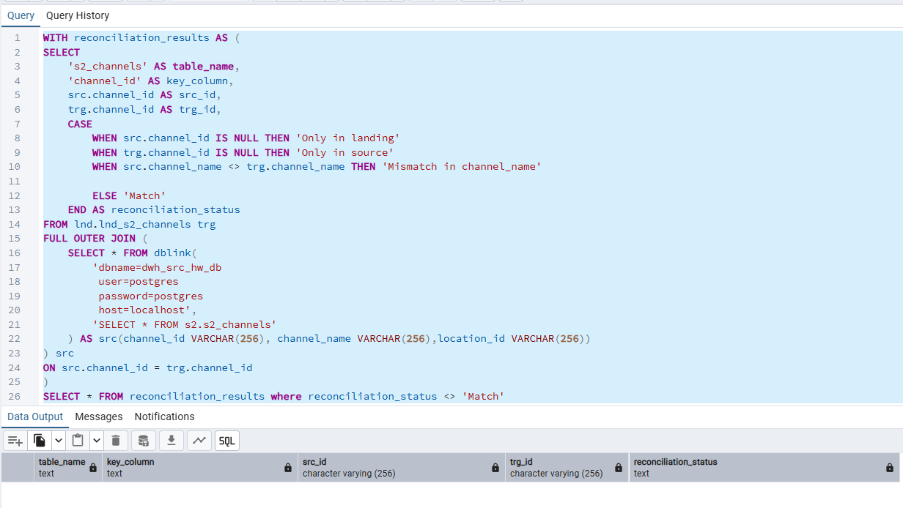
No primary key in s2_client_sales, either. Take client_id, product_id, saled_at as a natural composite key.
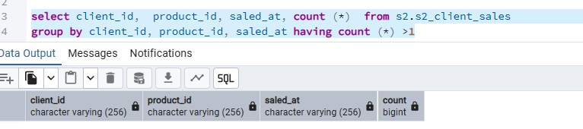then insert
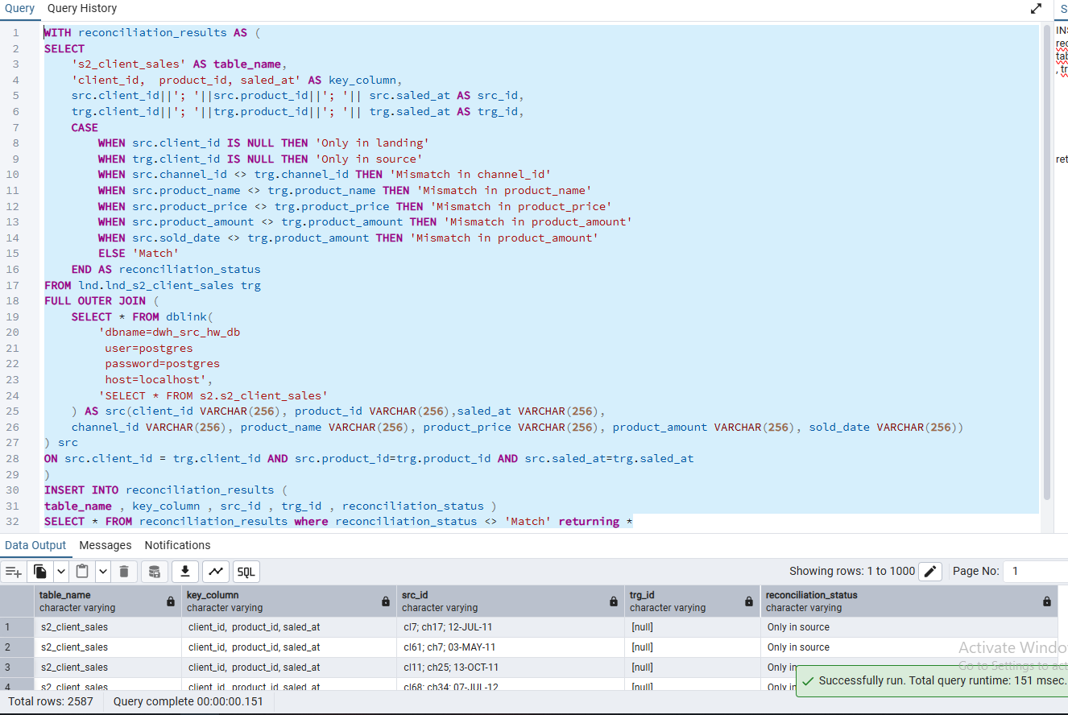

No mismatches in s2_clients, no need for insert
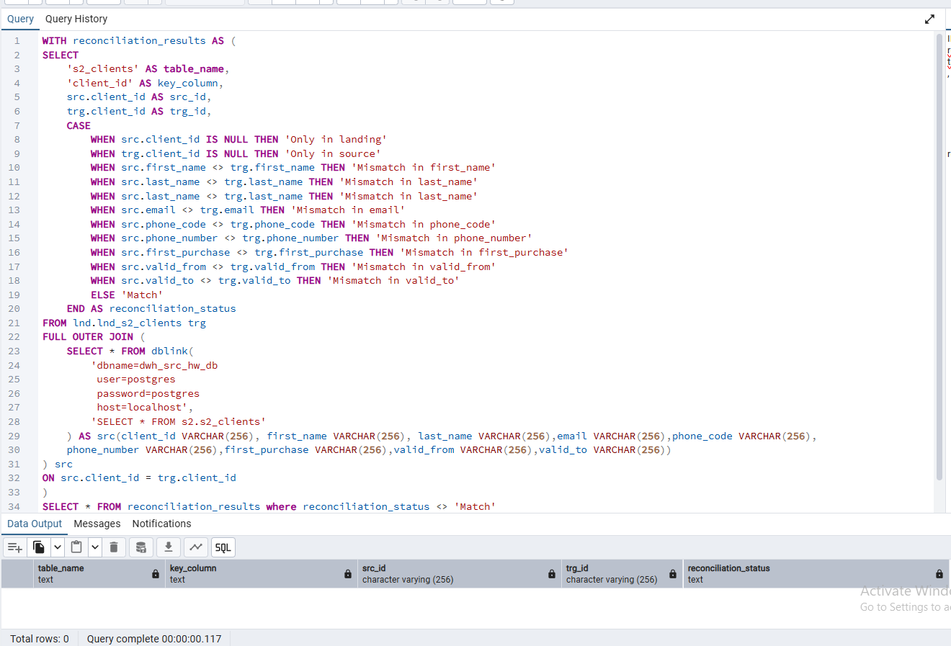
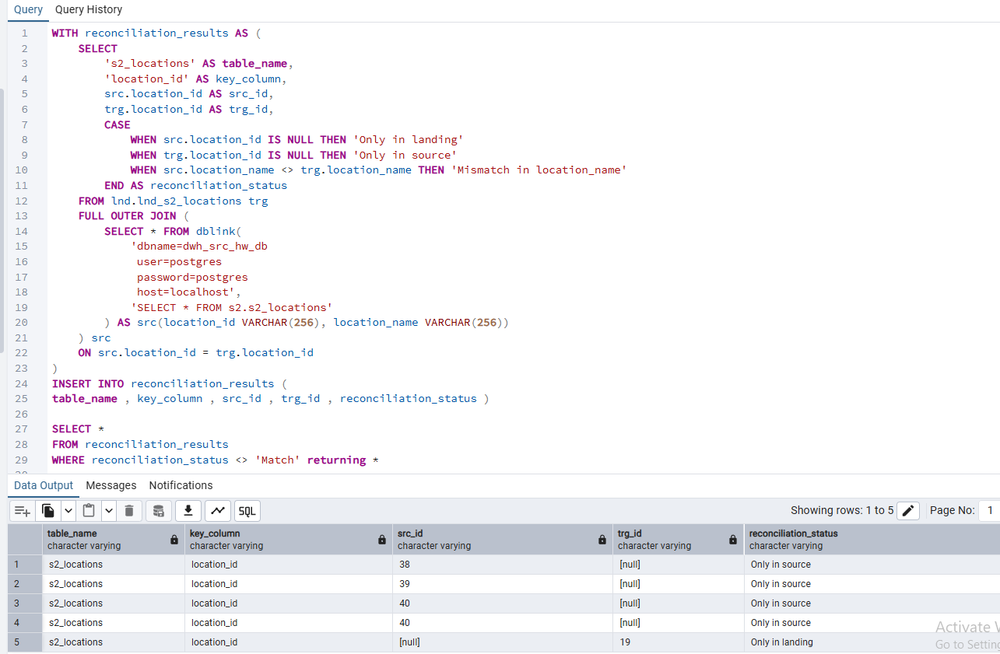

2. DWH TESTING AND BUGS CREATION
None of my test cases on TesTRail showed any bugs. Examples:
