1.1.2 create the date formatted column
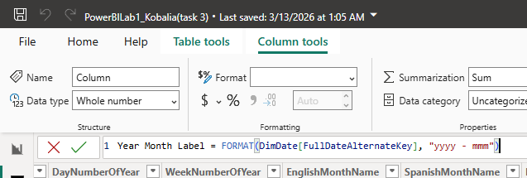
1.1.5 filter year >= 2013
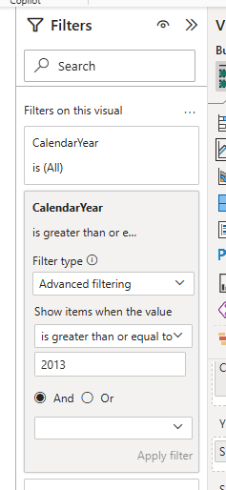
1.1.6 to solve this problem, we just add ‘FullDateAlternateKey’ to tooltips and sort by it
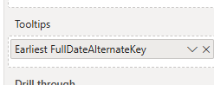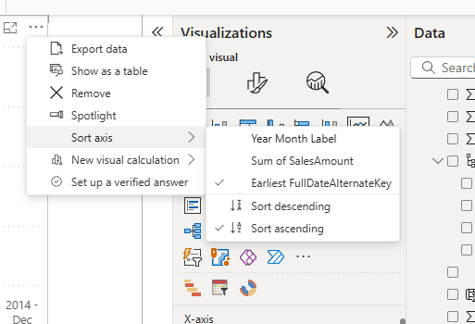

1.2.6
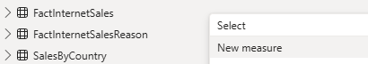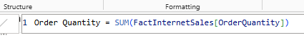
1.2.8
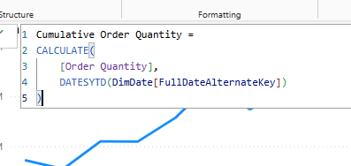
2.1
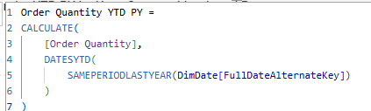
2.2 first create a simple measure that adds all sales together
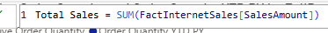
Then add the same cumulative calculations
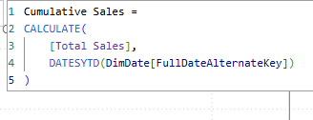
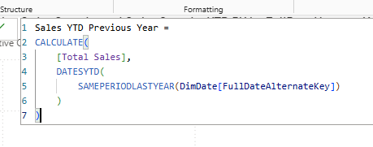
2.3
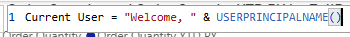
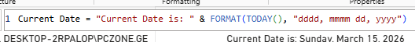
2.4
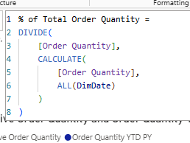
2.5
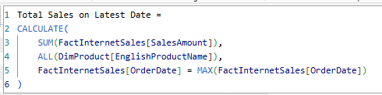
From analytics pane, add constant line depicting this value
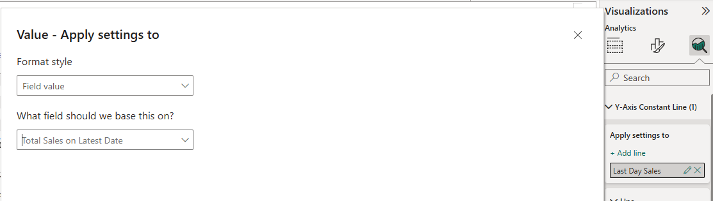
I used this measure with CALCULATE and MAX(OrderDate) to ensure the chart always shows data for the latest available date. This is useful in reports where management wants to see the most recent day’s performance without manually changing filters.

2.6 Create two measures, one will return the top country, the other – sum of sales made in it. Sane exact logic for both.
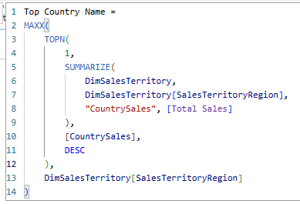
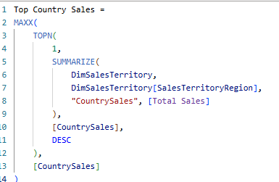
I used the SUM to calculate total sales from the SalesAmount column. The SUMMARIZE function groups the data by SalesTerritoryRegion so sales can be evaluated per country. Then we use TOPN to select the country with the highest total sales. MAXX returns the country name and its sales value from the resulting table, so the result is dynamic to report filters.
2.7
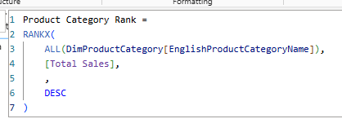
I used the RANKX function to rank product categories based on their total sales. The SUM aggregation calculates the total SalesAmount, and ALL removes category filters so every category can be compared in the ranking.

