PAGE 1
1.2 In the facts table, Expand ‘Full Name’ from DimCustomer
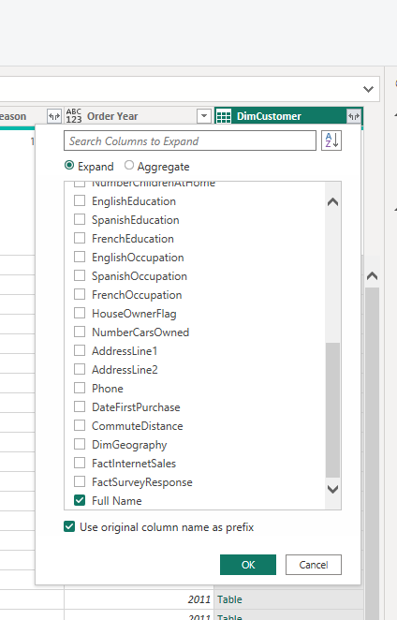

1.2.3 & 4 Let’s add a custom visual to the page. To do to that you must use Import from AppSource:
I add a custom visual from extension ‘Inforiver Super Filter’. This let’s me use the territorial hierarchy to create a hierarchy filter.
For the final visual, I wanted to group our customers by income level, so I added a new column in DimCustomer:
