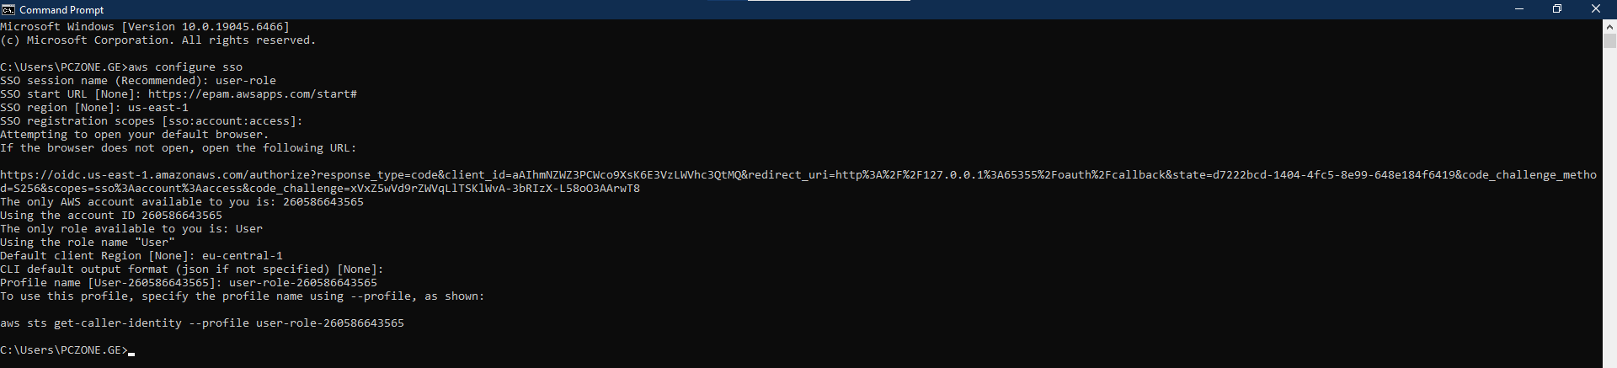

Add new profile for students-role into config file. 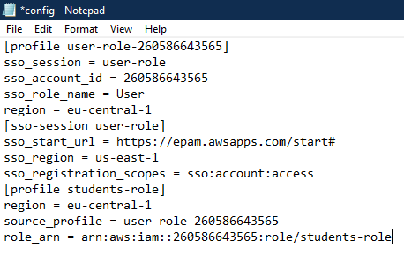

Verify the new profile
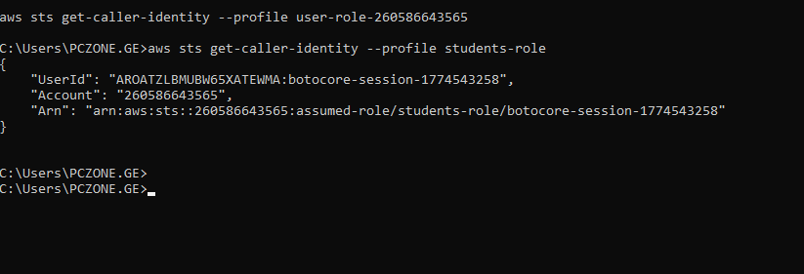
Create new bucket
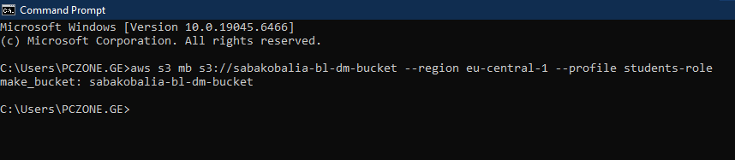
Create a test file and upload it to verify access
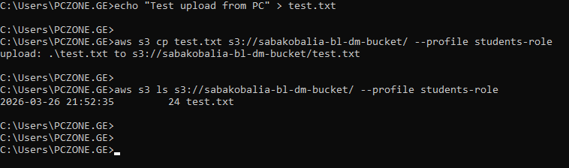
Upload data files to bucket:

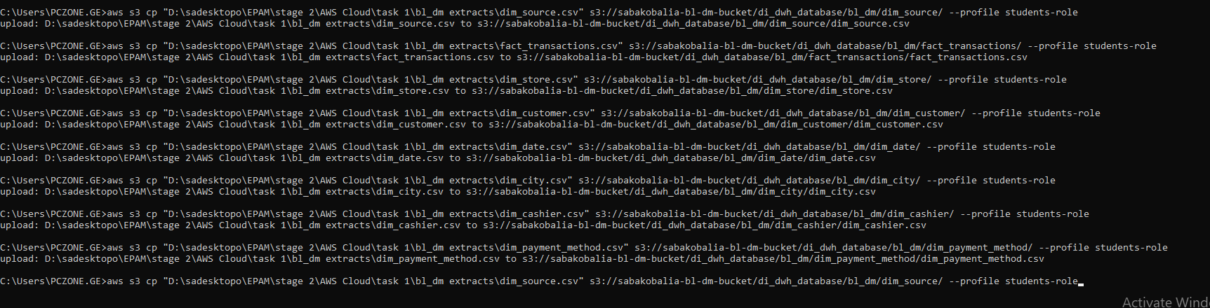
Create crawler
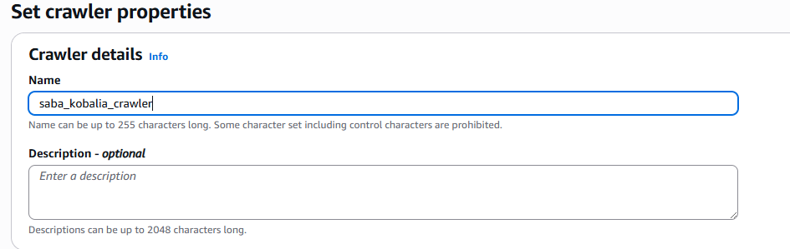
Add data souce
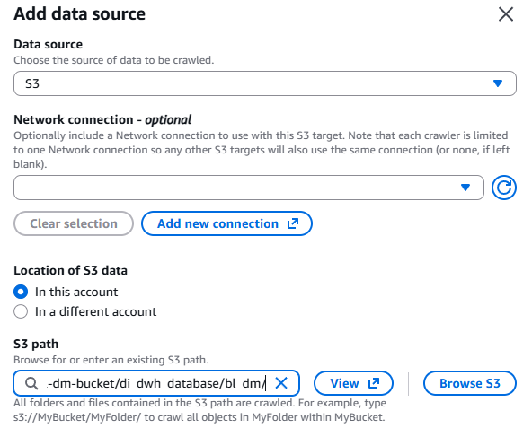
Add target database
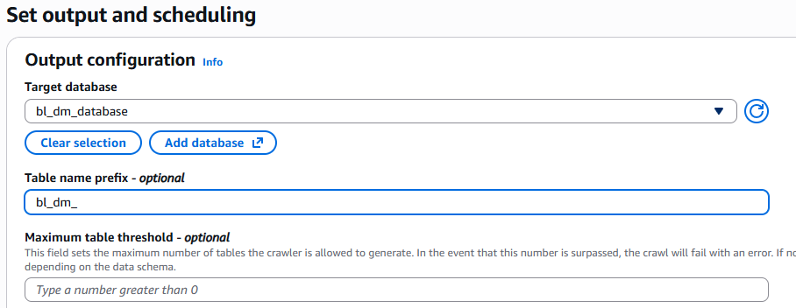
Run queries
