TASK 1. RDS MYSQL
Install mysql into instance
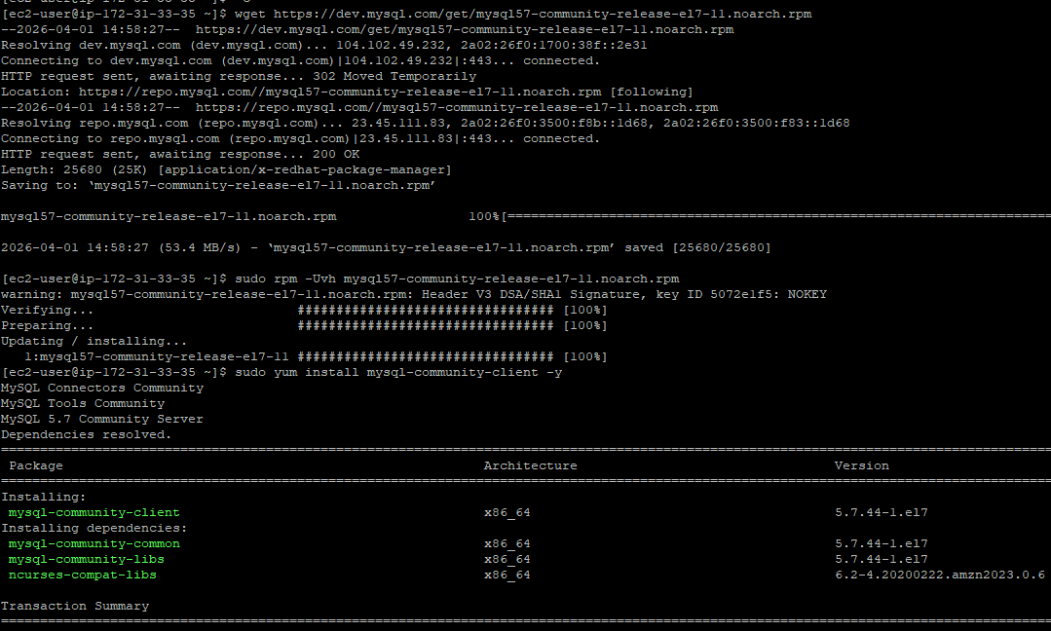
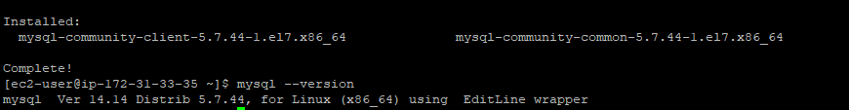
Connect from my EC2 to dilab-mysql
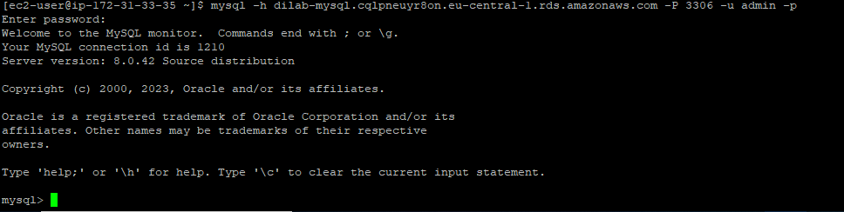

Create my user
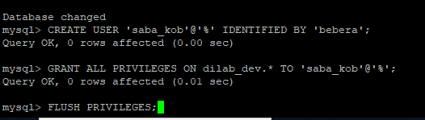
Create new schema and grant privileges
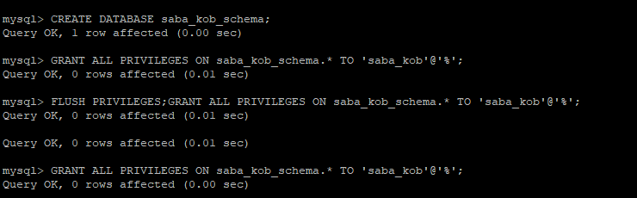
Create objects
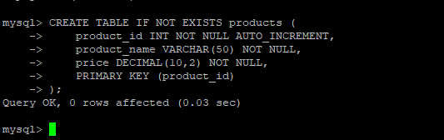
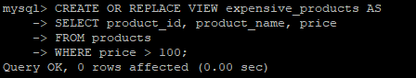
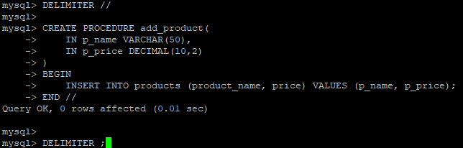
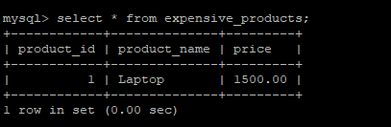
TASK 2. RDS AURORA
Connect to dilab-aurora in query editor
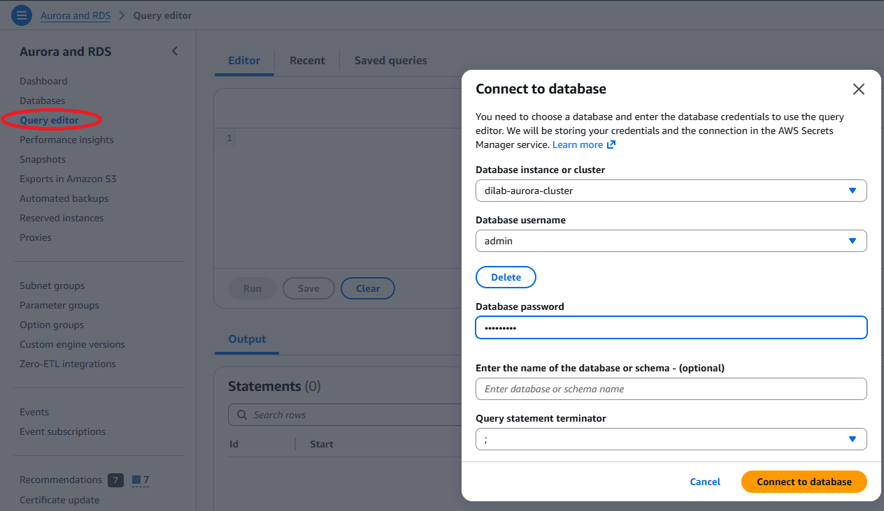

Create new schema
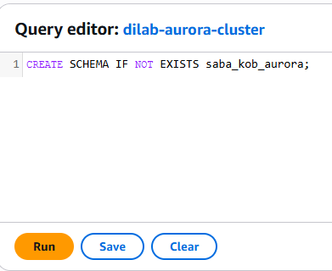
Now connect using mysql workbench
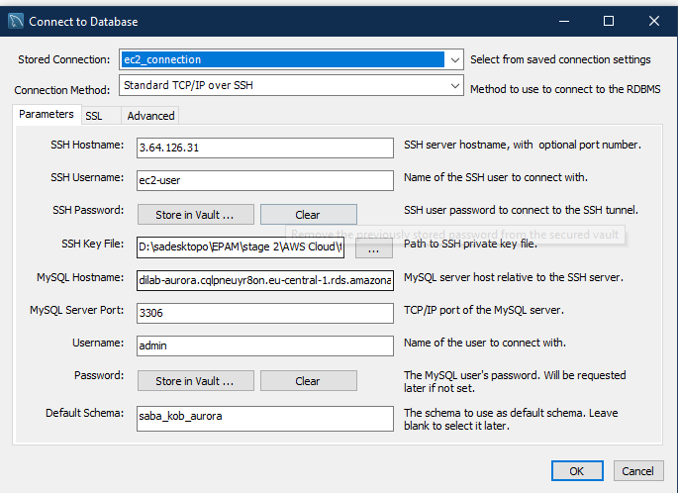
Start loading sakila database
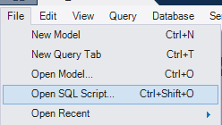
Import and run both these files
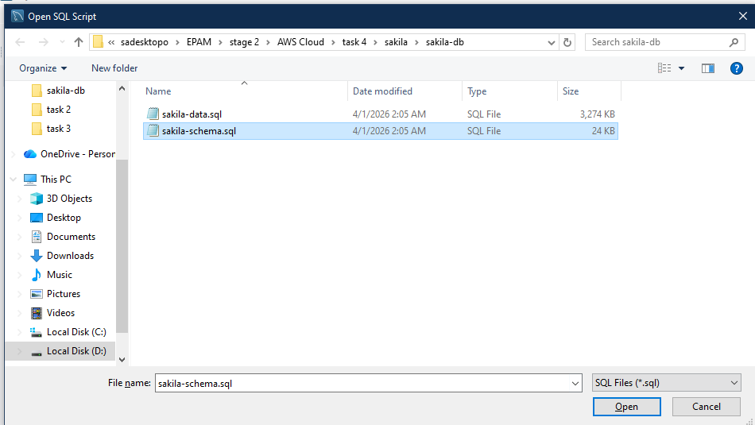

Run queries
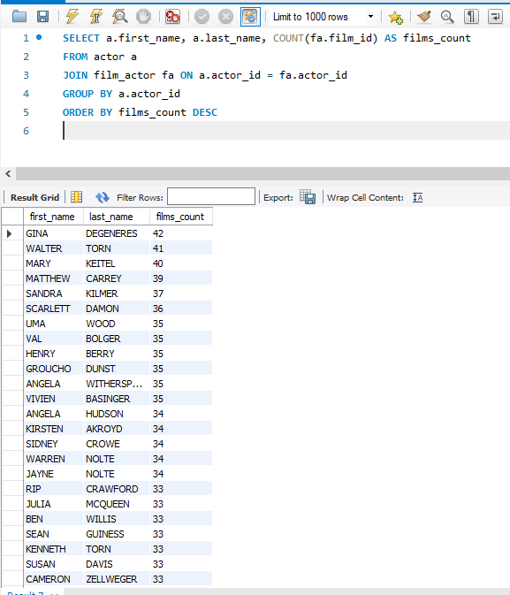
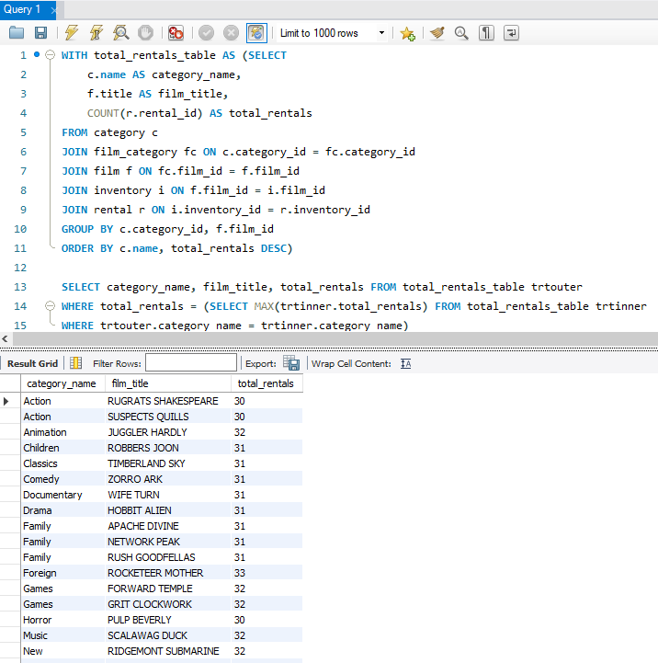

- Describe why it is the only way to connect to Aurora from local PC oppose to Amazon RDS MySQL.
Aurora RDS is usually deployed in a private VPC, which means it does not have a public IP address that you can connect to directly from your local computer. But, a standard Amazon RDS MySQL instance can be configured with a public endpoint, allowing direct connections from your PC.
Because Aurora is in a private network, the only way to connect from a local PC is through a jump server or an EC2 instance inside the same VPC. my PC connects to the EC2, and then the EC2 connects to Aurora. This ensures that the database remains private and secure while still allowing remote access for authorized users.
TASK 3
Create table in dynamo
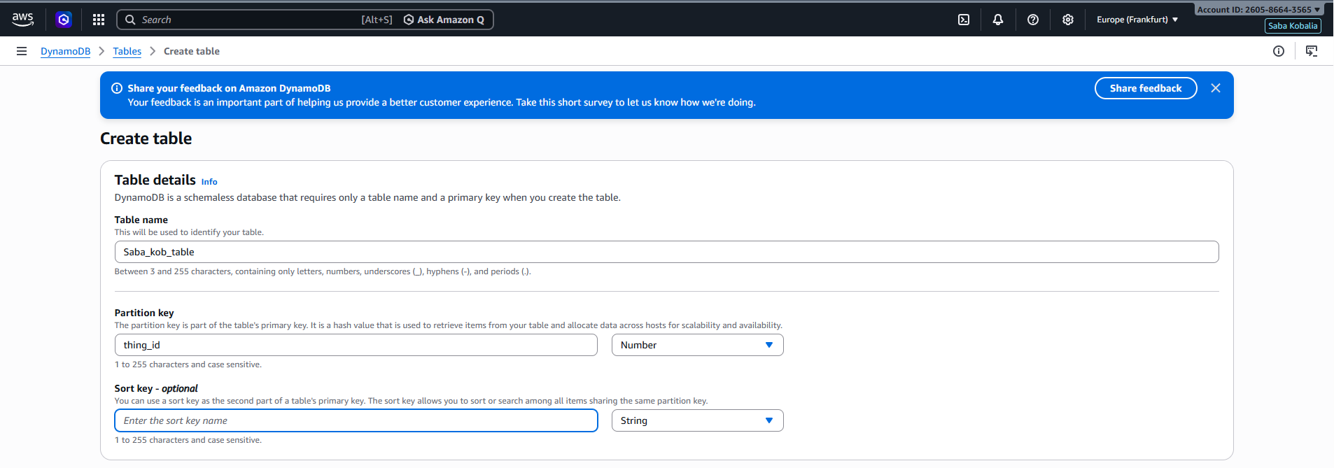
Create items from browser
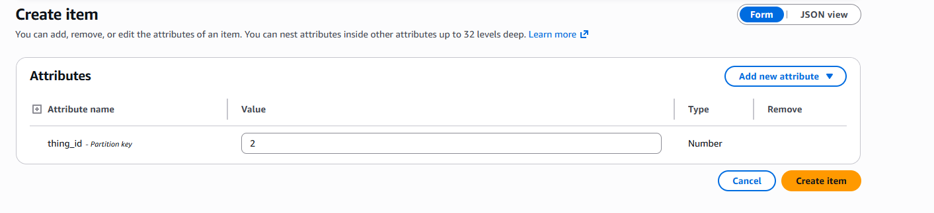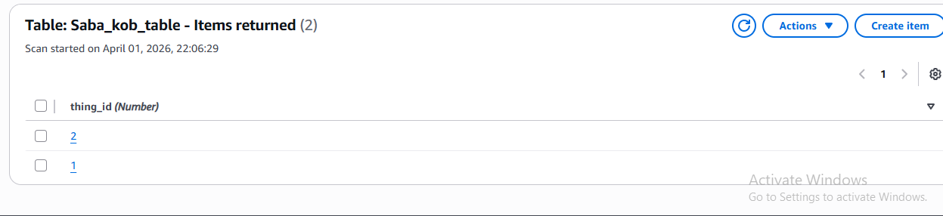

Delete them
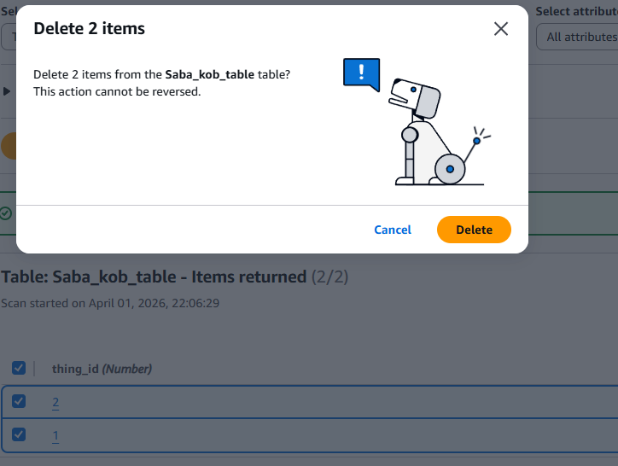
Connect to dynamodb from my pc using powershell
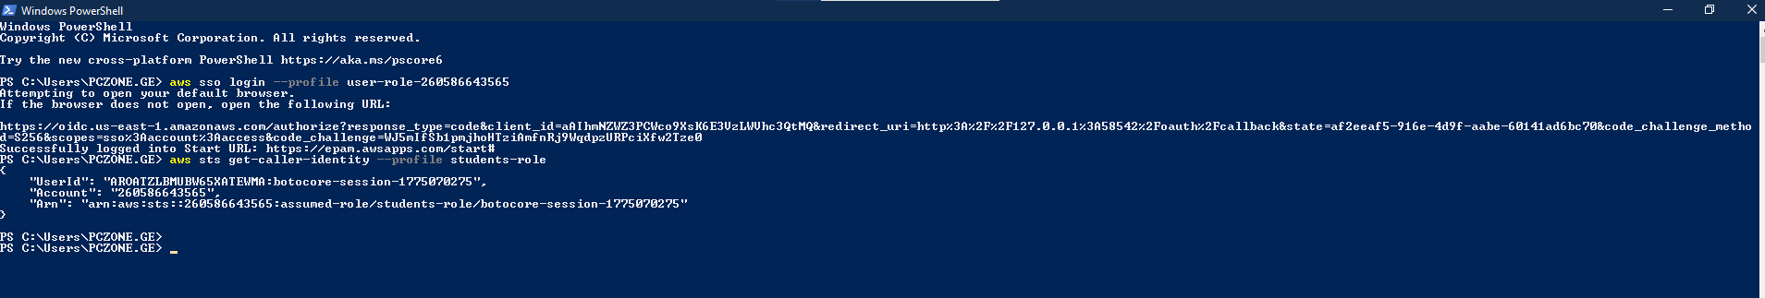
Add 20 items
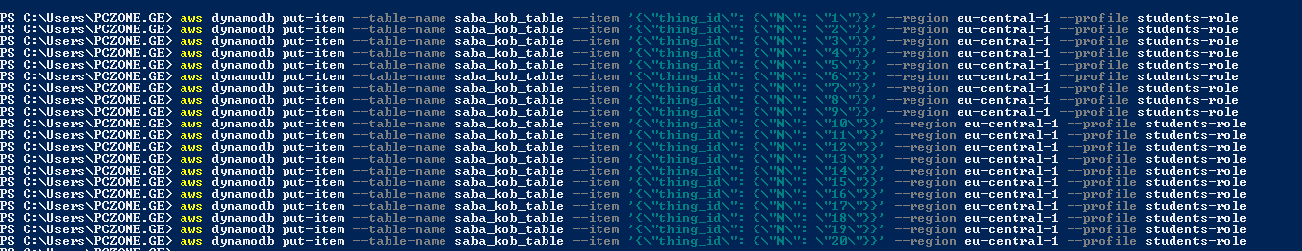
Retrieve 5 items
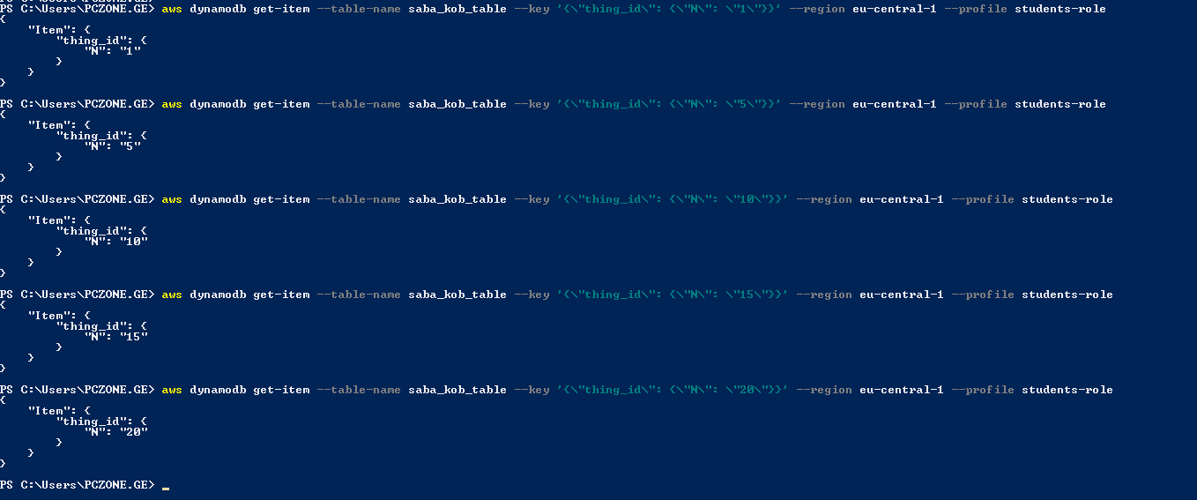
Delete two rows

