Cost Snipper – Prediction of Prices of Online Shopping Items based on Past Data
Sabareesan R, Somasundaram C , Selvakumar K

Abstract— The variation of product prices in online shopping is high which makes it difficult to decide when to buy. However the tremendous growth of e-commerce helps us to create the solution of price prediction. We used web scraping technique to get the price data from various online shopping retailers and process the data for each commodity to predict the price for tomorrow which helps us to make decisions on buying online products. We automated the web scraping of data and price prediction daily to make the price available for the customer without any delay. .
Index Terms— Machine Learning, Web Scraping, Variation, Feature extraction, Prediction, Automation, SVM, Regression
——————————  ——————————

1 Introduction

THIS document is a template for Microsoft Word versions 6.0 or later. If you are reading a paper version of this document, please download the electronic file from the template download page so you can use it to prepare your manuscript.
When you open the document, select “Page Layout” from the “View” menu in the menu bar (View | Page Layout), which allows you to see the footnotes. Then type over sections of the document or cut and paste from another document and then use markup styles. Please keep the template at 8.5” x 11”—do not set the template for A4 paper. The pull-down style menu is at the left of the Formatting Toolbar at the top of your Word window (for example, the style at this point in the document is “Text”). Highlight a section that you want to designate with a certain style, then select the appropriate name on the style menu. The style will adjust your fonts and line spacing. Use italics for emphasis; do not underline. Do not change the font sizes or line spacing to squeeze more text into a limited number of pages. Please be certain to follow all submission guidelines when formatting an article or it will be returned for reformatting.

To modify the running headings, select View | Header and Footer. Click inside the text box to type the name of the journal the article is being submitted to and the manuscript identification number. Click the forward arrow in the pop-up tool bar to modify the header or footer on subsequent pages.

IJSTR staff will edit and complete the final formatting of your paper.

2 Procedure for Paper Submission

2.1 Review Stage
Detailed submission guidelines can be found on the author resources Web pages. Author resource guidelines are specific to each journal, so please be sure to refer to the correct journal when seeking information. All authors are responsible for understanding these guidelines before submitting their manuscript. For further information on both submission guidelines, authors are strongly encouraged to refer to http://www.ijstr.org.

2.2 Final Stage
For papers accepted for publication, it is essential that the electronic version of the manuscript and artwork match the hardcopy exactly! The quality and accuracy of the content of the electronic material submitted is crucial since the content is not recreated, but rather converted into the final published version.
All papers in IJSTR Transactions are edited electronically. A final submission materials check list, transmission and compression information, and general publication materials can be found at: http://www.ijstr.org.

2.3 Figures
All tables and figures will be processed as images. You need to embed the images in the paper itself. Please don’t send the images as separate files.

Copyright Form
An IJSTR copyright form must accompany your final submission. You can get a .doc version at http://www.ijstr.org/Copyright-Agreement.doc. Authors are responsible for obtaining any security clearances.
————————————————
- Author name is currently pursuing masters degree program in electric power engineering in University, Country, PH-01123456789. E-mail: author_name@mail.com
- Co-Author name is currently pursuing masters degree program in electric power engineering in University, Country, PH-01123456789. E-mail: author_name@mail.com
(This information is optional; change it according to your need.)
For any questions about initial or final submission requirements, please contact one of our staff members. Contact information can be found at: http://www.ijstr.org.

3 Sections
As demonstrated in this document, the numbering for sections upper case Arabic numerals, then upper case Arabic numerals, separated by periods. Initial paragraphs after the section title are not indented. Only the initial, introductory paragraph has a drop cap.

4 Citations
IJSTR style is to not citations in individual brackets, followed by a comma, e.g. “[1], [5]” (as opposed to the more common “[1, 5]” form.) Citation ranges should be formatted as follows: [1], [2], [3], [4] (as opposed to [1]-[4], which is not IJSTR style). When citing a section in a book, please give the relevant page numbers [2]. In sentences, refer simply to the reference number, as in [3]. Do not use “Ref. [3]” or “reference [3]” At the beginning of a sentence use the author names instead of “Reference [3],” e.g., “Smith and Smith [3] show ... .” Please note that references will be formatted by IJSTR production staff in the same order provided by the author.

5 Equations
If you are using Word, use either the Microsoft Equation Editor or the MathType add-on (http://www.mathtype.com) for equations in your paper (Insert | Object | Create New | Microsoft Equation or MathType Equation). “Float over text” should not be selected.
Number equations consecutively with equation numbers in parentheses flush with the right margin, as in (1). First, use the equation editor to create the equation. Then, select the “Equation” markup style. Press the tab key and write the equation number in parentheses. To make your equations more compact, you may use the solidus ( / ), the exp function, or appropriate exponents. Use parentheses to avoid ambiguities in denominators. Punctuate equations when they are part of a sentence, as in
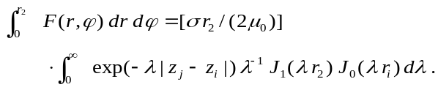 (1)
Be sure that the symbols in your equation have been defined before the equation appears or immediately following. Italicize symbols (T might refer to temperature, but T is the unit tesla). Per IJSTR, please refer to “(1),” not “Eq. (1)” or “equation (1),” except at the beginning of a sentence: “Equation (1) shows ... .” Also see The Handbook of Writing for the Mathematical Sciences, 1993. Published by the Society for Industrial and Applied Mathematics, this handbook provides some helpful information about math typography and other stylistic matters. For further information about typesetting mathematical equations, please visit the IJSTR styel guide: http://www.ijstr.org.
Please note that math equations might need to be reformatted from the original submission for page layout reasons. This includes the possibility that some in-line equations will be made display equations to create better flow in a paragraph. If display equations do not fit in the two-column format, they will also be reformatted. Authors are strongly encouraged to ensure that equations fit in the given column width.

6 Helpful Hints

6.1 Figures and Tables
Because IJSTR staff will do the final formatting of your paper, some figures may have to be moved from where they appeared in the original submission. Figures and tables should be sized as they are to appear in print. Figures or tables not correctly sized will be returned to the author for reformatting.
Detailed information about the creation and submission of images for articles can be found at: http://www.ijstr.org. We strongly encourage authors to carefully review the material posted here to avoid problems with incorrect files or poorly formatted graphics.
Place figure captions below the figures; place table titles above the tables. If your figure has two parts, include the labels “(a)” and “(b)” as part of the artwork. Please verify that the figures and tables you mention in the text actually exist. Figures and tables should be called out in the order they are to appear in the paper. For example, avoid referring to figure “8” in the first paragraph of the article unless figure 8 will again be referred to after the reference to figure 7. Please do not include figure captions as part of the figure. Do not put captions in “text boxes” linked to the figures. Do not put borders around the outside of your figures. Per IJSTR, please use the abbreviation “Fig.” even at the beginning of a sentence. Do not abbreviate “Table.” Tables are numbered numerically.
Figures may only appear in color for certain journals. Please verify with IJSTR that the journal you are submitting to does indeed accept color before submitting final materials. Do not use color unless it is necessary for the proper interpretation of your figures.
Figures (graphs, charts, drawing or tables) should be named fig1.eps, fig2.ps, etc. If your figure has multiple parts, please submit as a single figure. Please do not give them descriptive names. Author photograph files should be named after the author’s LAST name. Please avoid naming files with the author’s first name or an abbreviated version of either name to avoid confusion. If a graphic is to appear in print as black and white, it should be saved and submitted as a black and white file (grayscale or bitmap.) If a graphic is to appear in color, it should be submitted as an RGB color file.
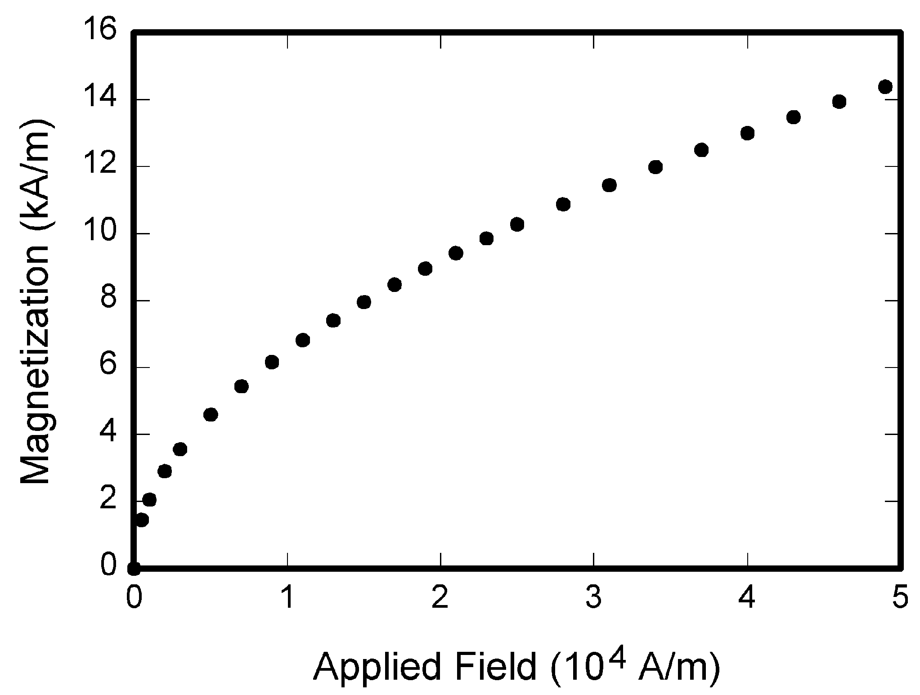
Fig. 1. Magnetization as a function of applied field. Note that “Fig.” is abbreviated. There is a period after the figure number, followed by one space. It is good practice to briefly explain the significance of the figure in the caption.

Figure axis labels are often a source of confusion.
Use words rather than symbols. As an example, write the quantity “Magnetization,” or “Magnetization M,” not just “M.” Put units in parentheses. Do not label axes only with units. As in Fig. 1, for example, write “Magnetization (A/m)” or “Magnetization (Am⁻¹),” not just “A/m.” Do not label axes with a ratio of quantities and units. For example, write “Temperature (K),” not “Temperature/K.” Table 1 shows some examples of units of measure.
Multipliers can be especially confusing. Write “Magnetization (kA/m)” or “Magnetization (103 A/m).” Do not write “Magnetization (A/m) × 1,000” because the reader would not know whether the top axis label in Fig. 1 meant 16,000 A/m or 0.016 A/m. Figure labels should be legible, approximately 8 to 12 point type. When creating your graphics, especially in complex graphs and charts, please ensure that line weights are thick enough that when reproduced at print size, they will still be legible. We suggest at least 1 point.

6.3 Footnotes
Number footnotes separately in superscripts (Insert | Footnote). Place the actual footnote at the bottom of the column in which it is cited; do not put footnotes in the reference list (endnotes). Use letters for table footnotes (see Table 1). Please do not include footnotes in the abstract and avoid using a footnote in the first column of the article. This will cause it to appear of the affiliation box, making the layout look confusing.

6.4 Lists
TABLE 1
Units for Magentic Properties
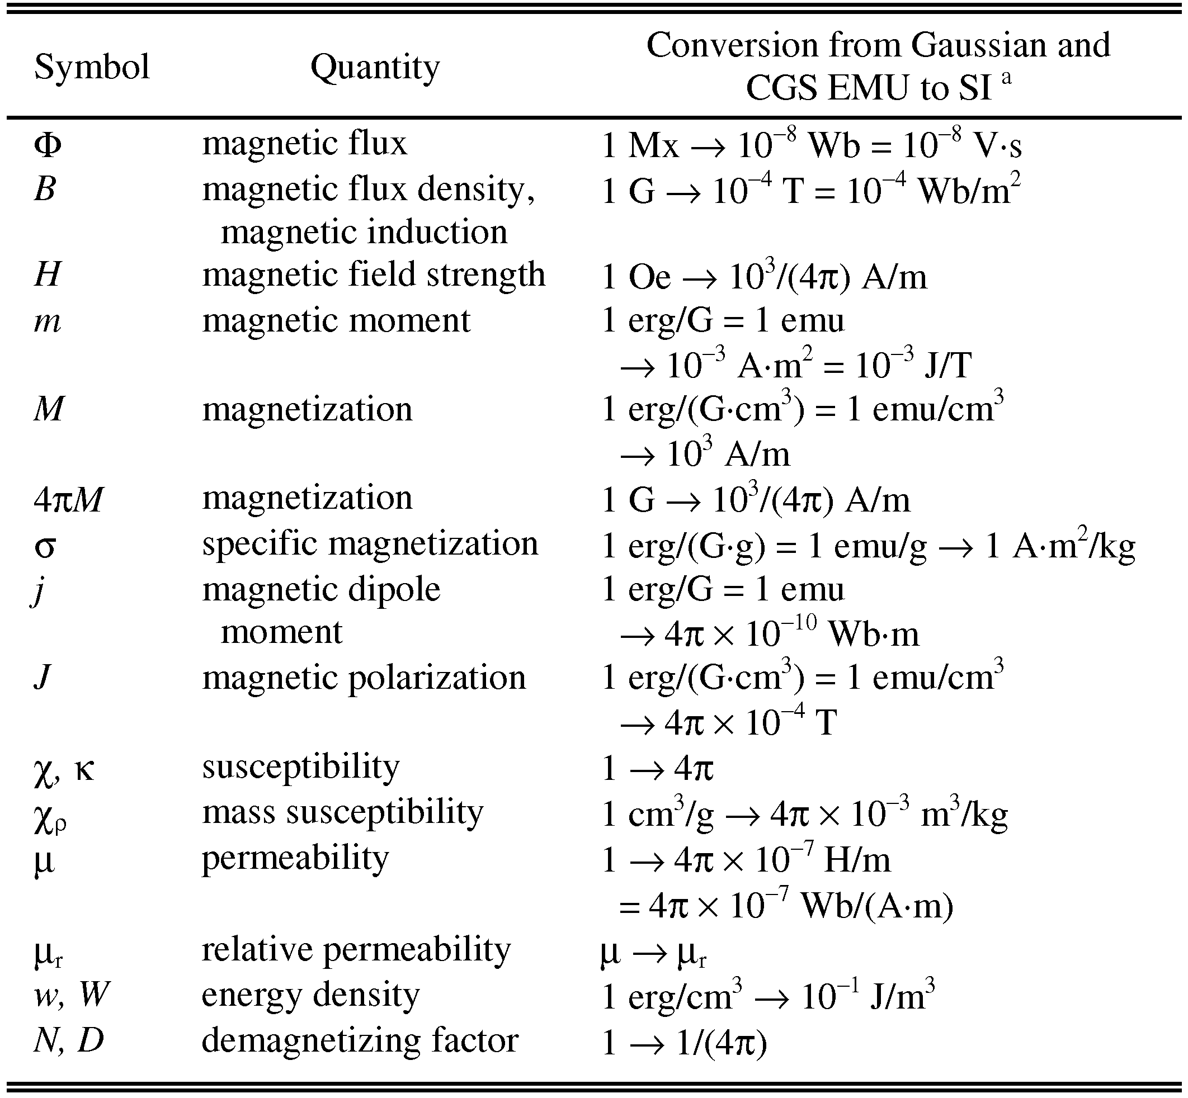
Statements that serve as captions for the entire table do not need footnote letters.
ªGaussian units are the same as cgs emu for magnetostatics; Mx = maxwell, G = gauss, Oe = oersted; Wb = weber, V = volt, s = second, T = tesla, m = meter, A = ampere, J = joule, kg = kilogram, H = henry.
The IJSTR style is to create displayed lists if the number of items in the list is longer than three. For example, within the text lists would appear 1) using a number, 2) followed by a close parenthesis. However, longer lists will be formatted so that:
- Items will be set outside of the paragraphs.
- Items will be punctuated as sentences where it is appropriate.
- Items will be numbered, followed by a period.

6.5 Theorems and Proofs
Theorems and related structures, such as axioms corollaries, and lemmas, are formatted using a hanging indent paragraph. They begin with a title and are followed by the text, in italics.
Theorem 1. Theorems, corollaries, lemmas, and related structures follow this format. They do not need to be numbered, but are generally numbered sequentially.
Proofs are formatted using the same hanging indent format. However, they are not italicized.
Proof. The same format should be used for structures such as remarks, examples, and solutions (though these would not have a Q.E.D. box at the end as a proof does).

7 End Sections

Appendices
Appendixes, if needed, appear before the acknowledgment. In the event multiple appendices are required, they will be labeled “Appendix A,” “Appendix B, “ etc. If an article does not meet submission length requirements, authors are strongly encouraged to make their appendices supplemental material.

IJSTR Transactions accepts supplemental materials for review with regular paper submissions. These materials may be published on our Digital Library with the electronic version of the paper and are available for free to Digital Library visitors. Please see our guidelines below for file specifications and information. Any submitted materials that do not follow these specifications will not be accepted. All materials must follow US copyright guidelines and may not include material previously copyrighted by another author, organization or company. More information can be found at http://www.ijstr.org.

7.2 Acknowledgments
The preferred spelling of the word “acknowledgment” in American English is without an “e” after the “g.” Use the singular heading even if you have many acknowledgments. Avoid expressions such as “One of us (S.B.A.) would like to thank ... .” Instead, write “F. A. Author thanks ... .” Sponsor and financial support acknowledgments are included in the acknowledgment section. For example: This work was supported in part by the US Department of Commerce under Grant BS123456 (sponsor and financial support acknowledgment goes here). Researchers that contributed information or assistance to the article should also be acknowledged in this section.

7.3 References
Unfortunately, the Computer Society document translator cannot handle automatic endnotes in Word; therefore, type the reference list at the end of the paper using the “References” style. See the IJSTR’s style for reference formatting at: http://www.ijstr.org
transref.htm. The order in which the references are submitted in the manuscript is the order they will appear in the final paper, i.e., references submitted nonalphabetized will remain that way.
Please note that the references at the end of this document are in the preferred referencing style. Within the text, use “et al.” when referencing a source with more than three authors. In the reference section, give all authors’ names; do not use “et al.” Do not place a space between an authors' initials. Papers that have not been published should be cited as “unpublished” [4]. Papers that have been submitted or accepted for publication should be cited as “submitted for publication” [5]. Please give affiliations and addresses for personal communications [6].
Capitalize all the words in a paper title. For papers published in translation journals, please give the English citation first, followed by the original foreign-language citation [7].

7.3 Additional Formatting and Style Resources
Additional information on formatting and style issues can be obtained in the IJSTR Style Guide, which is posted online at: http://www.ijstr.org/. Click on the appropriate topic under the Special Sections link.

Conclusion
Although a conclusion may review the main points of the paper, do not replicate the abstract as the conclusion. A conclusion might elaborate on the importance of the work or suggest applications and extensions. Authors are strongly encouraged not to call out multiple figures or tables in the conclusion—these should be referenced in the body of the paper.
Acknowledgment
The authors wish to thank A, B, C. This work was supported in part by a grant from XYZ.
References
- J.S. Bridle, “Probabilistic Interpretation of Feedforward Classification Network Outputs, with Relationships to Statistical Pattern Recognition,” Neurocomputing—Algorithms, Architectures and Applications, F. Fogelman-Soulie and J. Herault, eds., NATO ASI Series F68, Berlin: Springer-Verlag, pp. 227-236, 1989. (Book style with paper title and editor)
- W.-K. Chen, Linear Networks and Systems. Belmont, Calif.: Wadsworth, pp. 123-135, 1993. (Book style)
- H. Poor, “A Hypertext History of Multiuser Dimensions,” MUD History, http://www.ccs.neu.edu/home/pb/mud-history.html. 1986. (URL link *include year)
- K. Elissa, “An Overview of Decision Theory," unpublished. (Unplublished manuscript)
- R. Nicole, "The Last Word on Decision Theory," J. Computer Vision, submitted for publication. (Pending publication)
- C. J. Kaufman, Rocky Mountain Research Laboratories, Boulder, Colo., personal communication, 1992. (Personal communication)
- D.S. Coming and O.G. Staadt, "Velocity-Aligned Discrete Oriented Polytopes for Dynamic Collision Detection," IEEE Trans. Visualization and Computer Graphics, vol. 14, no. 1, pp. 1-12, Jan/Feb 2008, doi:10.1109/TVCG.2007.70405. (IEEE Transactions )
- S.P. Bingulac, “On the Compatibility of Adaptive Controllers,” Proc. Fourth Ann. Allerton Conf. Circuits and Systems Theory, pp. 8-16, 1994. (Conference proceedings)
- H. Goto, Y. Hasegawa, and M. Tanaka, “Efficient Scheduling Focusing on the Duality of MPL Representation,” Proc. IEEE Symp. Computational Intelligence in Scheduling (SCIS ’07), pp. 57-64, Apr. 2007, doi:10.1109/SCIS.2007.367670. (Conference proceedings)
- J. Williams, “Narrow-Band Analyzer,” PhD dissertation, Dept. of Electrical Eng., Harvard Univ., Cambridge, Mass., 1993. (Thesis or dissertation)
- E.E. Reber, R.L. Michell, and C.J. Carter, “Oxygen Absorption in the Earth’s Atmosphere,” Technical Report TR-0200 (420-46)-3, Aerospace Corp., Los Angeles, Calif., Nov. 1988. (Technical report with report number)
- L. Hubert and P. Arabie, “Comparing Partitions,” J. Classification, vol. 2, no. 4, pp. 193-218, Apr. 1985. (Journal or magazine citation)
- R.J. Vidmar, “On the Use of Atmospheric Plasmas as Electromagnetic Reflectors,” IEEE Trans. Plasma Science, vol. 21, no. 3, pp. 876-880, available at http://www.halcyon.com/pub/journals/21ps03-vidmar, Aug. 1992. (URL for Transaction, journal, or magzine)
- J.M.P. Martinez, R.B. Llavori, M.J.A. Cabo, and T.B. Pedersen, "Integrating Data Warehouses with Web Data: A Survey," IEEE Trans. Knowledge and Data Eng., preprint, 21 Dec. 2007, doi:10.1109/TKDE.2007.190746.(PrePrint)

Cost Snipper – Prediction of Prices of Online Shopping Items based on Past Data
Sabareesan R, Somasundaram C , Selvakumar K

Abstract— The variation of product prices in online shopping is high which makes it difficult to decide when to buy. However the tremendous growth of e-commerce helps us to create the solution of price prediction. We used web scraping technique to get the price data from various online shopping retailers and process the data for each commodity to predict the price for tomorrow which helps us to make decisions on buying online products. We automated the web scraping of data and price prediction daily to make the price available for the customer without any delay. .
Index Terms— Machine Learning, Web Scraping, Variation, Feature extraction, Prediction, Automation, SVM, Regression
——————————  ——————————

1 INTRODUCTION

With the rapid development of the Internet and data-processing technologies, Web Scraping can be used to explore many possibilities, from Internet news about products or the influence of product price to the influence of sale behavior and important brand strategies. In this paper, we analyze features affecting the price of products, and establish a new model for price prediction. The results show that we have an impact on the sale prices of products, and can improve the accuracy of price prediction over time. Thus, the contribution of this paper is to propose a new prediction model for the price of e-commerce products.
Inflation is the tendency of the prices of goods and services to rise in general and continuously [2],[3]. High inflation may cause a negative impact on the socio-economic conditions [1]. The problem with race-to-the-bottom marketing is that it’s short-termism. Retailers think, I need to hit my quarterly KPIs and I’ll do anything to make that happen [4]. Ecommerce will go from being “reactive” to “proactive”: Ecommerce interactions have always been reactive; however, with adoption of machine learning many processes will become proactive. For example: Brands will be able to identify customers who are likely to make a purchase, abandon cart or even return items and personalize their experience. Customers too need to become proactive for enjoying the best experience. We help the customers to overcome the challenges of regular price inflation and variations that commerce sites use to get the high profit.
————————————————
- Sabareesan R is currently pursuing bachelor’s degree program in computer science engineering in Sri krishna college of engineering and technology, India, PH-9751293927. E-mail: 16eucs138@skcet.ac.in
- Somasundaran C is currently pursuing bachelor’s degree program in computer science engineering in Sri krishna college of engineering and technology, India, PH-8667790724. E-mail: 16eucs159@skcet.ac.in
- Selvakumar K is currently pursuing bachelor’s degree program in computer science engineering in Sri krishna college of engineering and technology, India, PH-8667790. E-mail: 16eucs150@skcet.ac.in

Moreover, it is not equipped with prediction of price data but only show the data from today and earlier. The system aims for early warning, prediction can be used to know the price of commodities in future so we can know the prediction price data for anticipating. As we use the real data for the prediction system we can also show the accuracy of our prediction. This helps us to improve the performance and accuracy of the model.
Since many e-commerce retailers not supporting any APIs for price data, we used web scraping for the price data of products from various retailers. There are a lot of use cases for web scraping: you might want to collect prices from various e-commerce sites for a price comparison site. Or perhaps you need flight times and hotel/AirBNB listings for a travel site. Maybe you want to collect emails from various directories for sales leads, or use data from the internet to train machine learning/AI models. Or you could even be wanting to build a search engine like Google. Getting started with web scraping is easy, and the process can be broken down into two main parts: acquiring the data using an HTML request library or a headless browser and parsing the data to get the exact information you want.
We used python for the prediction because from development to deployment and maintenance, Python helps developers be productive and confident about the software they’re building. Benefits that make Python the best fit for machine learning includes simplicity and consistency [5], access to great libraries and frameworks for AI and machine learning (ML), flexibility, platform independence, and a wide community. These add to the overall popularity of the language.
The best part of programming is the triumph of seeing the machine do something useful. Automate the Boring Stuff with Python frames all of programming as these small triumphs; it makes the boring fun [5]. We automated the web scraping using the CRON scheduling daily to get the price of the product. Cron is the system’s main scheduler for running jobs or tasks unattended. A command called crontab allows the user to submit, edit or delete entries to cron. A crontab file is a user file that holds the scheduling information. You can use crontab to run any of your scripts or one-liners every hour, or maybe just three days a week, it’s up to you. Each user can have their own crontab file if they wish, but on large systems root usually disallows this and just uses one main crontab file for the whole system. Root is able to do this because of a file called ‘cron.deny’ and ‘cron.allow’ where root can specify who can and cannot have their own crontab [6]. We used the cron tab to automate web scraping using a python script and the predicted prices were pre calculated with the model for the fast delivery of result to the customers about the predicted price.
Thus, in this research we will propose an online price prediction system of consumption commodities. This system helps and supports them in making decisions about their date of purchase and get the profit by effectively utilizing our prediction system.

2 WEB SCRAPING

We used nodeJS for the web scraping. Web scraping is a technique used for retrieving data from websites. You fetch the page’s contents, and then extract the data you need from the page for processing, saving it, or simply displaying it on your app. It comes in handy when the app/website you are trying to scrape does not expose any external API for public consumption. Web scraping mainly involves four steps.

2.1 Fetching a Webpage
The web scraping first starts with fetching a webpage. The nodeJS script first accepts the URL as the input and web scrap the details using various nodeJS libraries. we got the raw HTML from the web page. But now we need to make sense of this giant blob of text. To do that, we’ll need to use Chrome DevTools to allow us to easily search through the HTML of a web page. Now, simply click inspect, and Chrome will bring up its DevTools pane, allowing you to easily inspect the page’s source HTML. So now we can find the name of the divison with this tool for the next step

2.2 Extracting the data from the webpage
The Chrome DevTools is now showing us the exact pattern we should be looking for in the code (a “big” tag with a hyperlink inside of it). Let’s use Cheerio.js to parse the HTML we received earlier to return the name and price of the commodity that is required for the price prediction system. We now ensure that the price and name of the product returned correctly because there may be chance of nested divisons in the division. Now we got the required data for the system. However a single value cannot be used for training the model.

2.3 Converting the data to JSON format
The name and price of the product is fetched from the url. However it is stored in a single variable which needs to be converted into JSON format for better processing, The JSON format is often used for serializing and transmitting structured data over a network connection.[7] It is used primarily to transmit data between a server and web application, serving as an alternative to XML. When exchanging data between a browser and a server, the data can only be text. JSON is text, and we can convert any JavaScript object into JSON, and send JSON to the server. We can also convert any JSON received from the server into JavaScript objects. This way we can work with the data as JavaScript objects, with no complicated parsing and translations. When storing data, the data has to be a certain format, and regardless of where you choose to store it, text is always one of the legal formats. [7] Here we manually constructed the JSON with the url, name and price. We now have the required data in a generalized format.

2.4 Storing the data into the database
We have the data from the url but a single value cannot be trained. So we need to save the data daily in the database to get the dataset for the training. We use MongoDB, a non-relational database for storing the data. MongoDB is an open-source document database and leading NoSQL database. [8] We created a database for storing the price values. Then the connection to the database and collection is made using connection string in nodeJS. Now the extracted data is inserted into the database. Now the dataset is ready for training the model.
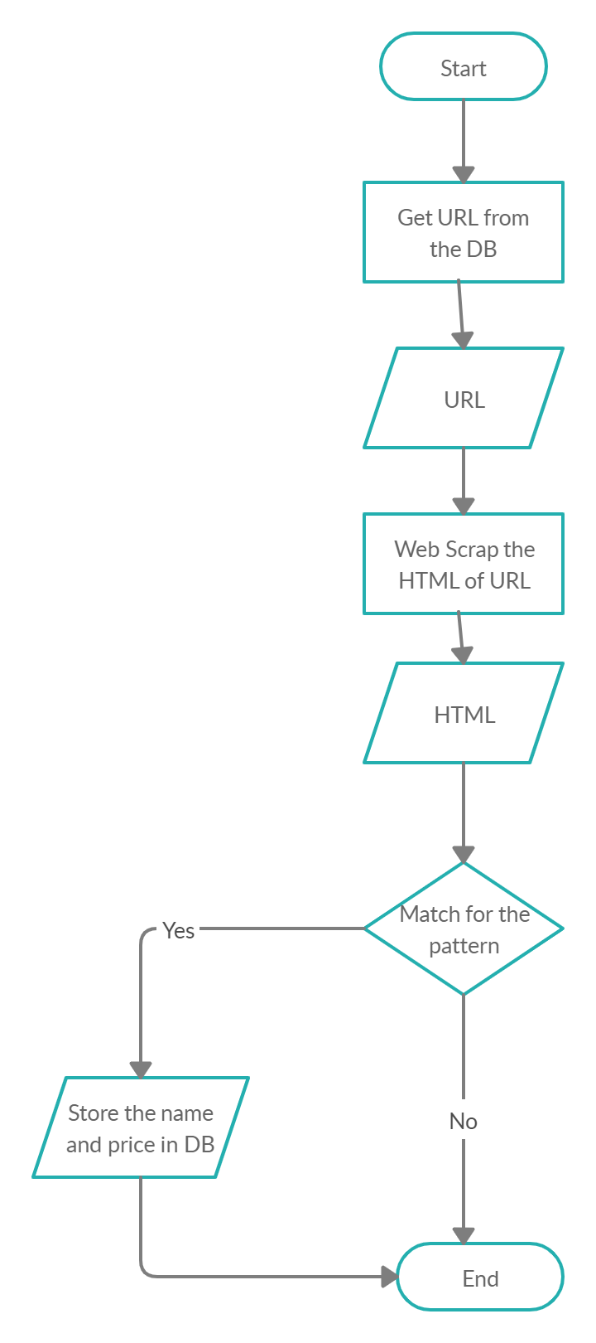
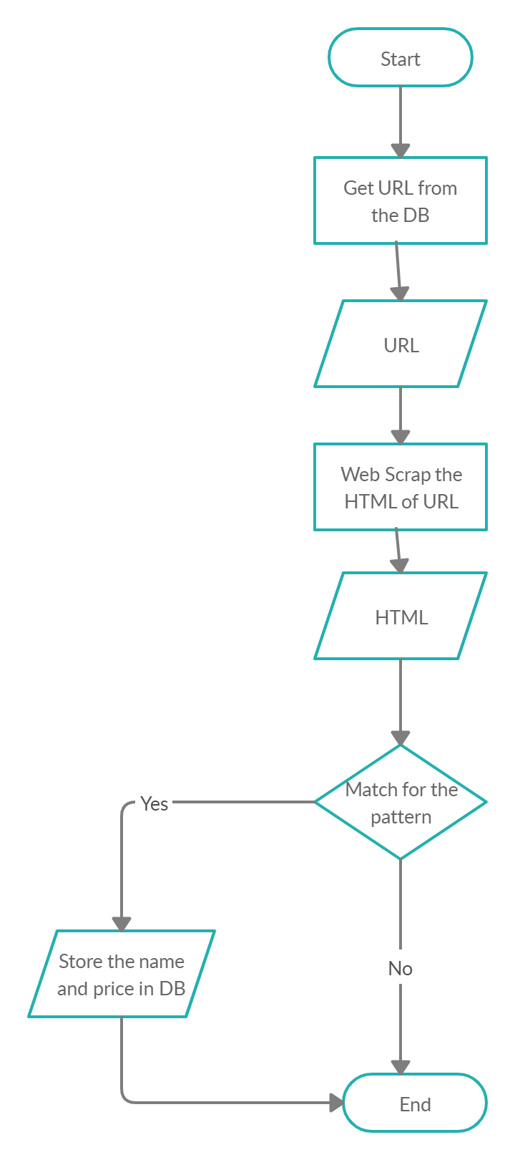

2.4 Automating the web scraping
Now the dataset is ready. However we cannot call the script daily. We need to automate the process so that the script automatically fetches data from the site and store it in the db. We made the automation using the CRON scheduler. The software utility CRON is a time-based job scheduler in Unix-like computer operating systems. Users that set up and maintain software environments use CRON to schedule jobs (commands or shell scripts) to run periodically at fixed times, dates, or intervals. It typically automates system maintenance or administration—though its general-purpose nature makes it useful for things like downloading files from the Internet and downloading email at regular intervals. We used this to schedule our script daily to insert the values of price. The amazon EC2 instance is used because we cannot keep our local machines awake all the time. We pushed the script into Amazon EC2 and scheduled using CRON to run the script daily. Now we have made the required dataset available for the model.

It is recommended that footnotes be avoided (except for the unnumbered footnote with the receipt date on the first page). Instead, try to integrate the footnote information into the text.

