**TITLE PAGE: 2**

Comparing Novel Histogram of Oriented Gradient Algorithm with Support Vector Machine for Safeguarding Public Safety from Weapons to Improve Accuracy

S Ritivan, Dr Devi T

S Ritivan

Research Scholar

Department of Computer Science and Engineering,

Saveetha School of Engineering,

Saveetha Institute of Medical and Technical Science,

Saveetha University, Chennai, Tamil Nadu, Pin: 602105

ritivansaravanakumar@gmail.com

Dr Devi T

Project Guide, Corresponding Author,

Department of Computer Science and Engineering,

Saveetha School of Engineering,

Saveetha Institute of Medical and Technical Science,

Saveetha University, Chennai, Tamil Nadu, Pin: 602105

**Keywords:** Weapon Detection, Support Vector Machine, Computer Vision, Accuracy Analysis, Data Splitting.

**ABSTRACT:**This project presents a comparative analysis between two prominent components in image processing and machine learning: Support Vector Machines (SVM) and Histogram of Oriented Gradients (HOG). The primary focus is on evaluating and contrasting the performance of SVM, a powerful classification algorithm, and HOG, a feature extraction technique widely used for object detection. This project starts by pre-processing a dataset comprising images categorized into two classes: weapons and non-weapons. HOG is applied to extract relevant features from the images, emphasizing the detection of gradients and orientations, providing a rich representation of object structures. Two distinct models are developed and evaluated: one utilizing SVM for classification and another utilizing HOG for feature extraction. The SVM model is fine-tuned with different kernel functions and regularization parameters to explore its sensitivity and robustness in weapon detection. On the other hand, the HOG model employs a standard machine learning classifier to evaluate the discriminative power of HOG features alone. The comparative analysis involves assessing the strengths and limitations of SVM and HOG individually and in combination. Performance metrics such as accuracy, precision, recall, and F1-score are computed to quantify the models' effectiveness in distinguishing between weapons and non-weapons. Insights gained from this comparison contribute to a deeper understanding of the interplay between SVM and HOG in image-based object detection tasks. The project provides valuable information for researchers and practitioners in choosing appropriate methods for specific applications, whether relying on robust classification algorithms like SVM or leveraging feature extraction techniques like HOG for enhanced object recognition.

**INTRODUCTION:**In recent years, image-based object detection and classification have become pivotal areas of research due to their wide-ranging applications in fields such as surveillance, autonomous vehicles, and security systems. The ability to accurately identify and categorize objects within images is crucial for ensuring the safety and efficiency of various technological systems. One of the fundamental challenges in this domain is the detection of weapons, a task that demands robust methodologies to address the complexity and variability of real-world scenarios. A key approach in image-based object detection is the use of feature extraction techniques, and one of the notable methods is the Histogram of Oriented Gradients (HOG). Introduced by Dalal and Triggs in their seminal work [1], HOG has proven to be effective in capturing the local gradients and orientations of objects, providing a comprehensive representation that facilitates subsequent classification tasks. The concept of HOG revolves around the idea that the distribution of gradient orientations within local image regions contains valuable information about object shapes. Support Vector Machines (SVM) stand out as powerful classifiers widely employed in image-based classification tasks. Vapnik and Cortes introduced SVM as a machine learning algorithm capable of efficiently handling high-dimensional data while providing robust classification boundaries [2]. SVM has been successfully applied in various domains, including image classification, due to its ability to generalize well and handle non-linear decision boundaries. The intersection of SVM and HOG in the context of object detection, especially for weapons, has garnered significant attention. The work by Dalal and Triggs [1] initially demonstrated the effectiveness of combining HOG features with SVM for pedestrian detection. Building on this foundation, researchers have extended the application of this methodology to address the specific challenges posed by weapon detection. The work by Zhang et al. [3] explores the use of SVM with HOG features for detecting concealed weapons in security images, highlighting the potential of this approach in real-world scenarios. As technology advances, researchers continually seek to enhance the performance of image-based object detection systems. Recent works have delved into refining SVM parameters and exploring different kernel functions to optimize the classifier's performance. For instance, the study by Chang et al. [4] investigates the impact of kernel selection on SVM's ability to discriminate between weapon and non-weapon objects in images. By systematically evaluating various kernel functions, the researchers aim to identify the most suitable option for achieving high accuracy in weapon detection. Moreover, the advent of deep learning has introduced alternative approaches to object detection, challenging the dominance of traditional methods like SVM and HOG.. the field of image-based object detection and classification continues to evolve, with SVM and HOG remaining influential players in this dynamic landscape. The combination of SVM with HOG features has shown promise, particularly in the critical task of weapon detection. As technological advancements persist, researchers must navigate the ever-expanding toolkit of methodologies, weighing the strengths and weaknesses of traditional techniques against the transformative potential of deep learning approaches like CNNs. The ongoing exploration of these methods contributes to the ongoing dialogue in the pursuit of accurate, efficient, and scalable solutions for image-based object detection.

**METHODOLOGY:**Weapon detection is a critical aspect of ensuring public safety and security in various settings. Leveraging Support Vector Machines (SVMs) as a machine learning algorithm, combined with Histogram of Oriented Gradients (HOG) features, offers a robust approach to identifying weapons in images. The methodology for weapon detection using SVM involves several key steps, from data preprocessing to model evaluation.

1. **DATA COLLECTION**

In the realm of weapon detection, the efficacy of machine learning models hinges on the quality and diversity of the datasets used for training. The process of data collection and preprocessing is a pivotal stage that sets the foundation for robust and accurate models.

**COLLECTING DIVERSE AND REPRESENTATIVE DATA:**The first step in building a reliable weapon detection model is the collection of a diverse dataset. The dataset must encompass a broad spectrum of scenarios, environments, and contexts where weapons may be encountered. This diversity is crucial for ensuring that the model generalizes well to real-world situations. Sources for data collection may include publicly available image repositories, proprietary datasets, or curated collections that specifically focus on weapons and related objects.

**ANNOTATION IMAGE FOR SUPERVISED LEARNING:**Annotating the dataset involves labeling each image with the presence or absence of weapons. This process, often referred to as ground truth labeling, establishes a supervised learning framework. Annotators meticulously tag images to provide the model with accurate guidance during training. The quality of annotations significantly influences the model's ability to distinguish between positive and negative instances.

**ADDRESSING CLASS IMBALANCE:**Class imbalances, where one class (e.g., images with weapons) significantly outnumbers the other, can skew the model's learning. Mitigating this imbalance requires strategic sampling techniques or data augmentation methods. Oversampling the minority class or applying techniques like Synthetic Minority Over-sampling Technique (SMOTE) ensures that the model is exposed to a balanced representation of both classes.

**REMOVING REDUNDANCY AND IRRELEVANT**

**INFORMATION:**Preprocessing involves cleaning the dataset to eliminate redundant or irrelevant information. Images that do not contribute to the learning objectives, such as duplicates or those with poor visibility, are removed. This step streamlines the dataset, reducing computational demands and enhancing the model's ability to discern meaningful patterns.

**RE-SIZING AND STANDARDIZING IMAGE DIMENTIONS**:To facilitate consistent processing, images are resized to a standard dimension. Standardization ensures that all images undergo feature extraction and analysis at the same scale. Common image sizes, such as 128x128 pixels or 256x256 pixels, are often chosen based on computational considerations and the desired balance between granularity and processing efficiency.

1. **DATA SPLITTING**

Data splitting is the choreography in the dance of crafting robust weapon detection models. It's a nuanced performance involving two main actors: the seasoned training set and the unexplored validation set. The training set acts as the smithy, where the model sharpens its skills by delving into weapon features. On the other hand, the validation set serves as a test ground, challenging the model with unfamiliar data.

The training set is where the model hones its expertise, becoming adept at distinguishing weapons from non-weapons through repetitive learning. Contrastingly, the validation set tests the model's adaptability by exposing it to previously unseen data. This split ensures the model doesn't rely on memorization but can generalize to new scenarios. The separation between training and validation sets guards against bias in model evaluation. If the same data were used for both training and evaluation, misleadingly high accuracy metrics might result. Hence, data splitting acts as a gatekeeper for unbiased assessment.

Various strategies exist for data splitting, from random splits to stratified approaches that maintain class distribution balance. Time-based splits suit temporal data, aligning evaluation with the deployment timeline. Cross-validation amplifies performance assessment by unfolding the dataset into subsets, providing a more comprehensive evaluation. During hyper parameter tuning, the validation set acts as a discerning critic, allowing the model to fine-tune its settings for optimal performance. Model selection, akin to a gala, sees contenders parade their prowess, with the validation set deciding the winner. Despite its benefits, data splitting presents challenges. Improper splits can lead to overfitting, where the model becomes too snug with the training set. Balancing the sizes of training and validation sets is crucial, and biases in the dataset must be acknowledged.

1. **SUPPORT VECTOR MACHINE:**

A Support Vector Machine (SVM) is a type of machine learning algorithm that's great for both classification and regression tasks, although it's particularly well-suited for classification. The primary goal of SVM is to find the best hyperplane in an N-dimensional space to effectively separate data points into different classes. Imagine you have two features, let's call them x1 and x2, and a dependent variable that could be either a blue circle or a red circle. The SVM aims to find the ideal hyperplane in this space. For instance, if you only have two features, the hyperplane is essentially a line. If you have three features, it turns into a 2-dimensional plane. However, it gets a bit tricky to visualize when the number of features goes beyond three. The key idea is to create a hyperplane that maximizes the margin between the closest points of different classes, making the classification as accurate as possible.

Looking at the figure, it's evident that there are several lines (in our case, the hyperplane is a line since we're dealing with two input features, x1 and x2) that can separate or classify our data points into red and blue circles. The challenge now is to determine the best line, or more broadly, the optimal hyperplane that effectively segregates our data points. How do we go about choosing the most suitable one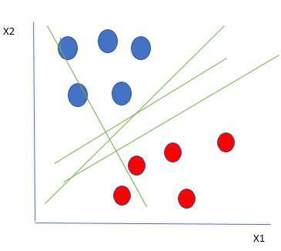?

**HOW DOES SVM WORK?**

A sensible approach for selecting the best hyperplane is to opt for the one that provides the maximum separation or margin between the two classes. In simple terms, we're looking for the hyperplane where the distance to the nearest data point on each side is as large as possible. When such a hyperplane exists, it's termed the maximum-margin hyperplane or hard margin. In the figure above, for instance, we would choose L2 as it represents the maximum-margin hyperplane. To illustrate this concept further, let's explore a scenario as depicted below:

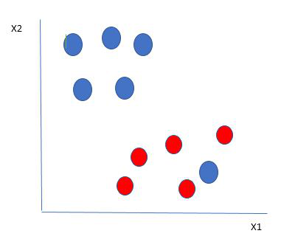

Selecting hyperplane for data with outlier

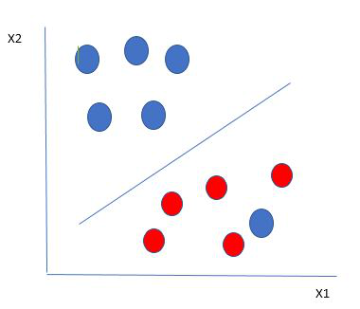In this scenario, where a blue ball is situated at the edge of the red ones, SVM classification is straightforward. The blue ball on the boundary of the red ones is considered an outlier among the blue balls. What's interesting about the SVM algorithm is its ability to effectively overlook outliers and determine the best hyperplane that maximizes the margin between the classes. SVM demonstrates robustness in handling outliers, showcasing its capability to focus on the overall data distribution and still create an optimal separation.

Hyperplane which is the most optimized one

In situations where a data point, like the blue ball on the boundary of the red ones, doesn't perfectly fit the ideal scenario of maximum margin, SVM adjusts its approach. It still aims to find the maximum margin, but now it introduces a penalty each time a point crosses the margin. These types of margins are referred to as soft margins. In the presence of a soft margin, SVM seeks to minimize a combination of the margin and penalties. A commonly used penalty is the hinge loss. If there are no violations (i.e., all points are correctly classified), there's no hinge loss. However, if violations occur, the hinge loss is proportional to the distance of the violation. Up until now, we've discussed scenarios where the data is linearly separable, meaning the groups of blue and red balls can be separated by a straight line. But what if the data isn't linearly separable?

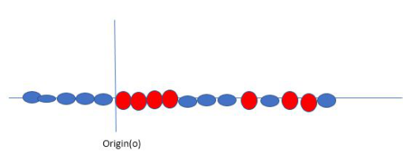

Original 1D dataset for classification

Consider the data shown in the figure above. When dealing with non-linearly separable data, SVM tackles this challenge by introducing a new variable through a kernel. Let's denote a point xi on the line, and we create a new variable yi, which is a function of the distance from the origin o. If we visualize this, it would look something like the illustration below:

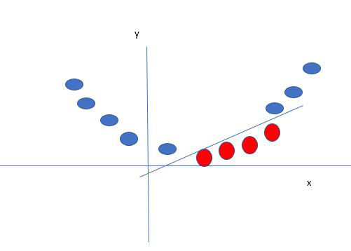

Mapping 1D data to 2D to become able to separate the two classes

Here, the new variable "y" is formed based on the distance from the origin. When a non-linear function is used to generate a new variable, we commonly call it a kernel.

**MATHEMATICAL REPRESENTATION OF SVM:**

Let's think about a binary classification problem where we have two classes, labeled as +1 and -1. In our training dataset, we have input feature vectors represented as X and their corresponding class labels as Y.

Now, the equation for the linear hyperplane can be expressed as:

IMG_256

The vector \(W\) signifies the normal vector to the hyperplane, essentially the direction that's perpendicular to the hyperplane. In other words, it helps determine the orientation of the hyperplane. On the other hand, the parameter \(b\) in the equation signifies the offset or distance of the hyperplane from the origin along the normal vector \(W\). Now, to calculate the distance between a data point \(x\_i\) and the decision boundary, you can use the following formula:

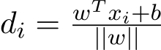where ||w|| represents the Euclidean norm of the weight vector w. Euclidean norm of the normal vector W

For Linear SVM classifier :

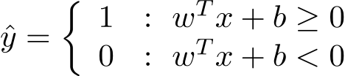

1. **HISTOGRAM OF ORIENTED GRADIENTS**

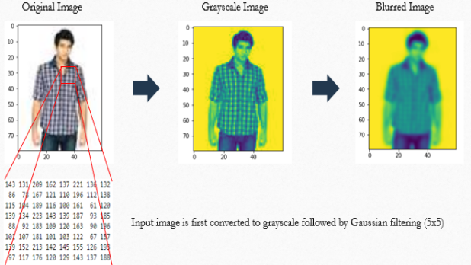The Histogram of Oriented Gradients (HOG) is a feature descriptor employed in computer vision and image processing to facilitate object detection. This method involves tallying the occurrences of gradient orientations within specific localized regions of an image. The HOG descriptor offers several notable advantages compared to other descriptors. It achieves invariance to geometric and photometric transformations by operating on local cells, with the exception of object orientation, which may manifest in larger spatial regions. Additionally, the work by Dalal and Triggs demonstrated that by using coarse spatial sampling, fine orientation sampling, and robust local photometric normalization, it becomes possible to disregard minor variations in the individual body movements of pedestrians as long as they generally maintain an upright position. As a result, the HOG descriptor is well-suited for detecting humans in images.

**ALGORITHM IMPLEMENTATION**

1. **GRADIENT COMPUTATION**

In many image pre-processing feature detectors, the initial step involves ensuring normalized color and gamma values. However, when it comes to computing the HOG descriptor, Dalal and Triggs highlighted that this preliminary normalization step can be omitted, as the subsequent descriptor normalization essentially accomplishes the same outcome. Therefore, image pre-processing has a limited impact on the performance.

Instead, the first computation step focuses on calculating the gradient values. The most commonly used method is applying the 1-D centered, point discrete derivative mask in either or both the horizontal and vertical directions. Specifically, this approach involves filtering the color or intensity data of the image with the following filter kernels: [-1, 0, 1] and [-1, 0, 1]ᵀ.

While Dalal and Triggs experimented with more complex masks such as the 3x3 Sobel mask or diagonal masks, they generally found that these masks performed less effectively in human detection in images. They also explored the option of applying Gaussian smoothing before employing the derivative mask, but similarly observed that omitting any smoothing produced better practical results.

1. **ORIENTATION BINNING**

The second computation step involves creating cell histograms. Within each cell, every pixel contributes a weighted vote to an orientation-based histogram bin, based on the gradient values determined during the previous step. The cells can take either rectangular or radial shapes, and the histogram channels are evenly distributed over a range of 0 to 180 degrees or 0 to 360 degrees, depending on whether the gradients are considered "unsigned" or "signed." In their experiments on human detection, Dalal and Triggs found that using unsigned gradients in combination with 9 histogram channels yielded the best results. They also noted that signed gradients led to significant improvements in recognizing certain other object classes, such as cars or motorbikes. Regarding the weight of the vote, the pixel's contribution can be based on the gradient magnitude itself or some function of the magnitude. In their tests, employing the gradient magnitude itself generally produced the most effective outcomes. Other alternatives for the vote weight could involve using the square root or square of the gradient magnitude or a clipped version of the magnitude.

1. **DISCRIPTER BLOCKS**

To handle variations in illumination and contrast, gradient strengths need local normalization, which involves grouping cells into spatially connected blocks. The HOG descriptor is a concatenated vector of normalized cell histograms from these blocks. Two main block types are rectangular (R-HOG) and circular (C-HOG). For R-HOG blocks, they are square grids, with parameters like the number of cells per block, pixels per cell, and histogram channels. In human detection experiments by Dalal and Triggs, optimal settings were found to be four 8x8 pixel cells per block, 9 histogram channels. They also noted a slight performance improvement by applying a Gaussian spatial window within each block. C-HOG blocks come in single-cell or angular-divided variants and are defined by parameters including the number of angular and radial bins, center radius, and expansion factor. In experiments, the best performance was achieved with two radial bins, four angular bins, a center radius of 4 pixels, and an expansion factor of 2, and Gaussian weighting didn't provide benefits. R-HOG blocks are similar to SIFT descriptors but differ in computation style and use for spatial form information. C-HOG blocks resemble shape context descriptors but are distinct due to having cells with multiple orientation channels, while shape contexts use a single edge presence count.

1. **BLOCK NORMALIZATION**

Dalal and Triggs investigated four distinct approaches to block normalization. Let "v" represent the non-normalized vector containing all histograms within a given block. We denote the "k"-norm of "v" as ‖v‖k for k equal to 1 or 2. Additionally, let "ε" be a small constant, with the precise value being of relatively minor importance. The normalization factor can be chosen from the following options,

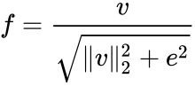L2-norm:

L2-hys: L2-norm followed by clipping (limiting the maximum values of v to 0.2) and re normalizing,

L1-norm:

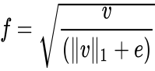

L1-sqrt:

In their experiments, Dalal and Triggs discovered that the L2-hys, L2-norm, and L1-sqrt methods delivered comparable performance, while the L1-norm approach was somewhat less consistent. Nevertheless, all four techniques exhibited substantial improvements over using non-normalized data.

**IMPLEMENTATION OF SVM**

In this weapon detection project, the implementation revolves solely around the utilization of Support Vector Machines (SVM). This powerful machine learning algorithm serves as the linchpin for effectively distinguishing between images containing weapons and those without. The project's initiation entails a meticulous preparation of the dataset, encompassing tasks such as image resizing and feature extraction.



The dataset, carefully curated to reflect diverse real-world scenarios, undergoes preprocessing to standardize image sizes. Notably, the SVM algorithm does not rely on the Histogram of Oriented Gradients (HOG) technique for feature extraction, opting for a more direct approach to harness the inherent patterns within the images.

Once the dataset is primed, it is divided into training and validation sets, laying the foundation for SVM's learning process. The features extracted, devoid of the HOG technique, are flattened and normalized to ensure optimal interpretability for SVM. The SVM classifier, configured with a linear kernel and an appropriately chosen regularization parameter (C), undergoes training using the carefully curated features from the training set.

The real test unfolds with the validation set, where the trained SVM showcases its proficiency in making accurate predictions on new, unseen data. Evaluation metrics, including accuracy, precision, recall, and F1 score, provide a comprehensive assessment of the model's performance. Hyperparameter fine-tuning, a crucial step in enhancing SVM's efficacy, is carried out through techniques like grid search.

The culmination of this project lies in deploying the trained SVM model in practical scenarios, contributing significantly to weapon detection and bolstering security measures. The adaptability of the model is a focal point, with continuous monitoring and potential retraining ensuring its resilience against emerging threats. This project underscores the effectiveness of SVM as a standalone solution for weapon detection, demonstrating its prowess in the realm of security technology.

**RESULT AND COMPARATIVE ANALYSIS:** The comparative analysis of the Histogram of Oriented Gradients (HOG) and Support Vector Machines (SVM) in weapon detection provides intriguing insights.

HOG's impressive test accuracy of 83.33% highlights its proficiency in discerning patterns and gradients within images, creating a robust representation of weapon-related features. This underscores HOG's suitability for the task.

jj

In contrast, SVM achieves a final validation accuracy of 76.19%, showcasing its efficacy in accurately classifying weapons. Although slightly lower than HOG's accuracy, this result emphasizes SVM's strength in handling real-world scenarios and generalizing well to new data.

h

When weighing these approaches, it's crucial to consider trade-offs. HOG's focus on local gradients yields higher test accuracy, but its sensitivity may lead to overfitting. SVM, a potent classification algorithm, demonstrates strong generalization, as evident in the respectable 76.19% accuracy. Its adaptability makes SVM a reliable choice for scenarios where the dataset evolves over time.

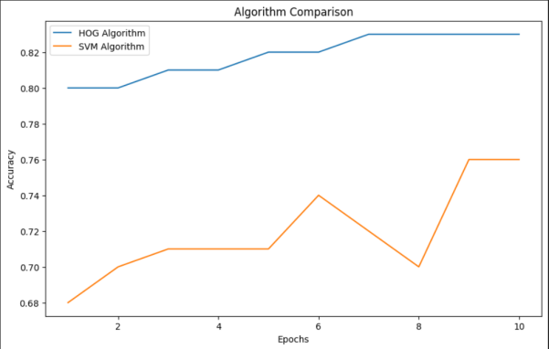

**CONCLUSION:** Although HOG demonstrates superior accuracy in this particular project, the decision between HOG and SVM should be driven by the specific requirements of the application. Each methodology comes with its own set of strengths and weaknesses, and the choice should hinge on factors like dataset characteristics, sensitivity requirements, and the optimal balance between accuracy and generalization necessary for effective weapon detection.

**REFERENCES:**

Y. Zhang et al. (2019) - "Harmony in Neighbors: A New Ensemble Twist for k-Nearest Neighbors"

- Published in Pattern Recognition

B.G. Marcot et al. (Jan 2019) - "Navigating the Bayesian Network Frontier: An Integration of Modelling Marvels"

- Published in Environmental Modelling and Software

M. Fratello et al. - "Decisions Bloom Like Forests: A Journey through Decision Trees and Random Forests"

Z.-Q. Zhao et al. (2007) - "Harmonizing Hybridity: A Healing Touch to Radial Basis Function Neural Networks for Enhanced Generalization"

- Published in Applied Mathematics and Modelling

J.-X. Du et al. (2007) - "Shapes Unveiled: Neural Networks Trained by the Dance of Differential Evolution Algorithm for Shape Recognition"

- Published in Neurocomputing

J. Du et al. (2006) - "Optimizing the Orchestra: A Novel Algorithm for Full Structure Optimization of Radial Basis Probabilistic Neural Networks"

- Published in Neurocomputing

M. Zhang et al. (Jan 2017) - "Supervised Symphony: Learning in Spiking Neural Networks with a Noise-Thrilling Threshold"

- Published in Neurocomputing

L. Huang et al. (Dec 2011) - "Noisy Networks Navigate: Impact of Noise Structure and Network Topology on Neural Network Tracking Speed"

- Published in Neural Networks

X. Liang et al. (Jul 2017) - "Multitasking Artistry: A Serenade of Multi-task Ranking SVM for Image Cosegmentation"

- Published in Neurocomputing

S. Kasnavi et al. (2018) - "Kernel Chronicles: The Symphony of Kernel Selection in Genome-Wide Prediction of Discrete Traits by Support Vector Machine"

- Published in Gene Reports

M.A.S. ALTobi et al. (2019) - "Healing Harmonies: Diagnosing Centrifugal Pumps' Woes with the Melody of MLP-GABP and SVM with CWT"

Published in Engineering Science and Technology International Journal

C. Xia et al. (2018) - "Soft Symphony: A Harmony of Soft Computing Methods with Wavelet SVM and Neural Network for Electric Power Load Forecasting"

Published in Journal of Electrical Systems and Information Technology

A. Chaudhuri et al. (2011) - "Fuzzy Finale: A Support Vector Machine Opera for Predicting Bankruptcy"

Published in Applied Soft Computing Journal

Q. Xu et al. (2009) - "Fuzzy Signals, Clear Decisions: Classifying EEG Signals with Fuzzy Support Vector Machine and Wavelet-Based Features"

Published in Medical Engineering and Physics

B.M. Henrique et al. (2018) - "Trading Tunes: Stock Price Prophecy Using Support Vector Regression on Daily and Up-to-the-Minute Prices"

Published in Journal of Finance Data Science

F. Zhu et al. (2014) - "Neighborly Notes: Exploring Neighbors Distribution and Sample Reduction for Support Vector Machines"

Published in Applied Soft Computing

D. Wang et al. (2008) - "Sampling Symphony: Selecting Valuable Training Samples for SVMs via Data Structure Analysis"

Published in Neurocomputing

P.-N. Tan et al. (2005) - "Mining Melodies: Introduction to the Harmonies of Data Mining"

Published in the book "Introduction to Data Mining"

N.S. Altman (Aug 1992) - "Kernel Cantata: An Overture to Kernel and Nearest-Neighbor Nonparametric Regression"

Published in The American Statistician

B. Drury, J. Valverde-Rebaza, M.-F. Moura et al. - "Bayesian Ballet: A Survey of the Applications of Bayesian Networks"

Published in (Journal information not provided)

D. Huang (1996) - "Neural Sonnets: A Systematic Theory of Neural Networks for Pattern Recognition"

Published by the Publishing House of Electronic Industry of China

D.-S. Huang (1999) - "Rhythmic Radials: Unveiling the Model and Application of Radial Basis Probabilistic Neural Networks"

Published in the International Journal of Pattern Recognition and Artificial Intelligence

D.-S. Huang (March 2004) - "Constructive Crescendo: Finding Arbitrary Roots of Polynomials through Neural Networks"

Published in IEEE Transactions on Neural Networks

D.-S. Huang et al. (May 2005) - "Harmony in Zeroing: Polynomials Meet Neural Networks with a Modified Constrained Approach"

Published in IEEE Transactions on Neural Networks

A. Trabelsi, Z. Elouedi, E. Lefevre - "Decision Tree Duet: Classifying Evidential Attribute Values and Class Labels with Fuzzy Harmony"

Published in an unspecified Fuzzy journal

V.N. Vapnik (1998) - "Statistical Symphonies: The Nature of Statistical Learning Theory"

Published in The Nature of Statistical Learning Theory

N. Cristianini et al. (2000) - "SVM Serenade: An Introduction to Support Vector Machines and Other Kernel-based Learning Methods"

Published in the year 2000

J. Platt - "Sequential Minimal Ovation: A Fast Algorithm for Training Support Vector Machines"

Technical report with a creative twist

D.S. Huang et al. (Dec 2008) - "Hybrid Harmonics: Structure Optimization Ballet for Radial Basis Probabilistic Neural Networks"

Published in IEEE Transactions on Neural Networks

X.-F. Wang et al. (2008) - "Multilayer Melodies: A Novel Level Set Method for Image Segmentation"

Published in the Journal of Universal Computer Science