Air quality monitoring using iot

Introduction:

1)An IoT-based air quality monitoring system is an ideal solution that can provide real-time data and insights about the air quality in a particular area.

2)The quality of the air we breathe is a critical factor in our overall well being and the health of our planet. Poor air quality can have detrimental effect on health, ecosystem, and even economic productivity. With the rise of urbanization and industrialization, monitoring and managing air quality have become increasingly important.

3)traditional air quality monitoring systems often consist of stationary monitoring stations that provide periodic data at limited locations. These system have limitations in term of spatial coverage and real time data availability. This is where IoT based air quality monitoring comes under play.

IoT BASED AIR QUALITY MONITORING

1)IoT based air quality monitoring involves the development of a network of sensors and connected devices that can measure various air pollutants and environmental parameter

2) These sensor can detect pollutants such as particulate matter (PM2.5, PM10),nitrogen dioxide (NO2),sulfur dioxide(SO2),carbon monoxide (CO), ozone(O3),and volatile organic compounds (VOCs),among others .

3)Additionally they can capture data on temperature, humidity , pressure, and even geographical coordinates.

SENSORS:

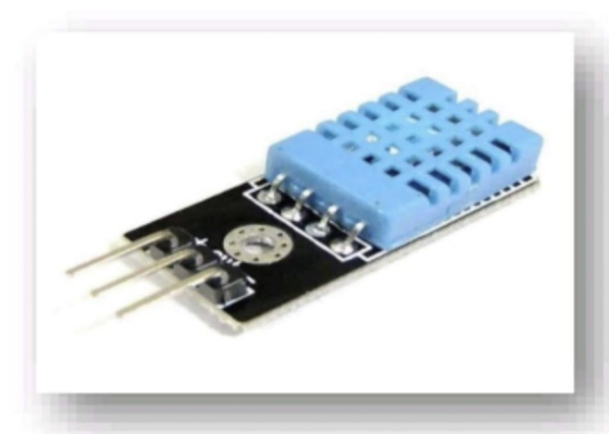

TEMPERATURE AND HUMIDITY SENSOR

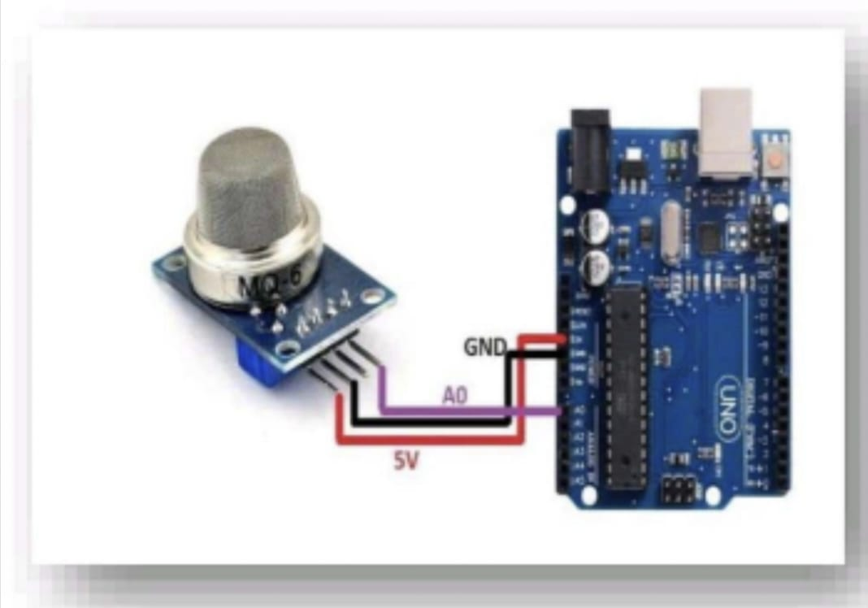

GAS SENSOR

IOT SENSOR WORK:

1)GAS SENSORS: these sensors detects specific gases like carbon dioxide (CO2), carbon monoxide (CO), nitrogen dioxide (NO2), sulfur dioxide (SO2), ozone(O3),and volatile organic compounds(VOCs).

2)Particulate matter sensors: It measures the concentration of airborne particles.

3)environmental sensors: in addition to pollutants these sensors measure environmental parameters such as temperature , humidity , atmospheric pressure , and GPS coordinates.

DATA COLLECTION:

1)IoT sensors continuously collect data from their surroundings . they may use various detection principles, including optical, electrochemical and laser based methods depending on the pollutant being measured.

WIRELESS CONNECTIVITY:

1)IoT sensors are equipped with wireless communication modules to transmit data to a central server or cloud platform.

POWER EFFICIENCY:

1)IoT based air quality sensors are designed to be low power devices enabling long term deployment without frequent battery replacements.

LOCATION BASED MONITORING:

1)sensors are often deployed at strategic location including urban areas , traffic intersections , industrial zones and residental area to capture variation in air quality.

DATA INTEGRATION:

1)the collected data is integrated into a centralized database allowing for easy access , storage , and analysis.

REAL TIME MONITORING:

1)IoT sensors provide real time data enabling immediate response to air quality fluctuations or pollution events.

REMOTE MANAGEMENT:

1)these sensors can be remotely configured and managed, reducing the need for physical maintenance

DATA ANALITICS:

1)Data from IoT based sensor can be analyzed to identify trends correlations and patterns supporting informed decision making and policy development .

PUBLIC ACCESS:

1)some air quality monitoring networks offer public access to real time data through web portals or mobile app , fostering transperancy and community awareness.

ALERTS AND NOTIFICATIONS:

1)when air quality reaches predefined thresholds or deteriorates significantly IoT based system can send alert and notifications to relevant authorities or the public.

SCALABILITY:

1)IoT based air quality monitoring networks can easily scale by adding more sensors to cover large geographical areas.

FLOW CHART:

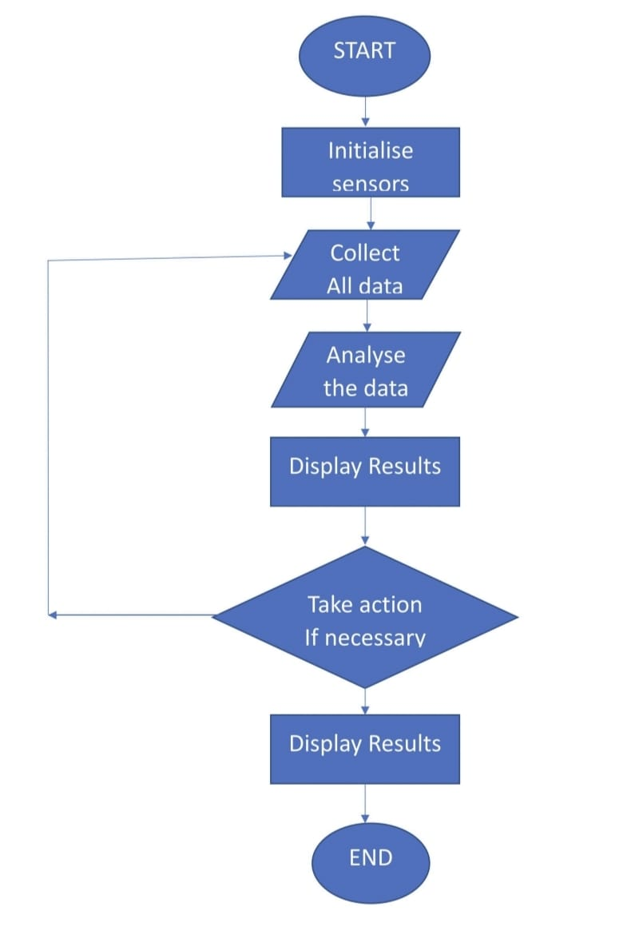

STEPS FOR FLOWCHART:

STEP 1: Start the program.

STEP2:Turn on the Gas ,Temperature and Humidity sensors.

STEP3:Collect the data:

1)Read gas concentration.

2)Measure temperature and humidity level.

STEP4:Analalyse the data:

1)Check if gas concentration is within safe limits.

2)Check if temperature and humidity is within comfort range.

STEP5:Display results

1. Show gas concentration on display
2. Show temperature value on display.
3. Show humidity percentage.

STEP6:Take action (if necessary) :

1)If gas concentration is high , activate alarm or ventilation.

2)if temperature is too high or low ,adjust heating or cooling system.

3)if humidity is too high or low , activate dehumidifier or humidifier .

STEP7: wait for a set time.

STEP8:Repeat 3-7 continuously.

STEP9:END the program.

BLOCK DIAGRAM: 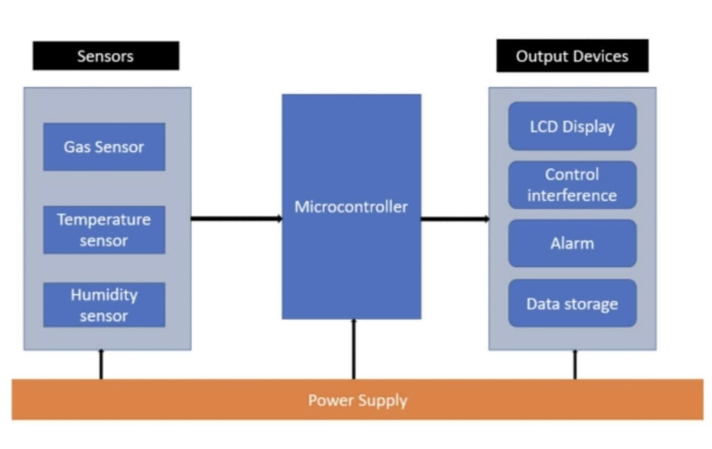

BLOCK DIAGRAM DESCRIPTION:

1)Microcontroller/Main Processing Unit:

This is the brain of the system , collecting data from sensors and process it and managing output actions and displays.

2)sensors:

Gas sensor: Connects to the microcontroller and detects specific gases.

Temperature Sensor: Connects to the microcontroller to measure temperature.

Humidity Sensor: connects to the microcontroller to measure humidity.

3)Communication Interface:

Enables the microcontroller to communicate with external devices or a computer . This can be Wi-Fi , Bluetooth, or wired connections like USB or Ethernet.

4)Display :

Shows real time data readings, alerts or system status.

5)Alarm/Notification system:

This can be an audible alarm , LED indicator ,or any other signaling device that alerts the user when air quality goes outside the desired range.

6)Power supply:

Provides power to the entire system . this could be batteries , solar panels , or a direct power source.

7)Data storage:

Where the data can be logged for historical analysis . This could be an SD card ,onboard memory or cloud storage.

8)Control Buttons/interface:

Allows the user to interact with the system , set threshold ,or view historical data.

CIRCUIT: 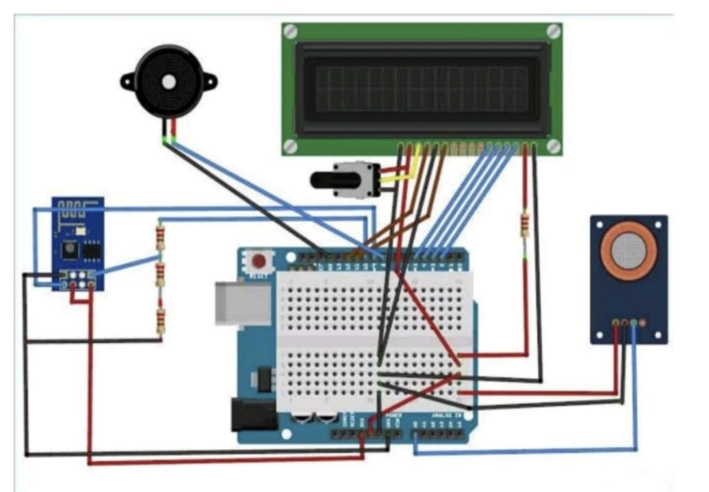

APPLICATION:

1)Monitor air in urban areas to ensure it is safe to breathe.

2)Detect haramful substance like CO2, Green house gases and volatile organic compounds.

3)inform farmers about best time of plant or harvest based on air quality.