**Ex 1 ADVANCED LINUX COMMANDS**

**Date: 18.08.20**

**Aim:**

To study and implement the Linux commands

**Description:**

|  |  |  |  |
| --- | --- | --- | --- |
| Sl. No. | Command Name | Meaning | options |
| 1. | ls | List files and/or directories. | -a, --all  do not ignore entries starting with.  -A, --almost-all  do not list implied. and.  --author  with -l, print the author of each file  -b, --escape  print C-style escapes for nongraphic characters  --block-size=SIZE |
| 2. | Who am i | This command reveals the user who is currently logged in. | -a, --all =same as -b -d --login -p -r -t -T -u  -b, --boot  time of last system boot  -d, --dead  print dead processes -H, --heading  print line of column headings  -l, --login  print system login processes  --lookup  attempt to canonicalize hostnames via DNS |
| 3. | pwd | prints the absolute path to the current working directory | -L, --logical  use PWD from the environment, even if it contains symlinks  -P, --physical  avoid all symlinks |
| 4. | cal | Displays the calendar of the current month | -1, --one  Display single month output. (This is the default.)  -3, --three  Display prev/current/next month output.  -s, --Sunday  Display Sunday as the first day of the week.  -m, --Monday  Display Monday as the first day of the week.  -j, --Julian  Display Julian dates (days one-based, numbered from January 1).  -y, --year |
| 5. | echo | This command will echo whatever you provide it. | -n do not output the trailing newline  -e enable interpretation of backslash escapes  -E disable the interpretation of backslash escapes (default) |
| 6. | date | Displays current time and date. | -d, --date=STRING  display time described by STRING, not 'now'  -f, --file=DATEFILE  like --date once for each line of DATAFILE |
| 7. | tty | Displays the current terminal. |  |
| 8. | id | This command prints user and groups (UID and GID) of the current user. | -a ignore, for compatibility with other versions  -Z, --context  print only the security context of the current user  -g, --troup  print only the effective group ID  -G, --groups  print all group IDs  -n, --name  print a name instead of a number, for -ugG |
| 9. | clear | This command clears the screen. |  |
| 10. | man | To show manual page |  |
| 11. | cd | Change the current working directory to the directory provided as an argument. |  |
| 12. | mkdir | To create a directory, the ‘mkdir’ command is used. |  |
| 13. | touch | For creating an empty file, use the touch command. |  |
| 14. | cp | Copy files and directories |  |
| 15. | mv | Move files or directories. The 'mv' command works like 'cp' command, except that the original file is removed. But, the mv command can be used to rename the files (or directories). |  |
| 16. | rmdir | the command removes any empty directories, but cannot delete a directory if a file is present in it. |  |
| 17. | file | The file command determines the file type of a given file. |  |
| 18. | cat | The 'cat' command is actually a concatenator but can be used to view the contents of a file. |  |
| 19. | head | Displays the first few lines of a file. By default, the ‘head’ command displays the first 10 lines of a file. |  |
| 20. | tail | the ‘tail’ command shows the last 10 lines by default | -c, --bytes=[-]K  print the first K bytes of each file  -n, --lines=[-]K  print the first K lines instead of the first 10  -q, --quiet, --silent  never print headers giving file names |
| 21. | wc | This command counts lines, words, and letters of the input given to it. |  |
| 22. | grep | The ‘grep’ command searches for a pattern in a file (or standard input). |  |
| 23. | vi | Visual editor |  |
| 24. | alias | The ‘alias’ is another name for a command. |  |
| 25. | history | shows the commands you have entered on your terminal so far. |  |
| 26. | passwd | To change your password |  |
| 27. | help | With almost every command, ‘--help’ option shows usage summary for that command. |  |
| 28. | chmod | The *chmod* command lets you change access permissions for a file. |  |
| 29. | stat | To check the status of a file. This provides more detailed information about a file than ‘ls -l’ output. | -L, --dereference  follow links  -f, --file-system  display file system status instead of file status  -c --format=FORMAT  use the specified FORMAT instead of the default; output a newline after each use of FORMAT  --printf=FORMAT |
| 30. | ln | The ln command is used in Linux to create links. |  |

**Exercise**

**1. List the contents of user's home directory including the hidden files**

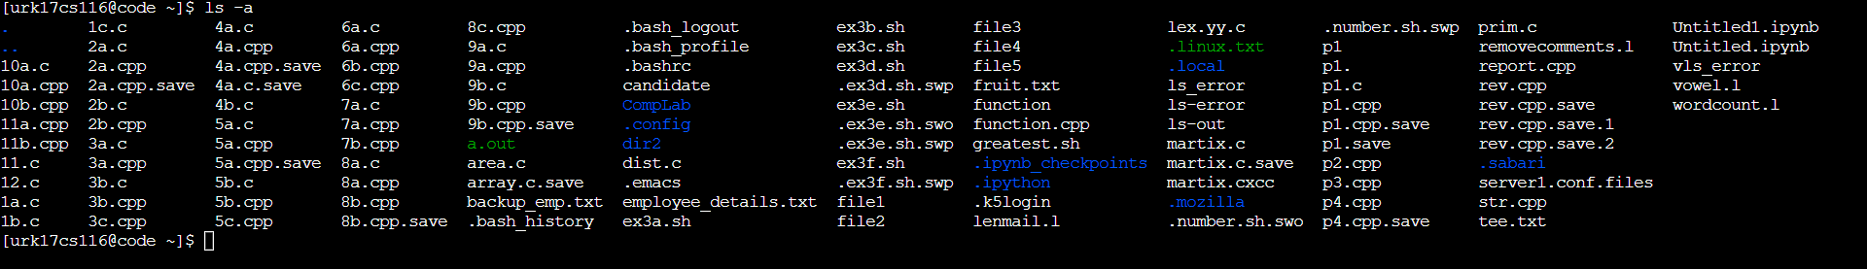

**2. List the content of /var directory?**

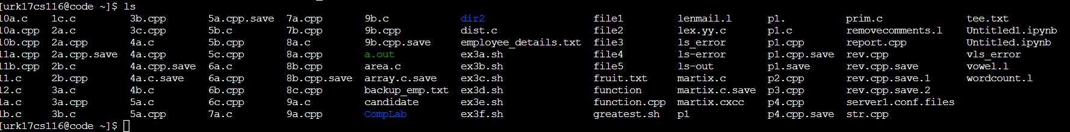

**3. Create two directories named dir1 & dir2**

C:\Users\sabar\Pictures\Screenshot 2020-11-22 152045.png

**4. Create a hidden directory with your name?**

C:\Users\sabar\Pictures\Screenshot 2020-11-22 152140.png

**5. Display the content of a hidden directory.**

C:\Users\sabar\Pictures\Screenshot 2020-11-22 153007.png

**6. Display the calendar of 2020.**

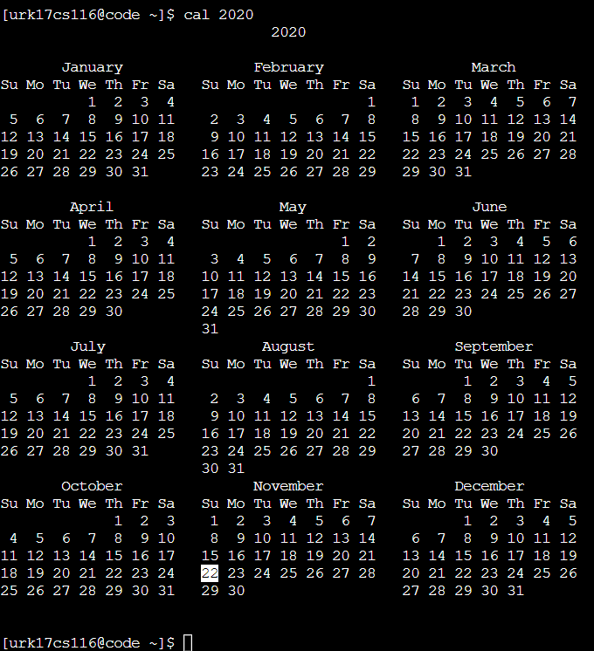

**7. Copy the file /etc/passwd file to current directory with sample.txt as the filename**

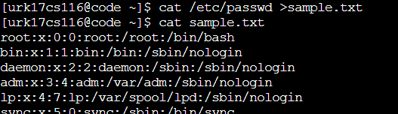

**8. Create a file test1.txt using Vim editor with the following contents to it**

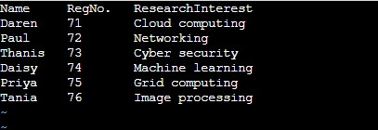

**Answer the following questions**

**a) Display the student names who are having Research Interest as GridComputing**

C:\Users\sabar\Pictures\Screenshot 2020-11-22 153615.png

**b) List all the student names& RegNo in the class**

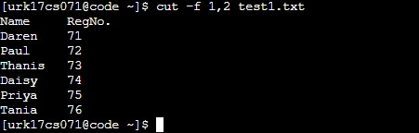

**c) List the count of students who have an interest as ImageProcessing and store the result in another file.**

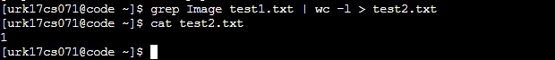

**d) Display the first two rows and last two and store them into another file.**

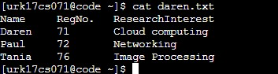

**9. Display the contents of the file test1.txt without any blank lines**

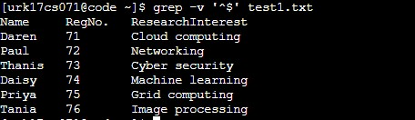

**10. Move the file sample.txt from dir1 directory to dir2 directory**

**C:\Users\sabar\Pictures\Screenshot 2020-11-22 154201.png**

**11. Change directory into dir2 directory**

**C:\Users\sabar\Pictures\Screenshot 2020-11-22 154234.png**

**12. Check whether the file sample.txt is present their**

**C:\Users\sabar\Pictures\Screenshot 2020-11-22 154300.png**

**13. Rename the file sample.txt to new.txt and check whether sample.txt is there or not?**

**C:\Users\sabar\Pictures\Screenshot 2020-11-22 154405.png**

**14. Remove the directory dir1**

**C:\Users\sabar\Pictures\Screenshot 2020-11-22 154443.png**

**15. Display last 3 lines of the file test1.txt**

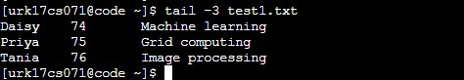

**16. Display all the commands you have executed so far and save the list into a file named todayshistory.txt**

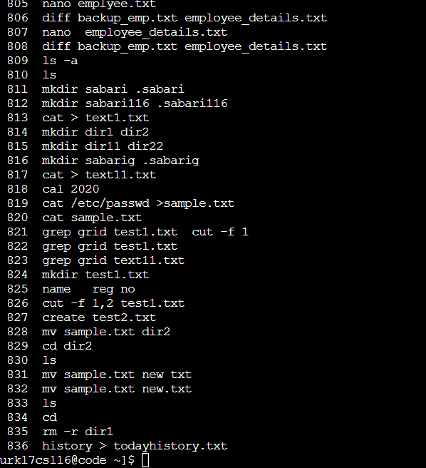

**17. How many files are present under your home directory?**

**C:\Users\sabar\Pictures\Screenshot 2020-11-22 155201.png**

**18. Perform the sorting of three files and store the sorted file in the fourth file.**

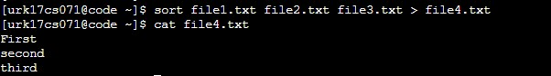

**19. Change the permission of your newly created file such that the group users and others don’t access any type of access.**

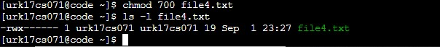

**20. Display the network status on the shell.**

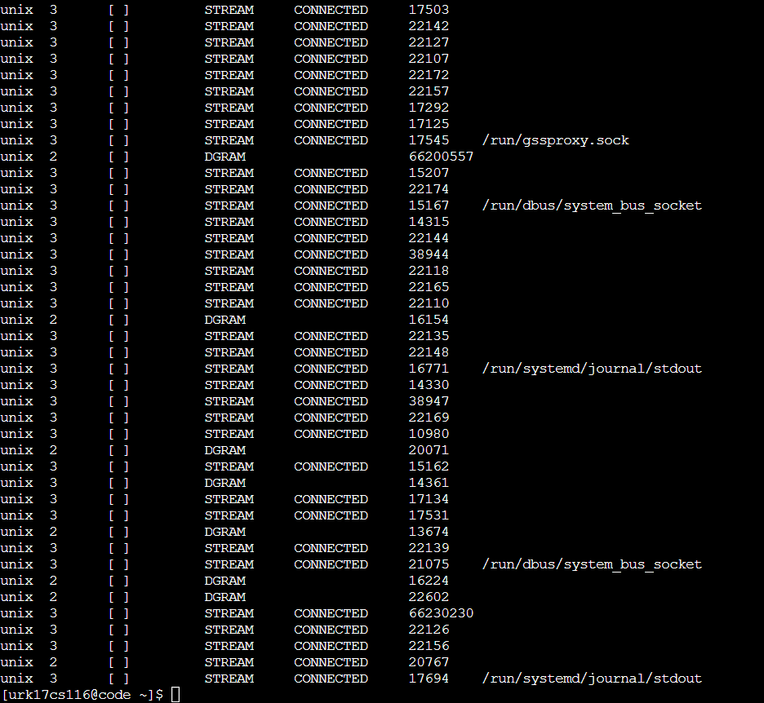

**21. Compares any two files and search for both common and exclusive features**

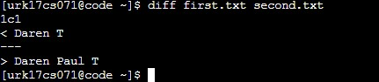

**22. Display the user ID, process ID, and parent process ID.**

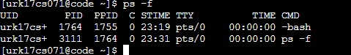

**23. Report disk usages of the file system.**

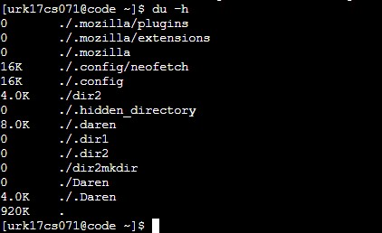

**24. Display the statistics of all ports connected to a network.**

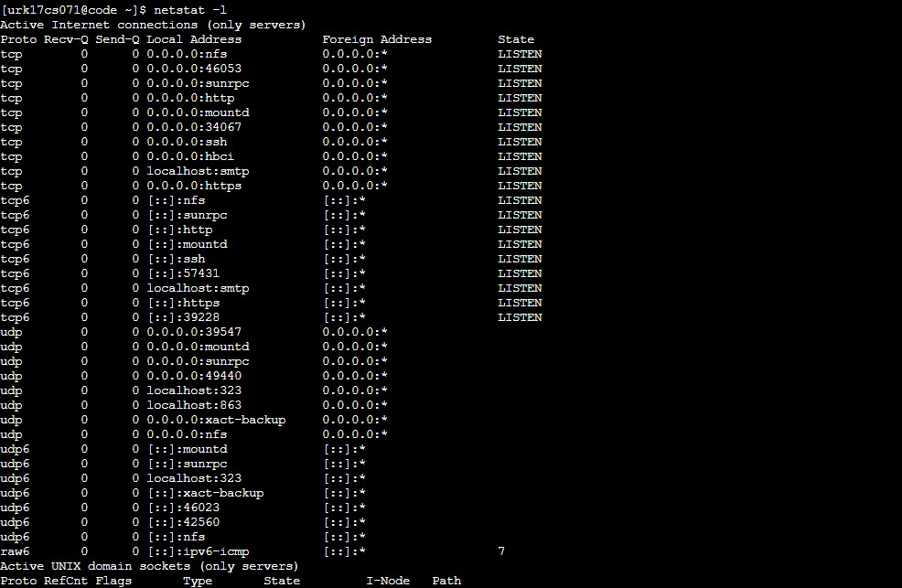

**25. Display the uptime of the system.**

**C:\Users\sabar\Pictures\25.png**

**26. Julian day.**

**C:\Users\Daren\Desktop\lab os 1\dp26.jpg**

**27. IP information.**

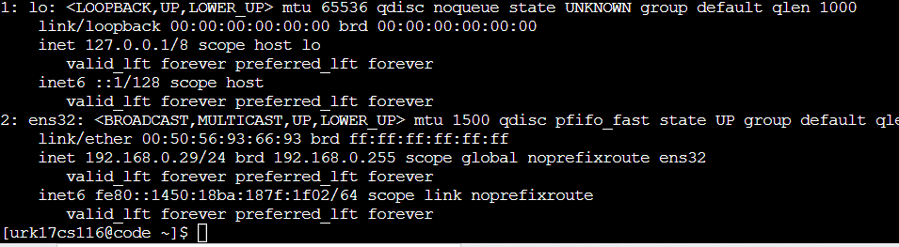

**28. Display only the free space in the system.**

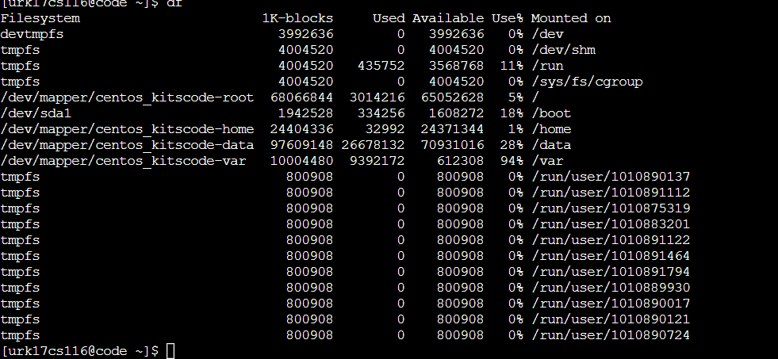

**29. Linux platform is infected over the network.**

**30. Display the configuration information of your network.**

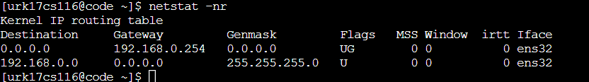

**Results:**

The Linux commands are studied and executed.

Video link :

https://youtu.be/CpqA97yHlNE