Customer Segmentation using Data Science
Phase 2 Submission Document

Team Member:
SWETHA M - 210821205114
SABARI JOTHI.A -210821205086
SIVA JEYANTHI.J -21082120104
Department:
BTech. INFORMATION TECHNOLOGY

Domain:
Applied Data Science

Team Mentor:
Mrs. Saranya

Project Title:
Future Sales Prediction

---

Introduction:
Future sale prediction is a process that involves using historical sales data and other input features to forecast the sales for future periods. This can be valuable for businesses in various industries, as it helps them make informed decisions about inventory management, production planning, and revenue projections.

To begin the process, the first step is to load the historical sales data and input features from a CSV file. This data may include information such as previous sales volumes, pricing, promotional activities, and other relevant factors that could influence future sales.

Once the data is loaded, it needs to be split into training and testing sets. The training set will be used to train the predictive model, while the testing set will be used to evaluate the model's performance.

Next, a linear regression model is created. Linear regression is a statistical method that aims to establish a linear relationship between the input features and the target variable (in this case, future sales). The model will learn from the patterns and trends in the training data to make predictions.

The model is then trained using the training data. This involves adjusting the model's parameters to minimize the difference between the predicted values and the actual sales data. The goal is to create a model that accurately captures the underlying patterns in the data.

Once the model is trained, future sales data is loaded. This data represents the input features for which we want to predict the sales. It could include factors such as pricing strategies, marketing campaigns, or seasonal variations.

Using the trained model, predictions for future sales are made based on the input features. The model uses the learned patterns from the training data to estimate the sales volumes for the future periods.

Finally, the predicted future sales are printed or displayed for further analysis or decision-making. These predictions can provide valuable insights into potential sales trends and help businesses plan their operations accordingly.

It's important to note that future sale prediction is not an exact science and relies on assumptions and historical data. The accuracy of the predictions may vary depending on the quality and relevance of the input features, as well as the complexity of the underlying sales patterns. Regular model evaluation and refinement are crucial to improving the accuracy of future sales predictions.
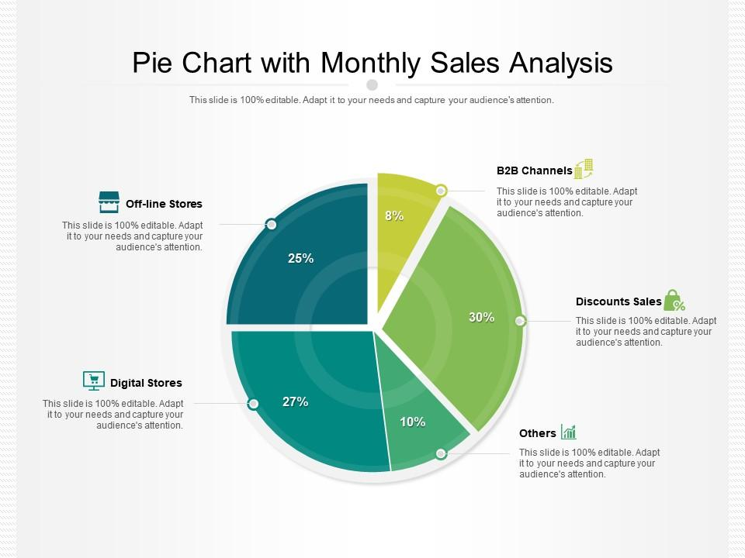

Problem Overview

Sales forecasting is a critical component of inventory management and business strategy for retailers. Accurate sales predictions enable the company to:

- Avoid overstocking and understocking of products.
- Optimize pricing and promotional strategies.
- Improve resource allocation and supply chain management.
- Enhance customer satisfaction by ensuring product availability.

Approach

To address this problem, we will follow a structured approach encompassing data preprocessing, feature engineering, and advanced time series forecasting techniques. Specifically, we will explore the use of Prophet and LSTM networks for improved accuracy in predicting future sales.

1. Data Collection and Preprocessing

- Collect historical sales data, including information on sales, products, dates, and additional relevant data such as weather, holidays, and marketing campaigns.
- Clean the data by addressing missing values and outliers.
- Normalize and transform data as necessary.

2. Feature Engineering

- Generate relevant features such as lagged sales, seasonal patterns, and holiday indicators.
- Select features that contribute to the model's accuracy.

3. Data Splitting

- Split the data into training and testing sets chronologically, ensuring that the training data includes older records and the testing data contains newer records.

4. Model Selection

a. Prophet

Prophet is a robust forecasting tool developed by Facebook that is particularly well-suited for time series data with daily observations. It can capture seasonality, holidays, and trend changes.

b. LSTM Networks

Long Short-Term Memory (LSTM) networks are a type of recurrent neural network (RNN) known for their ability to capture long-term dependencies in time series data. They are effective for sequence prediction tasks.

5. Model Training

- Train both the Prophet and LSTM models on the training dataset.
- Experiment with hyperparameter tuning to optimize model performance.

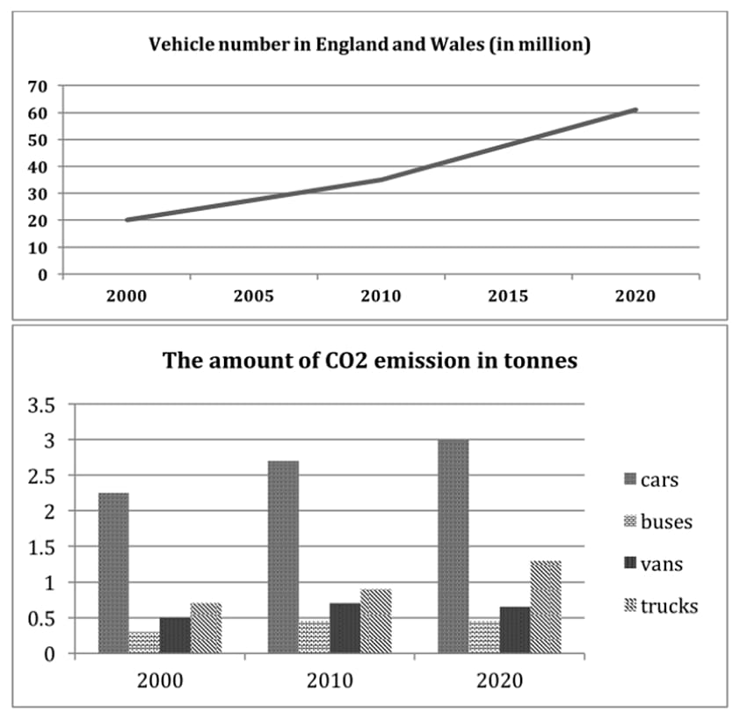

6. Model Evaluation

- Evaluate the performance of both models using appropriate metrics such as Mean Absolute Error (MAE), Mean Squared Error (MSE), and Root Mean Squared Error (RMSE).
- Use cross-validation techniques to ensure model generalization.

7. Model Interpretation

- Understand how the models make predictions, which is crucial for making informed business decisions based on the forecasts.

8. Deployment

- Implement the selected model, or a combination of both models, in a production environment to generate real-time sales forecasts.

9. Monitoring and Maintenance

- Regularly monitor the model's performance in the production environment.
- Retrain the model as needed to adapt to changing sales patterns.

10. Optimization and Continuous Improvement

- Continuously seek ways to improve model accuracy and efficiency.
- Explore additional data sources or refine feature engineering to enhance forecasting capabilities.

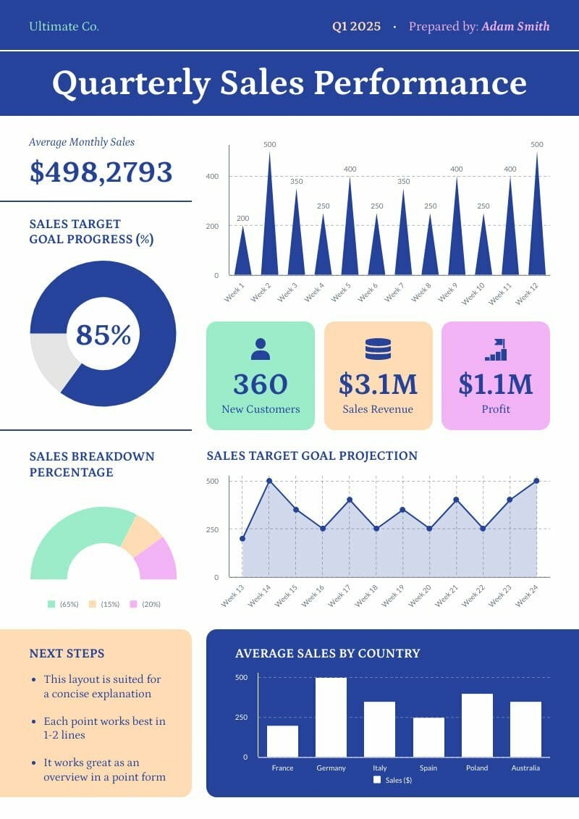

Python program:

Required packages and Installation
numpy
pandas
keras
tensorflow
csv
matplotlib.pyplot

import pandas as pd # to extract data from dataset(.csv file)
import csv #used to read and write to csv files
import numpy as np #used to convert input into numpy arrays to be fed to the model
import matplotlib.pyplot as plt #to plot/visualize sales data and sales forecasting
import tensorflow as tf # acts as the framework upon which this model is built
from tensorflow import keras #defines layers and functions in the model

#here the csv file has been copied into three lists to allow better availability
list_row,date,traffic = get_data('/home/abh/Documents/Python/Untitled Folder/Sales_dataset')

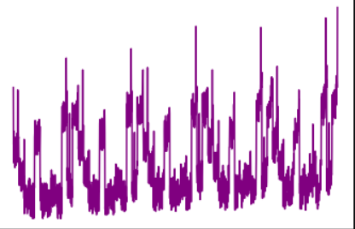

from tensorflow.keras.models import Model
from tensorflow.keras.layers import Input, Dense,LSTM,Flatten
from tensorflow.keras.layers import concatenate
#an Input variable is made from every input array
input_day = Input(shape=(inp_day.shape[1],),name = 'input_day')
input_mon = Input(shape=(inp_mon.shape[1],),name = 'input_mon')
input_year = Input(shape=(inp_year.shape[1],),name = 'input_year')
input_week = Input(shape=(inp_week.shape[1],),name = 'input_week')
input_hol = Input(shape=(inp_hol.shape[1],),name = 'input_hol')
input_day7 = Input(shape=(inp7.shape[1],inp7.shape[2]),name = 'input_day7')
input_day_prev = Input(shape=(inp_prev.shape[1],),name = 'input_day_prev')
input_day_sess = Input(shape=(inp_sess.shape[1],),name = 'input_day_sess')
# The model is quite straight-forward, all inputs were inserted into a dense layer with 5 units and 'relu' as activation function
x1 = Dense(5, activation='relu')(input_day)
x2 = Dense(5, activation='relu')(input_mon)
x3 = Dense(5, activation='relu')(input_year)
x4 = Dense(5, activation='relu')(input_week)
x5 = Dense(5, activation='relu')(input_hol)
x_6 = Dense(5, activation='relu')(input_day7)
x__6 = LSTM(5,return_sequences=True)(x_6) # LSTM is used to remember the importance of each day from the seven days data
x6 = Flatten()(x__10) # done to make the shape compatible to other inputs as LSTM outputs a three dimensional tensor
x7 = Dense(5, activation='relu')(input_day_prev)
x8 = Dense(5, activation='relu')(input_day_sess)
c = concatenate([x1,x2,x3,x4,x5,x6,x7,x8]) # all inputs are concatenated into one
layer1 = Dense(64,activation='relu')(c)
outputs = Dense(1, activation='sigmoid')(layer1) # a single output is produced with value ranging between 0-1.
# now the model is initialized and created as well
model = Model(inputs=[input_day,input_mon,input_year,input_week,input_hol,input_day7,input_day_prev,input_day_sess], outputs=outputs)
model.summary() # used to draw a summary(diagram) of the model

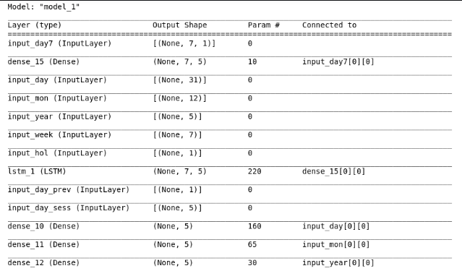

def forecast_testing(date):
maxj = max(traffic) # determines the maximum sales value in order to normalize or return the data to its original form
out=[]
count=-1
ind=0
for i in list_row:
count =count+1
if i[0]==date: #identify the index of the data in list
ind = count
t7=[]
t_prev=[]
t_prev.append(list_row[ind-365][1]) #previous year data
# for the first input, sales data of last seven days will be taken from training data
for j in range(0,7):
t7.append(list_row[ind-j-365][1])
result=[] # list to store the output and values
count=0
for i in list_date[ind-364:ind+2]:
d1,d2,d3,week2,h,sess = input(i) # using input function to process input values into numpy arrays
t_7 = np.array([t7]) # converting the data into a numpy array
t_7 = t_7.reshape(1,7,1)
# extracting and processing the previous year sales value
t_prev=[]
t_prev.append(list_row[ind-730+count][1])
t_prev = np.array([t_prev])
#predicting value for output
y_out = model.predict([d1,d2,d3,week2,h,t_7,t_prev,sess])
#output and multiply the max value to the output value to increase its range from 0-1
print(y_out[0][0]*maxj)
t7.pop(0) #delete the first value from the last seven days value
t7.append(y_out[0][0]) # append the output as input for the seven days data
result.append(y_out[0][0]*maxj) # append the output value to the result list
count=count+1
return result

plt.plot(result,color='red',label='predicted')
plt.plot(test_sales,color='purple',label="actual")
plt.xlabel("Date")
plt.ylabel("Sales")
leg = plt.legend()
plt.show()

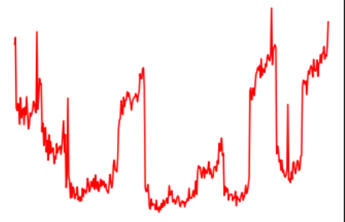

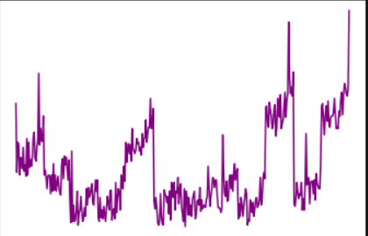

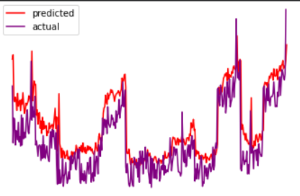

Dataset link:
https://www.kaggle.com/datasets/chakradharmattapalli/future-sales-prediction

Conclusion

Sales forecasting is a complex task with significant business implications. By leveraging advanced time series forecasting techniques such as Prophet and LSTM networks, we aim to provide the retail company with more accurate and actionable sales predictions. This will enable them to optimize inventory management and make informed decisions, ultimately enhancing their competitiveness and customer satisfaction.

---

This design document outlines the strategy for developing a sales forecasting model using advanced time series forecasting techniques. The next steps would involve implementing this plan, carrying out the actual analysis, and continuously monitoring and improving the model's performance as needed.

