Texas Instruments Fusion API README
This document describes how to use TI’s Fusion Application Programming Interface (API) to communicate with supported TI devices such as UCD92xx digital power controllers, UCD30xx Isolated controllers, TPS404xx analog controllers, and UCD90xxx sequencers and system health controllers.
Michael S Muegel
fusion-tools-help@list.ti.com

IMPORTANT NOTICE
Texas Instruments and its subsidiaries (TI) reserve the right to make changes to their products or to discontinue any product or service without notice, and advise customers to obtain the latest version of relevant information to verify, before placing orders, that information being relied on is current and complete. All products are sold subject to the terms and conditions of sale supplied at the time of order acknowledgment, including those pertaining to warranty, patent infringement, and limitation of liability.
TI warrants performance of its products to the specifications applicable at the time of sale in accordance with TI’s standard warranty. Testing and other quality control techniques are utilized to the extent TI deems necessary to support this warranty. Specific testing of all parameters of each device is not necessarily performed, except those mandated by government requirements.
Customers are responsible for their applications using TI components.
In order to minimize risks associated with the customer’s applications, adequate design and operating safeguards must be provided by the customer to minimize inherent or procedural hazards.
TI assumes no liability for applications assistance or customer product design. TI does not warrant or represent that any license, either express or implied, is granted under any patent right, copyright, mask work right, or other intellectual property right of TI covering or relating to any combination, machine, or process in which such products or services might be or are used. TI’s publication of information regarding any third party’s products or services does not constitute TI’s approval, license, warranty or endorsement thereof.
Reproduction of information in TI data books or data sheets is permissible only if reproduction is without alteration and is accompanied by all associated warranties, conditions, limitations and notices. Representation or reproduction of this information with alteration voids all warranties provided for an associated TI product or service, is an unfair and deceptive business practice, and TI is not responsible nor liable for any such use.
Resale of TI’s products or services with statements different from or beyond the parameters stated by TI for that product or service voids all express and any implied warranties for the associated TI product or service, is an unfair and deceptive business practice, and TI is not responsible nor liable for any such use.

Also see: Standard Terms and Conditions of Sale for Semiconductor Products. www.ti.com/sc/docs/stdterms.htm

Mailing Address:
Texas Instruments
Post Office Box 655303
Dallas, Texas 75265

Copyright © 2007, Texas Instruments Incorporated

Table of Contents
1 API Overview 1
2 API Files 1
3 API Versioning 2
4 Sample Code 2
5 Developing Graphical Applications in Microsoft.NET 4
6 Using the API In a Microsoft.NET Project 4
7 Distributing Your Application / Library 5
8 Using the API in Other Environments 6
8.1 MATLAB 6
9 Release Notes 7

- API Overview
The API is in the form of a number of Microsoft.NET assemblies. .NET 2.0 is targeted, although most of the API is developed using Visual Studio 2008 and C# 3.5. The API setup installer will check for the .NET 2.0 runtime (aka Framework) and install it if necessary.
Documentation is available under the Doc folder or through the Start Menu:
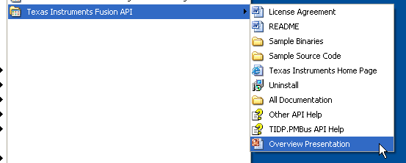

Detailed API documentation is available through the two Help files shown above. “TIDP.PMBus API Help” documents the TIDP.PMBus assembly, which is the primary assembly you will use. Other support libraries are documented in the “Other API Help” file.
The help files provide class-level documentation: what properties, methods, and events a given class supports. There are thousands of classes in the API, however. The documentation should therefore be used as a reference based on the sample code provided with the API.
An overview of the API in the form of a PowerPoint presentation also comes bundled with the API. It is in the “All Documentation” folder.
We recommend learning about the API in this order:
- Read the overview presentation
- Review samples
- Experiment with changes to samples
- Use the help files as a reference to learn more about certain classes and class members.

API Files
In Microsoft.NET, as assembly is the reusable component that can be shared and reused. It is a binary library file ending in .dll. Do not confuse these files with class Microsoft WIN32 library dlls. While they have the same extension, they are very different.
The API installs its assemblies in two places:
- To the Global Assembly Cache (GAC) on your PC. This allows you to build many different applications against the API, but not keep a whole bunch of copies of the API in various places. This is a special folder on your PC, normally C:\WINDOWS\assembly.
- To a Library folder within the Program Files folder where you installed the API, typically C:\Program Files\Texas Instruments Fusion API\Library. These copies are necessary to support development against the API with Microsoft Visual Studio. Also contained there are the “Intellisense” support files for each assembly. These end in .xml. These files are used to provide contextual help as you type in class names, properties, etc. in Visual Studio or C#/VB.NET Express.
For example:
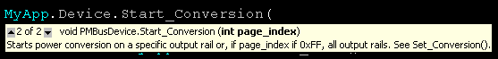

API Versioning
Assemblies named Com.Muegel.*, Free.*, and TIDP.* will have the same version number. The version is the same as the Fusion Digital Power Designer (aka Fusion GUI) build that the API was used for. For example, API version 1.6.85 will use the same API build that Fusion GUI 1.6.85 uses. Note that the Fusion GUI uses its own copy of the API. The Fusion GUI does not install these API files to the GAC. It copies the files to the GUI’s bin folder, using one of the distribution techniques described in section 7. You can install different versions of the Fusion GUI and Fusion API without impacting the other.
The GAC supports installing different versions of an assembly simultaneously. Fusion API assemblies are all digitally signed, and have “strong names” which include a version number. When an application that is compiled against the API runs, it will look for the version it was compiled against. You can therefore have different versions of the API installed on a single PC, and different applications installed which target different versions of the API.

Sample Code
Sample code is available under the Samples folder. Currently only .NET C# samples are provided. Open the solution Samples/Microsoft.NET/.Fusion API Samples:
- ConsoleSample1: this has a number of individual samples that perform common device tasks, including:
  - Writing to OPERATION.
  - Reading and displaying all parameters on a device.
  - Importing a project or data flash file.
  - Saving the state of a device to a project, text, or data flash file.
  - Doing a rudimentary test of over voltage warning/fault limits.
- ATMSystemGUISample: this is a graphical user interface (GUI) sample. It shows how you can access multiple devices through the API. In the example, up to 4 different Isolated controllers can be controlled. A plot of overall system input and output power is displayed. You must compile this project before you can open up MainForm due to custom user controls that are part of the project (ChartControl, PinChartControl, PoutChartControl, and ControllerControl).
Compiled versions of each sample is in the Bin folder. ConsoleSample1 should be run from the command line. It accepts an argument to specify which smaller sub-sample to run:
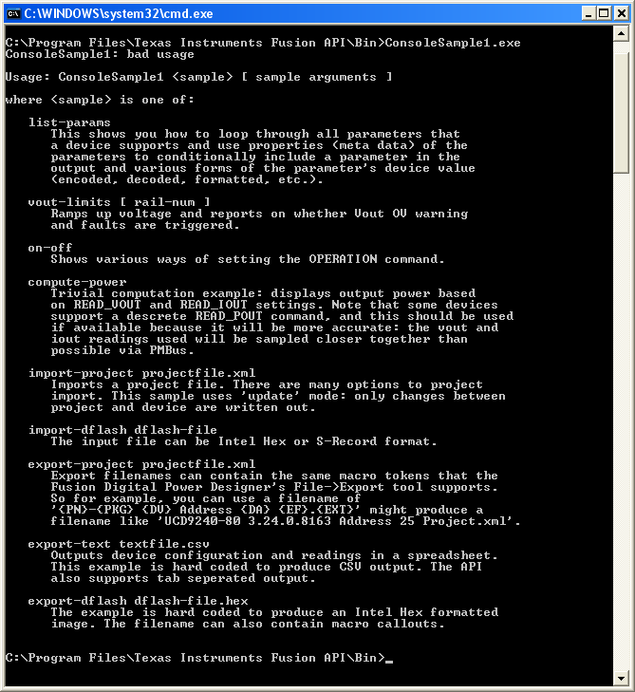
Todo: create sample using TIDP.PMBus.ParameterControls and ParameterControlManager to provide simple editing/display interface to sample commands similar to Fusion GUI.
Samples can be opened with Visual Studio 2008+ or Visual C# 2008 Express Edition. C# Express is free and can be downloaded from Microsoft.

Developing Graphical Applications in Microsoft.NET
If you create graphical applications using any of the API’s WinForms controls, widgets, or forms, you must purchase a license of DXperience WinForms. This is a commercial user interface toolkit that the Fusion Digital Power Designer software is built on. For example, the ATMSystemGUISample makes heavy use of these components. The Fusion API is coded against version 6.2.6 of DXperience. You can install newer versions of DXperience, because the Fusion API comes bundled with 6.2.6 libraries and installs them in the GAC.
We do not recommend you mix and match 6.2.6 controls and newer DXperience controls in your application. Doing so will dramatically increase the memory footprint of your application, because 6.2.6 and newer versions of the same control will be used and loaded.
How do you know whether you are using only 6.2.6 assemblies? Review the references for your project. For example, the ATMSystemGUISample:
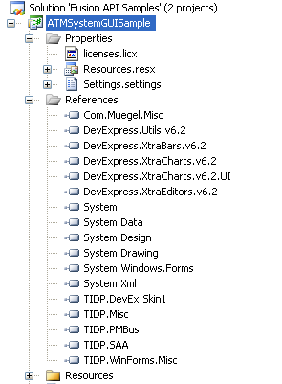
You do not have to use the Developer Express toolkit to develop graphical PMBus applications using the Fusion API. All of the non-UI APIs can be used to drive a custom UI you develop using any UI toolkit, including Microsoft’s Windows Presentation Foundation (WPF) UI toolkit that is part of .NET 3.0. Simply remove references to DevExpress.* from your project and follow the examples in the ConsoleSample1 sample project.

Using the API In a Microsoft.NET Project
How to start from scratch: adding references

Distributing Your Application / Library
You must distribute the support libraries that your application uses. There are three approaches you can take:
- Copy all of the assemblies to the same folder where your application lives. The .NET runtime will automatically look for the assemblies an EXE depends on in the same folder as the EXE. This is dubed “side by side” execution. This is the technique that the Fusion team uses to distribute its applications.
- Distribute the API installer. Run this on target PCs. This will copy the Fusion API assemblies to the Global Assembly Cache (GAC). Then just copy your application files.
- If you are using a setup creator such as Install Shield or Inno Setup to create an installer for your application, have it install the API’s files to the GAC. Consult your installer documentation for assistance. Note that Inno Setup 3.5, in Beta as of May 9 2009, supports copying files to the GAC.
If you will be distributing a number of applications, especially in the case of “console” programs, then (2) may be easiest. Then you can just send updates to your exes as needed. But (1) is also very easy and appropriate for simple GUIs. Just copy the Library .dll files to the same directory that your exe is in. Then ZIP this up.
Currently non-graphical (console) programs and libraries require certain Developer Express and TI UI oriented assemblies to run. While we hope to remove these dependencies in the future, you currently need to copy some core UI assemblies to your target PC even for simple console programs.
For most non-WinForms applications or libraries, the following assemblies will need to be copied to your target PCs:
- Com.Muegel.Misc.dll
- DevExpress.Utils.v6.2.dll
- DevExpress.XtraEditors.v6.2.dll
- Free.Hid.dll
- Free.LinqBridge.dll
- Free.Misc.dll
- TIDP.Misc.dll
- TIDP.PMBus.dll
- TIDP.SAA.dll
- TIDP.WinForms.Misc.dll
- TIDP.WinForms.Util.dll
Note that DevExpress.*.Designer.dll files never need to be distributed with your application. These are design time assemblies used when designing your user interface with Visual Studio.

Using the API in Other Environments

MATLAB
While MATLAB 2009 supports using .NET assemblies from MATLAB, MATLAB 2009a does not support several key features that the API uses. According to MATLAB documentation, the following are not supported:
- Creating an instance of a nested class. This would impact several data import and export features that make sure of inner classes to define options. Static convenience methods are available in many instances, however, that would get around this limitation.
- Invoking generic methods. The API makes heavy uses of generics to provide strongly typed properties and methods for each command “class.” Without testing, it is not possible to know whether this limitation means you can not use a class that is generic or sub-classes from a generic class, or simply can not invoke a method that is generic, such as Foo<TBar>(“hello world”). The later is generally not used in the API that end-customers would use.
- Non-Int32 underlying types for enumerations. Some samples show enumerating over a PAGE object that represents a rail on a device. You can use equivalent for (page_i = 0; page_i < Device.Num_Outputs; page_i++) instead.
The MATLAB documentation has instructions on using a .NET library. The installer installs the API’s .NET assemblies into the Global Assembly Cache (GAC). Follow the instructions for registering a “global” assembly. For example:
NET.addAssembly(‘TIDP.PMBus’);
To Do: Test, provide simple example.

