**Implementation of Personal Fitness Tracker**

**using Python**

A Project Report

submitted in partial fulfillment of the requirements

of

AICTE Internship on AI: Transformative Learning

with

TechSaksham – A joint CSR initiative of Microsoft & SAP

by

**Sabarinathan S, sk93629611@gmail.com**

Under the Guidance of

**Pavan Kumar**

**ACKNOWLEDGEMENT**

I would like to take this opportunity to express my sincere gratitude to my guide “Pavan Kumar”, for their valuable support, mentorship, and encouragement throughout the duration of this project. Their insights and guidance have been instrumental in shaping this work and enhancing my technical skills. I also extend my thanks to AICTE and the TechSaksham initiative for providing me with the opportunity to work on this project and for fostering an environment of innovation and learning. Finally, I am grateful to my family and friends for their unwavering support and encouragement.

It will very useful for my future enhancement and learn something new ideas of project which would improve my skills.

#### **ABSTRACT**

Many individuals face challenges in setting, tracking, and achieving their fitness goals due to the lack of accessible and personalized tools. Current fitness applications provide data in a generic manner, failing to cater to individual user preferences, fitness levels, or health conditions. This results in a lack of motivation and adherence to fitness plans.

This project proposes a **Personal Fitness Tracker** using Python and Machine Learning to address the gap in personalized fitness tracking. The system collects user data, including fitness goals, activity levels, and preferences, as well as data from wearable devices such as steps and heart rate. Machine learning algorithms analyze this data to deliver personalized insights. Classification models suggest tailored workout plans, regression models predict calorie burn, and a recommendation system customizes activities to user needs.

The implementation involves data preprocessing, model training, and deploying the system to provide real-time recommendations. The system improves user engagement by offering individualized insights, fostering better adherence to fitness plans. This project demonstrates how advanced technologies can enhance personal health management and provide a scalable solution for fitness tracking.

**TABLE OF CONTENT**

**Abstract I**

**Chapter 1.**  **Introduction 1**

1.1 Problem Statement 1

1.2 Motivation 1

1.3 Objectives 2

1.4. Scope of the Project 2

**Chapter 2.**  **Literature Survey 3**

**Chapter 3.**  **Proposed Methodology**

**Chapter 4.**  **Implementation and Results**

**Chapter 5. Discussion and Conclusion**

**References**

**LIST OF FIGURES**

|  |  |  |
| --- | --- | --- |
| **Figure No.** | **Figure Caption** | **Page No.** |
|  |  |  |
|  |  |  |
|  |  |  |
|  |  |  |
|  |  |  |
|  |  |  |
|  |  |  |
|  |  |  |
|  |  |  |

**LIST OF TABLES**

|  |  |  |
| --- | --- | --- |
| **Table. No.** | **Table Caption** | **Page No.** |
| **1.** | **CHAPTER 1**  **Introduction** | **7** |
| **2.** | **CHAPTER 2**  **Literature Survey** | **8** |
| **3.** | **CHAPTER 3**  **Proposed Methodology** | **9** |
| **4.** | **CHAPTER 4**  **Implementation and Result** | **10** |
| **5.** | **CHAPTER 5**  **Discussion and Conclusion** | **11** |
| **6.** | **REFERENCES** | **12** |
|  |  |  |
|  |  |  |
|  |  |  |

**CHAPTER 1**

**Introduction**

* 1. **Problem Statement:**

Many individuals struggle to achieve their fitness goals due to the lack of personalized tracking systems. Existing fitness applications often present generic data without considering individual user needs, fitness levels, or health conditions. This lack of personalization reduces user engagement and adherence to fitness programs.

* 1. **Motivation:**

The motivation behind this project stems from the need for a more personalized and intelligent fitness tracking solution. By leveraging machine learning and data analytics, the system can provide tailored recommendations and insights, improving user adherence and making fitness journeys more accessible and effective.

* 1. **Objective:**
* To develop a personal fitness tracker using Python and machine learning.
* To collect and analyze user-specific data (fitness goals, activity levels, health metrics).
* To provide personalized workout plans using classification models.
* To predict calorie burn using regression models.
* To offer activity recommendations based on user preferences and progress
  1. **Scope of the Project:**
* Data collection from users and wearable devices (e.g., steps, heart rate).
* Implementation of machine learning models for classification and regression.
* Providing personalized fitness insights and recommendations.
* Future expansion to include dietary tracking and advanced analytics.

**CHAPTER 2**

**Literature Survey**

* 1. **Review relevant literature or previous work in this domain.**

Previous work in the domain of fitness tracking emphasizes the use of data analytics and machine learning to deliver insights. However, most existing solutions lack deep personalization. This project builds on prior research by implementing advanced algorithms for tailored recommendations and real-time predictions.

Existing models use general data for calorie estimation and workout suggestions. Our system integrates classification models to suggest workouts and regression models to predict calorie expenditure, enhancing personalization.

* 1. **Mention any existing models, techniques, or methodologies related to the problem.**

• **Regression Models:** Used to predict continuous values like calories burned. Linear Regression and Gradient Boosting are popular choices.

• **Recommendation Systems:** These systems suggest personalized activities using

based on similar users and user preferences.

• **Deep Learning Models:** Advanced models like Recurrent Neural Networks (RNN) and Convolutional Neural Networks (CNN) analyse complex data from wearable devices.

* 1. **Highlight the gaps or limitations in existing solutions and how your project will address them.**

• Most fitness trackers offer general recommendations without considering individual needs.

• Many platforms do not adapt to users' progress over time.

• Existing tools rarely provide instant insights using live data.

• Without personalized goals, users lose motivation to stick to their plans.

**CHAPTER 3**

**Proposed Methodology**

* 1. **System Design**

Data Collection:

* + - User information: age, weight, fitness goals.
    - Wearable device data: steps, heart rate.

Data Processing:

* Cleaning and normalizing data.
* Feature engineering for model inputs.

Model Development:

* Classification: Suggest personalized workout plans.
* Regression: Predict calorie burn.

System Deployment:

* Interactive Python-based interface for user input and output.
  1. **Requirement Specification**

Mention the tools and technologies required to implement the solution.

* + 1. **Hardware Requirements:**
* CPU: Intel i5 or higher
* RAM: 8GB or more
  + 1. **Software Requirements:**
* Python 3.x
* Libraries: scikit-learn, pandas, numpy, matplotlib

**CHAPTER 4**

**Implementation and Result**

* 1. **Snap Shots of Result:**
* **User Input Interface**: Collects user data and wearable device metrics.
* **Output Dashboard**: Displays personalized recommendations and calorie burn predictions.

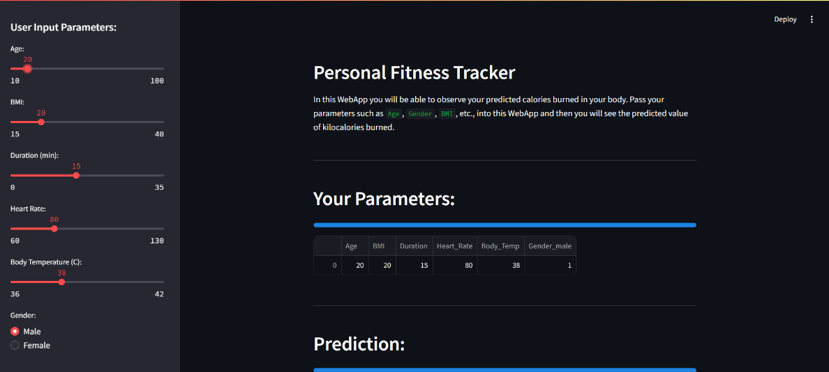

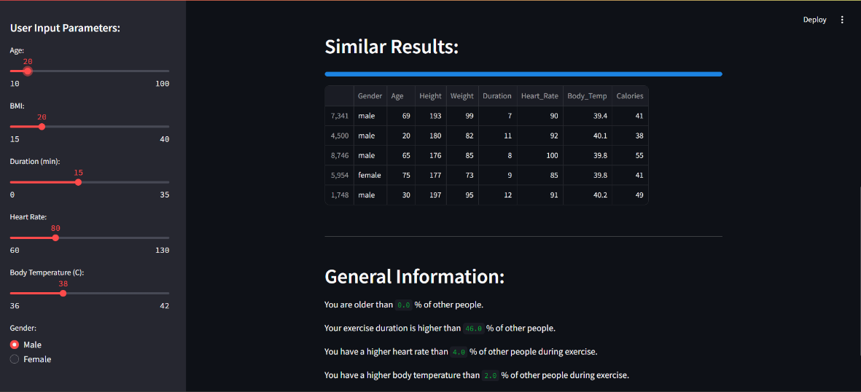

**4.2 GitHub Link for Code:**

**Personal Fitness Tracker using Python and Machine Learning**

**https://github.com/sabari128/Fitness_Tracker.git**

**CHAPTER 5**

**Discussion and Conclusion**

* 1. **Future Work:**
* Integrate real-time data streaming from wearable devices.
* Expand recommendation algorithms for dietary and lifestyle suggestions.
* Enhance the model for multi-user scalability and cloud deployment.

.

* 1. **Conclusion:**
* This project successfully implemented a **Personal Fitness Tracker** using Python and machine learning. It addresses the lack of personalization in existing fitness applications by providing tailored insights and actionable recommendations. The system improves user engagement and offers a scalable approach to personalized health management.
* Thank you for the wonderful opportunity to work with this project and gained some knowledge.

**REFERENCES**

1. Ming-Hsuan Yang, David J. Kriegman, Narendra Ahuja, “Detecting Faces in Images: A Survey”, IEEE Transactions on Pattern Analysis and Machine Intelligence, Volume. 24, No. 1, 2002.