SABARI.K. S
192472055
CO4-AT1

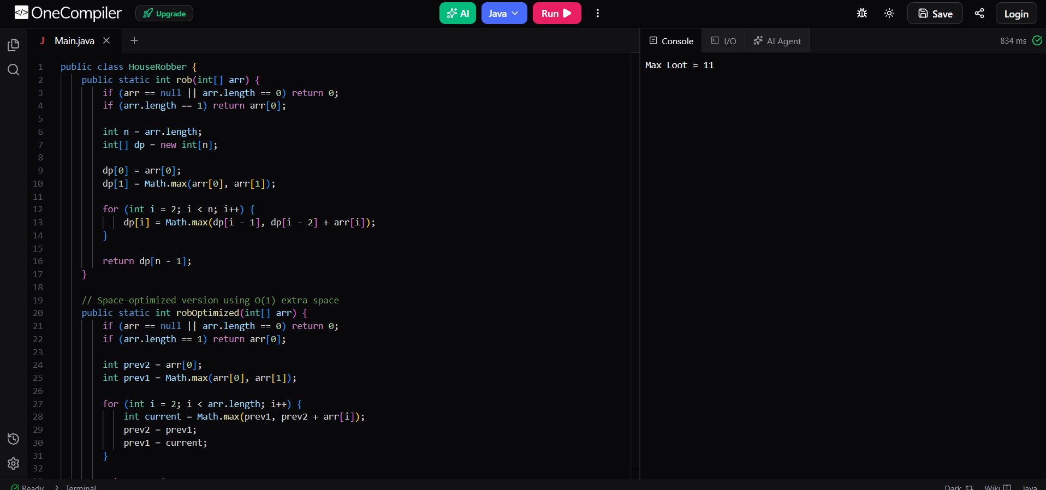

DP Definition & Recurrence Relation
Let $dp\left[i\right]$ represent the maximum amount of money that can be robbed from the first $i+1$ houses (indices $0$ to $i$).
- Base Cases:
  - $dp\left[0\right]=arr\left[0\right]$
  - $dp\left[1\right]=\max\left(arr\left[0\right],arr\left[1\right]\right)$
- Recurrence Relation (for $i≥2$):
$$dp\left[i\right]=\max\left(dp\left[i-1\right],dp\left[i-2\right]+arr\left[i\right]\right)$$
Step-by-Step Execution (Sample Input)
For $n=4$ and $arr=\left[2,7,9,3\right]$:
- $i=0$: $dp\left[0\right]=arr\left[0\right]=2$
- $i=1$: $dp\left[1\right]=\max\left(2,7\right)=7$
- $i=2$: $dp\left[2\right]=\max\left(dp\left[1\right],dp\left[0\right]+arr\left[2\right]\right)=\max\left(7,2+9\right)=11$
- $i=3$: $dp\left[3\right]=\max\left(dp\left[2\right],dp\left[1\right]+arr\left[3\right]\right)=\max\left(11,7+3\right)=11$
Max Loot: $dp\left[3\right]=11$

