Department of Computer Science and Engineering

Assignment Questions

Course Code & Name : CSA0609 –Design and Analysis of Algorithms

Assignment Information

Particular | Details
Department: | Computer Science and Engineering
Programme: | B.E/B.Tech-Computer Science and Engineering
Course Code & Course Name | CSA0609-Design and Analysis of Algorithms
Academic Year / Batch | 2026-Regular
Faculty Name | Dr.P.Solainayagi
Assignment Title | Analytical Study and Implementation of Brute Force Algorithms for Closest Pair and Convex Hull Problems
Date of Issue | 01-09-2026
Date of Submission | 02-09-2025
Maximum Marks | 100
Course Outcome(s) – CO | CO2: Apply Brute Force, Searching, Sorting, Closest Pair, Convex Hull.
Bloom's Taxonomy Level | L4 – Analyse; L5 – Evaluate; L6 – Create
SDG Mapping (SDG 1-17) | SDG 4 – Quality Education: Develops analytical thinking, programming, and computational problem-solving skills.  SDG 9 – Industry, Innovation and Infrastructure – Promotes innovation and development of computational techniques for solving real-world spatial and engineering problems.
Industry / Societal Relevance | Promotes innovation and development of computational techniques for solving real-world spatial and engineering problems.

Assignment Problem / Challenge
Given the set of 10 two-dimensional points (P={(2,3),(5,8),(9,4),(12,10),(7,2),(3,11),(15,6),(10,14),(6,12),(1,7)}), apply the Brute Force technique to solve the Closest Pair and Convex Hull problems. Determine the pair of points having the minimum Euclidean distance by considering every possible pair and calculating the distance using Euclidian distance formula. Analyze the calculations performed by both approaches and evaluate their efficiency as the number of points increases. For $n=10$, determine the number of pairwise distance comparisons and analyze the time and space complexity. Using the Brute Force technique, determine the Convex Hull of the same set of points by examining all possible candidate edges and checking the orientation/relationship of the remaining points. Identify all points that belong to the convex hull, show the major intermediate calculations, and provide a graphical representation of the points and the resulting hull. Develop a suitable Brute Force algorithm/pseudocode for the Convex Hull and analyze its time and space complexity. In particular, determine the number of candidate edges and explain the resulting complexity.

Requirements and Constraints
Use a publicly available real-world coordinate dataset with enough points to test different input sizes from (10³–10⁶ points). Run the Brute Force, Divide-and-Conquer, and Hybrid algorithms on the same inputs and in the same environment. Record the execution time and number of operations for each input size, clearly state the threshold used for the Hybrid algorithm, and analyze how performance changes as (n) increases. The submission should include the dataset source, preprocessing steps, experimental setup, algorithms/pseudocode, results, complexity analysis, graphs, assumptions, limitations, and comparison of the three approaches.

Student Work

Problem Understanding and Formulation

- Problem analysis
- Brute Force algorithm/pseudocode for both problems
- Step-by-step calculations
- Closest-pair result
- Convex Hull result
- Graphical representation of the points and Convex Hull
- Time and space complexity analysis
- Comparative analysis
- Final conclusion

Application of Course Knowledge

Identify and apply the relevant:

  - Principles
  - Theories
  - Mathematical models
  - Algorithms
  - Engineering concepts
  - Scientific concepts
  - Design methodologies

Show necessary calculations, derivations or reasoning.

Solution / Design / Methodology

Develop the proposed solution. Depending upon the nature of the course, this may include:

  - Design
  - Algorithm
  - Model
  - Circuit
  - Architecture
  - Experiment
  - Process
  - Prototype
  - Simulation
  - Case analysis
  - Data analysis
  - Mathematical solution

Where appropriate, consider more than one possible solution.

Use of Modern Tools

Use appropriate tools wherever relevant-Examples: Python, MATLAB, TensorFlow, cloud platforms, Git, simulation tools. Students shall provide appropriate evidence of tool usage and outputs.

Results and Validation

Present the results using appropriate:

  - Tables
  - Graphs
  - Simulation outputs
  - Experimental observations
  - Screenshots
  - Performance metrics
  - Statistical analysis
  - Test results

Validate whether the proposed solution satisfies the stated requirements.

Analysis and Engineering Decision

Interpret the results.

Where applicable:

  - Compare alternatives.
  - Identify advantages and limitations.
  - Discuss trade-offs.
  - Explain why the final solution was selected.
  - Justify the decision using quantitative or qualitative evidence.

Broader Considerations

Where relevant to the problem, discuss the impact of the proposed solution with respect to:
  - Sustainability
  - Environment
  - Society
  - Safety
  - Ethics
  - Economics
  - Accessibility

  - Professional responsibility

Conclusion

Summarize:
  - Proposed solution
  - Major findings
  - Achievement of requirements
  - Limitations
  - Possible improvements

Student Reflection

  - What did you learn from this assignment beyond what was directly taught in the classroom?
  - If you were given additional time/resources, what would you improve and why?

References

Use an appropriate citation format and acknowledge all external sources, datasets, standards, software and AI-assisted tools used.

Assessment Rubric

Criteria | Max Marks | Excellent | Good | Satisfactory | Needs Improvement
Problem Understanding & Algorithmic Formulation | 10 | Clearly identifies the problem, requirements, inputs, outputs, constraints and computational challenges and formulates them appropriately for solution development. | Problem and major requirements are correctly formulated with minor gaps. | Basic formulation is provided, but requirements or constraints are partially identified. | Problem is poorly understood or inadequately formulated.
Algorithmic Solution Design | 15 | Designs a clear, logical and feasible solution strategy with appropriate algorithmic techniques, pseudocode/flowchart and well-justified design decisions. | Appropriate solution design with minor gaps in logic, representation or justification. | Basic solution design is presented but lacks completeness or clear justification. | Solution design is inappropriate, incomplete or unclear.
Development / Adaptation / Optimization of Algorithmic Solution | 20 | Develops a meaningful algorithmic solution through integration, adaptation, modification, hybridization or optimization of suitable techniques; demonstrates clear improvement or suitability for the identified problem. | Develops an appropriate solution with meaningful adaptation or improvement, with minor limitations. | Solution demonstrates limited adaptation or development beyond standard implementation. | Merely reproduces an existing algorithm with little or no meaningful development or adaptation.
Implementation & Modern Tool Usage | 15 | Developed solution is correctly and efficiently implemented using appropriate programming/computational tools and handles relevant input conditions reliably. | Implementation is functional with minor logical or efficiency issues. | Core implementation works but contains limitations or incomplete functionality. | Implementation is incomplete, unreliable or non-functional.
Efficiency, Testing & Validation | 15 | Performs appropriate complexity evaluation and systematic testing using suitable data/input sizes; validates correctness, efficiency and scalability with clear evidence. | Complexity evaluation and testing are mostly appropriate with minor gaps. | Basic testing and efficiency evaluation are provided but lack sufficient validation. | Testing, complexity evaluation or validation is inadequate or substantially incorrect.
Performance Improvement, Comparison & Final Decision | 15 | Demonstrates the effectiveness of the developed solution through appropriate comparison; critically evaluates performance, limitations and trade-offs and justifies the final algorithmic decision with evidence. | Good performance comparison and justification with minor limitations. | Basic comparison is provided, but improvement or final justification lacks depth. | Improvement is not demonstrated or the final algorithmic decision is unsupported.
Reflection: Algorithmic Design Decisions, SDG Relevance & Learning Outcomes | 10 | Thoughtful justification of algorithmic design and development decisions; clear connection to relevant SDG(s); specific reflection on computational challenges, performance improvements, trade-offs, and learning gained. | Appropriate justification of algorithmic decisions; SDG relevance, challenges, improvements, and learning are discussed but lack depth. | Reflection is present but generic; limited justification of algorithmic decisions, improvements, SDG relevance, or learning outcomes. | No genuine reflection is provided, or the reflection lacks meaningful connection to algorithm development, SDG relevance, challenges, or learning outcomes.

Deliverables
To receive full credit, each submission must include the following deliverables:
- Pseudo code
- Implementation & Results
3. Github Upload
ANSWER – ANALYTICAL STUDY AND IMPLEMENTATION OF BRUTE FORCE ALGORITHMS

1.Problem Understanding and Formulation

The given input contains 10 two-dimensional points:
P = {(2,3), (5,8), (9,4), (12,10), (7,2), (3,11), (15,6), (10,14), (6,12), (1,7)}.
• Closest Pair: examine every possible unordered pair and calculate its Euclidean distance.
• Convex Hull: examine every candidate pair as a possible hull edge and use an orientation test on all remaining points.
• For n = 10, the number of unordered pairs and candidate edges is C(10,2) = 10×9/2 = 45.

2.Brute Force Closest-Pair Algorithm

BRUTE_FORCE_CLOSEST_PAIR(P, n)
minDist ← ∞
bestPair ← NIL
for i ← 1 to n-1
for j ← i+1 to n
dx ← x[i] − x[j]
dy ← y[i] − y[j]
d ← √(dx² + dy²)
if d < minDist
minDist ← d
bestPair ← (P[i], P[j])
return bestPair, minDist
Exactly n(n−1)/2 distance calculations are required because every unordered pair is examined once.

3.Step-by-Step Closest-Pair Calculations

All 45 pairs were considered. The ten smallest distances are shown below.
Pair | Coordinates | Δx, Δy | d² | d
P3–P5 | (9, 4) and (7, 2) | 2, 2 | 8 | 2.8284
P6–P9 | (3, 11) and (6, 12) | -3, -1 | 10 | 3.1623
P2–P6 | (5, 8) and (3, 11) | 2, -3 | 13 | 3.6056
P1–P10 | (2, 3) and (1, 7) | 1, -4 | 17 | 4.1231
P2–P9 | (5, 8) and (6, 12) | -1, -4 | 17 | 4.1231
P2–P10 | (5, 8) and (1, 7) | 4, 1 | 17 | 4.1231
P4–P8 | (12, 10) and (10, 14) | 2, -4 | 20 | 4.4721
P6–P10 | (3, 11) and (1, 7) | 2, 4 | 20 | 4.4721
P8–P9 | (10, 14) and (6, 12) | 4, 2 | 20 | 4.4721
P4–P7 | (12, 10) and (15, 6) | -3, 4 | 25 | 5.0000

Minimum distance pair: P1 = (2,3) and P5 = (7,2).

d(P1,P5) = √[(2−7)² + (3−2)²] = √(25+1) = √26 ≈ 5.0990 units.

4.Brute Force Convex Hull

The orientation of three points Pi, Pj and Pk is computed by:
Orientation(Pi,Pj,Pk) = (xj−xi)(yk−yi) − (yj−yi)(xk−xi).
If all remaining points have non-positive orientations or all have non-negative orientations with respect to a candidate edge, that edge can belong to the convex hull. Repeating this for all 45 candidate edges identifies the hull vertices.
BRUTE_FORCE_CONVEX_HULL(P, n)
H ← empty set
for i ← 1 to n−1
for j ← i+1 to n
positive ← false; negative ← false
for k ← 1 to n, k ≠ i,j
s ← Orientation(P[i], P[j], P[k])
if s > 0: positive ← true
if s < 0: negative ← true
if not (positive and negative)
add Pi and Pj to H
return H

5. Major Orientation Calculations

Orientation((1, 7), (2, 3), (7, 2)) = 19 (positive).
Orientation((2, 3), (7, 2), (15, 6)) = 28 (positive).
Orientation((7, 2), (15, 6), (10, 14)) = 84 (positive).
Orientation((15, 6), (10, 14), (3, 11)) = 71 (positive).
Orientation((10, 14), (3, 11), (1, 7)) = 22 (positive).
Orientation((3, 11), (1, 7), (2, 3)) = 12 (positive).

The convex-hull vertices, in cyclic order, are:

H = {(1,7), (2,3), (7,2), (15,6), (10,14), (3,11)}.

The remaining points {(5,8), (9,4), (12,10), (6,12)} lie inside the hull and therefore are not hull vertices.

6. Graphical Representation

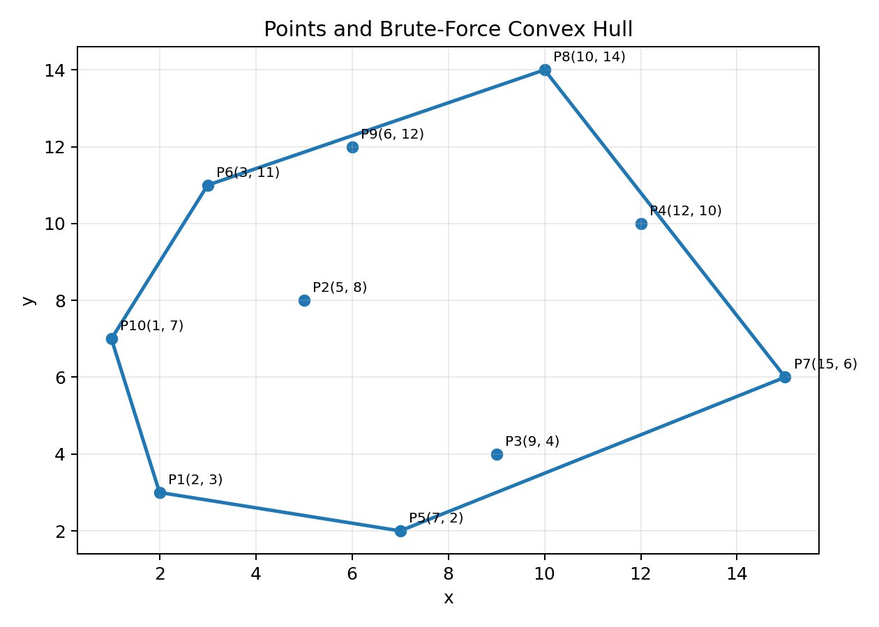
Figure 1. Given points and the resulting convex hull.

7. Time and Space Complexity

Problem | Main operations | Time complexity | Space complexity
Closest Pair | n(n−1)/2 distance comparisons | O(n²) | O(1) auxiliary
Convex Hull | C(n,2) candidate edges × (n−2) orientation tests | O(n³) | O(n) for hull/output storage
For n = 10, closest-pair comparisons = 10×9/2 = 45. For the brute-force hull, there are 45 candidate edges and at most 8 remaining points per edge, giving 45×8 = 360 orientation evaluations in the straightforward implementation.

8. Application of Course Knowledge

• Principle: exhaustive search evaluates every candidate before selecting the best valid result.
• Mathematical model: Euclidean distance and signed orientation/cross-product tests.
• Algorithm: nested loops for closest pair and triple nested loops for brute-force convex hull.
• Engineering concept: correctness is prioritized through complete enumeration, while scalability is evaluated using asymptotic complexity.
• Design methodology: define input, generate candidates, test candidates, retain valid/best candidates, and report the result.
9. Solution / Methodology

The solution follows four stages: (1) represent the points as coordinate pairs, (2) enumerate all candidate pairs, (3) compute either distance or orientation values, and (4) select the minimum-distance pair or collect hull vertices. The same input is used for both problems so that the algorithmic behavior can be compared directly.

10.Use of Modern Tools

Python can be used to implement the nested-loop algorithms, calculate distances and orientations, and generate the point/hull graph. Git/GitHub can be used to version the source code and preserve implementation evidence. The assignment itself requires appropriate evidence of tool usage and outputs.
11. Results and Validation

Closest-pair validation: the exhaustive search checks all 45 possible pairs; the minimum is √26 ≈ 5.0990 between (2,3) and (7,2).
Convex-hull validation: the orientation criterion identifies the six outer vertices (1,7), (2,3), (7,2), (15,6), (10,14), and (3,11). The plotted polygon encloses all ten input points.
Scalability: the number of closest-pair comparisons grows quadratically, while the straightforward brute-force convex-hull orientation testing grows cubically. Thus, exhaustive brute force becomes impractical much sooner as n increases.

12.Comparative Analysis

Approach | Closest Pair | Convex Hull | Observation
Brute Force | O(n²) | O(n³) | Simple and easy to verify, but poor scalability.
Divide-and-Conquer | O(n log n) | Typically O(n log n) | Much better for large datasets, but more complex.
Hybrid | Can combine efficient algorithm with brute force below a threshold | Can use a small brute-force base case | Balances implementation complexity and practical performance.
For a hybrid implementation, a reasonable small-input threshold is 32 points: use brute force for subproblems of size ≤32 and the divide-and-conquer method above that threshold. The exact threshold should be tuned experimentally for the chosen hardware and implementation.

13. Broader Considerations

• Sustainability: efficient algorithms reduce CPU time and energy consumption when processing large coordinate datasets.
• Society and accessibility: geometric algorithms support applications such as mapping, logistics, spatial analysis and engineering design.
• Economics: improved scalability can reduce computational infrastructure and processing costs.
• Professional responsibility: results should be reproducible, assumptions documented, and external datasets/software properly acknowledged.

14. Conclusion

The brute-force closest-pair method examines all 45 point pairs and finds the minimum-distance pair P1=(2,3) and P5=(7,2), with distance √26 ≈ 5.0990. The brute-force convex-hull method examines candidate edges using orientation tests and produces the hull vertices {(1,7), (2,3), (7,2), (15,6), (10,14), (3,11)}. The study demonstrates that brute force is transparent and reliable for small inputs, but its O(n²) and O(n³) growth makes divide-and-conquer or hybrid approaches preferable for large datasets.

15. Student Reflection

This assignment strengthened my understanding of how a simple exhaustive-search strategy can be converted into a formally analyzable algorithm. Beyond classroom examples, I learned to distinguish candidate generation from candidate validation, use the cross product as a geometric predicate, and connect the number of operations directly to asymptotic complexity. I also learned that a correct algorithm may still be unsuitable for large inputs when its growth rate is high.
With additional time and resources, I would implement and benchmark the brute-force, divide-and-conquer and hybrid methods on a public coordinate dataset at input sizes from 10³ to 10⁶ points, record execution time and operation counts in the same environment, and tune the hybrid threshold experimentally. This would provide stronger empirical evidence in addition to the theoretical analysis.

16. References

1. Course assignment specification: CSA0609 – Design and Analysis of Algorithms, Department of Computer Science and Engineering, supplied assignment document.
2. Standard Euclidean distance formula and planar orientation/cross-product formulation used in computational geometry.
3. Python documentation and Git/GitHub documentation may be cited in the final submission if those tools are used for implementation.

