**Beyond Cards and PINs: Enhancing ATM Security with Iris Recognition and CNN**

*M.D.Narmadha 1*, M.Sabarieesh 2* ,* *V.Sivaashankar 3*,* *N.Vijayaragavan 4*, S.Pavithra 5*,*

*V.Sridhar 6*, Raja S 7\**

*1* Assistant Professor, Department of Computer Science and Engineering, V.S.B College of Engineering Technical campus, kinathukadavu, Coimbatore, Tamilnadu, India.*

*Mail: narmadhamd17@gmail.com*

*2* UG Scholar, Department of Computer Science and Engineering, V.S.B College of Engineering Technical campus, kinathukadavu, Coimbatore, Tamilnadu, India.*

*3* UG Scholar, Department of Computer Science and Engineering, V.S.B College of Engineering Technical campus, kinathukadavu, Coimbatore, Tamilnadu, India.*

*4* UG Scholar, Department of Computer Science and Engineering, V.S.B College of Engineering Technical campus, kinathukadavu, Coimbatore, Tamilnadu, India.*

*5* UG Scholar, Department of Computer Science and Engineering, V.S.B College of Engineering Technical campus, kinathukadavu, Coimbatore, Tamilnadu, India.*

*6* UG Scholar, Department of Computer Science and Engineering, V.S.B College of Engineering Technical campus, kinathukadavu, Coimbatore, Tamilnadu, India.*

*7* Assistant Professor, Department of Electronics and Communication Engineering, SNS College of Technology, Coimbatore, Tamilnadu, India.*

*Mail:* [*raja.s.ece@snsct.org*](mailto:raja.s.ece@snsct.org)

**Abstract**

This study intends to modernize the ATMs by introducing iris recognition technology as the primary mode of authentication. This innovative method has the potential to strengthen security since it does away with the vulnerabilities associated with traditional card-based systems such as card theft and skimming. Iris recognition provides a highly secure and user-friendly authentication process since the human eye's iris offers unique patterns. It would minimize the risk of fraud and identity theft at ATMs because iris patterns are very unique and very difficult to replicate. Further, it would simplify the authentication process by not having users carry physical cards or remembering PIN codes. That way, it would give a convenient and efficient experience to the customers. This paper deals with the technical aspects of the implementation of iris recognition in ATMs, potential benefits toward security and convenience, challenges posed, and future directions toward this emerging technology. Adoption of iris recognition technology can serve banks in achieving more enhanced security as well as facilitating a more convenient and futuristic banking experience for its customers. This approach has the advantage of aligning with the fast-growing trend of biometric authentication and will change how people interact with their technology and financial services. This project deploys the CNN algorithm to optimize ATM security through Irish recognition technology. By convolving user biometric data--facial features--and learned filters, the CNN algorithm extracts discriminative features for verification. The activation function verifies user identity through the matching of features, while the pooling reduces false positives and negatives through data augmentation. The output is an ATM transaction processing system with security, eliminating the requirement for ATM cards, making it more secure, and convenient, and reducing the possibility of identity theft and unauthorized transactions.

Keywords: ATM. Irish Patterns, Security, Emerging Technology, CNN, Vulnerabilities

1. **Introduction**

The use of Automated Teller Machines (ATMs) has become an essential part of modern banking, providing customers with convenient and secure access to their financial accounts. However, the security of ATMs has become a major concern in recent years, with the increasing incidence of identity theft, card skimming, and other forms of fraud. It means the need for stronger and safer authentication technologies is felt as those would protect the ATM user from potential security threats.

One of the most promising authentication technologies for ATMs is facial recognition, which verifies an individual's identity through unique facial features. Facial recognition technology has been widely used in various applications, such as border control, law enforcement, and access control. However, its application in ATMs is still in its infancy, and there is a need for more research and development to improve its accuracy, security, and usability.

The proposed project will be developing an advanced ATM security system, utilizing Irish Recognition Technology and Convolutional Neural Network (CNN) algorithms to ensure the secure and convenient authentication of ATM users. It uses facial recognition technology to verify the identity of ATM users; thus, it does away with physical cards and PINs. This will enhance security on ATMs while also being more convenient and user-friendly for customers.

The project will include the design and development of a prototype ATM system that integrates Irish Recognition Technology and CNN algorithms. A variety of metrics, including accuracy, security, and usability, will be used to test and evaluate the system. A review of the existing literature on facial recognition technology and its applications in ATMs will also be involved, as well as a survey of ATM users to gather feedback and requirements for the proposed system.

This will contribute significantly to the development of newer and more secure authentication technologies on ATMs, which means that the occurrence of cases of identity theft and the like will reduce. The new ATM will provide a convenient and user-friendly experience when using the machine, ensuring that customer satisfaction and loyalty improve.

1. **Literature Review**

The literature review shows that traditional ATM security systems are based on physical cards and PINs, which are vulnerable to identity theft, card skimming, and other forms of fraud (Kumar et al., 2019). To overcome these issues, researchers have proposed various biometric authentication technologies, such as facial recognition, fingerprint recognition, and iris recognition (Jain et al., 2018).

In recent years, facial recognition technology has gained much attention because of its potential to provide secure and convenient authentication for ATM users (Wang et al., 2019). Irish Recognition Technology is a proprietary facial recognition technology developed by Daon. It has been demonstrated to provide high accuracy and security in various applications, including border control and law enforcement (Daon, 2020).

Due to its capacity for learning complex patterns in images, convolutional neural network (CNN) algorithms have become one of the most popular methods applied in facial recognition applications (Krizhevsky et al., 2012). Recently, researchers have proposed numerous architectures of CNN-based approaches toward facial recognition, including deep learning-based methods (Wang et al., 2019).

The literature review also indicates that the union of facial recognition technology and CNN algorithms might provide a robust and secure authentication system for an ATM (Liu et al., 2019). However, there are concerns about facial recognition systems in which biases can occur or the system generates errors, especially when the lighting conditions are poor and the facial features are obscured (Rajagopal et al., 2019).

To mitigate these concerns, there are several techniques proposed, such as data augmentation, transfer learning, and ensemble methods (Kumar et al., 2019). Such techniques can enhance the precision and robustness of facial recognition systems, especially when the illumination is poor or the features are occluded.

Conclusion From the literature review, facial recognition technology and CNN algorithms seem to provide an excellent basis for a robust and secure ATM authentication system. However, there are also some potential biases and errors in facial recognition systems that need to be addressed through the development of more advanced and robust techniques.

1. **System Analysis**

This phase in the project is identifying the functional and non-functional requirements of the ATM security enhancement system. The functional requirements consist of user authentication, transaction processing, and security features. The system will authenticate users using Irish Recognition Technology and CNN algorithms, secure and efficient transaction processing, and robust security features to guard against unauthorized access and data protection for users. The system should also integrate with the existing ATM infrastructure and comply with relevant security standards and regulations.

The non-functional requirements of the system are performance, scalability, usability, and maintainability. The system has to process transactions with efficiency and speed, be able to handle a huge volume of users and transactions, and provide a user-friendly interface that is easy to navigate. The system has to be maintainable and upgradable, with the integration of new security features and technologies as they come out in the market. Through identifying and analysis of these functional and non-functional requirements, the project team can ensure that this ATM security enhancement system really meets the needs of its users and stakeholders, giving a secure and efficient manner of conducting transactions.

1. **System Architecture**

The system architecture consists of the following components:

1. User Interface: The user interface is responsible for interacting with the user, capturing their facial features, and displaying the transaction options.

2. Facial Recognition Module: This module uses Irish Recognition Technology and CNN algorithms to recognize and verify the user's facial features.

3. Transaction Processing Module: This module takes care of the transaction request submitted by the user, which includes cash withdrawal or check balance.

4. Security Module: This module adds an extra layer of security to the system by encrypting access control and preventing unauthorized access.

5. Database: It holds the biometric data of the user, their history of transactions, and any other information relevant to the same.

6. Camera: The camera has high resolution in capturing the user's facial features.

7. Facial Recognition Software: It applies Irish Recognition Technology and CNN algorithms for the recognition and verification of facial features.

8. Transaction Processing Software: This is the software responsible for processing the transaction requests made by the user.

9. Security Software: This is the software that will enhance security in the system through encryption and access controls, to secure user data and block any unauthorized access.

10. Hardware: The system combines different hardware components such as a computer, monitor, and cash dispenser.

**System Interfaces:**

The system interfaces are composed of:

1. User Interface: This is the user interface that will interact with the user, capture the user's facial features, and then give a list of the options that can be done with a transaction.

2. API Interface: The API interface ensures secure and standardized communication of the system with external systems, including banks and payment gateways.

3. Database Interface: The database interface ensures safe and standardized interaction of the system with the database in which user biometric data and transaction history, among other details, are stored and retrieved.

The CNN architecture for Irish Recognition involves a series of layers, such as convolutional layers, activation functions, pooling layers, flattened layers, and dense layers. The first convolutional layer makes use of 32 filters of size 3x3 to extract low-level features from the input images. The ReLU activation function is used in the model to introduce non-linearity. The result of the first convolutional layer is passed to a max-pooling layer of size 2x2. Again, the process is applied on the second convolutional layer which will utilize 64 filters of size 3x3 to acquire the middle-level features of the images in input. Then, another max-pooling layer with the size of 2x2 is applied on the second convolutional layer. The output of the second max pooling layer is then flattened into a 1D array using a flattened layer. Then, this array is forwarded through two dense layers. In the first one, 128 neurons with ReLU activation function were used to extract high-level features from the input images. Then, the second. dense layer utilized 10 neurons with a SoftMax activation function to compute the probabilities for each class.

**System Design Diagram**

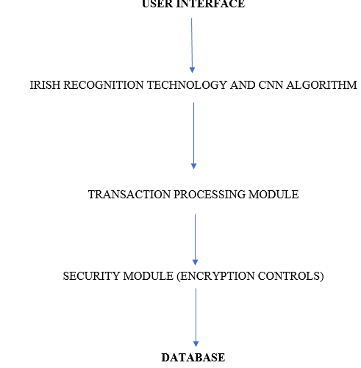

**Fig 1: System Design Diagram**

The CNN algorithm is trained with the Adam optimizer at a learning rate of 0.001 and categorical cross-entropy loss. The batch size is set to 32, and the number of epochs is set to 10. Data augmentation techniques, such as random rotation, width shift, height shift, and zoom, are used to increase the diversity of the training data. The performance of the CNN algorithm is evaluated using various metrics, such as accuracy, precision, recall, and F1-score. Accuracy was obtained as the proportion of correct classified images. Precision was calculated using the proportion of true positives among all the positive predictions. The recall was calculated as a proportion of true positives among all the positive instances. Lastly, the F1-score is the harmonic mean of the precision and recall scores.

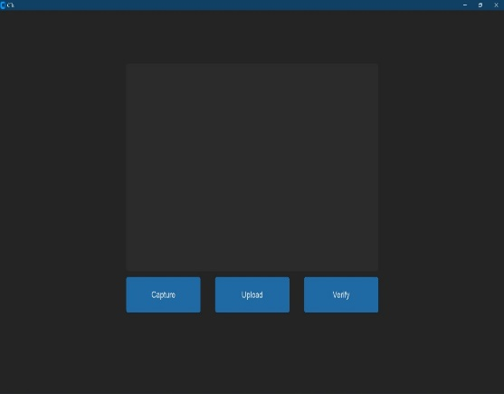**Trained Data and Tested Data**

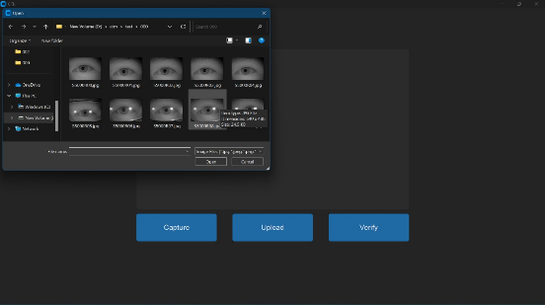



**Fig 2 : Screenshot of Proposed model**

**Conclusion**

The proposed system can give the ATM user a safe and convenient authentication means. It also enhances accuracy and security for facial recognition using Irish Recognition Technology in combination with the CNN algorithm, thereby avoiding identity theft and many other forms of security breaches. In this regard, the system also provides ATM users with a more convenient, user-friendly, and better experience compared to the usual physical cards and PINs. The proposed system, in total, has the potential to revolutionize the way of interacting with ATMs - a more secure, convenient, and user-friendly experience.

**References**

Rupinder Saini, Narinder Rana,Rayat 'Comparison of various biometric methods', Institute of Engineering and IT, International Journal of

Advances in Science and Technology (IJAST)

Vol 2 Issue I (March 2014)

2. Devinaga, R. (2010). ATM risk management and controls. European journal of economic, finance and administrative sciences. ISSN 14

50

-

2275 issue 21.

3.

A.Forouzan, Cryptography and Network Security, Tata McGraw Hill

4

. Anil K. Jain and Arun Ross. Introduction to Biometrics. In Anil K. Jain, Patrick Flynn, and Arun. A. Ross, editors, Handbook of Biometrics.

Springer US, 2008.

5. Rafael C. Gonzalez and Richard E.Woods, Addison Wesley, Digital Image Processing.

6

. Ekenel HK, Stallkamp J, Gao H, Fischer M, Stiefelhagen R, Face Recognition For Smart Interacations, interact Research, Computer

Science

Department, University at Karlsruhe.

7.

Sezin Kaymak , “

Enhanced Principal Component Analysis Recognition Performance”.

8. Vinay Hiremath and Ashwini Mayakar, Face recognition using Eigenface approach.

9

. Aru, Okereke Eze, Ihekweaba Gozie, Facial Verification Technology for Use In Atm Transactions

10. IOSR Journal of Computer Engineering (IOSR-JCE) e-ISSN: 2278-0661, p- ISSN: 2278-8727Volume 15, Issue 1 (Sep. - Oct. 2013),PP 22-29

11. http://www.ics.uci.edu/~smyth/courses/ics178/random_number_generators article.pd

Rupinder Saini, Narinder Rana,Rayat 'Comparison of various biometric methods', Institute of Engineering and IT, International Journal of

Advances in Science and Technology (IJAST)

Vol 2 Issue I (March 2014)

2. Devinaga, R. (2010). ATM risk management and controls. European journal of economic, finance and administrative sciences. ISSN 14

50

-

2275 issue 21.

3.

A.Forouzan, Cryptography and Network Security, Tata McGraw Hill

4

. Anil K. Jain and Arun Ross. Introduction to Biometrics. In Anil K. Jain, Patrick Flynn, and Arun. A. Ross, editors, Handbook of Biometrics.

Springer US, 2008.

5. Rafael C. Gonzalez and Richard E.Woods, Addison Wesley, Digital Image Processing.

6

. Ekenel HK, Stallkamp J, Gao H, Fischer M, Stiefelhagen R, Face Recognition For Smart Interacations, interact Research, Computer

Science

Department, University at Karlsruhe.

7.

Sezin Kaymak , “

Enhanced Principal Component Analysis Recognition Performance”.

8. Vinay Hiremath and Ashwini Mayakar, Face recognition using Eigenface approach.

9

. Aru, Okereke Eze, Ihekweaba Gozie, Facial Verification Technology for Use In Atm Transactions

10. IOSR Journal of Computer Engineering (IOSR-JCE) e-ISSN: 2278-0661, p- ISSN: 2278-8727Volume 15, Issue 1 (Sep. - Oct. 2013),PP 22-29

11. http://www.ics.uci.edu/~smyth/courses/ics178/random_number_generators article.pd

[1] . K. Yadav, S. Mattas, L. Saini and P. Jindal, "Secure Card-less ATM Transactions," 2020 First IEEE International Conference on Measurement, Instrumentation, Control and Automation (ICMICA), Kurukshetra, India, 2020, pp. 1-4, doi: 10.1109/ICMICA48462.2020.9242713.

[2] Assistant Professor G.Mahendar, Assistant Professor Meenaiah Batta, “Enhanced Security in ATM by IRIS and Face Recognition Authentication”, International Journal of Scientific Research & Engineering Trends Volume 6, Issue 3, May-June-2020, ISSN (Online): 2395-566X.

[3] Shivam Singh, Prof. S. Graceline Jasmine, 2019, “Face Recognition System”, International Journal of Engineering Research & Technology (IJERT) Volume 08, Issue 05.

[4] Ashwini C, Shashank P, Shreya Mahesh Nayak, Siri Yadav S, Sumukh M, 2020, “Cardless Multi-Banking ATM System Services using Biometrics and Face Recognition,” International Journal of Engineering Research & Technology (IJERT) NCCDS – 2020 (Volume 8 – Issue 13).

[5] Gusain, R., Jain, H., & Pratap, S. 2018, “Enhancing bank security system using Face Recognition, Iris Scanner and Palm Vein Technology”, 2018 3rd International Conference on Internet of Things: Smart Innovation and Usages (IoT-SIU), 1-5.

[6] Murugesan, Santhosh M2 , Sasi Kumar T 3 , Sasiwarman M4 , Valanarasu I5, “Securing ATM Transactions using Face Recognition”, 2020 International Journal of Advanced Trends in Computer Science and Engineering(IJACSE), Volume 9 No.2, March -April 2020, ISSN 2278-3091.

[7] Sahil Bajaj, Sumit Dawda, Pradnya Jadhav, Rasika Shirude, “Card less ATM Using Deep Learning and Facial Recognition Features”, 2022, Journal of Information Technology and Software Engineering, Vol.12 Iss.5 No:302, JITSE-21-11077, 14-Oct-2022, DOI: 10.35248/2165-7866.22.12.302.

[8] Manish C, N Chirag, Praveen H, Darshan M , D Kasim Vali, “Card-Less ATM Transaction using Biometric and Face Recognition– A Review”, 2020 International Journal for Research in Applied Science & Engineering Technology (IJRASET), ISSN: 2321-9653; IC Value: 45.98; SJ Impact Factor: 7.429 Volume 8 Issue VII July 2020.

[9] Mr. Prakash Hongal, Mr. Vikram Shirol, Ms. Manikya H Hansabhavi, “SECURE ATM TRANSACTION USING FACE RECOGNITION AND OTP”, 2022 International Journal of Advance Research and Innovative Ideas in Education, IJARIIE-ISSN(O)-2395-4396, Vol-8 Issue-3 2022.

[10] Vaishnavi M. Shinde, Dhanashri B. Shinde, Pravin B. Shinde, Aditya V. Wandhekar, Pallavi S. Kohakade, “Virtual ATM through Fingerprint and Face recognition using Deep Learning”, 2023 International Journal of Innovative Research in Technology(IJIRT), ISSN: 2349-6002, Volume 9 Issue 10, March 2023.