**WEBSITE TRAFFIC ANALYSIS**

**Development part - 2**

|  |  |
| --- | --- |
| **Date** | **26-10-2023** |
| **Team ID** | **497** |
| **Project Name** | **6112 - Website Traffic Analysis** |

**Table of Contents:**

|  |  |
| --- | --- |
| 1. | Problem Statement |
| 2. | Data Visualization using Python |
| 3. | Data Visualization using IBM Cognos |
| 4. | Conclusion |

**1.Problem statement:**

In today’s digital landscape, businesses and website owners face the challenge of effectively understanding and leveraging their web traffic data to optimize their online presence and achieve their goals. The problem lies in the complexity of modern websites, the vast amount of data generated by users, and the need to turn this data into actionable insights. Key issues include identifying traffic sources, improving user engagement, reducing bounce rates, and enhancing conversion rates. Additionally, ensuring compliance with data privacy regulations adds a layer of complexity to web traffic analysis. To succeed in the online marketplace, businesses need a robust and efficient web traffic analysis solution that addresses these challenges, enabling them to make data-driven decisions, enhance user experiences, and meet their objectives.

**2.Data Visualization using Python:**

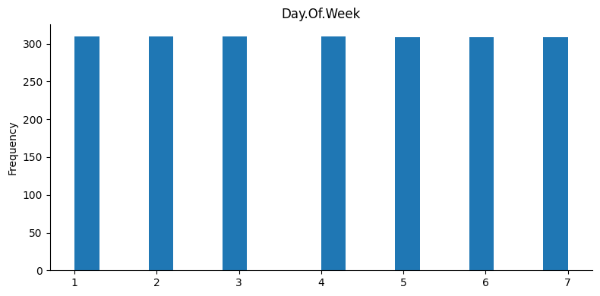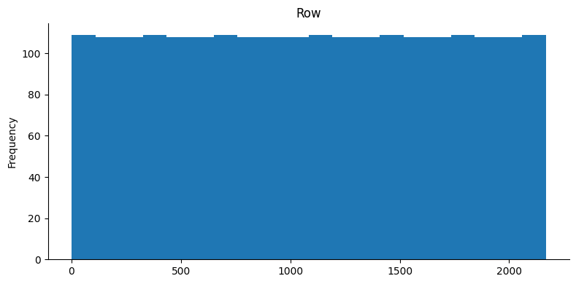

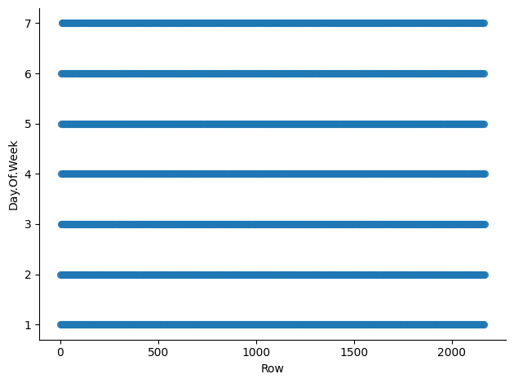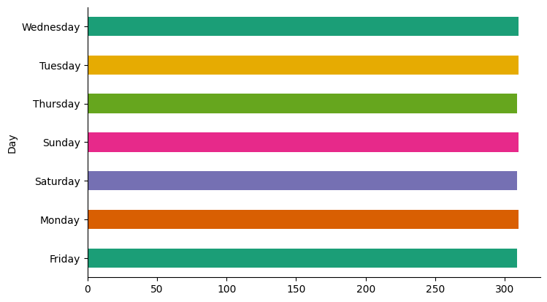

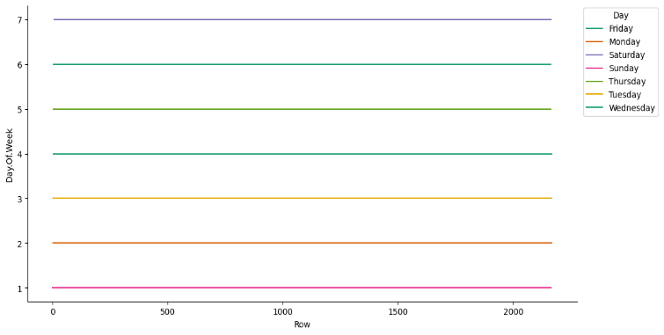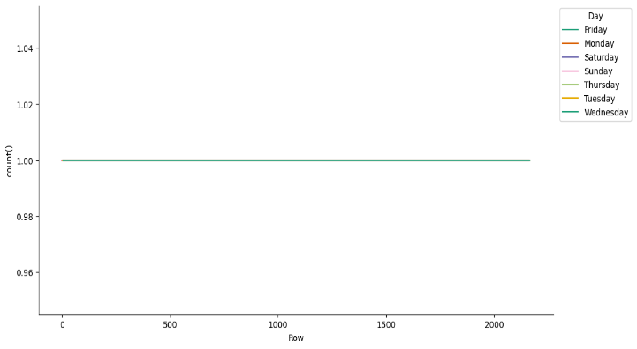

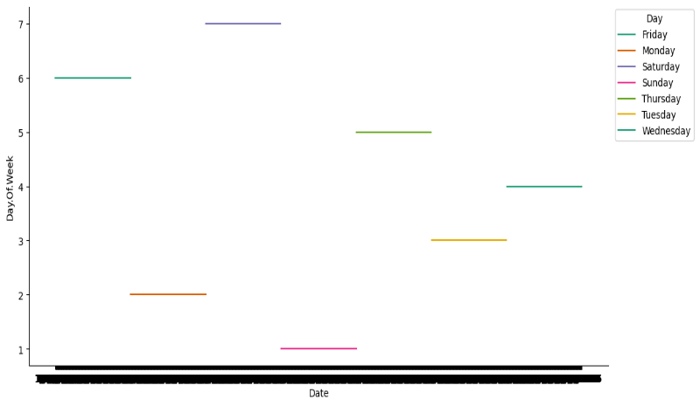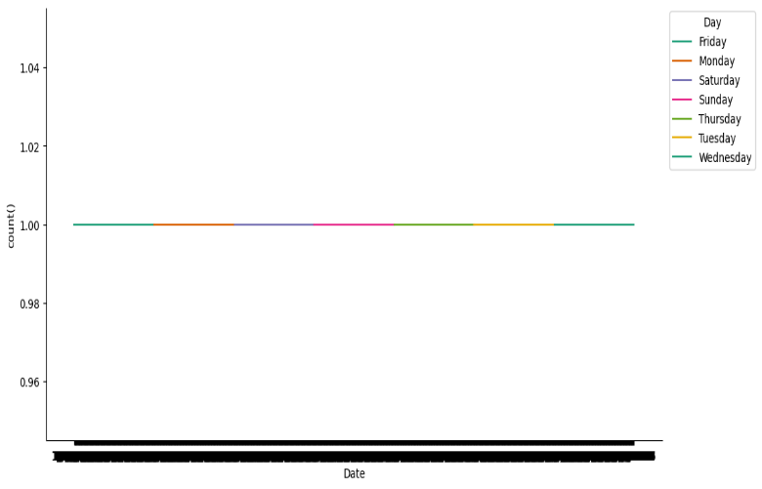

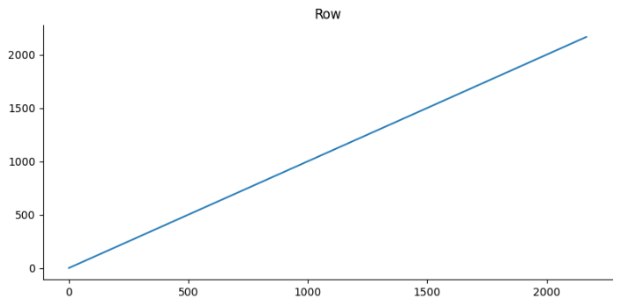

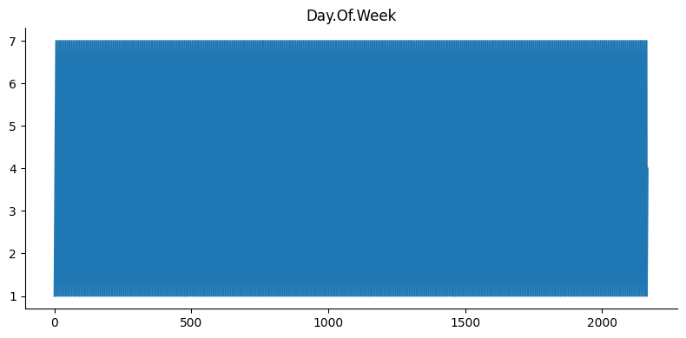

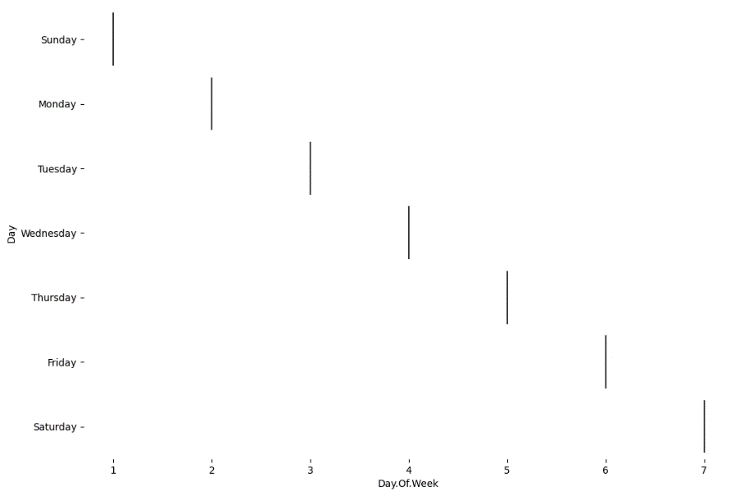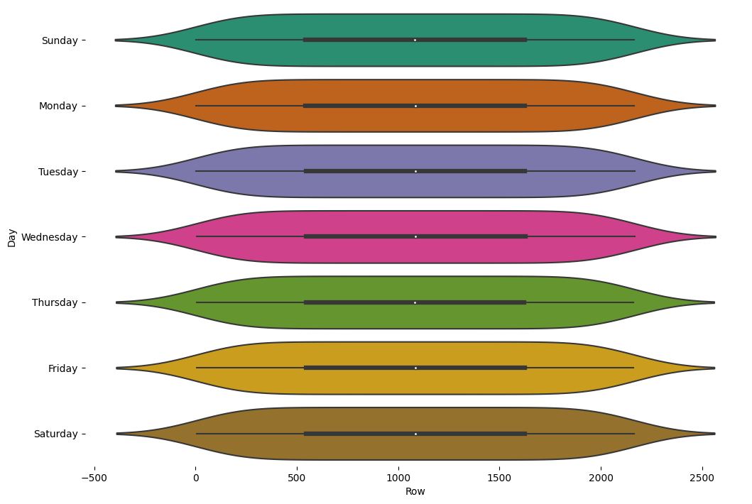

**3.Data visualization using IBM Cognos:**

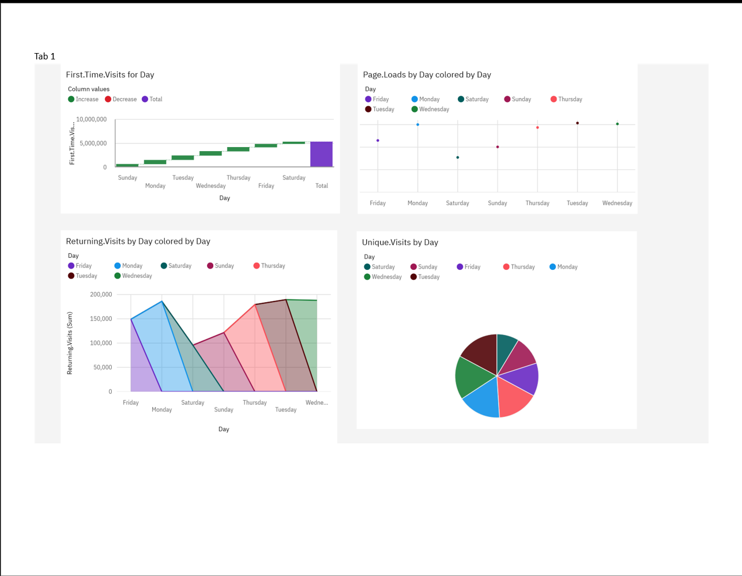

**4.Conclusion:**

In Conclusion, Website traffic analysis is vital practice for understanding how users interact with your site. This data visualization helps to understand the data in an easier way how the user experiences, assess website performance, make data-driven decisions, optimize marketing efforts, enhance content strategies, and increase conversion rates.