

**Sub. Code : 21AIE201**

**Sub Name : Introduction to robotics**

**Name of the Project : Autonomous organic crop monitoring system**

**Team members**

**1.Sabarinath (21141)**

**2.Shyam Ganesh (21149)**

**3.Sidesh Sundar (21150)**

**4.Sasank Sami(21160)**

**5.Bharadwaj (21165)**

**ACKNOWLEDGEMENT**

We would like to express our gratitude to

our professor Dr. Golak Bihari Mahantha sir who gave us this golden opportunity to do the project on the topic **“Autonomous organic crop monitoring system”.**

We would like to extend our gratitude to the AIE department of Amrita Vishwa Vidhyapeetham, Chennai who assigned this project to us and helped us to improve our knowledge.

**TABLE OF CONTENTS**

|  |  |  |
| --- | --- | --- |
| **S.no** | **Topic** | **Page No** |
| 1 | ABSTRACT | 4 |
| 2 | INTRODUCTION | 4 |
| 3 | REVIEW OF LITERATURE | 4 |
| 4 | PROBLEM STATEMENT | 5 |
| 5 | METHODOLOGY | 6 |
| 6 | RESULT | 8 |
| 7 | CONCLUSION | 8 |
| 8 | FUTURE SCOPE | 9 |
| 9 | REFERENCE | 9 |

**ABSTRACT:**

Maximizing food output per area is necessary to feed the world's expanding population. This demand can be met by a vertical system. This method effectively eliminates water and nutrient waste by using stacked grow beds with artificial illumination and an autonomous irrigation system. By incorporating polyhouse into the system, it is now possible to grow factories at high altitudes, reducing overall cost and transportation. The majority of crops, from ornamentals to high-altitude plants and grasses, are frequently produced using this approach. The significant nutrient recycling involved in the application of this agricultural method makes it both sustainable and profitable. It's ideal for urban populations where agricultural space is getting smaller and beverage availability is getting more and more scarce every day.

**Keywords—**mechatronic system, drones, NIR, image acquisition, UAV

**INTRODUCTION:**

Precision farming began to advance in a number of technologies about 2010. inexpensive and enhanced sensors as well as servomotors, inexpensive microprocessors, cloud-based systems, sophisticated automation, critical data analysis, and an onboard computer. The phrase "Agriculture 4.0" is used in agriculture based on the concept of future production because this evolution began concurrently with an industrial development known as Industry 4.0.

Agriculture 4.0 refers to an integrated internal and external network of agricultural operations, and all agricultural industries use digital forms. Digital farming and intelligent agriculture are two additional prevalent concepts related to Agriculture 4.0 is a set of transformations that, through the use of remotely controlled decision-making systems, are based on the development of intelligent agricultural technologies and equipment. With roots in precision farming, the major goals are adaptation of production systems, crop development and efficiency, water usage optimization, and phyto-sanitary goods [2].

Satellites and drones are fundamental tools used today and in the future to collect the data required to support the growth of agriculture and investigate future opportunities.

**REVIEW OF LITERATURE:**

After completing a lot of research, it was discovered that there are many products on the market that are geared toward the growth of Agriculture 4.0 and have different features that supply the requirements for monitoring and boosting the productivity of agricultural crops. The drawback of existing systems is their high cost. For instance, Sentera's suggested entire system starts at $4,000 and can cost up to $10,000 in total. For these reasons, the authors suggested creating a SAAMDA—an Automatic Autonomous Monitoring and Decision System for Agriculture—that would enable even the tiniest farms to practise intelligent agriculture.

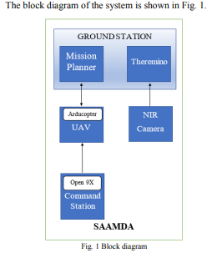

After examining the current market offerings, it was discovered that the SAAMDA mechatronic system's development has less expensive production costs than the competition, as indicated in Table 1.

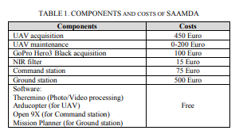

**PROBLEM STATEMENT:**

One of the main problems of organic farming is that of timing in generally, organically produced crop products require efficient supply chains to reach the market quicker since they are more vulnerable to environmental conditions.Another critical challenge of organic farming is that of pest infestations that are as old as farming itself. Pests such as rodents or insects, if not controlled, are responsible for the destruction of crops. For that reason, humans have been using chemicals known as pesticides to deal with them effectively for a long time now. One final challenge of organic farming is that production yields are lower compared to conventionally grown food. In addition to lower production, mainly due to not using industrial fertilizers, herbicides and pesticides, organic agriculture also requires more land to meet the previous production levels and is time consuming than regular farming. Since manual labouring is expensive and not efficient if the field is vast we require a robotic assistance in spite of human care

**METHODOLOGY:**

The main components of a precision agriculture monitoring system are sensing agricultural parameters, location identification and data collection, data routing from the crop field to the control station for decision-making, actuation and control decision-making based on sensed data, and visualisation of results to the grower through an application. Our model's architectural layout is based on the OSI Model, also known as the ISO/IEC 7498-1 standard , which divides a communication system into seven abstraction layers. However, because IoT and artificial intelligence technologies are being used, the basic agricultural layers are now specified as shown in Figure 1:

**Figure 1.**

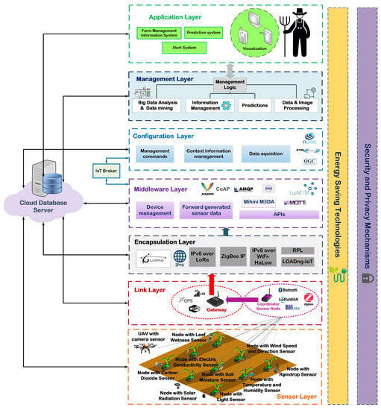

**The Sensor Layer:**

All types of agricultural sensors and intelligent objects for data collecting and monitoring are included in the Sensor Layer, which refers to the Physical Layer of the OSI Model. Sensors can be mounted on UAVs, crops, or the soil (in the soil) [6]. Underground sensors typically refer to readings of moisture, pH, and soil chemical characteristics like sulphur. These sensors are made specifically to be water resistant. Environmental factors including humidity, temperature, wind speed, brightness, or sun radiation are measured by UAV sensors. However, thermal cameras are the most common type of sensor used on UAVs. By detecting heat emanating from practically all objects and materials and converting it into photos and videos, thermal drones with vision imaging cameras offer a wide range of beneficial applications.

**The Link Layer:**

The OSI Model's Data Link Layer, also known as the Link Layer, is made up of all networking and routing techniques that can be used to transport data between sensors. Wireless Sensor Networks are used by the IoT platform to implement effective crop and field management (WSNs). WSN integration with smart farming systems allows for immediate crop quality monitoring and optimization as well as the possibility of wide-area surveillance with high sampling densities. The farmer can continuously monitor and maintain ideal conditions to achieve maximum productivity with impressive energy savings thanks to dispersed sensor nodes placed across the field.

**The Encapsulation Layer:**

The OSI Model's Encapsulation Layer, often known as the Network Layer, is concerned with setting up connections for smart sensors to the IPv6-based internet. This layer consists of routing protocols and IoT networking encapsulation techniques to convert the standard WSN network traffic into intelligent data. In other words, the technologies of this layer enable the IPv6 routing packets carrying the cultivated field sensory data to be transmitted to the appropriate network server.

**The Middleware Layer:**

To transmit the data generated by IoT sensor devices based on various paradigms, the Middleware Layer, which is the Transport Layer of the OSI Model, uses several application level transport protocols. Additionally, it offers interfaces for managing or activating device communication. Due to the existence of numerous unique standards that have the support of various entities, this layer makes the needed interoperability possible.

**The Configuration Layer:**

Between the Middleware Layer and the Management Layer is the Configuration Layer, which in the OSI Model refers to the Session and Presentation Layers. In order to broadcast the raw data as context information or to provide it to upstream data processing algorithms or analytics, this layer must collect it from the devices or other external services, curate, harmonise, and maybe aggregate it. Additionally, this layer has the ability to communicate actuation instructions to the Middleware Layer. Finally, the Configuration Layer might also be able to collect information from other data sources, including public geo-services or agricultural equipment.

**The Management Layer:**

Processing and analysis of the gathered data are tasks for the management layer. The most effective data management and data mining techniques are used in this layer to obtain precise predictions and support for field activities like efficient irrigation management, disease diagnosis, and optimum pesticide application. Decision Support Systems (DSS), which handle the available information from the fields in order to increase production, optimise crop output, maintain quality, and conserve resources, support data processing. It is commonly known that farmers experience significant financial losses as a result of inaccurate weather predictions or improper irrigation techniques. The most crucial part of IoT agricultural systems is data processing, which ensures effective pesticide application and disease prevention.

**The Application Layer:**

It comprises the appropriate application module interfaces for implementing fertiliser and irrigation control, disease and animal detection, alarms regarding the cultivation process, and the visualisation of statistical data, with reference to the Application Layer of the OSI Model. This layer makes it possible for the farmer to easily monitor and manage his fields. A variety of data visualisation methods are used, including graphs, heatmaps, orthomosaics, and three-dimensional models, to make the knowledge gleaned from field monitoring simple and understandable. The farmer can examine the outcomes generated by the system's services and take appropriate action.

**RESULT:**

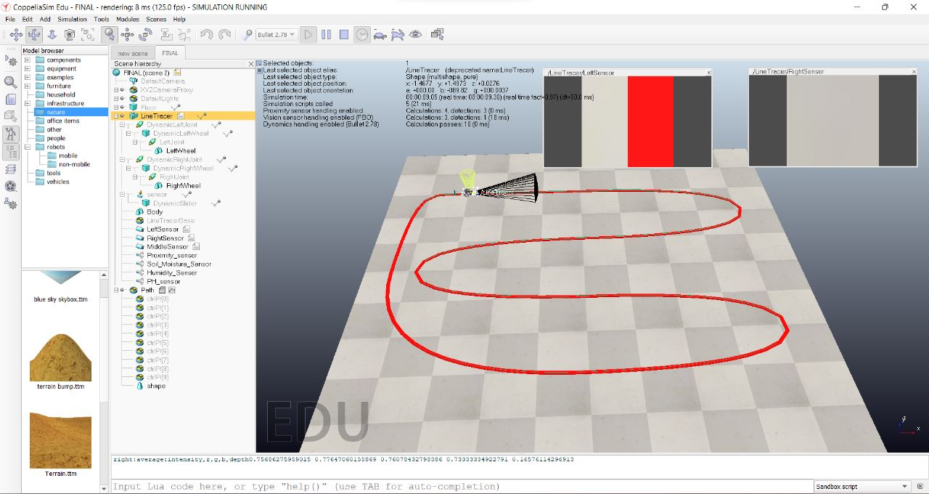

**CONCLUSION:**

Imagine a robot, then add three sensors:

Right sensor

Left sensor

Middle sensor

Create a route around the field.

Adjust the path's intensity so that the robot can travel along the necessary path. The vision sensor will detect the altered path's intensity and travel along the designated region.

In order to make the robot work, we are installing sensors.

We employed proximity, soil moisture, humidity, and ph sensors as our sensors.

**FUTURE SCOPE:**

**REFERENCES:**

1. <https://onlinelibrary.wiley.com/doi/abs/10.1111/joac.12470>

[2] <https://www.mdpi.com/2078-2489/10/11/348>

[3] <https://ieeexplore.ieee.org/abstract/document/8399635>

[4] [https://sci-hub.se/https://ieeexplore.ieee.org/abstract/document/8399635](https://sci-hub.se/https:/ieeexplore.ieee.org/abstract/document/8399635)