

**Sub. Code : 21AIE205**

**Sub Name : Python for Machine Learning**

**Name of the Project : Face recognition using Fire-Fly algorithm**

**Team members**

**1.Sabarinath (21141)**

**2.Shyam Ganesh (21149)**

**3.Sidesh Sundar (21150)**

**4.Sasank Sami(21160)**

**5.Bharadwaj (21165)**

**ACKNOWLEDGEMENT**

same, I shall be held responsible for answering any queries in this regard.

I hereby declare that my Project Report titled face recognition using firefly algorithm is a bonafide record for the course **21AIE205 – Python for Machine Learning** which I have submitted to Department of Computer Science and Engineering (AIE), Amrita School of Computing, Amrita Vishwa Vidyapeetham, Chennai in partial fulfillment of the credit requirements for the B.Tech. degree, is my authenticwork done under the guidance of **Ms. Deena** and **Dr. I R Oviya**. This project report has not been copied, duplicated or plagiarised from any other paper, journal, document or book and has not been submitted to any educational institute, course, department or otherwise for the award of any credit, certificate, diploma, degree or recognition. This is an authentic piece of work and in case there is any query regarding the same, I shall be held responsible for answering any queries in this regard.

**TABLE OF CONTENTS**

|  |  |  |
| --- | --- | --- |
| **S.no** | **Topic** | **Page No** |
| 1 | Introduction | 3 |
| 2 | Literature Review | 5 |
| 3 | Methodology | 8 |
| 4 | Simulation and  Result | 18 |
| 5 | Conclusion | 19 |
| 6 | Future works | 19 |
| 7 | Reference | 20 |

**1. ABSTRACT:**

The suggested method makes use of the firefly algorithm to gather naturally occurring sub-clusters of training face images caused by changes in position, illumination, expression, and occlusion, among other factors. The gamma (γ) parameter of the firefly method, which is crucial for maintaining the trade-off between efficient search space exploration, firefly convergence, overall processing time, and recognition accuracy, controls the movement of fireflies in a hyper-dimensional input space. The suggested method is unique because it combines the benefits of RBFNN and the evolutionary firefly algorithm to adaptively evolve the number and centres of hidden neurons. The fast convergence, enhanced face recognition performance, decreased feature selection overhead, and algorithm stability of the suggested technique are its strengths. Benchmark face databases are used to validate the suggested approach like namely ORL, Yale, AR and LFW. The suggested algorithm outperforms some of the already used face recognition techniques in terms of the average face recognition accuracy obtained for the aforementioned face databases.So in this project we are detecting the face using firefly algorithm

1. **1. KEYWORDS:**

DNN, Face recognition , RBFNN, FireFly optimization algorithm , Open CV, Numpy.

1. **INTRODUCTION:**
   1. **Face Recognition:**

A method of recognising or verifying a person's identification using their face is facial recognition. People can be recognised using facial recognition technology in real-time or in still images and videos.A subcategory of biometric security is facial recognition. Voice, fingerprint, and eye retina or iris recognition are examples of further biometric software types. Although there is growing interest in using the technology in other areas, security and law enforcement still account for the majority of its uses. [1]

* 1. **History and creation of python face module:**

Adam Geitgey created a Python library for face recognition. This library gives us one of the simplest and most straightforward ways to identify and recognise faces. For each face it recognises, the face recognition library creates a total of 128 digital printouts. The label (name) of the person can be obtained by decoding the prints and comparing them later after they have been encoded in some vector encodings.[1][2]

* 1. **Open CV:**

The most widely used library in computer vision is open cv. Although it was originally created in C and C++, Python is now also an option. Intel is the company that created it first. The library is an open-source, cross-platform library. The use of it is free. The primary focus of the highly optimised OpenCV library is on real-time applications. The development of face recognition systems also uses OpenCV.More than 2500 efficient algorithms can be found in the collection. which can be used to find similar images from an image database, remove red eyes from images taken using flash, follow eye movements, detect and recognise faces, identify objects, classify human actions using videos, track camera movements, track moving objects, extract 3D models of objects, stitch images together to produce high-resolution images of scenes, etc.[3]

* 1. **DNN**

Deep learning, commonly referred to as deep structured learning, is one of several machine learning techniques built on representation learning and artificial neural networks. Unsupervised, semi-supervised, and

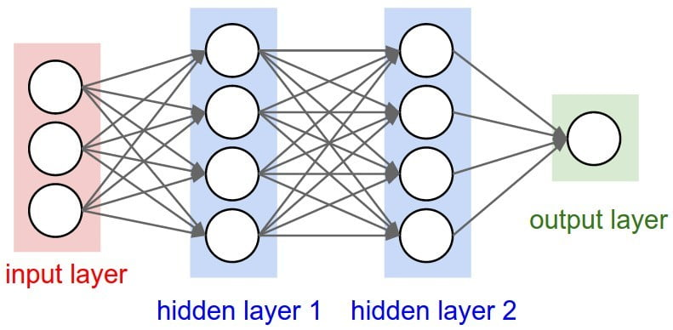

DNN model [4]

supervised learning are all possible.Deep-learning architectures such as deep neural networks, deep belief networks, deep reinforcement learning, recurrent neural networks, convolutional neural networks and Transformers have been applied to fields including computer vision, speech recognition, natural language processing, machine translation, bioinformatics, drug design, medical image analysis, climate science, material inspection and board game programmes, where they have produced results comparable to and in some cases surpassing human expert performance.

* 1. **FireFly Algorithm**

This algorithm was originally proposed in [Yang (2009)](https://www.sciencedirect.com/science/article/pii/S0952197617301264" \l "b33) and [Yang and He (2013)](https://www.sciencedirect.com/science/article/pii/S0952197617301264" \l "b34). This algorithm is based on the flashing and behavior of the fireflies. This algorithm uses three basic rules [Yang (2009)](https://www.sciencedirect.com/science/article/pii/S0952197617301264" \l "b33), [KumarSrivastava and Singh (2016)](https://www.sciencedirect.com/science/article/pii/S0952197617301264" \l "b20) :

1.A firefly is unisex, and can be attracted to others no matter of their sex.

2.The [attractiveness](https://www.sciencedirect.com/topics/computer-science/attractiveness" \o "Learn more about attractiveness from ScienceDirect's AI-generated Topic Pages) is proportional to the brightness, and they both decrease as their distance increases, and for a couple of fireflies, the firefly with less brightness will move toward the brighter one. If there is no brighter one than a particular firefly, then it will move randomly.

3.The brightness of a firefly is given by the objective function.[5]

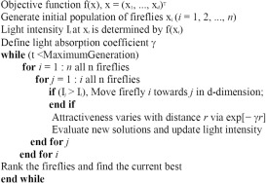

Pseudocode[6]

1. **LITERATURE REVIEW:**

Researchers have created a number of methods for facial recognition. An overview of a few significant contributions to the body of literature is provided in this section.

An illumination invariant local binary descriptor learning methodology for face recognition was created by L. Zhou, W. Li, Y. Du, B. Lei, and S. Liang. Instead of using data distribution, the new methodology often uses the stiff sign function for binarization. In order to extract the nonlinear multi-layer contrast characteristics, the devised approach first calculates the dynamic thresholds, which incorporate the information of light variation. In this study, exponential discriminant analysis was employed as a pre-processing technique to considerably improve the facial image's capacity to distinguish between different classes from one another.

The recognition outcomes for the multi-scale features space were also incorporated using the adaptive fuzzy fusion approach. According to the experimental simulation, the created methodology produced better results in terms of recognition accuracy compared to the earlier research. The performance of the established methodology suffered greatly from the environment and facial recognition.

A hybrid approach for face identification using Probabilistic Neural Networks (PNNs) and Improved Kernel Linear Discriminant Analysis was given by A. Ouyang, Y. Liu, S. Pei, X. Peng, M. He, and Q. Wang (IKLDA). The retrieved features' dimension was initially shrunk in order to preserve the pertinent data. Then, PNN methodology was used to solve the challenges relating to face recognition.The created approach (IKLDA+PNN) not only increases computation precision, but also its efficiency. The AR, ORL, and YALE databases, which contain a wide range of facial characteristics and expressions, were used for the experimental inquiry in this body of work. The experimental findings demonstrated that the created methodology (IKLDA+PNN) achieved superior performance using conventional accuracy and variation. The new hybrid technique dramatically lowers the recognition performance when there are less photos collected.

X.Y. Jing, C. Wang, and Q. Liu created a brand-new nonlinear feature extraction method for colour face recognition called dual multi-kernel discriminant analysis. The best kernel mapping function for each colour component of the facial photos was initially chosen using a kernel selection approach.Then, a model for selecting the best colour space was created, which was used to map the different colour components of the facial images into different high-dimensional kernel spaces. Finally, multi kernel learning and discriminant analysis were used not only across dissimilar components but also inside each component. Labelled Faces in the Wilds (LFW) and the Face Recognition Grand Challenge Version 2 databases were used to test the effectiveness of the created methodology. According to the results of the experiment, the created approach performs better in terms of recognition rate than the current approaches. The training and testing process is necessary for this work.

1. **METHODOLOGY:**
   1. **How face recoginition works**

The images on the watch lists can come from anywhere, including our social media accounts, and they can show anyone, even those who are not suspected of any crime. Although facial technology systems can differ, they typically function as follows:[7]

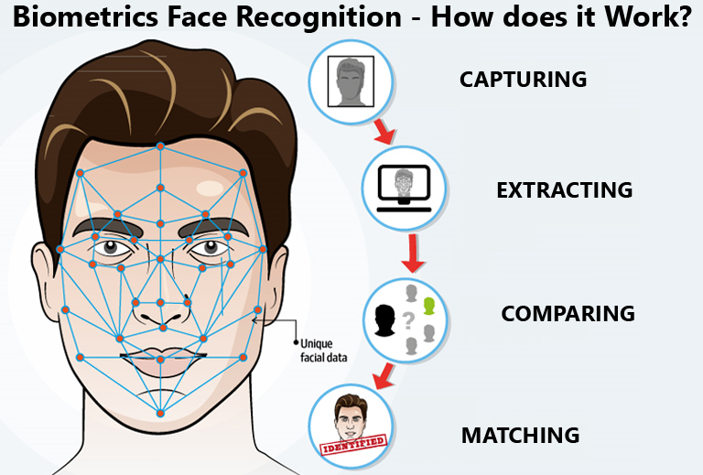

Step-1 : Face recognition

Step 2 : Face analysis

Step 3 : Converting the image to data

Step 4 : Finding a match

* 1. **Proposed system:**

Facial recognition is a new topic of study in artificial intelligence and pattern recognition in recent years. Face recognition is also a difficult topic since in the actual world, facial images are created by the interaction of many different elements, including facial rotation, lighting, background interferences, etc. Some issues, notably those related to feature extraction and classification, need to be solved in order to create a facial recognition system that works effectively. The individual facial images are transformed into very high dimensional vectors during classification. This research study suggests a novel facial recognition technique to alleviate the "curse of dimensionality" worry

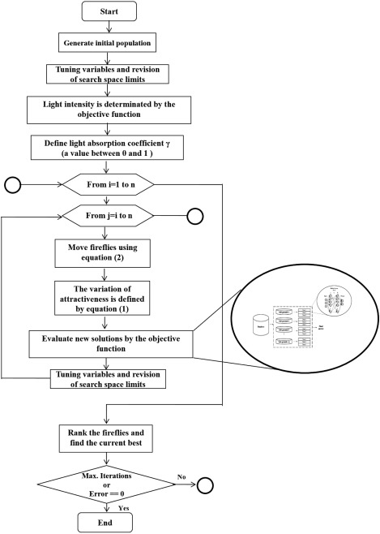

Diagram of proposed model[8]

**4.2.1 Image Pre - Processing:**

Based on the subject's facial traits, the face capture procedure converts analogue information (a face) into a collection of digital information (data). The examination of your face is basically reduced to a mathematical formula. The faceprint is a numerical code. Every person has their own faceprint, just like every thumbprint is different.

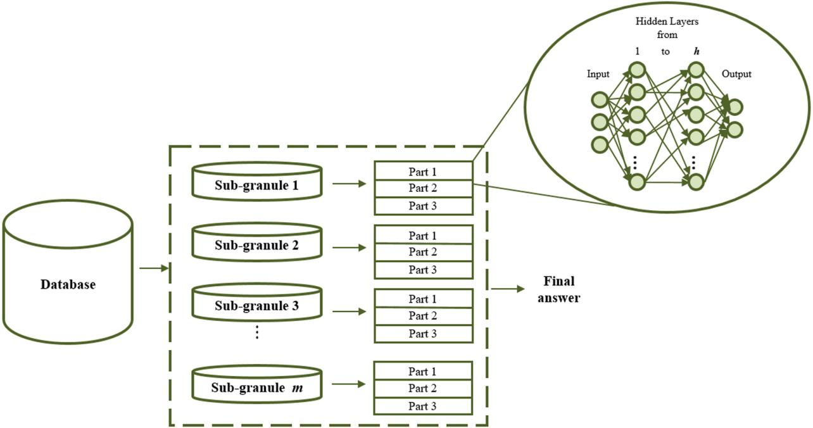

The

First, the input face photos are gathered from the FASSEG, YALE, and ORL datasets. Histogram equalisation is used for pre-processing the photos after the face image collection. It's a method for adjusting face picture intensities to improve image contrast.The images are already pre processed and stored in github.

**4.2.2. Feature Extraction:**

After the facial photos have been denoted, feature extraction is completed to retrieve the feature values. Here, feature information is extracted from the denoised facial photos using hybrid feature descriptors. BRISK and LTP are two of the descriptors for hybrid features. Below is a basic explanation of hybrid feature extraction.

**4.2.3.Feature optimization:**

Following feature extraction, optimization is carried out to reduce the extracted features' dimension. Numerous optimization techniques have been developed recently for feature optimization. In this regard, the fire-fly optimizer excels at addressing issues related to global optimization. Based on firefly behaviour and flashing patterns, Xin-She Yang developed the fire-fly optimization method at Cambridge University. Typically, the three idealised rules in the fire-fly optimizer are beauty, gender, and brightness. Since fire-fly insects are typically unisex, they are drawn to one another based on their sex. The value of the objective function's landscape is used to gauge how brilliant the fireflies are. Additionally, a firefly's attraction is closely correlated with its brightness, whereas the less bright fire-flies are attracted by the brighter fire-flies.

**4.2.4.Classification:**

The face image classification is carried out using DBN after the best features have been chosen. Among all deep learning models, the DBN is a crucial methodology because it uses a lot of Restricted Boltzmann Machines (RBMs). One RBM's learnt activation unit serves as the "data" for the following RBM in the stack. Additionally, it uses an undirected graphical technique in which undirected weight is used to relate visible variables x to a hidden unit y. Where there is no connection between the hidden or visible variables because the DBN are restricted. The probability distribution across x and y is shown in Eq. (18), and the energy function is denoted as E(x, y; ). The mathematical symbol for the binary RBM is given in Eq.



1. **EXISTING WORK:**

**5.1 Histogram Of Oriented Gradients:**

The histogram of oriented gradients (HOG) is a feature descriptor used in computer vision and image processing for the purpose of object detection. The technique counts occurrences of gradient orientation in localized portions of an image. Using this method for face recognition is convenient to perform and accurate, in current days usage of this specific method is popular among developers.

**5.2 Viola-Jones Algorithm:**

The Viola–Jones object detection framework is a machine learning object detection framework proposed in 2001 by Paul Viola and Michael Jones. The algorithm is efficient for its time, able to detect faces in 384 by 288 pixel images at 15 frames per second on a conventional 700 MHz Intel Pentium III. It is also robust, achieving high precision and recall. While it has lower accuracy than more modern methods such as convolutional neural network, its efficiency and compact size which means it is still used in cases with limited computational power.

**INPUT:**

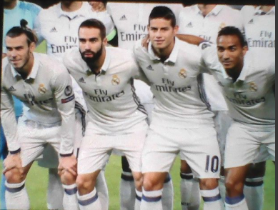

**OUTPUT:**

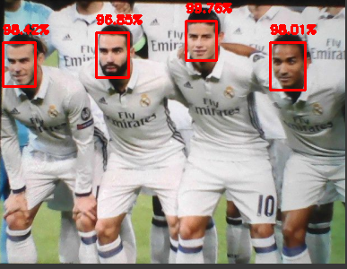

The boxes in the picture shows the recognized images

**CONCLUSION:**

The main aim of the project is detect the face from a picture using fire fly algorithm.The graph shows the accuracy recoil ans precision of various methods.So we can conclude that the best algorithm for detecting face is DNN and DBN.With the help of firefly algorithm we can increase the matching pattern as it uses intensity only so it will be more precise.

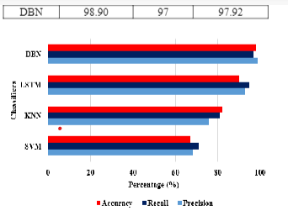

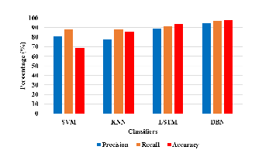

**FUTURE SCOPE:**

We are planing to add expression recognition and also image processing so that we can effectively classify the objects and group them accordingly.

**SOURCE CODE:**

[LINK](https://colab.research.google.com/drive/1_TxYJ8_FCuuvvYPee6OzTucPHp2UHm71?usp=sharing)

**REFERENCE**

1. [Face recognition](https://levelup.gitconnected.com/face-recognition-system-using-google-colab-ccca1d56f5f3)
2. [Face recognition](https://www.google.com/url?sa=t&rct=j&q=&esrc=s&source=web&cd=&cad=rja&uact=8&ved=2ahUKEwjSv63Dl4b8AhU_TGwGHXibAOYQFnoECA4QAQ&url=https%3A%2F%2Fen.wikipedia.org%2Fwiki%2FFacial_recognition_system&usg=AOvVaw3qO-K2Wd970bR3YJH7Sdpb)
3. [Open CV](https://opencv.org)
4. [DNN image](https://www.google.com/url?sa=i&url=https%3A%2F%2Fwww.researchgate.net%2Ffigure%2FConstruction-of-the-deep-neural-network-DNN-model_fig4_333567419&psig=AOvVaw1o8vR62hbx04eNv1zo0cSQ&ust=1671553988428000&source=images&cd=vfe&ved=0CA8QjRxqFwoTCMjpkf-NhvwCFQAA)
5. [Pseudocode](https://ars.els-cdn.com/content/image/1-s2.0-S0952197617301264-gr4.jpg)
6. [How face recognition work](The face capture process transforms analog information (a face) into a set of digital information (data) based on the person's facial features. Your face's analysis is essentially turned into a mathematical formula. The numerical code is called a faceprint)

[7]Daniela Sánchez, Patricia Melin, Oscar Castillo,Optimization of modular granular neural networks using a firefly algorithm for human recognition, Engineering Applications of Artificial Intelligence,

Volume 64,2017,Pages 172-186,ISSN 0952-1976

[8]A survey on firefly algorithms Jun Li, Xiaoyu Wei, Bo Li and Zhigao Zeng

Journal: Neurocomputing, 2022, Volume 500, Page 662

DOI: [10.1016/j.neucom.2022.05.100](http://dx.doi.org/10.1016/j.neucom.2022.05.100" \t "https://citations.springernature.com/book?doi=10.1007/_blank)

This item cites DOI: [10.1007/978-981-15-0306-1_7](https://citations.springernature.com/item?doi=10.1007/978-981-15-0306-1_7)

1. [Proposed model](https://ars.els-cdn.com/content/image/1-s2.0-S0952197617301264-gr5.jpg)