**ABSTRACT:**

A transformation is a mathematical model that describes signal operations, where the original signal is treated as the input and the resulting signal as the output. In this assignment we will be going to perform some of the signal operations or transformations by taking an input audio signal.

**INTRODUCTION:**

A Signal, comprises of a set of information expressed as a function of any number of independent variables, that can be given as an input to a system, or derived as output from the system, to realize its true practical utility. The signal we derive out of a complex system might not always be in the form we want,being well acquainted with some**basic signal operations** may come really handy to enhance the understandability and applicability of signals.  
The mathematical transformation from one signal to another can be expressed as  
 Y(t) = c.x(t)  
Where, Y(t) represents the modified signal derived from the original signal X(t), having only one independent variable t.  
The **basic set of signal operations** can be broadly classified as below:

1. Amplitude related operations
2. Time related operations

Amplitude related operations:

1. **Addition of Signals:**

This particular operation involves the addition of amplitude of two or more signals at each instance of time or any other independent variables which are common between the signals.

Y(t) = X1(t) + X2(t)

where X1(t) and X2(t) are two time dependent signals, performing the additional operation on them we get the output signal.

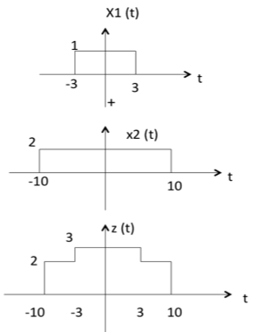

1. **Subtraction of Signals:**

This particular operation involves the subtraction of amplitude of two or more signals at each instance of time or any other independent variables which are common between the signals.

Y(t) = X1(t) - X2(t)

where X1(t) and X2(t) are two time dependent signals, performing the subtraction operation on them we get the output signal.

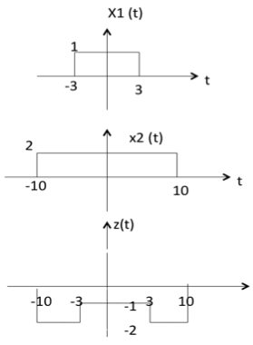

1. **Multiplication of Signals:**

This particular operation involves the multiplication of amplitude of two or more signals at each instance of time or any other independent variables which are common between the signals.

Y(t) = X1(t).X2(t)

where X1(t) and X2(t) are two time dependent signals, performing the multiplication operation on them we get the output signal.

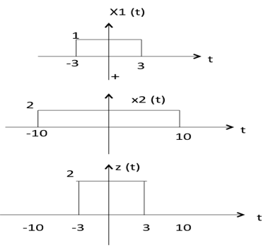

Time related operations:

1. **Shifting of Signal:**

A delay shifts right a time signal, while a modulator shifts the signal in frequency.

Time scaling—The time variable of a signal x(t) is scaled by a constant α to give x(αt).

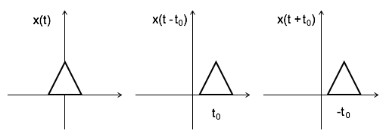

1. **Reversing of Signal:**

Whenever the time in a signal gets multiplied by -1, the signal gets reversed. It produces its mirror image about Y or X-axis. This is known as Reversal of the signal.

Reversal can be classified into two types based on the condition whether the time or the amplitude of the signal is multiplied by -1.

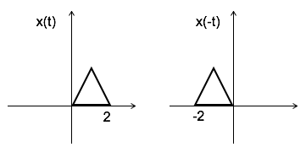

**PROBLEM STATEMENT:**

Design a python/matlab based tool and implement to demonstrate multiple variants of signal operations /transformations by utilizing your own voice signal or desired audio signals of choice. Preferably think like creating a mixture of ring tones or audio files.

**METHODOLOGY OR BLOCK DIAGRAM:**

Input audio

Signal operations like addition ,subtraction,etc

Transform the given audio as discrete time (using Fourier transform)signal

Input audio 2

Output in the form of graph

Discrete time plot function function

**CODE:**

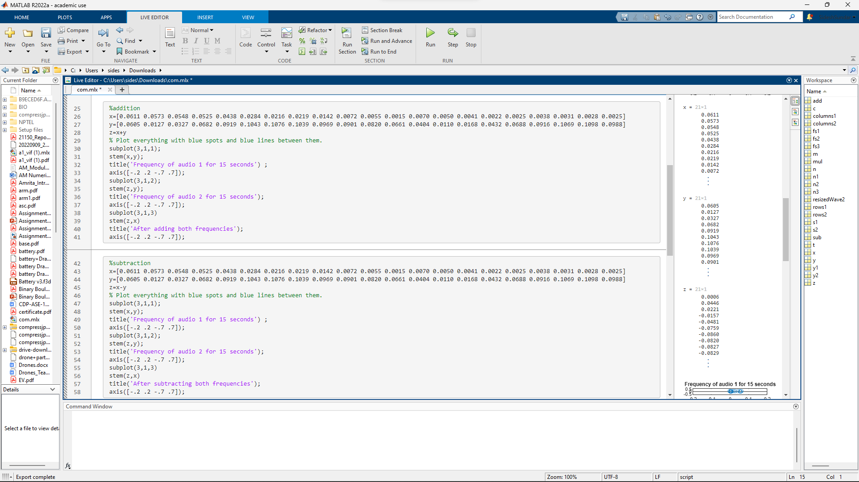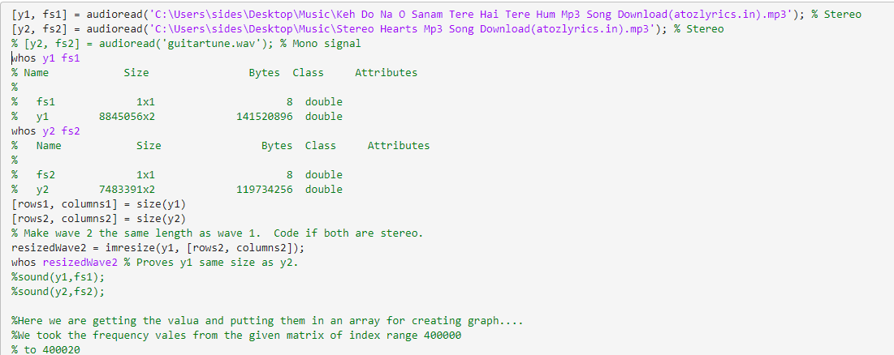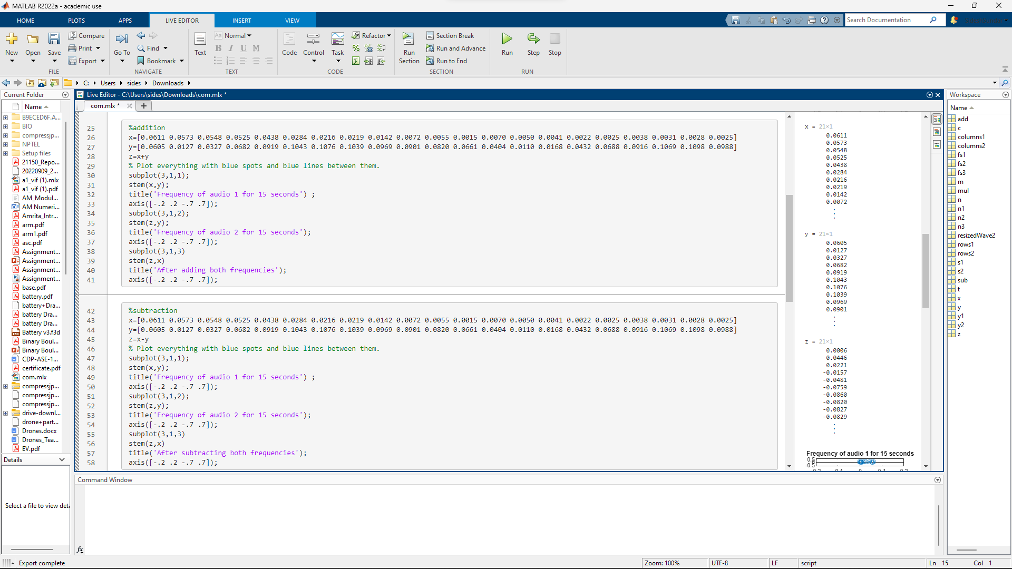

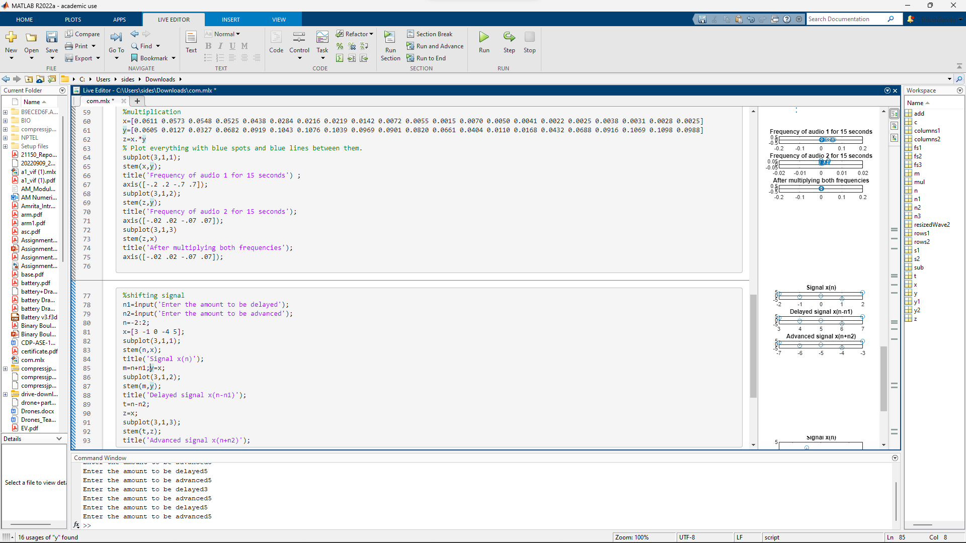



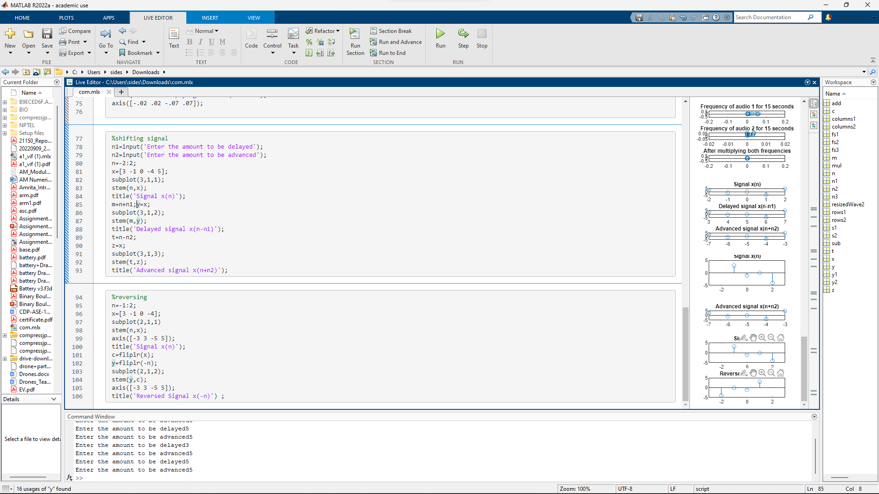

**OUTPUT:**

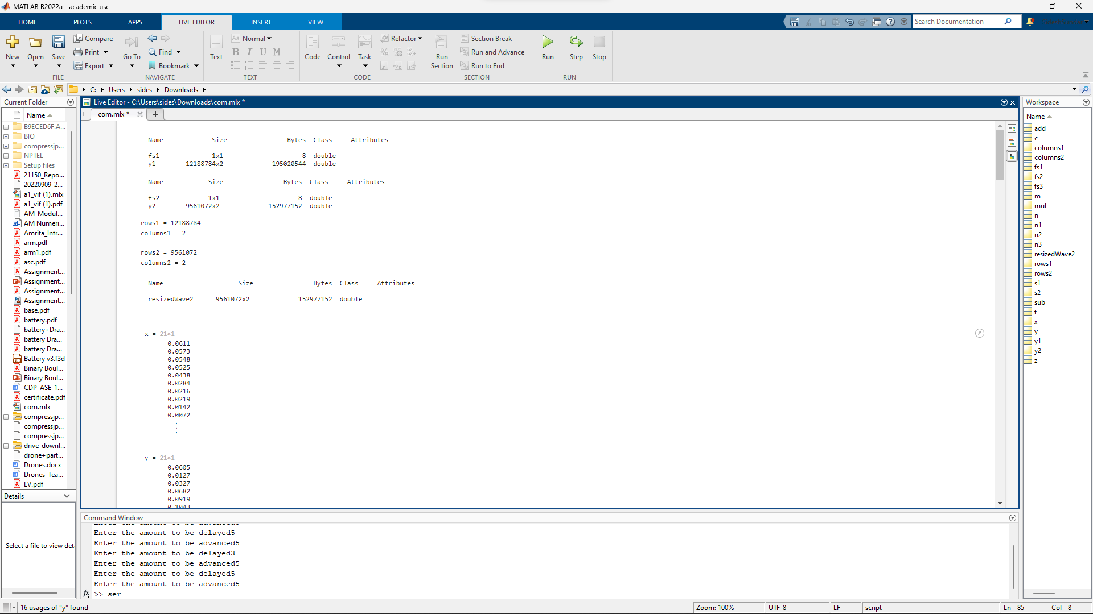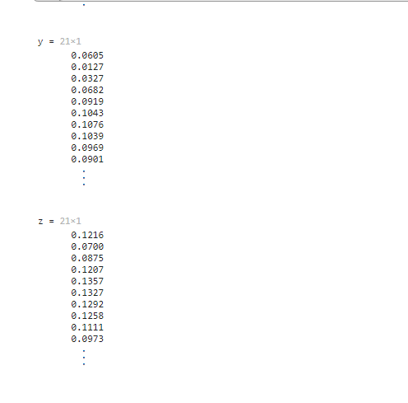

**Addition of signal**

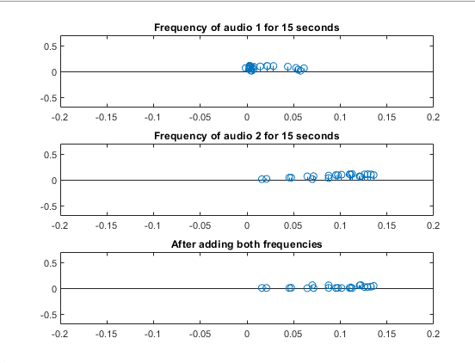

**Subtraction of signal**

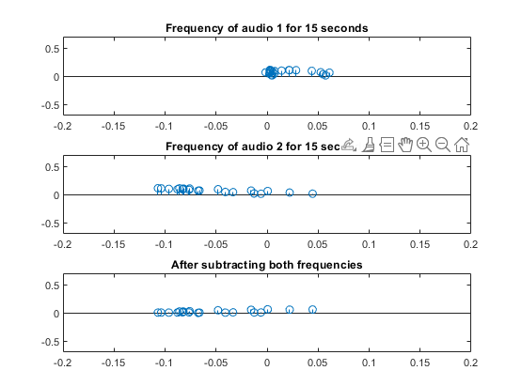

**Multiplication of signal**

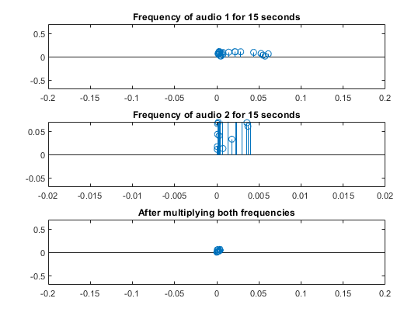

**Shifting of signal**

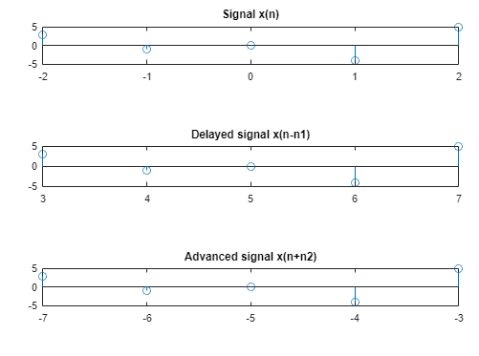

**Reversing of signal**

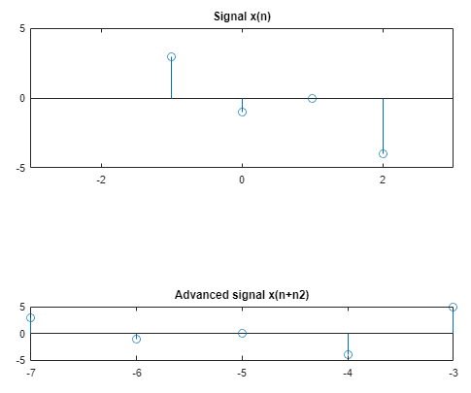

**RESULT AND INFERENCE:**

For performing basic signal operations on audio files, as a prerequisite we must first convert them into a discrete signal by matrix form containing frequency and amplitude in a defined time quantum and perform the operations such as multiplication, addition , subtraction, etc… between two matrices and plot them to visually refer the impact of the operation which was the resultant.