

**Sub. Code**: 21MAT204

**Sub Name**: Mathematics for Intelligent Systems - 3

**Project Title**: Frequency Estimation and Applications using Linear Algebra

**Team members :**

1. Sabarinath J - [21141]

2. Shyam Ganesh - [21149]

3. Sidesh Sundar - [21150]

4. SasankSami - [21160]

5. Bharadwaj - [21165]

**ACKNOWLEDGEMENT**

We would like to express our gratitude to our professor Dr. AISHWARYA mam who gave us this golden opportunity to do the project on the topic “FREQUENCY ESTIMATION AND ITS APPLICATIONS”.

We would like to extend our gratitude to the AIE department of Amrita Vishwa Vidyapeetham, Chennai who assigned this project to us and helped us to improve our knowledge.

**TABLE OF CONTENTS**

|  |  |  |
| --- | --- | --- |
| **S.no** | **Topic** | **Page No** |
| 1) | ABSTRACT | 4 |
| 2) | INTRODUCTION | 4 |
| 3) | REVIEW OF LITERATURE | 4 |
| 4) | DEFINITIONS | 5 |
| 5) | THEORY OF ALGORITHMS | 5 - 7 |
| 6) | METHODOLOGY | 7 - 9 |
| 7) | APPLICATIONS AND ITS IMPLEMENTATION  [CODE & OUTPUT] | 9 - 16 |
| 8) | CONCLUSION | 16 |
| 9) | FUTURE SCOPE | 17 |
| 10) | REFERENCE | 17 |

**ABSTRACT**

Estimation of the frequency (f) has been one of the main problems in the field of signal processing and communications, due to its vast applications. For getting accurate and instant frequency estimation from we used an algorithm called non uniform fast fourier transform [FFT]. Fourier Transform (FFT) is any efficient algorithm for calculating the DFT. And for comparative study with FFT, we have introduced another method named Subspace method.

**INTRODUCTION**

Frequency estimation has fundamental, significant and wide relevance for many reasons. First, any arbitrary signal may be modeled as a sum of frequencies. Hence, any signal estimation problem may be expressed in terms of frequency estimation problems. Second, many parameter estimation applications may be mathematically expressed as a frequency estimation problem. An example is active noise and vibration control.

The problem of estimating the frequencies of sinusoidal components from a finite number of discrete-time measurements has attracted a great deal of attention and still is an active research area to date, because of its wide applications in science and engineering. Many theoretical techniques have been proposed to solve this problem; examples include discrete Fourier transform, least squares methods and phase-locked loops. All of the proposed methods are focused on speed and accuracy of the estimation.

**LITERATURE REVIEW**

**DEFINITIONS**

**LINEAR ALGEBRA:**

It is a branch of mathematics that is concerned with mathematical structures closed under the operations of addition and scalar multiplication and that includes the theory of systems of linear equations, matrices, determinants, vector spaces, and linear transformations.

**DFT:**

Discrete Fourier Transform (DFT) is the discrete version of the Fourier Transform (FT) that transforms a signal (or discrete sequence) from the time domain representation to its representation in the frequency domain.

**FFT:**

Fast Fourier Transform (FFT) is any efficient algorithm for calculating the DFT.

* Computing a DFT of n n points by using only its definition, takes Θ(n^2) time , whereas an FFT can compute the same result in only Θ(n log n) steps.

**SUBSPACE METHOD:**

The concept of the subspace method is derived from the observation that patterns belonging to a class form a compact cluster in high-dimensional vector space.

**THEORY OF ALGORITHMS**

**ALGORITHM - 1: DFT**

The DFT can transform a sequence of evenly spaced signals to the information about the frequency of all the sine waves needed to sum to obtain the time-domain signal. It is defined as

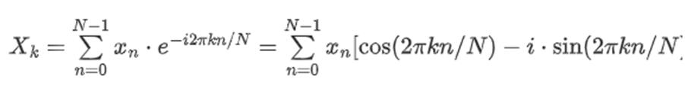

*N* = number of samples

*n* = current sample

*k* = current frequency, where

k∈[0,N−1]

xn = the sine value at sample *n*

Xk = the DFT that includes information of both amplitude and phase

Also, the last expression in the above equation is derived from the *Euler's formula*, which links the trigonometric functions to the complex exponential function: e^(i⋅x)=cos⁡x+i⋅sin⁡x

Note that

Xk, is a complex number that encodes both the amplitude and phase information of a complex sinusoidal component e^(i⋅2πkn/N) of function xn. The amplitude and phase of the signal can be calculated as:

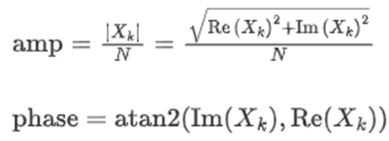

where Im(Xk) and Re(Xk) are the imaginary and real parts of the complex number, and atan2 is the two-argument form of the arctan function.

**Fast Fourier Transform**

The "Fast Fourier Transform" (FFT) is an important measurement method in the science of audio and acoustics measurement. It converts a signal into individual spectral components and thereby provides frequency information about the signal. FFTs are used for fault analysis, quality control, and condition monitoring of machines or systems. This article explains how an FFT works, the relevant parameters and their effects on the measurement result.

Strictly speaking, the FFT is an optimized algorithm for the implementation of the "Discrete Fourier Transformation" (DFT). A signal is sampled over a period of time and divided into its frequency components.

**[COMPARATIVE STUDY]**

**ALGORITHM - 2: SUBSPACE METHOD**

**THEORY**

The key idea of the subspace method is to convert the complex valued autocorrelation matrix in Hankel-like shape into a real valued data matrix with the same dimension. The resultant real valued matrix will be used to extract the noise and/or the signal subspace instead of the original complex one.

Frequency estimation is the process of estimating the complex frequency components of a signal in the existence of noise. The most common frequency estimation methods involve identifying the noise subspace to extract these components. For example, consider a signal, x (n), consisting of a sum of P complex exponentials in the presence of white noise, w (n). This may be represented as:

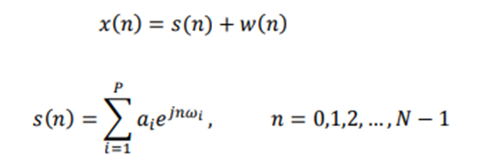

**METHODOLOGY**

**ALGORITHM - 1: DFT**

In the first step, a section of the signal is scanned and stored in the memory for further processing. Two parameters are relevant:

1. The sampling rate or sampling frequency fs of the measuring system (e.g. 48 kHz). This is the average number of samples obtained in one second (samples per second).
2. The selected number of samples; the blocklength BL. This is always an integer power to the base 2 in the FFT (e.g., 2^10 = 1024 samples).

From the two basic parameters fs and BL, further parameters of the measurement can be determined.

**Bandwidth fn** (= Nyquist frequency). This value indicates the theoretical maximum frequency that can be determined by the FFT.

*fn = fs / 2*

For example at a sampling rate of 48 kHz, frequency components up to 24 kHz can be theoretically determined. In the case of an analog system, the practically achievable value is usually somewhat below this, due to analog filters - e.g. at 20 kHz.

**Measurement duration D**. The measurement duration is given by the sampling rate fs and the blocklength BL.

*D = BL / fs.*

At fs = 48 kHz and BL = 1024, this yields 1024/48000 Hz = 21.33 ms

**Frequency resolution df**. The frequency resolution indicates the frequency spacing between two measurement results.

*df = fs / BL*

At fs = 48 kHz and BL = 1024,

This gives a df of 48000 Hz / 1024 = 46.88 Hz.

In practice, the sampling frequency fs is usually a variable given by the system. However, by selecting the blocklength BL, the measurement duration and frequency resolution can be defined. The following applies:

* A small blocklength results in fast measurement repetitions with a coarse frequency resolution.
* A large blocklength results in slower measuring repetitions with fine frequency resolution.

**ALGORITHM - 2: SUBSPACE METHOD**

The generic steps of the subspace methods of frequency estimation are summarized by three steps:

1. Construct a matrix from the vector x given by:

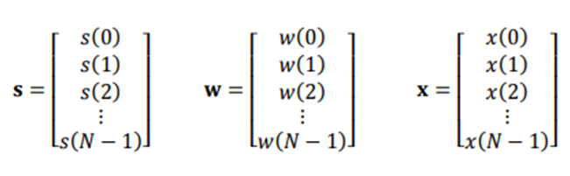

This matrix could appear in different forms like the autocorrelation matrix.

2. Derive the noise subspace and /or the signal subspace. This step could be achieved through decomposition techniques or non decomposition techniques. The popular matrix decomposition techniques are SVD and Eigen value Decomposition.

3. Frequency estimation function is used to find the component frequencies from the noise subspace or signal subspace. The most popular methods of noise subspace based frequency estimation are: Music and Eigenvector solution.

**APPLICATIONS AND ITS IMPLEMENTATION**

**1)** **APPLICATION – 1:**

Estimating the frequency of a noisy signal by using the above mentioned algorithms.

**INPUT:** Noisy signal with unmeasured frequency.

**IMPLEMENTATION : ALGORITHM - 1: [FFT]**

close all;

clear all;

clc;

% Assume we capture 8192 samples at 1kHz sample rate

Nsamps = 8192;

fsamp = 1000;

Tsamp = 1/fsamp;

t = (0:Nsamps-1)*Tsamp;

% Assume the noisy signal is exactly 123Hz

fsig = 123;

signal = sin(2*pi*fsig*t);

noise = 1*randn(1,Nsamps);

x = signal + noise;

% Plot time-domain signal

subplot(2,1,1);

plot(t, x);

ylabel('Amplitude'); xlabel('Time (secs)');

axis tight;

title('Noisy Input Signal');

% Choose FFT size and calculate spectrum

Nfft = 1024;

[Pxx,f] = pwelch(x,gausswin(Nfft),Nfft/2,Nfft,fsamp);

% Plot frequency spectrum

subplot(2,1,2);

plot(f,Pxx);

ylabel('PSD'); xlabel('Frequency (Hz)');

grid on;

% Get frequency estimate (spectral peak)

[~,loc] = max(Pxx);

FREQ_ESTIMATE = f(loc)

title(['Frequency estimate = ',num2str(FREQ_ESTIMATE),' Hz']);

**OUTPUT:** Estimated frequency with graphical Representation.

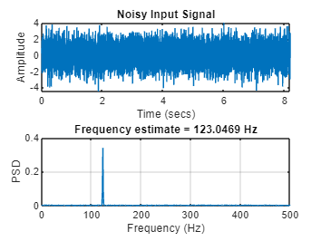

**IMPLEMENTATION : ALGORITHM - 2: [SUBSPACE METHOD]**

**CODE :**

close all;

clear all;

clc;

% Assume we capture 8192 samples at 1kHz sample rate

Nsamps = 8192;

fsamp = 1000;

Tsamp = 1/fsamp;

t = (0:Nsamps-1)*Tsamp;

% Assume the noisy signal is exactly 123Hz

fsig = 123;

signal = sin(2*pi*fsig*t);

noise = 1*randn(1,Nsamps);

x = signal + noise;

pspectrum(x,Nsamps,'Leakage',1)

[X,R] = corrmtx(x,14,'mod');

peig(R,2,[],1,'corr')

title(['Frequency estimate -> 123.83 Hz'] )

**OUTPUT:** Estimated frequency with graphical Representation.

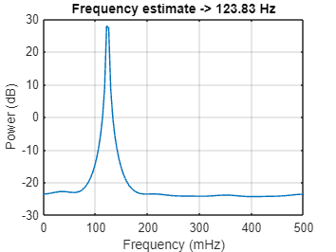

**2) APPLICATION – 2:**

In power systems there are situations in which the output signal can be combined with the other output,here we are estimating the frequency in those signals.

**INPUT:** Combined signal with unmeasured frequency.

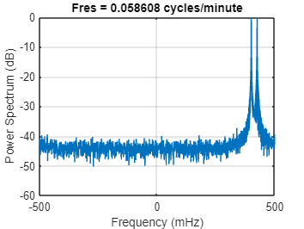

**IMPLEMENTATION : ALGORITHM - 1 [FFT]**

**CODE:**

close all;

clear all;

clc;

% Assume we capture 8192 samples at 1kHz sample rate

Nsamps = 0:8191;

fsamp = 1000;

Tsamp = 1/fsamp;

t = (0:Nsamps-1)*Tsamp;

% The signal consists of two complex exponentials (sine waves)

% with frequencies of 0.4 Hz and 0.425 Hz

% additive complex white Gaussian noise.

x = exp(1j*2*pi*0.4*Nsamps) + exp(1j*2*pi*0.425*Nsamps)+ ...

0.2/sqrt(2)*(randn(size(Nsamps))+1j*randn(size(Nsamps)));

pspectrum(x,Nsamps,'Leakage',1)

[X,R] = corrmtx(x,14,'mod');

% Choose FFT size and calculate spectrum

Nfft = 1024;

[Pxx,f] = pwelch(x,gausswin(Nfft),Nfft/2,Nfft,fsamp);

% Plot frequency spectrum

subplot(2,1,2);

plot(f,Pxx);

ylabel('PS (dB)'); xlabel('Frequency (MHz)');

grid on;

% Get frequency estimate (spectral peak)

[~,loc] = max(Pxx);

FREQ_ESTIMATE = f(loc);

title(['Frequency estimate -> ','f1 = 0.4 hz; f2 = 0.425 hz']);

**OUTPUT:** Estimated frequency with graphical Representation.

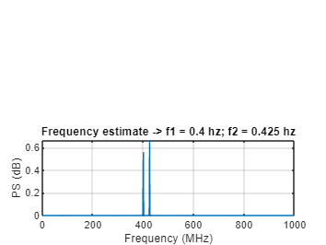

**IMPLEMENTATION : ALGORITHM - 2 [SUBSPACE METHOD]**

**CODE :**

close all;

clear all;

clc;

% Created a complex-valued signal 8191 samples in length.

n = 0:8191;

% The signal consists of two complex exponentials (sine waves)

% with frequencies of 0.4 Hz and 0.425 Hz

% additive complex white Gaussian noise.

x = exp(1j*2*pi*0.4*n) + exp(1j*2*pi*0.425*n)+ ...

0.2/sqrt(2)*(randn(size(n))+1j*randn(size(n)));

pspectrum(x,n,'Leakage',1)

[X,R] = corrmtx(x,14,'mod');

peig(R,2,[],1,'corr')

title([' ']);

title(['Frequency estimate -> ' ...

'f1 = 0.4 hz' ...

' f2 = 0.437 hz'])

**OUTPUT:** Estimated frequency with graphical Representation.

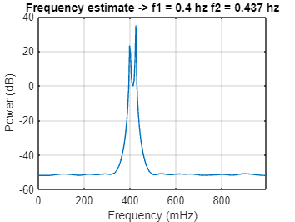

**CONCLUSION:**

**FUTURE SCOPE:**