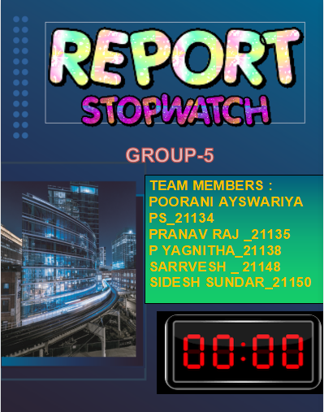

**ACKNOWLEDGEMENT:**

We would like to express our gratitude to our professor M. Muthulakshmi mam who gave us this golden opportunity to do the project on the topic “**DIGITAL STOPWATCH”.**

           We would like to extend our gratitude to the AIE department of Amrita Vishwa Vidhyapeetham, Chennai who assigned this project to us and helped us to improve our knowledge.

**ABSTRACT**

**Stopwatches find use as time keeping device in many fields, namely sports. Stopwatches may be analog or digital. Its function is to find out how long it takes in an activity .Digital stopwatches are much more common the analog version owing to their higher accuracy and ease of use. Here we have tried to realize a digital stopwatch of reasonable accuracy and reliability.**

**This particular stopwatch can count up to 12hours 59 minutes and 59.9 seconds .It is accurate up to one tenth of a second. The circuit is relatively simple and easy to realize.**

**INTRODUCTION**

**STOPWATCHES**

**Stopwatches can be classified into two categories,**

* **Type I**
* 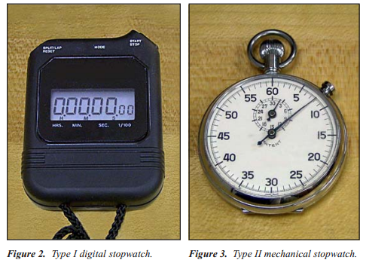**Type II**

**In general, stopwatches are classified as Type I if they have a digital design employing quartz oscillators and electronic circuitry to measure time intervals (Figure 2). Type II stopwatches have an analog design and use mechanical mechanisms to measure time intervals (Figure 3).**

**FEATURES OF TYPE I AND TYPE II STOPWATCHES**

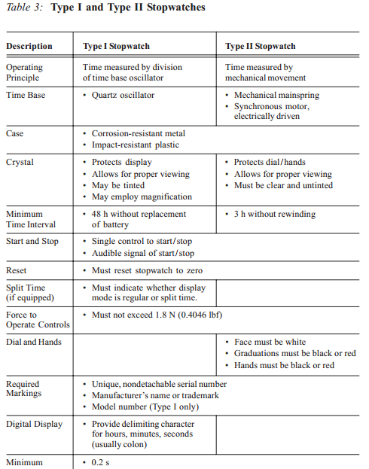

**TIMERS:**

**Timers, unlike stopwatches, count down from a preset time period instead of counting up from zero. They can be small, battery-operated devices that are used to signal when a certain time period has elapsed, or they can be larger devices that plug into a wall outlet and control other items.**

**A parking meter is an example of a countdown timer. Inserting a coin starts the internal timer counting down from an initial preset point. When the time has elapsed, the “EXPIRED” flag is raised.**

**One type of timer used extensively in industry is the process control timer. As their name implies, these devices measure or control the duration of a specific process. For example, when a product is made, it may need to be heat treated for a specific length of time.**

**In an automated manufacturing system, the process control timer determines the amount of time that the item is heated.**

**In some applications, such as integrated circuit manufacturing, the timing process can be critical for proper operation.**

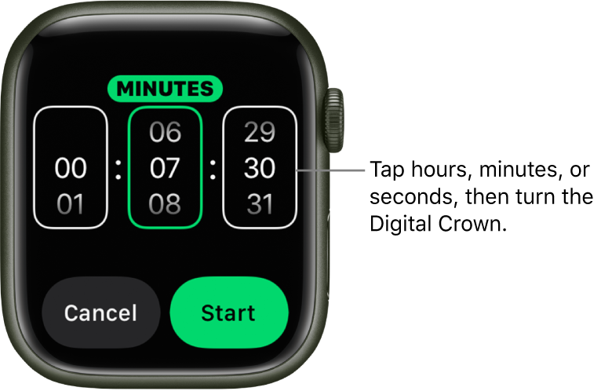

**WORKING PRINCIPLE:**

**The circuit is based on the principle of 2-stages counter operation, based on synchronous cascading.**

**The idea is to count from 0 to 59 representing 60-second time interval**

**This is done by using a 555 Timer IC (LCD) connected in a stable mode to produce the clock pulses of 1 second interval each.**

**While the first counter counts from 0 to 9, the second counter starts its counting operation every time the count value of first counter reaches 9.**

**COMPONENTS**

**ARDUINO:**

**Arduino is an open-source electronics platform based on easy-to-use hardware and software.**

**Arduino boards are able to read inputs - light on a sensor, a finger on a button, or a Twitter message - and turn it into an output - activating a motor, turning on an LED, publishing something online.**

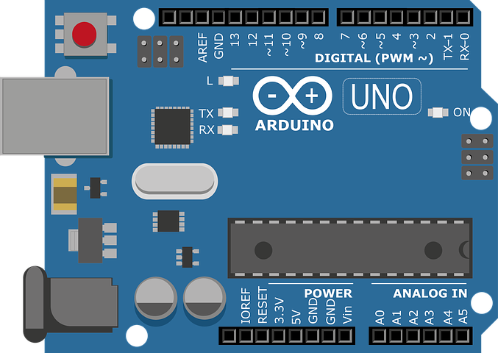

**PIEZO:**

**A piezoelectric microphone is used in these devices to detect pressure variations in sound waves, which can then be converted to an electrical signal for processing.**

**One of the simplest applications for piezoelectricity is the electric cigarette lighter.**

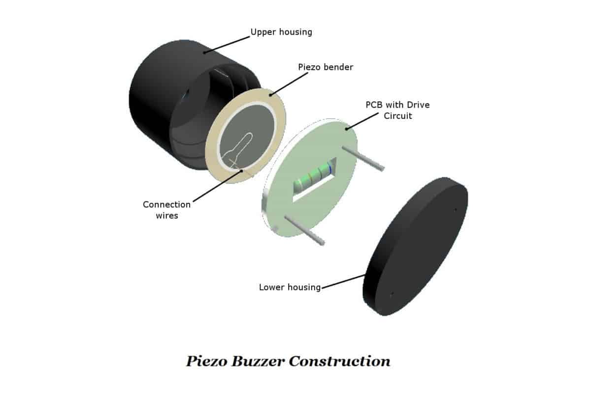

1. **SEGEMENT DISPLAY:**

**A seven-segment display is a form of electronic display device for displaying decimal numerals that is an alternative to the more complex dot matrix displays. Seven-segment displays are widely used in digital clocks, electronic meters, basic calculators, and other electronic devices that display numerical information.**

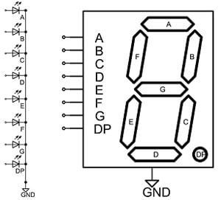

**RESISTOR:**

**A resistor is a passive electrical component with the primary function to limit the flow of electric current.**

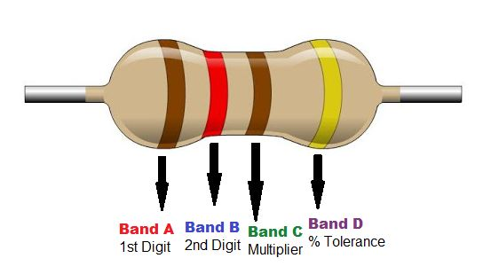

**PUSH BUTTON:**

**They are common features within the home and workplace, and are also referred to as pushbutton switches or push switches.**

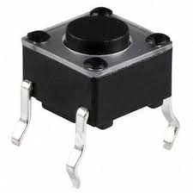

**BREAD BOARD:**

**A breadboard is used to build and test circuits quickly before finalizing any circuit design.**

**The breadboard has many holes into which circuit components like ICs and resistors can be inserted.**

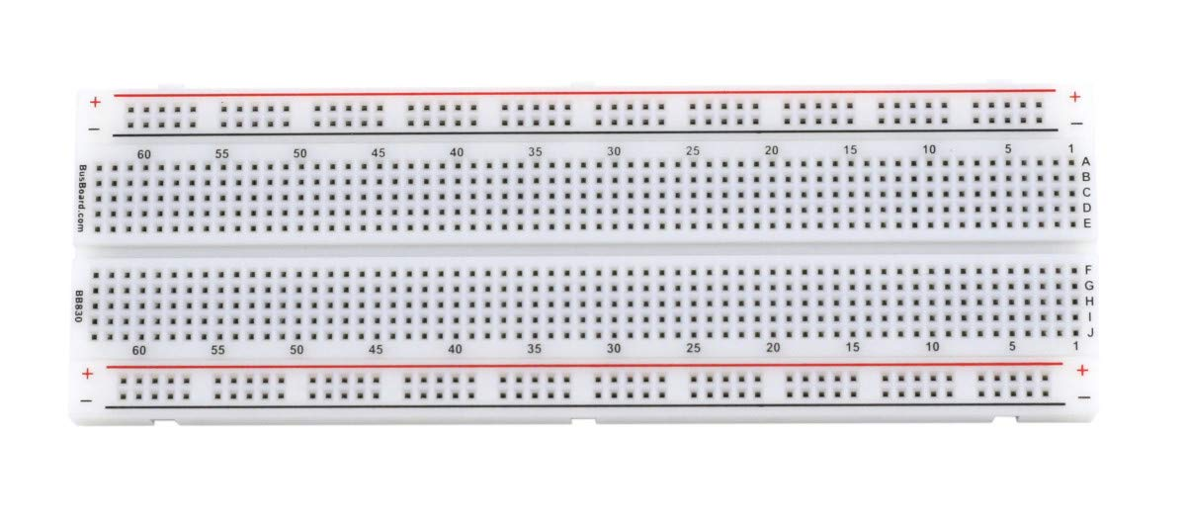

**LCD:**

**LCDs are commonly used for portable electronic games, as viewfinders for digital cameras and camcorders, in video projection systems, for electronic billboards, as monitors for computers, and in flat-panel televisions.**

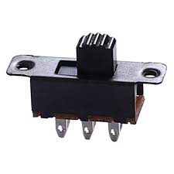

**SLIDE SWITCH:**

**A slide switch is a mechanical switch that slides from the open (off) position to the closed (on) position and allows control of a circuit's current flow without having to manually splice or cut wire.**

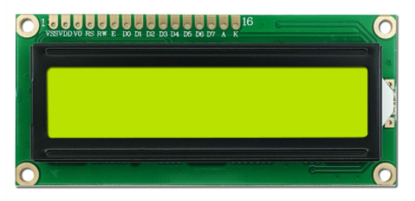

**MODELS**

**STOPWATCH:**

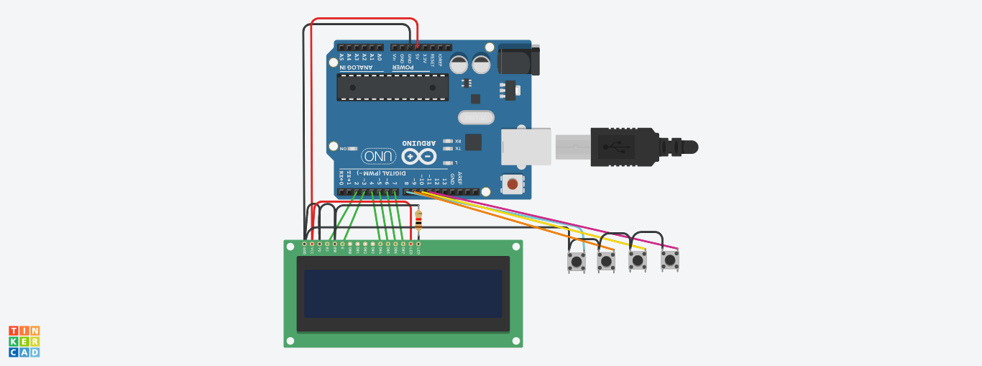

**LINK:**

[**https://www.tinkercad.com/things/8m1kr3g5tBW-stopwatch/editel**](https://www.tinkercad.com/things/8m1kr3g5tBW-stopwatch/editel)

**TIMER:**

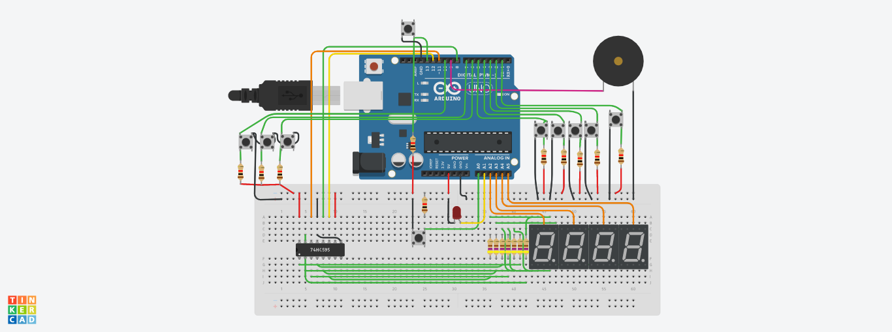

**LINK:**

[**https://www.tinkercad.com/things/dIw5qTKL6TC-countdown-timer/editel**](https://www.tinkercad.com/things/dIw5qTKL6TC-countdown-timer/editel)

**ALARM:**

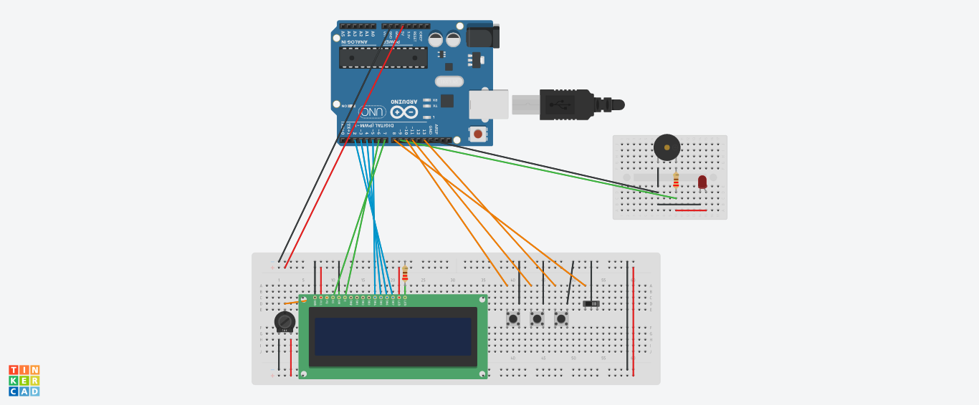

**LINK:**

[**https://www.tinkercad.com/things/78CYeD8XcU7-alarm-clock/editel**](https://www.tinkercad.com/things/78CYeD8XcU7-alarm-clock/editel)

**BLOCK DIAGRAMS:**

**STOP WATCH:**

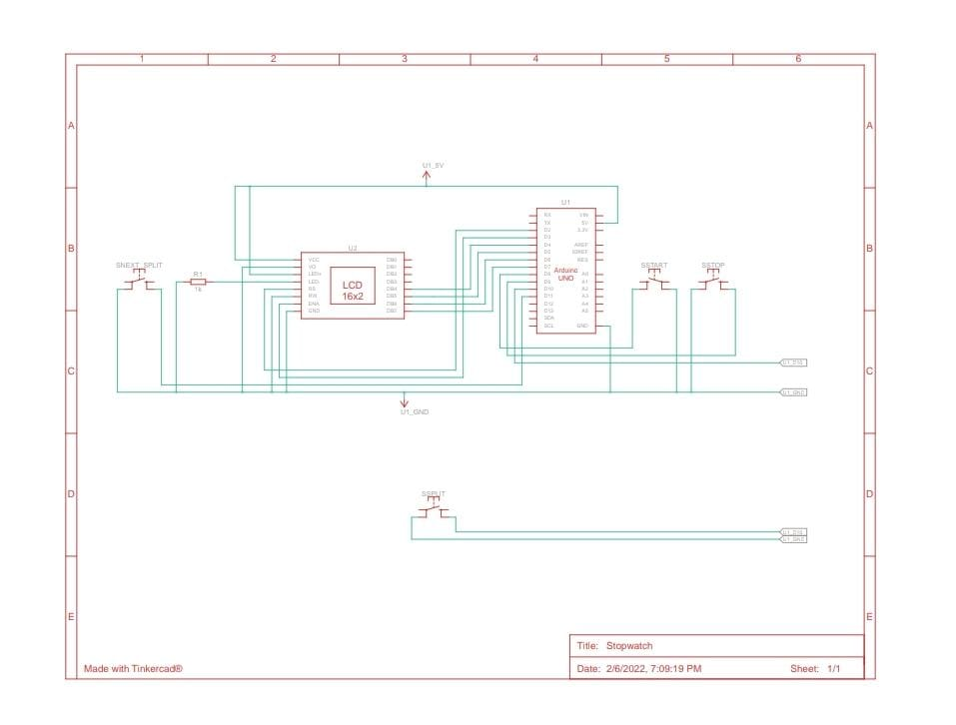

**ALARM:**

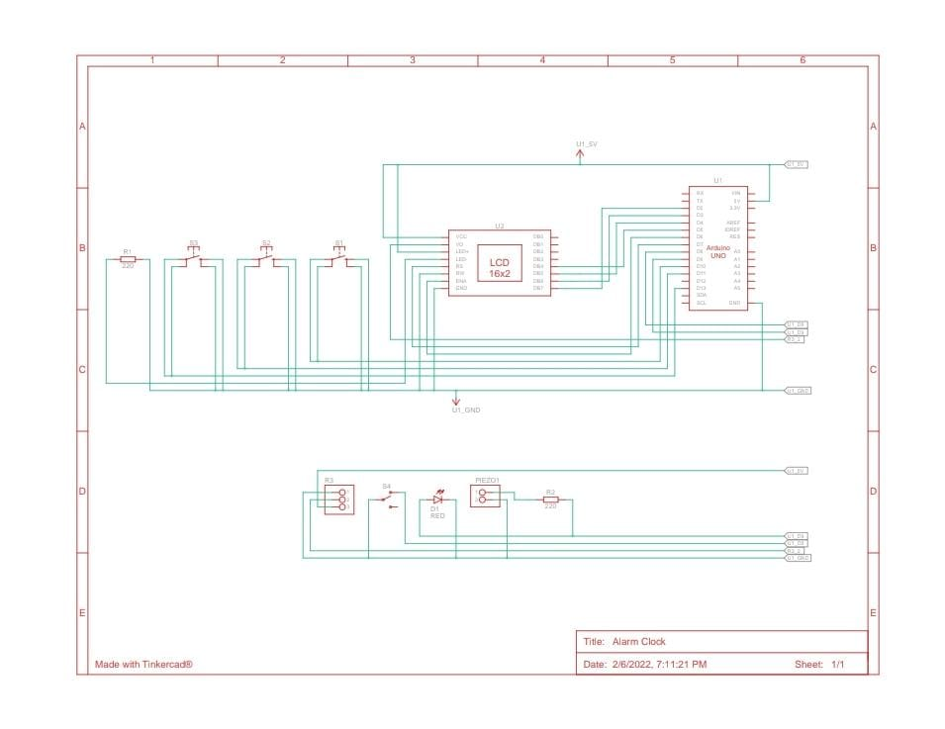

**COUNTDOWN TIMER:**

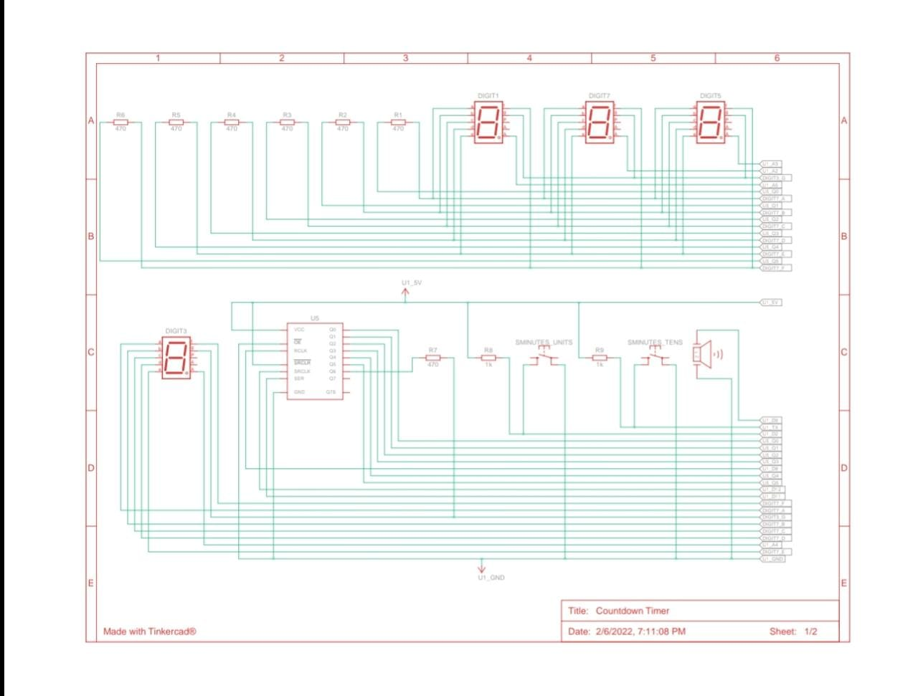

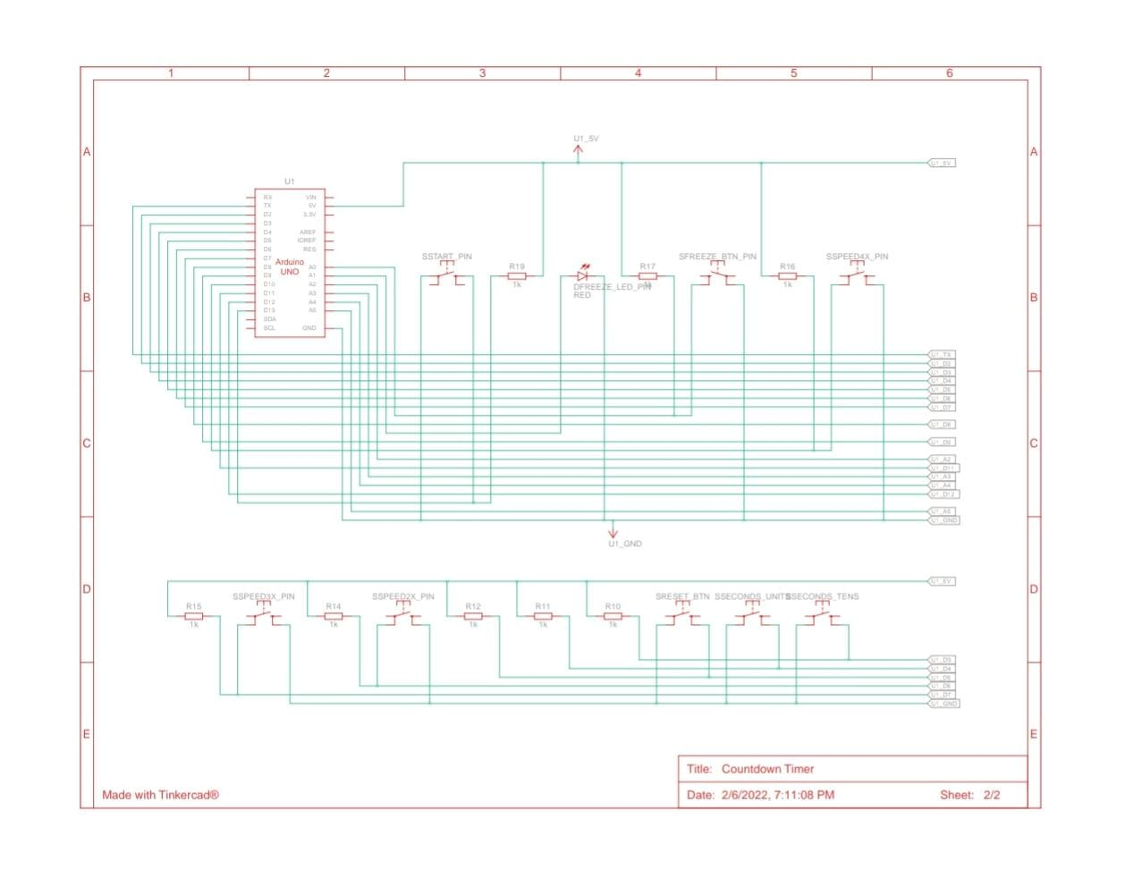

**USES OF STOPWATCH:**

* The device is used when time periods need to be measured precisely and with minimum complications. Laboratory experiments and sports events like sprints are classic examples of its application.
* The stopwatch function is also present in many electronic devices such as wristwatches, computers, cell phones, and portable music players.

**CONCLUSION:**

In this project of making “DIGITAL STOPWATCH” by using TinkerCad software we have implemented start, stop, split, and next buttons. We have also fixed alarm option in the model.

