Digital Design of a Synthetic Ramp & Patterns Generation Unit for High-Speed Communication CMOS-Image-Sensor Applications

Students : Oded Sabari and Margarita Kouzmine
Supervisor : Vered Antebi
Semester : Spring 2024

Project Description:
An image sensor is a camera that captures light using an array of pixels. Each pixel's light intensity is converted from an analog voltage to a 12-bit digital value (A/D) and organized into frames. The goal of this project is to design a module that handles the digital processing of this A/D unit. The module will operate in two modes:
- Regular Mode:
  - In regular operation, the module will extract the 12-bit digital outputs from the A/D and organize them into frames.
- Test Mode:
  - In test mode, the unit generates synthetic configurable values as outputs. The pixels array is bypassed, and the camera output consists of synthetic values generated according to the following test cases:
    - Extraction of constant values based on 12-bit input.
    - Extraction of checkerboard patterns: 1x1 and 2x2, starting with either "white" (all '0's) or "black" (all '1's).
    - Extraction of a ramp (up counter) with options to adjust delta x (gap between numbers in the same row: 0, 1, 4, 8) and delta y (gap between rows: 0, 1, 16, 1290).
The project aims to meet timing, low power consumption, and minimal area requirements.

Project Requirements:
- Real time performance
- Maximum area efficiency
- Low power
- Timing
- Synthesis
- Physical design (layout)
Project Specifications:
- Clock Frequency: 62.5[MHz] (Clock cycle of 16 nsec)
- Technology: Tower 65nm CMOS
Development Stages / Design Flow | Tools
Architectural and Logic Design
HDL Implementation | Verilog
Functional simulation | Ncsim
Synthesis | Design Compiler
Layout Design | First Encounter

Literature
- ASIC design and synthesis : RTL design using Verilog / Vaibbhav Taraate.
- Principles of verifiable rtl design : a functional coding style supporting verification processes in verilog / Lionel Bening and Harry Foster.
- The Verilog hardware description language / Donald E. Thomas, Philip R. Moorby.

Alternative solutions
Our initial approach involved separating the Normal mode counter and tests into distinct blocks, each with its own counters. To streamline implementation and conserve resources, we consolidated the counters to just three: one for output and two smaller ones to manage the next output. Despite this, we maintained separate blocks for different tests. Finally, to further optimize resource usage, we transitioned from using separate blocks for different tests to implementing a unified state machine that encompasses all test cases.

Selected solution
In continuation from the previous section, our ultimate solution involved implementing a Mealy state machine to govern the operation of the output counter, alongside a block dedicated to computing initial values for each count. This state machine is designed with distinct modes tailored for various tests. Additionally, the control block incorporates two simple counters to manage the initiation and conclusion of counts.
Furthermore, in our final solution, we incorporated the ability to disable inactive blocks to optimize power consumption.

Top Level Interface:
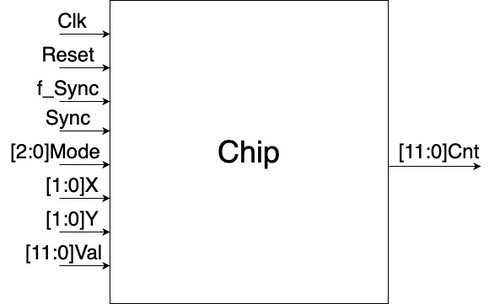

Top Level Architecture
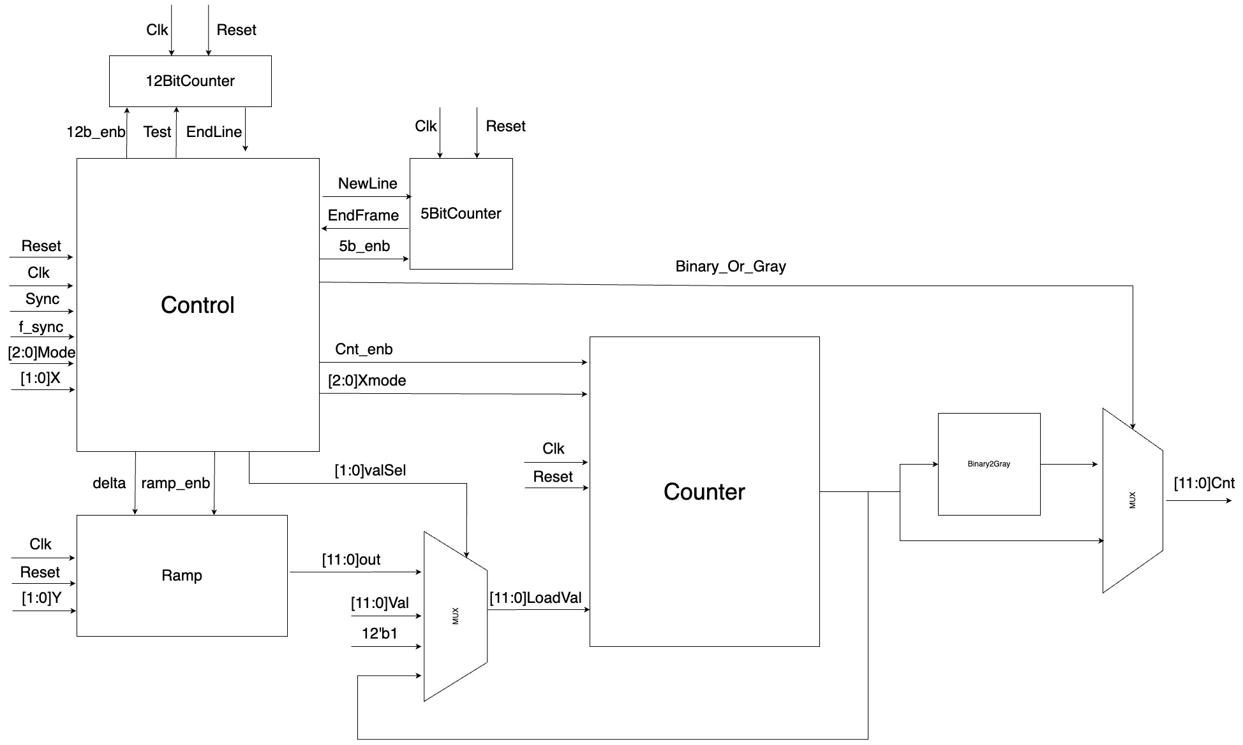

Project Schedule :

Provisional/Preliminary Schedule  Architectural and Logic Design  HDL Implementation  Functional simulation  Synthesis  Layout Design  Report | Week  1-5  6-8  7-12  13  14  15

Gantt Chart:
Week 1 2 3 4 5 6 7 8 9 10 11 12 13 14 15
Architectural and Logic Design

HDL Implementation

Functional simulation

Synthesis

Layout Design

Report

