Digital Design of a Synthetic Ramp & Patterns Generation Unit for High-Speed Communication CMOS-Image-Sensor Applications

Students : Oded Sabari and Margarita Kouzmine
Supervisor : Vered Antebi
Semester : Spring 2024

Project Description:
An image sensor is a camera that captures light on an array of pixels. The light of every pixel is converted from an analog voltage value to a 12bits digital value (A/D) and extracted out in a frame structure. The goal of the project is to design a module which implements the digital part of this A/D (analog to digital) unit. The unit will have two modes of operation:
Regular mode:
In regular operation mode, the module will extract the 12bits outputs of the A/D and organize them the digital values in a frame structure.
Test mode:
In test mode, the unit generates synthetic configurable values which will be synthetic outputs of the module. In this mode the pixels array is bypassed and the camera output is composed of the synthetic values which are generated according to the following testcases:
1. Extracting constant value according to 12bits input.
2. Extracting checkerboard values: 1x1, 2x2, start with “white” or start with “black”. (White = all ‘0’, black = all ‘1’ )
3. Extracting ramp (up counter) with option to change delta x (the gap between numbers at the same row. Can be: 0, 1, 4, 8.) and delta y (the gap between rows. Can be: 0, 1, 16, 1290.).
The project should achieve timing, low power and minimal area requirements.

Project Requirements:
- Real time performance
- Maximum area efficiency
- Low power
- Timing
- Synthesis
- Physical design (layout)
Project Specifications:
- Clock Frequency: 62.5[MHz] (cycle of 16nsec)
- Technology: Tower 65nm CMOS
Development Stages / Design Flow | Tools
Architectural and Logic Design
HDL Implementation | Verilog
Functional simulation | Ncsim
Synthesis | Design Compiler
Layout Design | First Encounter

Literature
- ASIC design and synthesis : RTL design using Verilog / Vaibbhav Taraate.
- Principles of verifiable rtl design : a functional coding style supporting verification processes in verilog / Lionel Bening and Harry Foster.
- The Verilog hardware description language / Donald E. Thomas, Philip R. Moorby.

Alternative solutions
The first idea we had was to separate the Normal mode counter and tests to different blocks with their own counters.
Then to save resources and make the implementation easier we reduced the number of counters to 3 , the counter at the output and 2 smaller counters to keep track of the next output but we kept separate blocks for different tests.
And finally to further reduce the resources needed, instad of different blocks for different tests, we created a state machine that covers all the test cases.

Selected solution
As mentioned in the previous section our final solution was to create a mealy state machine that controls the way the counter at the output counts, with a block that calculates the first value at each count.
Said state machine has different modes for different tests.
Additionally the control block has 2 simple counters to keep track of when the count has to either start or end.
furthermore the final solution we chose has the option to disable inactive blocks to save power.

Top Level Interface:
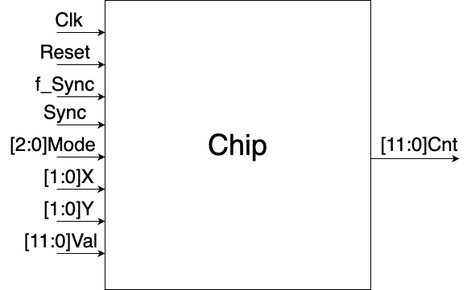

Top Level Architecture

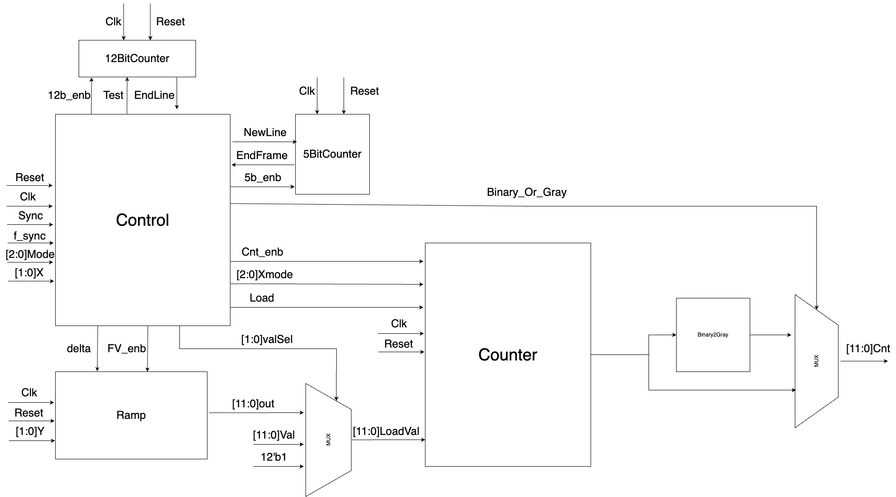

Project Schedule :

Provisional/Preliminary Schedule  Architectural and Logic Design  HDL Implementation  Functional simulation  Synthesis  Layout Design  Report | Week  1-4  5-6  6-11  12-13  14  15

Gantt Chart:
Week 1 2 3 4 5 6 7 8 9 10 11 12 13 14 15
Architectural and Logic Design

HDL Implementation

Functional simulation

Synthesis

Layout Design

Report

