**Customer Churn Prediction Using Machine Learning**

Phase 3 Submission Document



|  |  |
| --- | --- |
| **Name** | P. Sabari Raj |
| **Reg. No** | 410121104039 |
| **NM ID** | Au410121104029 |
| **Department** | CSE-III |
| **Domain** | Data Analytics with Cognos |
| **Project Title** | Customer Churn Prediction |
| **Phase 3** | Development Part I |
| **College** | 4101-Adhi College of Engineering and Technology, Kanchipuram |

**Customer Churn Prediction**

**Introduction to Telco Customer Churn:**

In the dynamic and fiercely competitive telecommunications (telco) industry, customer churn is a persistent challenge that can significantly impact a company's bottom line and market position. Customer churn, also known as customer attrition or turnover, occurs when subscribers decide to switch their telecom service providers. This phenomenon is driven by a myriad of factors, including pricing, service quality, customer service, and evolving technology. To combat this issue, telco companies employ various strategies and initiatives aimed at retaining their customers, collectively known as customer retention programs. This introduction provides an overview of the critical concept of customer churn in the telco industry and the need for effective customer retention efforts to mitigate its negative consequences.

**Given Data Set:**

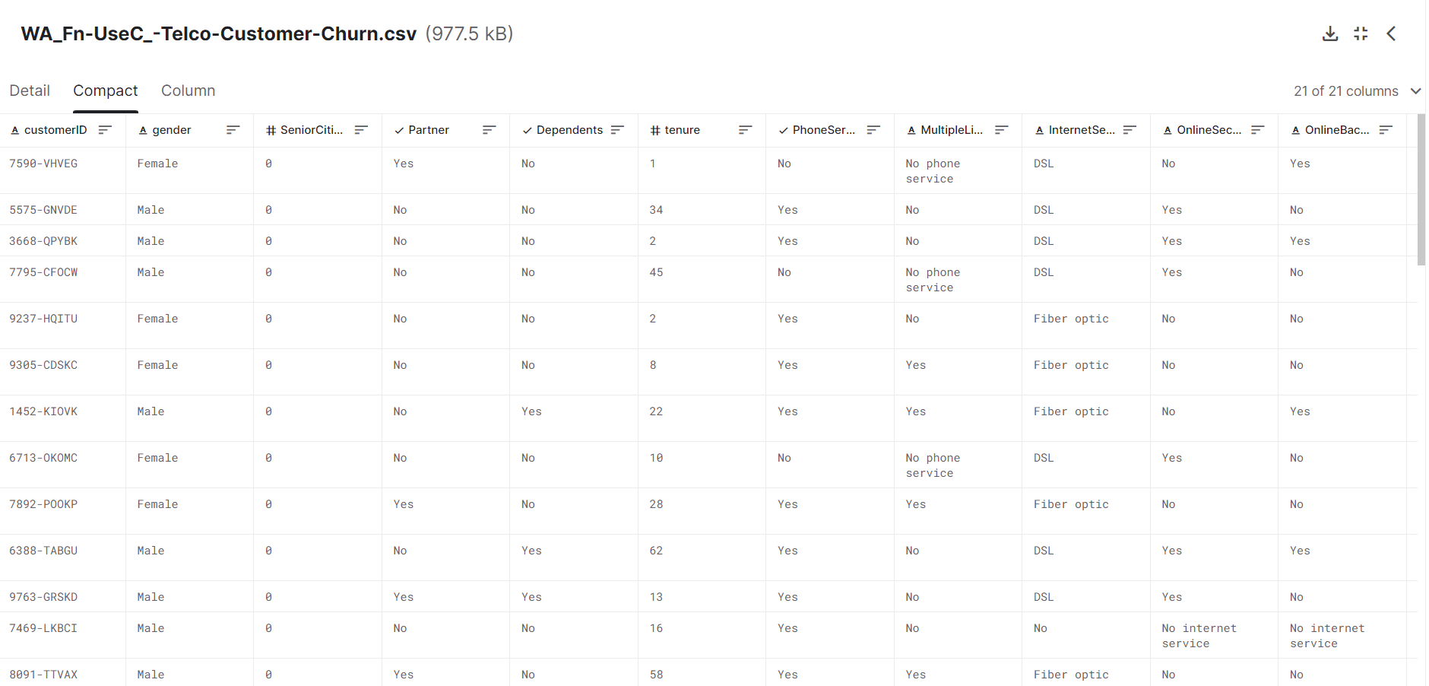

**Necessary step to follow:**

**1.Import Libraries:**

**Program:**

import pandas as pd

from sklearn import metrics

from sklearn.model_selection import train_test_split

from sklearn.metrics import recall_score

from sklearn.metrics import classification_report

from sklearn.metrics import confusion_matrix

from sklearn.tree import DecisionTreeClassifier

from imblearn.combine import SMOTEENN

**2. Load the Dataset:**

df=pd.read_csv("C:\Users\PAZHANI SABARI RAJ\Downloads\MLProject-ChurnPrediction-main\MLProject-ChurnPrediction-main\tel_churn.csv")

df.head()

**3. Exploratory Data Analysis(EDA):**

* Exploratory Data Analysis is an approach to analyse the datasets to summarize their main characteristics in form of visual methods.
* EDA is nothing but an data exploration technique to understand various aspects of the data.
* The main aim of EDA is to obtain confidence in a data to an extent where we are ready to engage a machine learning model.
* EDA is important to analyse the data it’s a first steps in data analysis process.
* EDA give a basic idea to understand the data and make sense of the data to figure out the question you need to ask and find out the best way to manipulate the dataset to get the answer of your question.
* Exploratory data analysis help us to finding the errors, discovering data, mapping out data structure, finding out anomalies.
* Exploratory data analysis is important for business process because we are preparing dataset for deep through analysis that will detect you business problem.
* EDA help to build a quick and dirty model, or a baseline model, which can serve as a comparison against later models that you will build.

**Programs:**

#Check the various attributes of data like shape (rows and cols), Columns, datatypes

telco_base_data.shape

telco_base_data.shape

telco_base_data.columns.values

**Output:**

array(['customerID', 'gender', 'SeniorCitizen', 'Partner', 'Dependents',

'tenure', 'PhoneService', 'MultipleLines', 'InternetService',

'OnlineSecurity', 'OnlineBackup', 'DeviceProtection',

'TechSupport', 'StreamingTV', 'StreamingMovies', 'Contract',

'PaperlessBilling', 'PaymentMethod', 'MonthlyCharges',

'TotalCharges', 'Churn'], dtype=object)

# Checking the data types of all the columns

telco_base_data.dtypes

**Output:**

customerID object

gender object

SeniorCitizen int64

Partner object

Dependents object

tenure int64

PhoneService object

MultipleLines object

InternetService object

OnlineSecurity object

OnlineBackup object

DeviceProtection object

TechSupport object

StreamingTV object

StreamingMovies object

Contract object

PaperlessBilling object

PaymentMethod object

MonthlyCharges float64

TotalCharges object

Churn object

dtype: object

# Check the descriptive statistics of numeric variables

telco_base_data.describe()

**Output:**

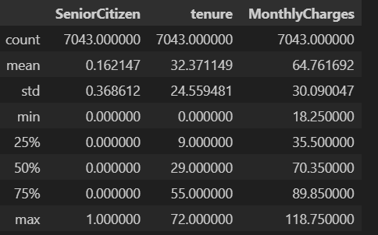

**\**

SeniorCitizen is actually a categorical hence the 25%-50%-75% distribution is not proper.

75% customers have tenure less than 55 months.

Average Monthly charges are USD 64.76 whereas 25% customers pay more than USD 89.85 per month.

**4.Feature Engineering:**

Depending on your dataset, you may need to create new features or transform existing ones. This can involve one-hot encoding categorical variables, handling data/time data, or scaling numerical features.

**5. Split the Data:**

Split your dataset into training and testing sets. This helps you evaluate your model’s performance later.

#Train Test Split

x_train,x_test,y_train,y_test=train_test_split(x,y,test_size=0.2)

**Steps Involved in EDA:=**

* Data Sourcing
* Data Cleaning
* Univariate Analysis with Visualisation
* Bivariate Analysis with Visualisation
* Derived Metrics

**Data Sourcing:**

Data Sourcing is the process of gathering data from multiple sources as external or internal data collection.

There are two major kind of data which can be classified according to the source:

* Public data
* Private data

**Public Data:-** The data which is easy to access without taking any permission from the agencies is called public data. The agencies made the data public for the purpose of the research. Like government and other public sector or ecommerce sites made there data public.

**Private Data:-** The data which is not available on public platform and to access the data we have to take the permission of organisation is called private data. Like Banking ,telecom ,retail sector are there which not made their data publicly available.

The following are some steps involve in Data Cleaning:

* Handle Missing Values
* Standardisation of the data
* Outlier Treatment
* Handle Invalid values

**Missing Data - Initial Intuition**

Here, we don't have any missing data.

**General Thumb Rules:**

* For features with less missing values- can use regression to predict the missing values or fill with the mean of the values present, depending on the feature.
* For features with very high number of missing values- it is better to drop those columns as they give very less insight on analysis.
* As there's no thumb rule on what criteria do we delete the columns with high number of missing values, but generally you can delete the columns, if you have more than 30-40% of missing values. But again there's a catch here, for example, Is_Car & Car_Type, People having no cars, will obviously have Car_Type as NaN (null), but that doesn't make this column useless, so decisions has to be taken wisely.

**Data Cleaning:**

Data cleaning is the process of identifying and correcting errors, inconsistencies, and inaccuracies in a dataset to ensure its quality and reliability for analysis. This involves tasks such as handling missing values, removing duplicates, and addressing outliers to improve data integrity.

**Program:**

**1. Create a copy of base data for manupulation & processing**

telco_data = telco_base_data.copy()

**2. Total Charges should be numeric amount. Let's convert it to numerical data type**

telco_data.TotalCharges=pd.to_numeric(telco_data.TotalCharges,errors='coerce’)

telco_data.isnull().sum()

**Output:**

customerID 0

gender 0

SeniorCitizen 0

Partner 0

Dependents 0

tenure 0

PhoneService 0

MultipleLines 0

InternetService 0

OnlineSecurity 0

OnlineBackup 0

DeviceProtection 0

TechSupport 0

StreamingTV 0

StreamingMovies 0

Contract 0

PaperlessBilling 0

PaymentMethod 0

MonthlyCharges 0

TotalCharges 11

Churn 0

dtype: int64

**3. As we can see there are 11 missing values in TotalCharges column. Let's check these records**

telco_data.loc[telco_data ['TotalCharges'].isnull() == True]

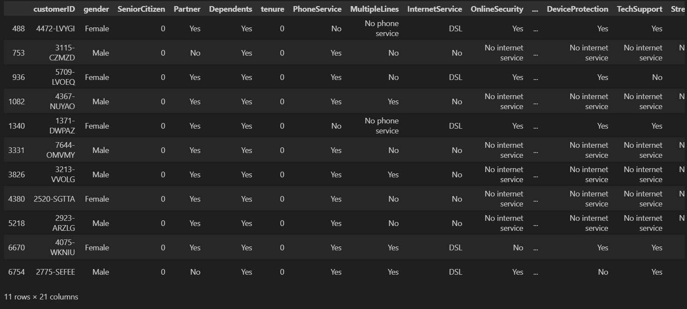

**4. Missing Value Treatement**

**Since the % of these records compared to total dataset is very low ie 0.15%, it is safe to ignore them from further processing.**

#Removing missing values

telco_data.dropna(how = 'any', inplace = True)

#telco_data.fillna(0)

**5. Divide customers into bins based on tenure e.g. for tenure < 12 months: assign a tenure group if 1-12, for tenure between 1 to 2 Yrs, tenure group of 13-24; so on...**

# Get the max tenure

print(telco_data['tenure'].max()) #72

**Output:**

72

# Group the tenure in bins of 12 months

labels = ["{0} - {1}".format(i, i + 11) for i in range(1, 72, 12)]

telco_data['tenure_group'] = pd.cut(telco_data.tenure, range(1, 80, 12), right=False, labels=labels)

telco_data['tenure_group'].value_counts()

**Output:**

1 - 12 2175

61 - 72 1407

13 - 24 1024

49 - 60 832

25 - 36 832

37 - 48 762

Name: tenure_group, dtype: int64

**6. Remove columns not required for processing**

#drop column customerID and tenure

telco_data.drop(columns= ['customerID','tenure'], axis=1, inplace=True)

telco_data.head()

**Output:**

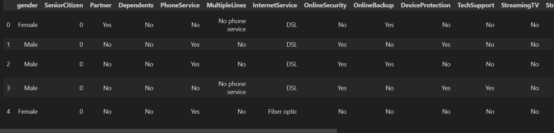

**Data Exploration:**

Data exploration refers to the process of examining and analyzing a dataset to understand its key characteristics, patterns, and relationships. It involves summarizing and visualizing data to gain insights and inform further data analysis and decision-making. Data exploration helps identify outliers, trends, and potential issues in the data, making it a crucial step in the data analysis process.

1. Plot distibution of individual predictors by churn

**Univariate Analysis:**

Segmented Univariate Analysis allow you to compare subset of data it help us to understand how the relevant metric varies across the different segment.

The Standard process of segmented univariate analysis is as follow:

* Take a raw data
* Group by dimensions
* Summarise using a relevant metric like mean ,median.
* Compare the aggregate metric across the categories

**Program:**

for i, predictor in enumerate(telco_data.drop(columns=['Churn', 'TotalCharges', 'MonthlyCharges'])):

plt.figure(i)

sns.countplot(data=telco_data, x=predictor, hue='Churn')

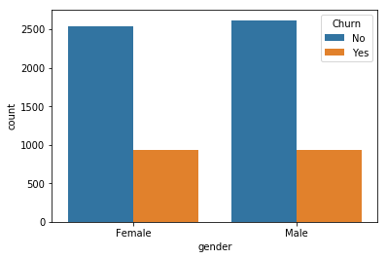  
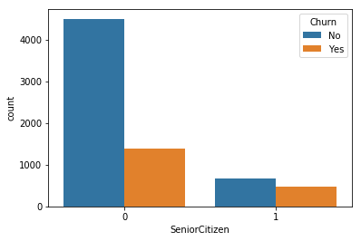

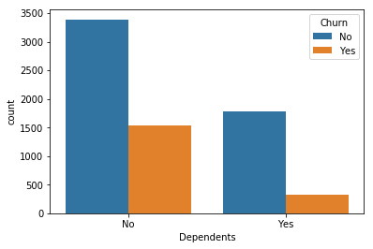



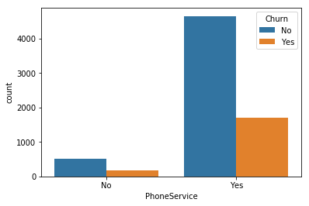 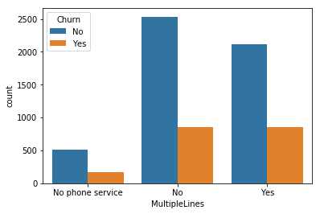

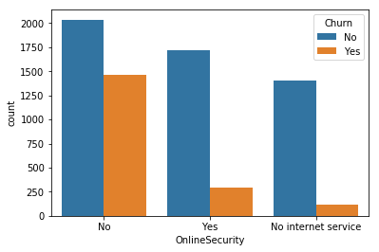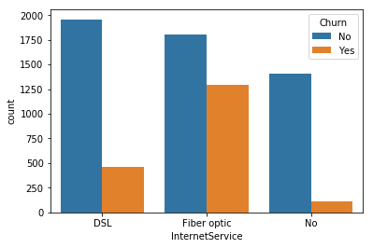  
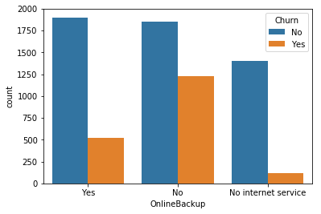 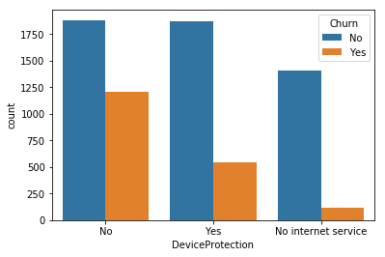

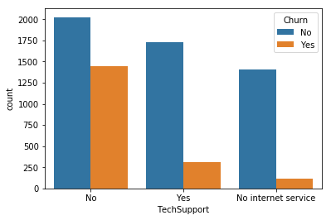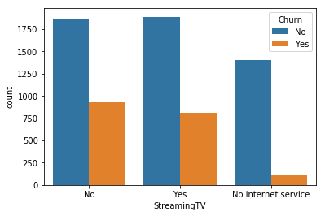

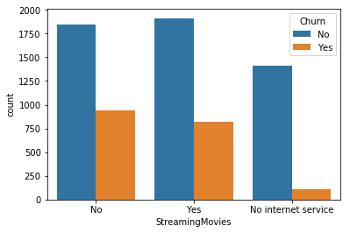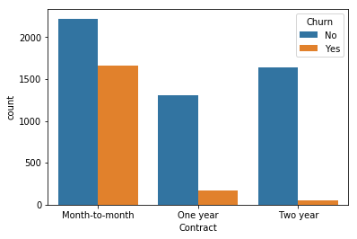

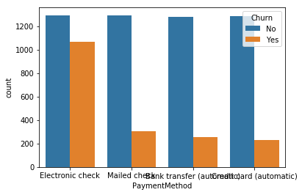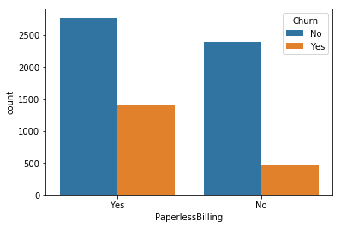

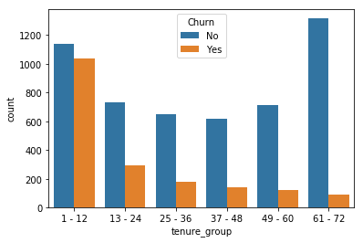

**2. Convert the target variable 'Churn' in a binary numeric variable i.e. Yes=1 ; No = 0**

telco_data['Churn'] = np.where(telco_data.Churn == 'Yes',1,0)

telco_data.head()

**Output:**

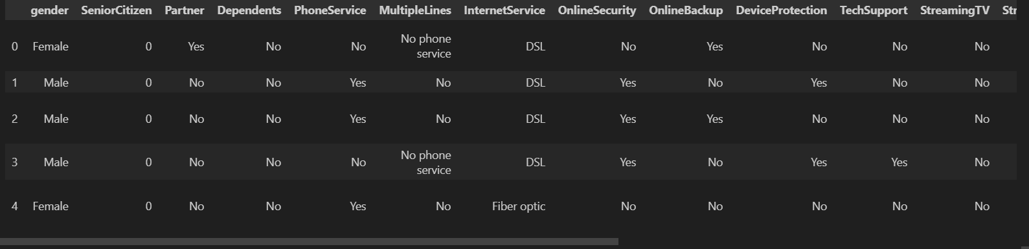

**3. Convert all the categorical variables into dummy variables**

telco_data_dummies = pd.get_dummies(telco_data)

telco_data_dummies.head()

**Output:**

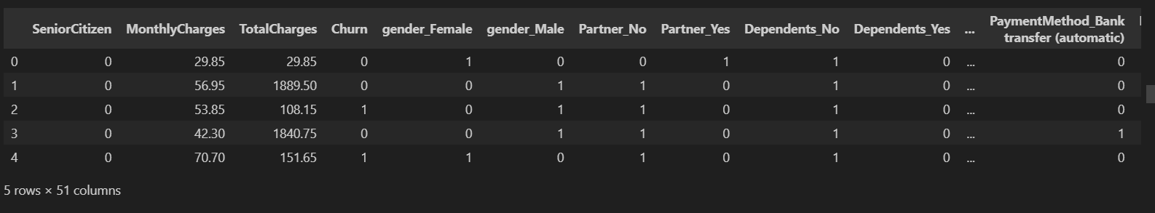

**4. Relationship between Monthly Charges and Total Charges**

sns.lmplot(data=telco_data_dummies, x='MonthlyCharges', y='TotalCharges', fit_reg=False)

**Output:**

<seaborn.axisgrid.FacetGrid at 0x20d8a9289e8>

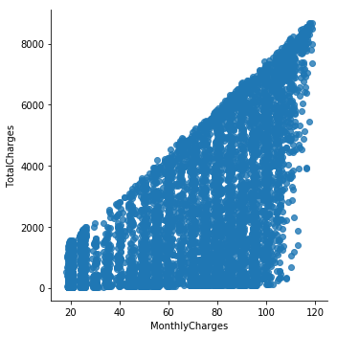

Total Charges increase as Monthly Charges increase - as expected.

**5. Churn by Monthly Charges and Total Charges**

Mth = sns.kdeplot(telco_data_dummies.MonthlyCharges[(telco_data_dummies["Churn"] == 0) ],

color="Red", shade = True)

Mth = sns.kdeplot(telco_data_dummies.MonthlyCharges[(telco_data_dummies["Churn"] == 1) ],

ax =Mth, color="Blue", shade= True)

Mth.legend(["No Churn","Churn"],loc='upper right')

Mth.set_ylabel('Density')

Mth.set_xlabel('Monthly Charges')

Mth.set_title('Monthly charges by churn')

**Output:**

Text(0.5, 1.0, 'Monthly charges by churn')

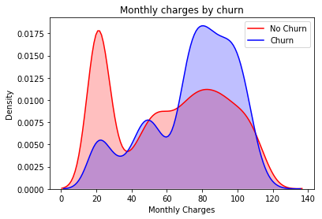

**Insight:** Churn is high when Monthly Charges ar high

Tot = sns.kdeplot(telco_data_dummies.TotalCharges[(telco_data_dummies["Churn"] == 0) ],

color="Red", shade = True)

Tot = sns.kdeplot(telco_data_dummies.TotalCharges[(telco_data_dummies["Churn"] == 1) ],

ax =Tot, color="Blue", shade= True)

Tot.legend(["No Churn","Churn"],loc='upper right')

Tot.set_ylabel('Density')

Tot.set_xlabel('Total Charges')

Tot.set_title('Total charges by churn')

**Output:**

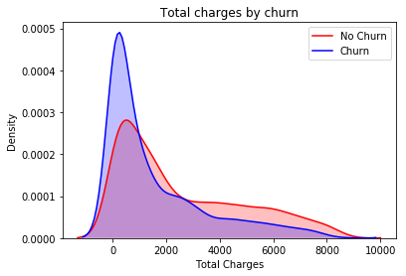

**Surprising insight ** as higher Churn at lower Total Charges

**6. Build a corelation of all predictors with 'Churn'**

plt.figure(figsize=(20,8))

telco_data_dummies.corr()['Churn'].sort_values(ascending = False).plot(kind='bar')

**Output:**

<matplotlib.axes._subplots.AxesSubplot at 0x20d8a979f98>

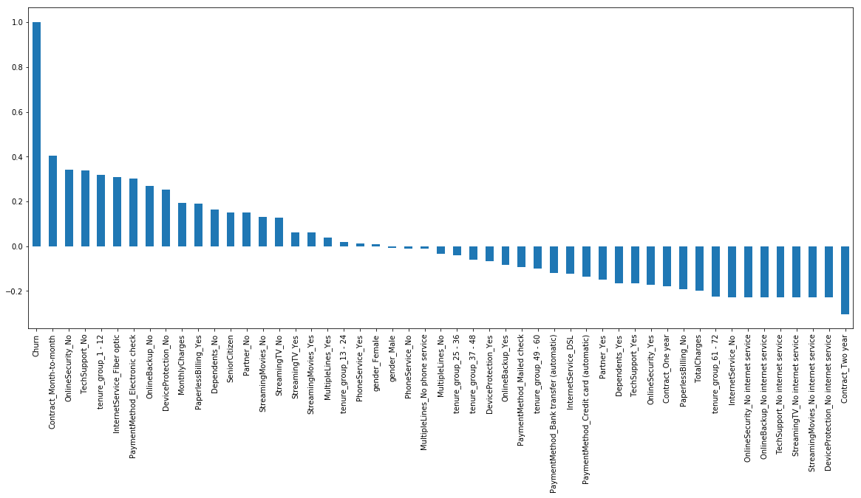

plt.figure(figsize=(12,12))

sns.heatmap(telco_data_dummies.corr(), cmap="Paired")

**Output:**

<matplotlib.axes._subplots.AxesSubplot at 0x1809ebfef60>

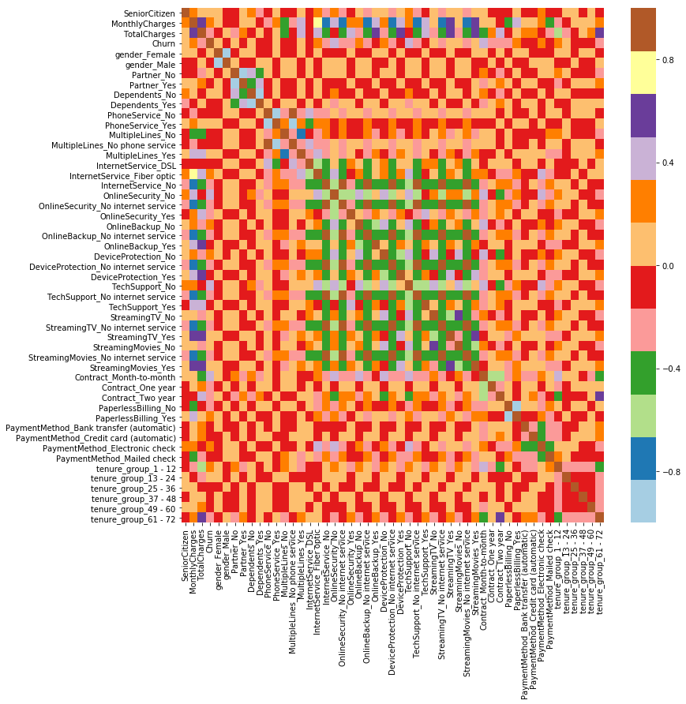

**BivariateAnalysis Correlation:**

Data which has two variables ,you often want to measure the relationship that exists between these two variables.

**Bi-variate Types:**

**Correlation**: Correlation measure the strength as well as the direction of the linear relationship between the two variables. Its range is from -1 to +1.

* ● If one increases as the other increases, the correlation is positive
* ● If one decreases as the other increases, the correlation is negative
* ● If one stays constant as the other varies, the correlation is zero

**Covariance:** Covariance measure how much two random variable vary together. Its range is from -∞ to +∞.

**Program:**

new_df1_target0=telco_data.loc[telco_data["Churn"]==0]

new_df1_target1=telco_data.loc[telco_data["Churn"]==1]

def uniplot(df,col,title,hue =None):

sns.set_style('whitegrid')

sns.set_context('talk')

plt.rcParams["axes.labelsize"] = 20

plt.rcParams['axes.titlesize'] = 22

plt.rcParams['axes.titlepad'] = 30

temp = pd.Series(data = hue)

fig, ax = plt.subplots()

width = len(df[col].unique()) + 7 + 4*len(temp.unique())

fig.set_size_inches(width , 8)

plt.xticks(rotation=45)

plt.yscale('log')

plt.title(title)

ax = sns.countplot(data = df, x= col, order=df[col].value_counts().index,hue = hue,palette='bright')

plt.show()

niplot(new_df1_target1,col='Partner',title='Distribution of Gender for Churned Customers',hue='gender')

**Output:**

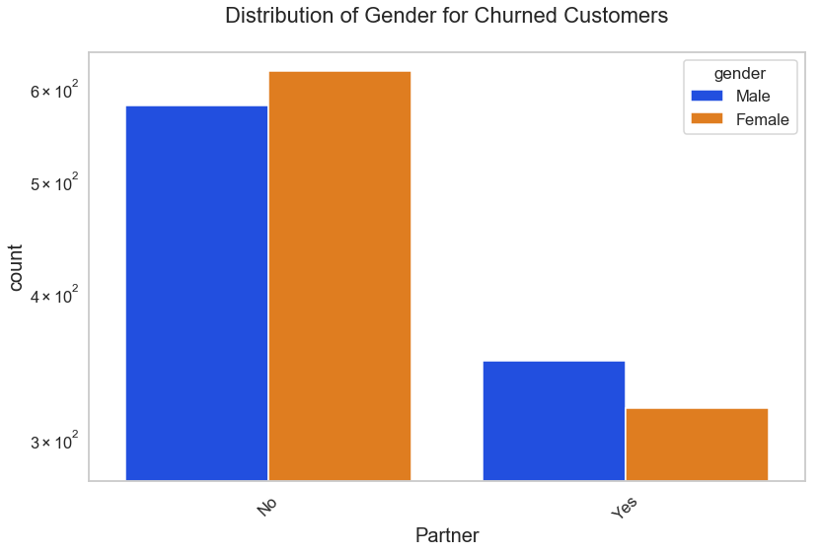

uniplot(new_df1_target0,col='Partner',title='Distribution of Gender for Non Churned Customers',hue='gender')

**Output:**

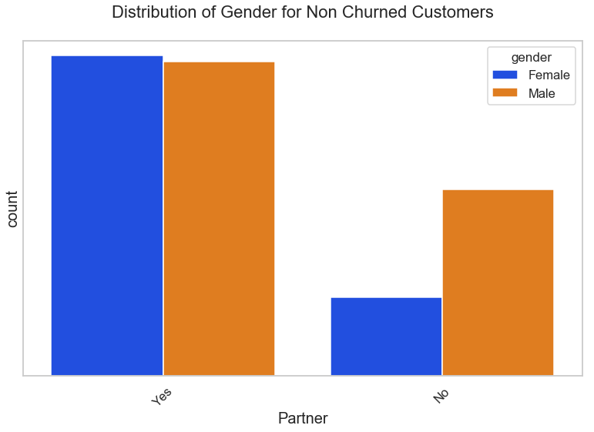

uniplot(new_df1_target1,col='PaymentMethod',title='Distribution of PaymentMethod for Churned Customers',hue='gender')

**Output:**

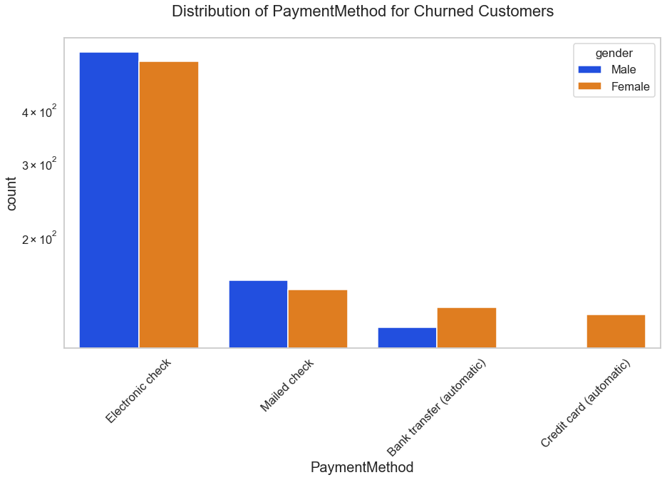

uniplot(new_df1_target1,col='Contract',title='Distribution of Contract for Churned Customers',hue='gender')

**Output:**

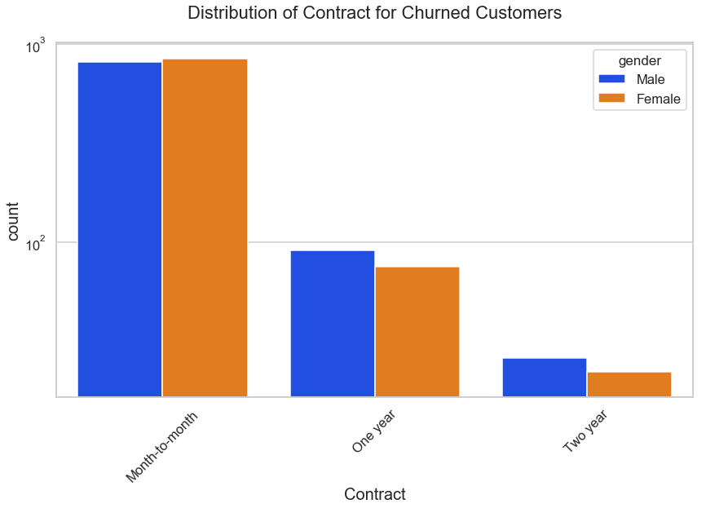

uniplot(new_df1_target1,col='TechSupport',title='Distribution of TechSupport for Churned Customers',hue='gender')

**Output:**

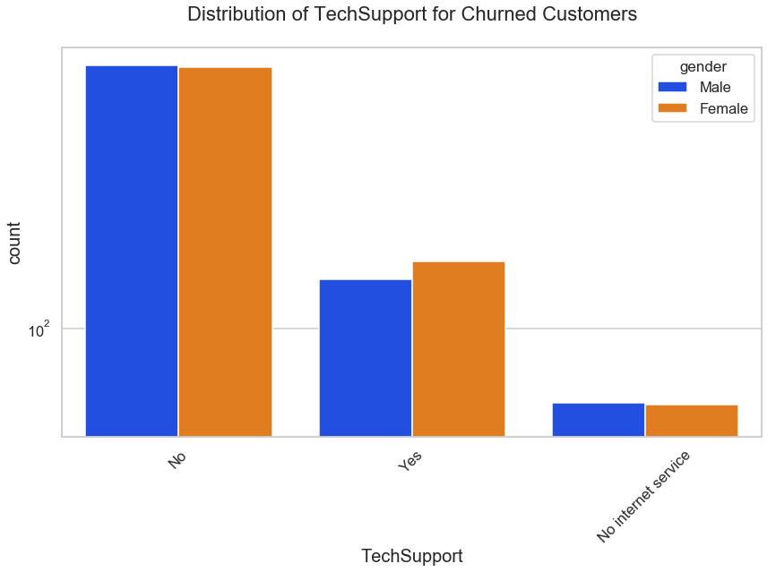

uniplot(new_df1_target1,col='SeniorCitizen',title='Distribution of SeniorCitizen for Churned Customers',hue='gender')

**Output:**

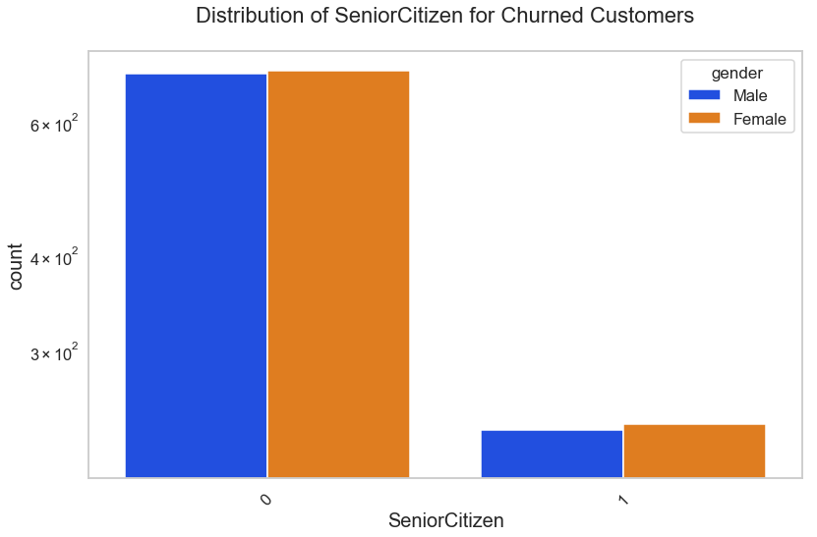

**Derived Metrics Feature Binning :**

Derived metrics create a new variable from the existing variable to get a insightful information from the data by analysing the data.

* Feature Binning
* Feature Encoding
* From Domain Knowledge
* Calculated from Data

**Conclusion:**

These are some of the quick insights from this exercise:

1. Electronic check medium are the highest churners.

2. Contract Type - Monthly customers are more likely to churn because of no contract terms, as they are free to go customers.

3. No Online security, No Tech Support category are high churners.

4. Non senior Citizens are high churners.



*****