ResNet50 for Image Forgery Classification
on the IMD2020 Dataset
Detailed report on the ResNet50 model trained with the patch-based pipeline
Binary classification: 0 = Authentic, 1 = Forged
Prepared: 4 October 2026

1. Summary
This report documents a ResNet50 image classifier trained to decide whether a photograph is authentic or forged, using the IMD2020 dataset on Kaggle. The model is the first of five architectures (ResNet50, EfficientNet-B0, DenseNet121, ConvNeXt-Tiny and ViT-B/16) trained in the same notebook on the same data split and patch pipeline (learning rates differed for ConvNeXt and ViT).
Because tampered regions are often tiny, images were not shrunk to a single 224×224 input. Instead the model was trained on native-resolution 224×224 patches, and each test image was scored by tiling it into patches and taking the highest forged probability.
Key results (test set, 244 images): AUC 0.783 (95% interval 0.71–0.85); accuracy 80.3%; Forged recall 91.1% (185 of 203); Authentic images recognised 26.8% (11 of 41); balanced accuracy 0.590 (0.52–0.67); F1 = Dice 0.885.
Main conclusion. The model carries a real but weak signal: its AUC interval stays well above 0.5. It is not a reliable forgery detector. It labels most images as forged, so its accuracy (0.803) and F1 (0.885) are slightly below a trivial classifier that always answers “Forged” (0.832 and 0.908). The same configuration scored an AUC of only 0.656 in an earlier run, so individual results should be treated as unstable.

2. Objective and scope
The goal is image-level binary classification of IMD2020 images. The report covers the dataset, the data preparation, the model and training configuration, the results of the final run, and the earlier runs that led to this design. It evaluates the model with accuracy, precision, recall, F1 score, Dice score, balanced accuracy, AUC and the confusion matrix.
Dice in this report is computed at image level for the Forged class. For a classifier this equals the F1 score of that class, so the two columns are identical. A pixel-level Dice against the mask images would require a localisation step and was not part of this run.

3. Dataset
IMD2020 is stored in three folders under /kaggle/input/datasets/saikotahmed/imd2020/IMD2020/.
Folder | Content | Files | Formats
Authentic | Original, untouched photographs (label 0) | 414 | 414 JPG
img | Forged photographs (label 1) | 2,010 | 1,813 JPG, 197 PNG
mask | Ground-truth tamper masks for the forged images | 2,010 | 2,010 PNG

3.1 What the inspection showed
- Pairing. Every forged image has a mask. The mask name is the forged name plus “_mask” (00006_fake.jpg ↔ 00006_fake_mask.png). All 2,010 forged images matched, with no orphan masks.
- Two naming schemes. Numeric IDs such as 00006_orig.jpg and 00006_fake.jpg form real authentic/forged pairs; 40 source images have both versions. The remaining 1,968 forged images (for example c8swtoq_0) and 374 authentic images (for example 1a07yi_orig) have no counterpart. Only two source IDs have two forged variants.
- Class imbalance. There are 414 authentic and 2,010 forged images, about 1 : 4.9.
- Variable size. Images are different sizes, for example 1368×953 and 1200×836, so a fixed-size input needs a deliberate strategy.
- Small tampered regions. Masks contain only the values 0 and 255. The tampered area has a median of 4.65% of the image, a minimum of 0.01% and a maximum of 88.3%.
- File format. All authentic images are JPG, while 197 forged images are PNG. A model could in principle use file format as a shortcut; this was not tested.

4. Data preparation

4.1 Train / validation / test split
The data was split 80 / 10 / 10 with StratifiedGroupKFold (10 folds, shuffled, random seed 42). Images are grouped by source ID so that an authentic photograph and its forged edit always land in the same split. This prevents the model from seeing an original in training and its edit in testing. Class proportions are preserved in every split.
Split | Authentic | Forged | Total
Train | 331 | 1,606 | 1,937
Validation | 42 | 201 | 243
Test | 41 | 203 | 244
All | 414 | 2,010 | 2,424
A check confirmed that no source ID is shared between any two splits.

4.2 Patch-based training
A first attempt resized every image to 224×224 (Section 7.1). That performs poorly on this task, which is consistent with resizing erasing fine tampering traces, although this explanation was not proven. The final pipeline therefore works at native resolution:
- Authentic images: a random 224×224 crop, label 0.
- Forged images: with probability 0.5 a crop containing tampered pixels (located with the mask), label 1; otherwise a crop from an untampered area of the same image, label 0, so the model must find the edit rather than recognise the picture.
- Random horizontal flip, ImageNet mean/standard-deviation normalisation, and zero padding for images smaller than 224 pixels.
- Two patches are drawn per training image per epoch (3,874 patches, 122 batches of 32).
About 43.3% of training patches are labelled Forged. A check on 300 sampled patches found no forged patch without tampered pixels and no clean patch containing any. Tampered pixels in positive patches ranged from 32 to 50,176, with a median of 12,485 (of 50,176 pixels per patch).

4.3 Image-level scoring
Validation and test images are cut into a regular grid of 224×224 tiles. At most 24 evenly spaced tiles are scored per image, and the image score is the highest forged probability among its tiles. The decision threshold is tuned on the validation set (0.05 to 0.95, maximising macro-F1) after every epoch; the test set is evaluated once with the threshold of the selected epoch.
Images have between 2 and 220 tiles (median 15 to 18). In total 73 of 243 validation images and 62 of 244 test images exceed the 24-tile cap, so for those images a very small forgery can be missed because its tile was not sampled.

5. Model and training configuration
Item | Setting
Architecture | ResNet50 (torchvision), ImageNet-pretrained weights
Classification head | Original fc layer replaced by Linear(2048→128) → ReLU → Linear(128→2); softmax is applied only when scoring
Parameters | 23,770,562 total, all trainable (full fine-tuning, no frozen layers)
Loss | Cross-entropy with class weights [Authentic 0.882, Forged 1.155] from the patch balance
Optimiser | Adam, learning rate 1e-4
Batch size / epochs | 32 / 10 (122 steps per epoch)
Input | 224×224 native-resolution patches, ImageNet normalisation
Model selection | Epoch with the best validation macro-F1 at its tuned threshold; checkpoint saved when a new best is reached
Random seed | 42
Hardware / time | CUDA GPU on Kaggle; training completed in 10 min 46 s

6. Results

6.1 Training behaviour
Training accuracy rose steadily from 70.5% to 87.3% and training loss fell from 0.573 to 0.307. Validation AUC rose from 0.70 to 0.80 but not smoothly, with a dip to 0.71 at epoch 5. The best epoch by the selection rule was the last one (epoch 10, validation macro-F1 0.684 at threshold 0.54), so it cannot be said from this run whether more epochs would help.
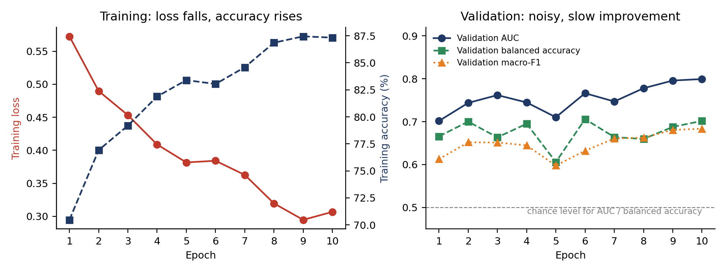
Figure 1. Training and validation curves for ResNet50 (patch pipeline, 10 epochs).
Epoch | Train loss | Train acc. (%) | Train F1 | Val AUC | Val macro-F1 | Val balanced acc. | Threshold
1 | 0.5726 | 70.47 | 0.7047 | 0.7017 | 0.6127 | 0.6658 | 0.65
2 | 0.4897 | 76.92 | 0.7690 | 0.7437 | 0.6519 | 0.7001 | 0.55
3 | 0.4532 | 79.19 | 0.7908 | 0.7618 | 0.6514 | 0.6635 | 0.54
4 | 0.4088 | 81.88 | 0.8182 | 0.7447 | 0.6447 | 0.6951 | 0.68
5 | 0.3816 | 83.40 | 0.8324 | 0.7103 | 0.5978 | 0.6059 | 0.65
6 | 0.3841 | 83.04 | 0.8297 | 0.7662 | 0.6322 | 0.7059 | 0.78
7 | 0.3627 | 84.59 | 0.8441 | 0.7469 | 0.6609 | 0.6640 | 0.58
8 | 0.3195 | 86.86 | 0.8672 | 0.7778 | 0.6626 | 0.6596 | 0.37
9 | 0.2946 | 87.45 | 0.8741 | 0.7957 | 0.6808 | 0.6878 | 0.36
10 | 0.3067 | 87.33 | 0.8721 | 0.7992 | 0.6835 | 0.7017 | 0.54
Table 1. Per-epoch results. The shaded row is the selected epoch. Validation uses image-level scoring, and macro-F1 and balanced accuracy are taken at that epoch's tuned threshold.
The tuned threshold jumps between 0.36 and 0.78 from one epoch to the next. This suggests the score distribution is not stable and that threshold tuning on only 42 authentic validation images is noisy.

6.2 Test-set performance
The test set contains 41 authentic and 203 forged images. Forged is the positive class. Intervals are 95% bootstrap intervals (2,000 resamples of the test images).
Metric | Value | 95% interval / meaning
Accuracy | 0.803 | 0.75–0.85 · share of images classified correctly
Precision (Forged) | 0.860 | 0.81–0.90 · of images called Forged, share that are Forged
Recall (Forged) | 0.911 | 0.87–0.95 · share of forged images detected
F1 score (Forged) | 0.885 | 0.85–0.91 · balance of precision and recall
Dice score (image level) | 0.885 | 0.85–0.91 · identical to F1 for the Forged class
Balanced accuracy | 0.590 | 0.52–0.67 · average of Forged recall and Authentic recall
Macro-F1 | 0.600 | 0.52–0.68 · F1 averaged over both classes
AUC | 0.783 | 0.71–0.85 · chance of ranking a forged image above an authentic one

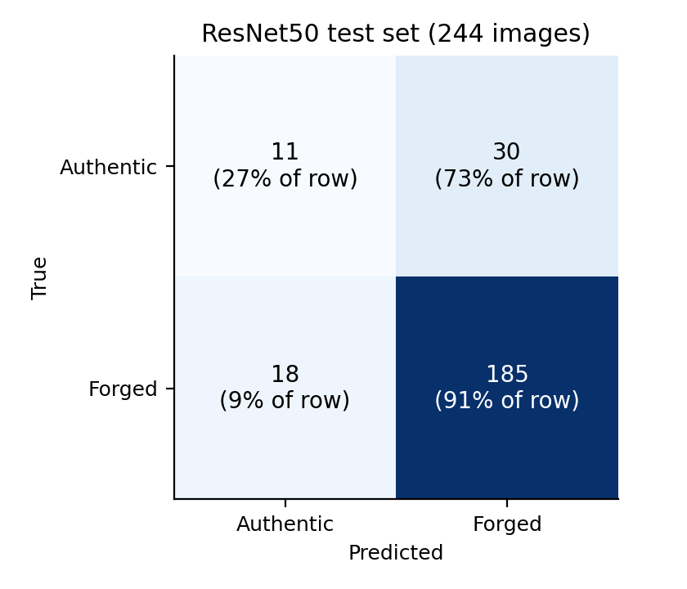
Figure 2. Confusion matrix on the test set (threshold 0.54).
 | Predicted Authentic | Predicted Forged
True Authentic (41) | 11 | 30
True Forged (203) | 18 | 185
Table 2. Test confusion matrix (rows = true class).

6.3 How to read these numbers
- Most detections come from saying “Forged” often. 215 of 244 images were labelled Forged. That finds 185 of 203 forgeries (91.1%) but also mislabels 30 of 41 authentic images (73.2%).
- Accuracy and F1 look good only because 83% of the test set is forged. A classifier that always answers “Forged” would score 0.832 accuracy and 0.908 F1 / Dice, which is higher than this model on both. Balanced accuracy (0.590) and AUC (0.783) are the more honest measures.
- The signal is real but modest. An AUC of 0.783 means the model ranks a random forged image above a random authentic image about 78% of the time. The lower end of its interval (0.71) is clearly above 0.5, but balanced accuracy has a lower bound of 0.52, close to chance.
- The test set is small on the authentic side. One authentic image changes Authentic recall by about 2.4 percentage points, so the Authentic-class numbers are noisy.

6.4 Comparison with the other four models (same notebook)
All five models used the same split, patches, loss weights and 10 epochs. Learning rates were 1e-4 (ResNet50, EfficientNet, DenseNet), 5e-5 (ConvNeXt) and 2e-5 (ViT).
Model | AUC | Balanced acc. | F1 / Dice | Authentic recognised | Forged detected
ResNet50 | 0.783 | 0.590 | 0.885 | 11 / 41 | 185 / 203
EfficientNet-B0 | 0.721 | 0.602 | 0.852 | 15 / 41 | 170 / 203
DenseNet121 | 0.698 | 0.597 | 0.834 | 16 / 41 | 163 / 203
ConvNeXt-Tiny | 0.720 | 0.636 | 0.913 | 13 / 41 | 194 / 203
ViT-B/16 | 0.672 | 0.619 | 0.848 | 17 / 41 | 167 / 203
Always predict Forged | 0.500 | 0.500 | 0.908 | 0 / 41 | 203 / 203
Table 3. Test-set comparison. ResNet50 has the highest AUC but the lowest balanced accuracy.
The 95% intervals of the five models overlap almost completely, so this run does not show that ResNet50 is the better architecture. The ranking also changed between runs (Section 7.3).

7. Development history and run-to-run stability
ResNet50 was trained three times in the course of the project. The results of the two earlier runs come from the outputs displayed during the project; their per-epoch logs are not part of the final notebook.

7.1 Whole-image attempt (resize to 224×224, 50 epochs)
This followed the original ResNet50 template: images were resized to 224×224, the full network was fine-tuned with Adam (1e-4) and a class-weighted loss, for 50 epochs. Training metrics kept improving (final training accuracy 97.1%, training F1 0.952), but validation macro-F1 stayed between 0.37 and 0.49 in every epoch and validation loss rose from 0.67 to 2.53. The selected checkpoint was epoch 2 (validation F1 0.485), meaning no later epoch improved on it.
On the test set this model reached accuracy 0.643, Forged precision 0.863, recall 0.680 and F1 0.760, with 19 of 41 authentic images recognised (confusion matrix [[19, 22], [65, 138]]). The model memorised the training images without learning something that transfers, which motivated the patch pipeline. Note that this run used a fixed 0.5 decision threshold, whereas the patch runs tune the threshold on validation, so the numbers are not strictly like-for-like.

7.2 First patch-pipeline run (10 epochs)
With patches, validation AUC rose to 0.70–0.79 during training. The selected epoch was 3 (validation macro-F1 0.682, threshold 0.49). On the test set it reached an AUC of 0.656, balanced accuracy 0.531 and F1 0.866, recognising only 7 of 41 authentic images (confusion matrix [[7, 34], [22, 181]]).

7.3 Final run (this report)
The same configuration, retrained in a fresh notebook, reached an AUC of 0.783 and balanced accuracy 0.590.
Run | Test AUC | Balanced acc. | F1 / Dice | Authentic recognised
Resize 224×224, 50 epochs | not measured | 0.571 | 0.760 | 19 / 41
Patch pipeline, first run | 0.656 | 0.531 | 0.866 | 7 / 41
Patch pipeline, final run | 0.783 | 0.590 | 0.885 | 11 / 41
Table 4. ResNet50 across the three runs.
Stability. Two runs of the same patch configuration differed by 0.127 in AUC. Differences of this size are as large as the differences between architectures, so a single run should not be used to rank models. Sources of variation include random patch sampling, GPU non-determinism and the very small authentic validation and test sets.

8. Discussion

8.1 Why performance is limited (hypotheses)
These are plausible explanations. None was tested in this project.
- Subtle, varied tampering. IMD2020 contains real-world edits; many tampered regions are a small fraction of the image, and an ImageNet-trained network is designed to recognise objects rather than editing traces.
- Small dataset. With 1,937 training images (331 authentic) the network can memorise content, which is the pattern seen in the whole-image run.
- Training/test mismatch. Training positives are centred on tampered areas using the masks, but at test time the model must scan up to 24 tiles with no mask. Taking the maximum over many tiles gives an authentic image many chances to produce one high score, which could explain the high false-alarm rate (30 of 41).
- Tile cap. Scoring at most 24 tiles applies to 62 of the 244 test images; in those, the tile containing a small forgery may not be sampled.
- Possible shortcuts. File format (JPG versus PNG) and image source differ between the classes.

8.2 Limitations
- Only 41 authentic images in the test set and 42 in validation, so Authentic-class results and threshold tuning are noisy.
- A single split; no cross-validation. The run-to-run change in Section 7.3 shows the result depends strongly on chance.
- Dice is image-level (equal to F1), not a pixel-level overlap with the masks.
- Selecting the best of five models on the test set is slightly optimistic. The ResNet50 AUC in particular should not be quoted as proof that it is the best architecture.

9. Conclusions and recommendations
The ResNet50 model trained with native-resolution patches detects some forgeries (AUC 0.783) but mostly by labelling images as forged, and it recognises only 11 of 41 authentic test images. The patch pipeline improved behaviour on validation (the whole-image run never exceeded a macro-F1 of 0.49 there), but this did not turn into a clear gain on the test set: balanced accuracy was 0.571 for the whole-image run and 0.531 and 0.590 for the two patch runs, and the runs also used different decision thresholds (fixed 0.5 versus tuned). The model is not reliable enough to be used as a forgery detector, and its performance varies noticeably from run to run.
Recommended next steps, in order of value:
- Cross-validation (for example five grouped folds) so that all 414 authentic images are used for evaluation and results can be averaged across runs.
- Pixel-level Dice. Produce heat-maps (for example Grad-CAM) and compare them with the mask images to test whether the model looks at the tampered region.
- Reduce false alarms. Try averaging the top few tile scores instead of the maximum, score more tiles per image, and use hard negatives (authentic patches that the model wrongly flags) in training.
- Check shortcuts. Re-train after converting all images to a common format and quality to see whether the result changes.
- Report balanced accuracy and AUC next to F1 in any future results, together with the always-Forged baseline.

Appendix A. Files produced by the run
File | Content
ResNet50_patch_training_log.csv | Per-epoch training and validation metrics
ResNet50_test_scores.npy | Test-image scores and true labels used for the metrics and intervals
best_overall_model.pth | Checkpoint of the selected ResNet50 epoch (epoch 10) with its threshold 0.54; ResNet50 had the highest test AUC, so it was saved as the best overall model
results_patch.pkl | Test results for all five models
comparison_table.csv / comparison.png | Five-model comparison table and chart
split.csv | Image paths, labels, source IDs and the train/validation/test assignment

