**Step1 – Creation of the Chatbot:**

Create the below intents in the bot

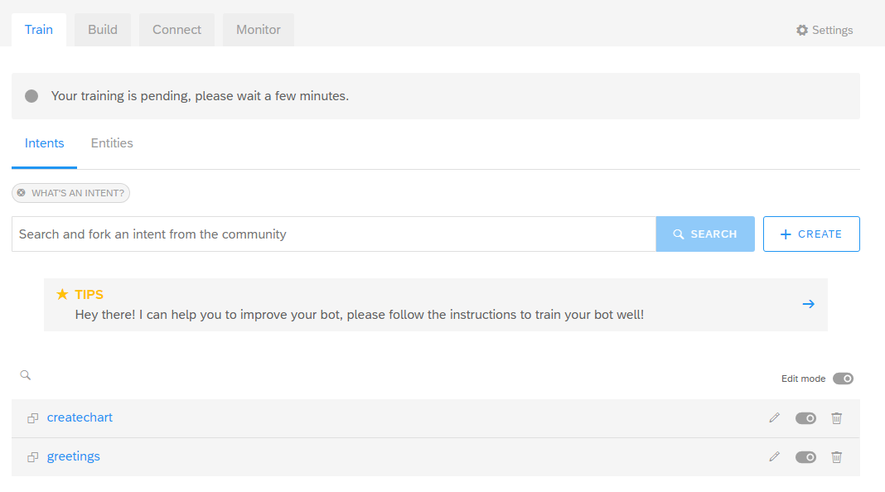

Create Entities:

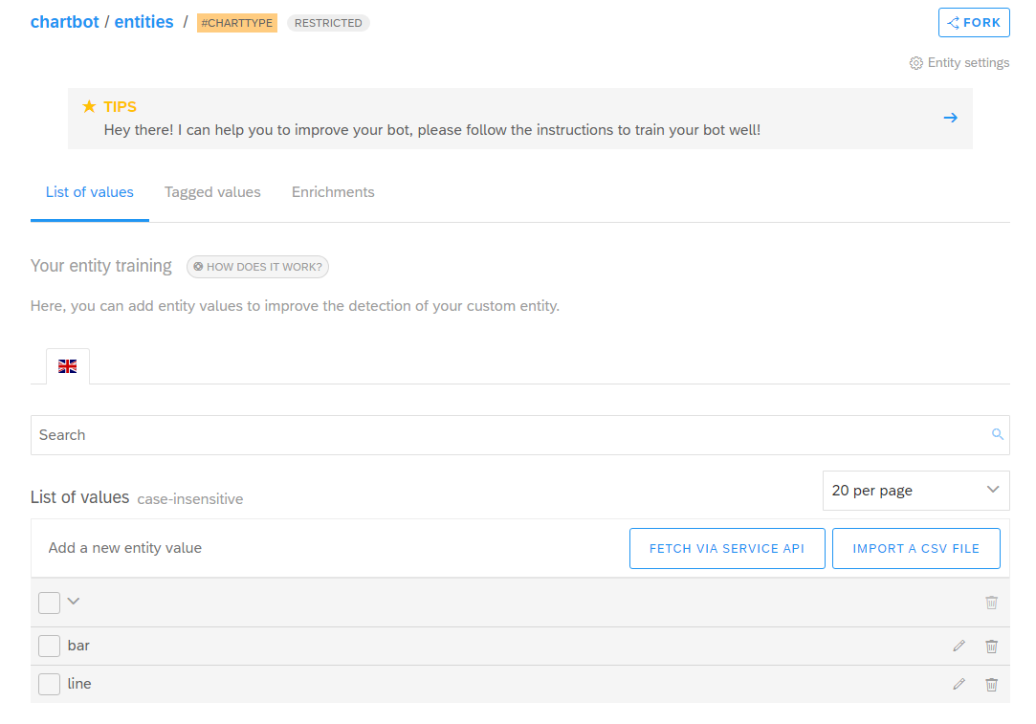

Create a Skill:

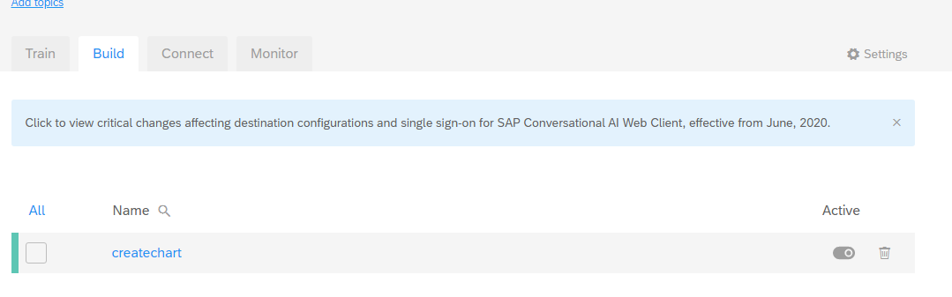

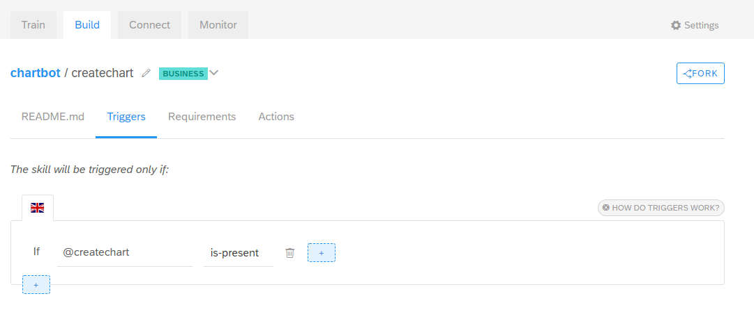

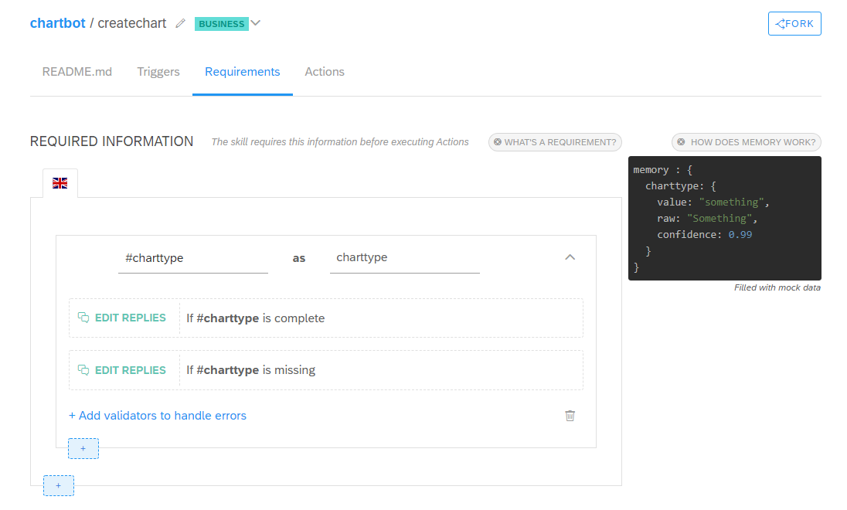

Is Complete:

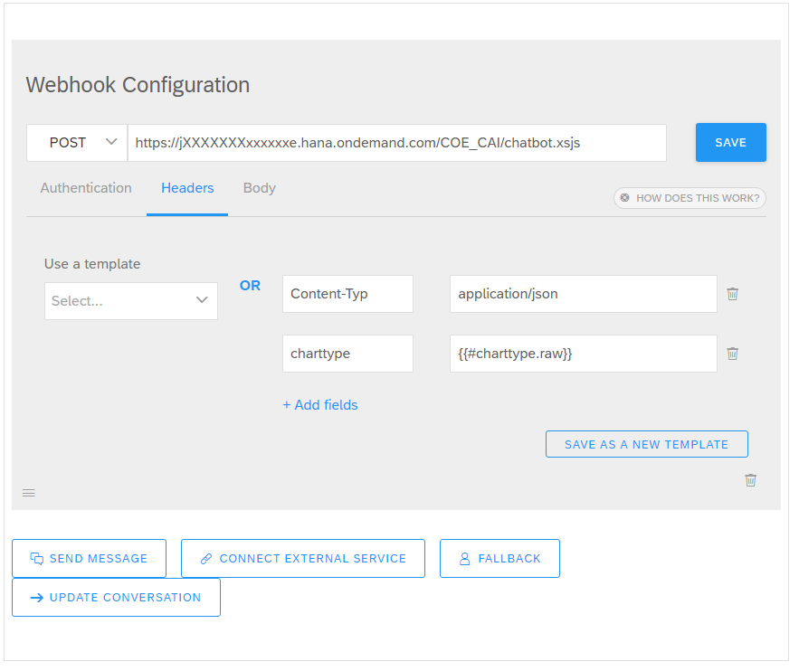

Is Missing:

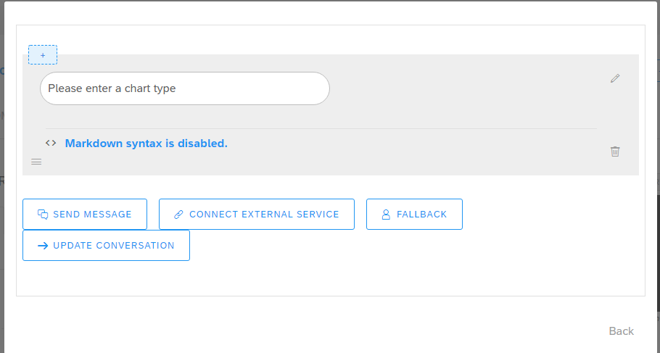

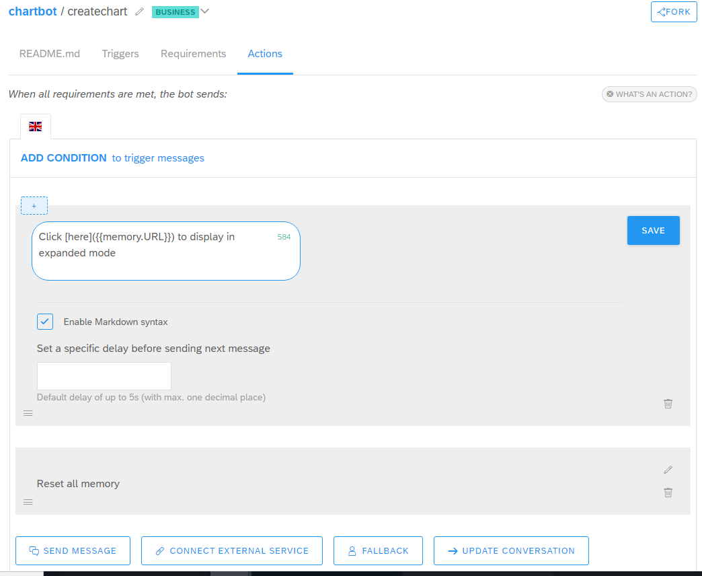

**Step2: Creation of Webhook**

* Fetch the data that you wan to be displayed in the Chart
* Then Create a Rich Message to send it back to SAP CAI ([chatbot.xsjs](https://github.com/sabarna17/CAICHART/blob/master/chatbot.xsjs))
* Update the Memory with a dynamic URL

**Step3: Implementation of the Dynamic URL based Web Page**

* Use code [dynURL.xsjs](https://github.com/sabarna17/CAICHART/blob/master/dynURL.xsjs) to deploy the webpage and [chart.js](https://github.com/sabarna17/CAICHART/blob/master/chart.js) for the JS Library