PART-1
Create a web interface and perform the following operations through the interface and display appropriate results.

Q1. Display the Artist details based on any one of the following: name, city, and commission.

i) Displaying Artist details based on Name.
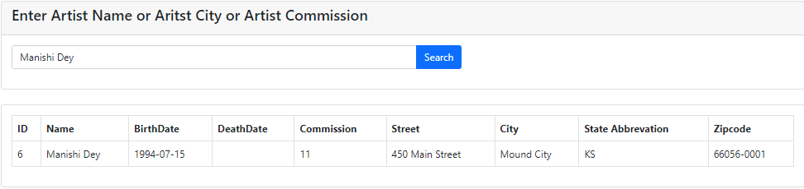
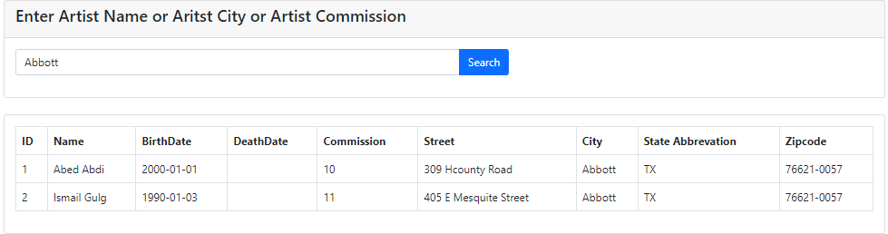
ii) Displaying Artist details based on City

iii) Displaying Artist details based on Commission
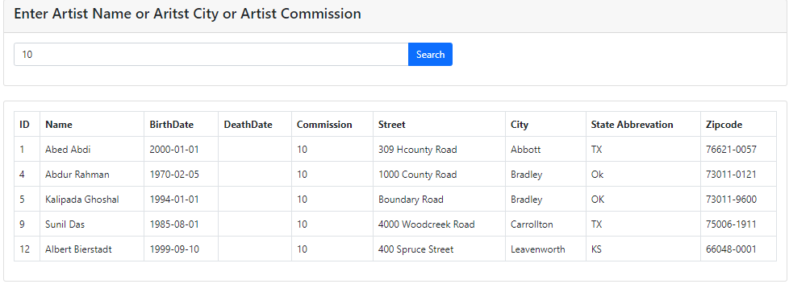
Q2. Insert a new artist “Rahim DograN”, in the ARTIST table in the database. You should insert values for all the attributes in the ARTIST table. Link the new artist with the state of Texas in the states table.
i) User Interface of Insert Artist

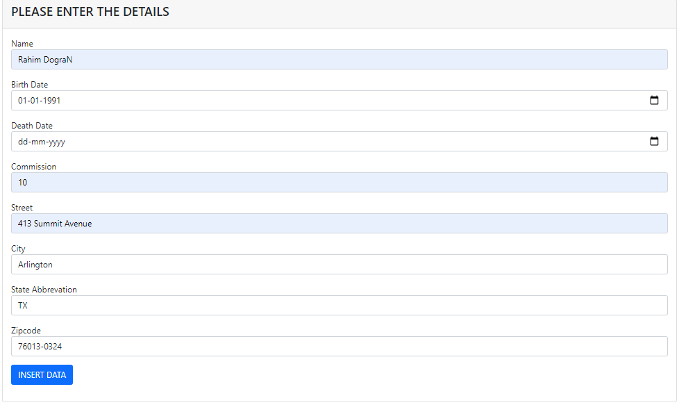
ii) Status to show whether Query is executed or not
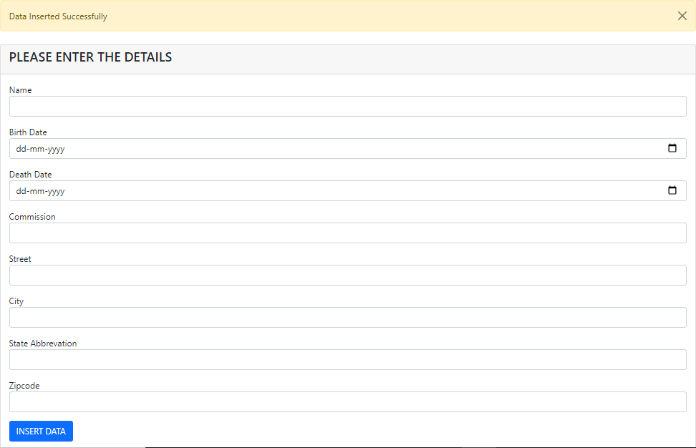
iii) Showing the inserted data in Display Artist Page and Database in phpMyadmin
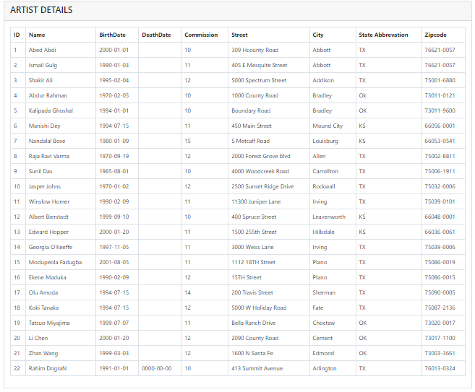
Note: The artist name “Rahim DograN” is inserted at ID 22
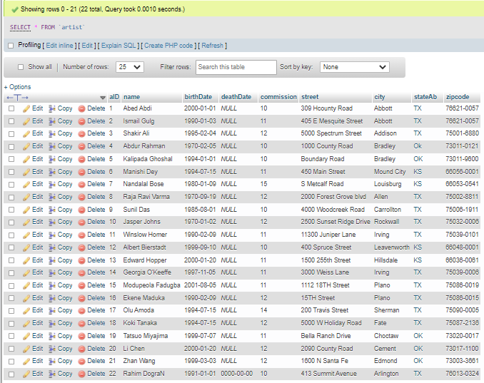
Q3. Update the artist name 'Nandalal BoseD' to 'Nandalal Bose' in the ARTIST record that you just added.

i) Update User Interface
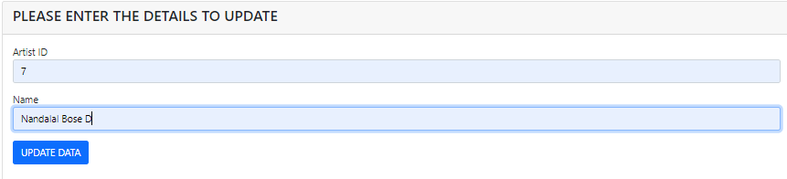
ii) Note: aID =7 has name as Nandalal Bose before Update is performed
iii) Status that shows whether Data was Updated or Not
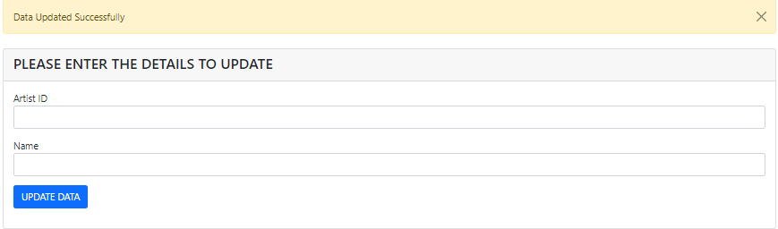
iii) Database of artist details in display artist page and in phpMyadmin
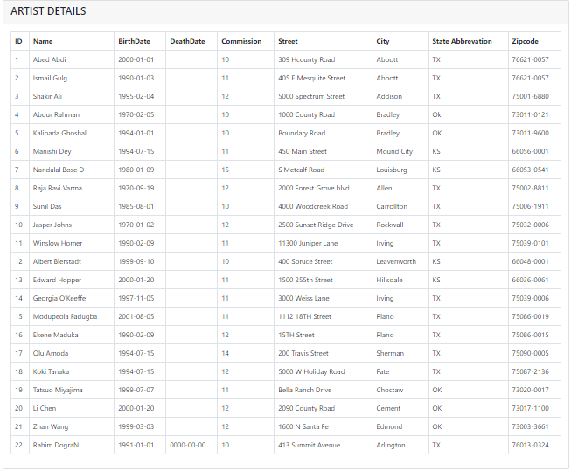Note: aID =7 has name changed to Nandalal Bose D after Update is performed.
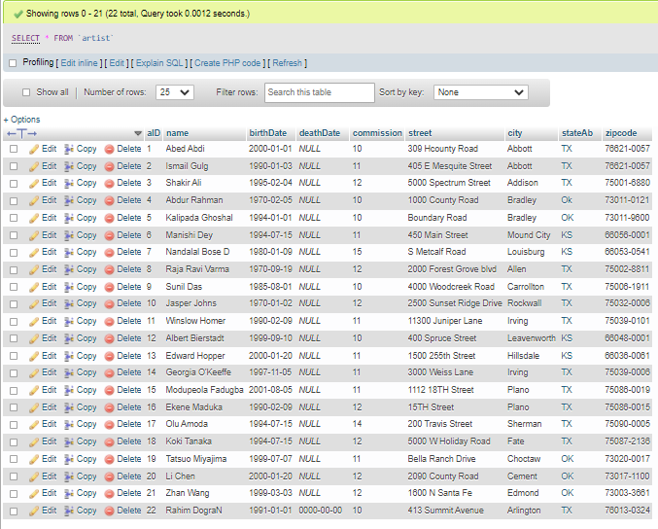
Q4. Delete the artist record that you just added to the database.

i) Delete Data User Interface

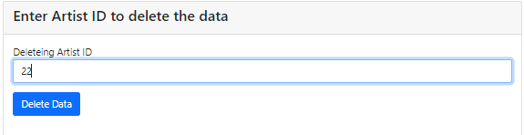
ii) Note: aID =22 is present in Database before delete query is executed.
iii) Status whether the data was deleted or not.
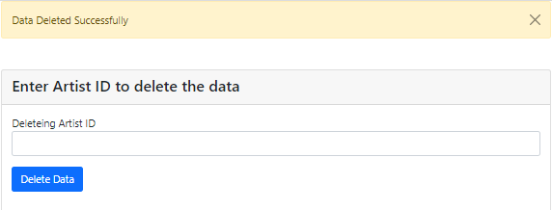
iv) Note: aID =22 is deleted in Database after delete query is executed.
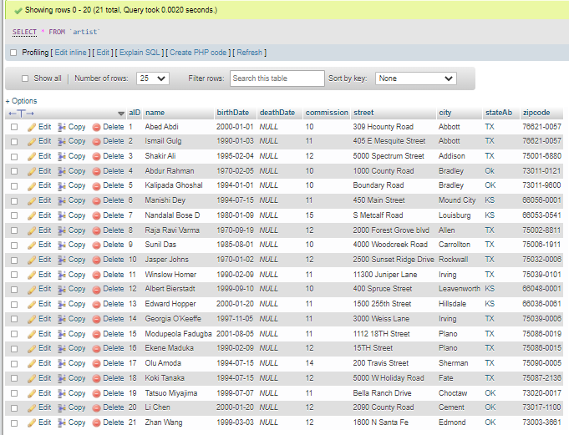
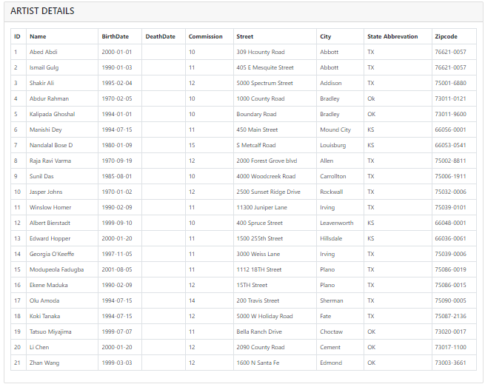
Technologies and Programming languages used
- HTML (Hyper Text Markup Language)
- PHP
- Bootstrap along with Content Delivery Networks for JavaScript, jQuery and Cascading Style Sheets (CSS)
- Software: XAMPP with phpMyadmin for database.
References for User Interface
- https://www.fundaofwebit.com/post/how-to-insert-data-into-database-in-php
- https://www.fundaofwebit.com/post/how-to-make-search-box-and-filter-data-in-html-table-from-database-in-php-mysql
- https://www.fundaofwebit.com/post/how-to-edit-and-update-data-by-id-in-php-mysql
- https://www.fundaofwebit.com/post/how-to-delete-data-from-database-by-id-in-php-mysql
- https://www.youtube.com/channel/UCFySUiNfhvtgdgTdWbXnn6Q
- https://www.w3schools.com/bootstrap4/bootstrap_cards.asp

Links to Run User Interface in Local System
- Search Artist on Name
http://localhost:8080/dbphase3/filterartist.php
- Display Artist
http://localhost:8080/dbphase3/dartist.php
- Insert Artist
http://localhost:8080/dbphase3/insertdata.php
- Delete Artist
http://localhost:8080/dbphase3/deletedata.php
- Display Artist
http://localhost:8080/dbphase3/dartist.php

PART-2
QV1 Create a view ArtworkInfo that has the following attributes:
AcqYear (the year the artwork was acquired by the art gallery), AcqMonth (the month, the artwork was acquired by the art gallery - January, February etc.), ArtistName (name of the artist), DOB (Artis’s birthDate), ArtistState (State where the artist lives), Title (title of the artwork), Form (form of the artwork – painting/sculpture etc.), ArtworkPrice (Price of the artwork), creationDate (the date when the artwork was created), AcquisitionDate (the date the artwork was acquired by the ), UpfrontDate (the date the first payment is made to the artist ), SaleDate (the date of the sale of the artwork – null value if the artwork is not sold), FinalDate (the date the artist receives the final payment after the sale of the artwork- null value if artwork is not sold), CustomerName (Name of the customer(s) who bought the artwork - null value if the artwork is not bought), CustomerState (the state where the customer lives). Use the tables as needed.
The records should be sorted by the AcqYear, AcqMonth month (March, April, May, … and NOT alphabetically by month name- April, March, May, ..), and the ArtistName.
Note: Write a sql statement to fetch all records from the view ArtworkInfo. Include the screenshot of the result set.
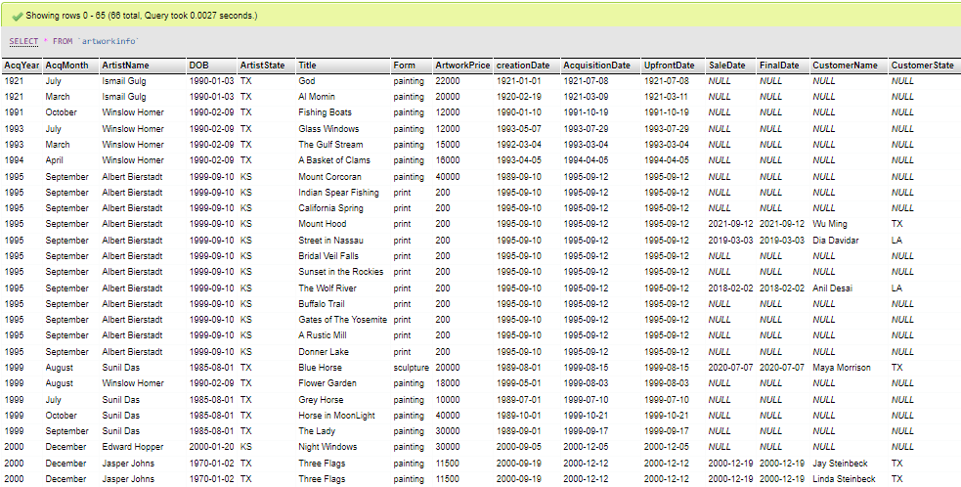
Note: There are 66 data present in view. As screenshot clarity decreases we have attached a few data here.
CREATE VIEW ArtworkInfo AS SELECT YEAR(acquisitionDate) AS AcqYear, MONTHNAME(acquisitionDate) as AcqMonth, artist.name AS ArtistName, artist.birthDate AS DOB, artist.stateAb AS ArtistState, artwork.title AS Title, artwork.form AS Form, artwork.price AS ArtworkPrice, artwork.creationDate AS creationDate, artwork.acquisitionDate AS AcquisitionDate, P.upfrontDate AS UpfrontDate, B.saleDate AS SaleDate, P.finalDate AS FinalDate, C.name AS CustomerName, C.stateAb AS CustomerState from artist AS artist INNER JOIN artwork AS artwork ON artist.aID = artwork.aID LEFT JOIN payments AS P ON artwork.artID = P.artID LEFT JOIN bought AS B ON P.artID = B.artID LEFT JOIN customer AS C ON B.cID = C.cID
ORDER BY AcqYear, AcqMonth, ArtistName;
QV2 Use the view ArtworkInfo to list the names of the artists, their state, customer name, and the customer state for artists whose artwork has been bought by a customer who lives in a state other than where the artist lives.
Write a query to verify that your list of Artist names is correct
SELECT ArtistName, ArtistState, CustomerName, CustomerState
FROM `artworkinfo`
WHERE SaleDate IS NOT NULL and ArtistState<>CustomerState;

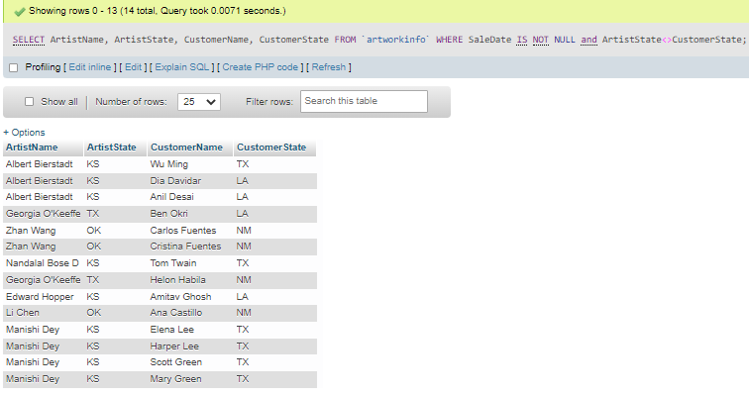
VERIFICATION
SELECT A.name,A.stateAb,C.name,C.stateAb
FROM artwork as AW inner join artist as A ON AW.aID = A.aID inner join bought as B ON AW.artID = B.artID inner join customer as C on C.cID = B.cID
WHERE A.stateAb<>C.stateAb;

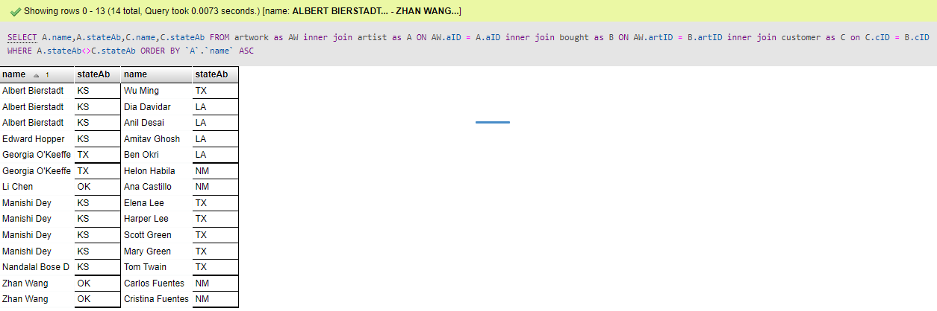

QV3 Use the view to list the names of artists and the number of customers they have so far. Sort the result by the artist name.
SELECT ArtistName, count(CustomerName) as CustomerCount
FROM `artworkinfo`
GROUP BY ArtistName
ORDER BY ArtistName ASC;

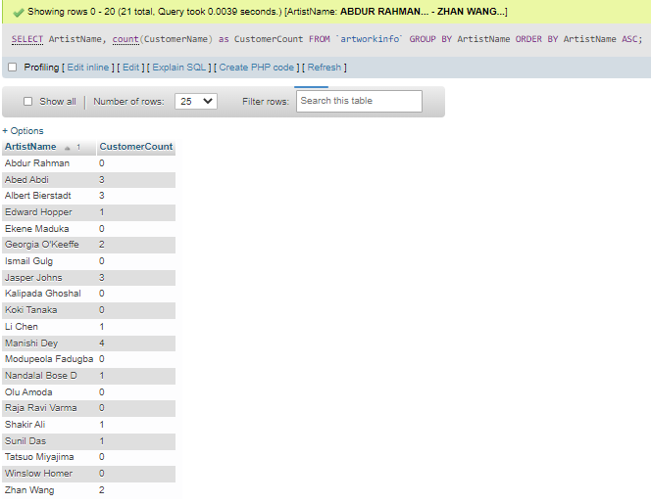
QV4 Use the view to list the names of artists and the number of artworks they have so far available in the Art Gallery.
SELECT COUNT(ArtistName) as Number_of_Artworks,ArtistName
FROM(SELECT ArtistName,Title
FROM artworkinfo
GROUP BY Title
ORDER BY ArtistName)as A
GROUP BY ArtistName
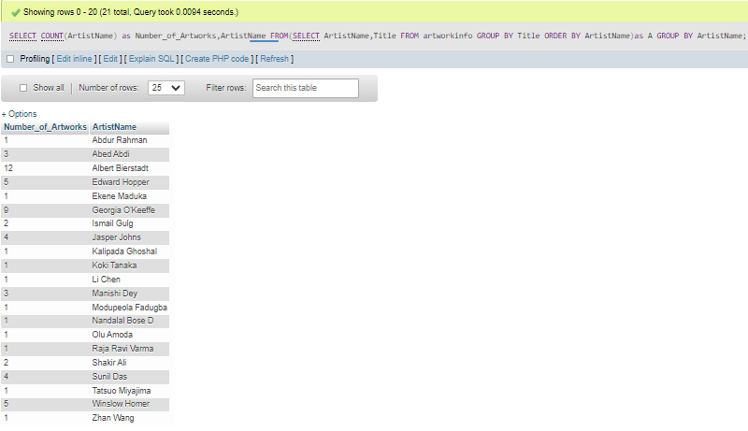

QV5 Use the view ArtworkInfo to list the names of the artists along with the number of artworks, minimum, and maximum price of their artwork.
How can you verify that your results are correct?

SELECT ArtistName, count(Title) AS CountOfArtworks, max(ArtworkPrice), MIN(ArtworkPrice)
FROM (SELECT ArtistName,Title,ArtworkPrice
FROM artworkinfo
GROUP BY Title
ORDER BY ArtistName)as A
GROUP BY ArtistName
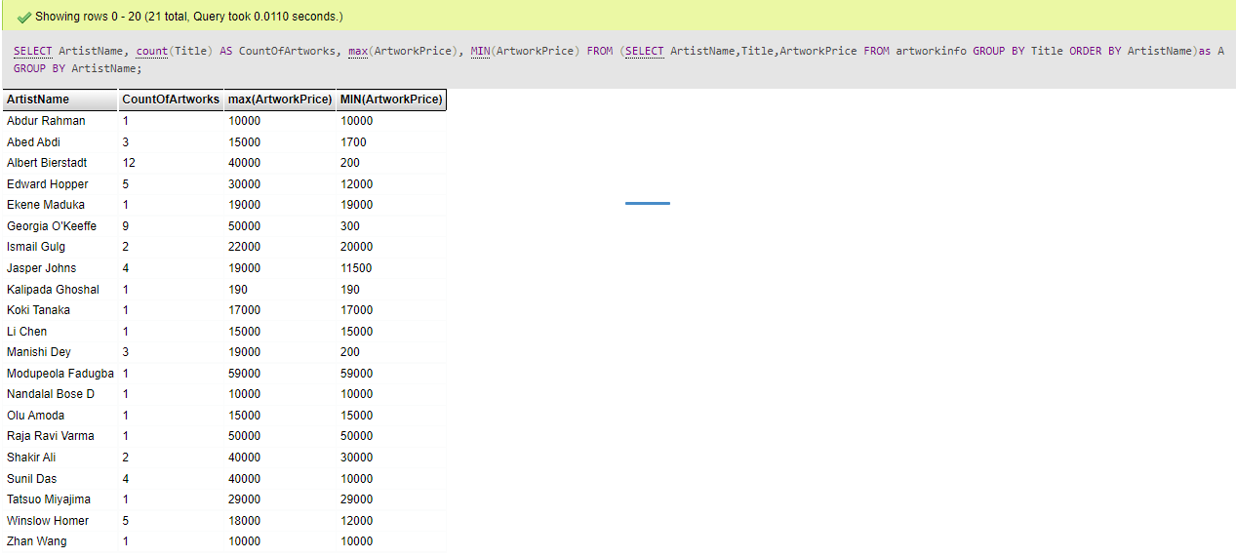

From above output I am going to fetch details about artist Ismail Gulg who has 2 artworks and its name along with its price.

SELECT DISTINCT AW.title, A.name, AW.price
FROM artist A ,artwork AW
WHERE A.aID = AW.aID and A.name='Ismail Gulg'
GROUP BY AW.title

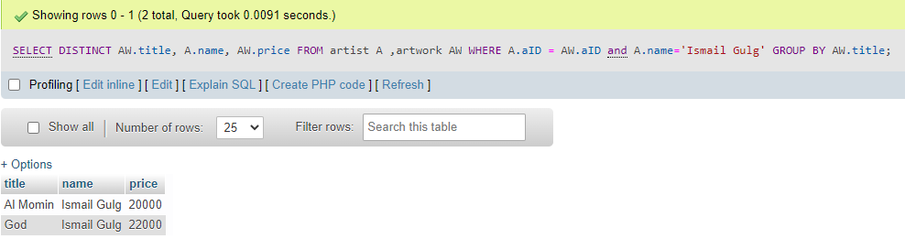

QV6 Use the view ArtworkInfo to list the names of the artists along with the artwork titles and the number of owners if the artwork was owned by more than 1 customer.

SELECT ArtistName, Title, COUNT(CustomerName) AS NumberOfOwners
FROM `artworkinfo`
GROUP BY Title
HAVING COUNT(CustomerName)>1;

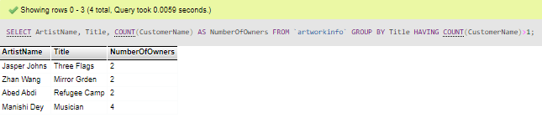
QV7 Use the view ArtworkInfo to list the names of the artists and the artwork titles if the artwork was owned by only 1 customer.

SELECT ArtistName, Title, COUNT(CustomerName) AS Owners
FROM `artworkinfo`
GROUP BY Title
HAVING COUNT(CustomerName)=1;

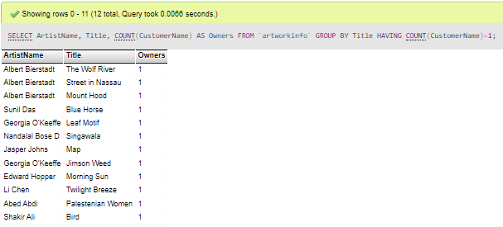

Work Distribution
Part 1 – Swaroop Belavadi Manjunatha (User-Interface)
Testing – Saba Ruhee Jagirdar
Part 2 – Saba Ruhee Jagirdar (Views and Queries)
Cross Check –Saba Ruhee Jagirdar & Swaroop Belavadi Manjunatha
Project Phase 3 Write up – Swaroop Belavadi Manjunatha
Project Phase 3 Evaluation – Saba Ruhee Jagirdar
References
- Fundamental of Database Systems 7th Edition by Dr. Elmasri.
HONOR CODE
I pledge, on my honor, to uphold UT Arlington's tradition of academic integrity, a tradition that values hard work and honest effort in the pursuit of academic excellence.
I promise that I will submit only work that I personally create or that I contribute to group collaborations, and I will appropriately reference any work from other sources. I will follow the highest standards of integrity and uphold the spirit of the Honor Code.
I will not participate in any form of cheating/sharing the questions/solutions
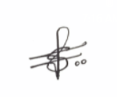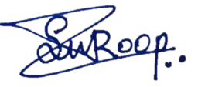

Saba Ruhee Jagirdar Swaroop Belavadi Manjunatha
1001848512 1001960012

Date of Submission: 28th November 2021.

