**Name**- Saba Ruhee Jagirdar

**ID**- 1001848512

**Course**- 5306 Distributed Systems-001 (Fall 2021)

# #LAB3

1. **HOW TO RUN THE CODE?**
   * Code can be executed on VSCode / Pycharm
   * Firstly, run the files- server_B.py, followed with the server_A.py and then run the client.py

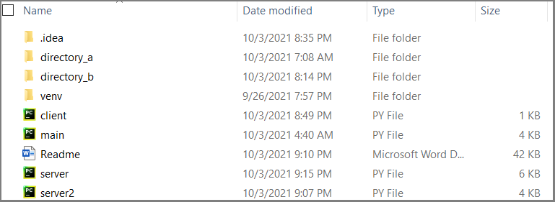

* + To run the files(server/client), use the Run Client (or server) on the right click (on Pycharm). Also, Ctrl+Shift+F10 could be used for the same purpose.

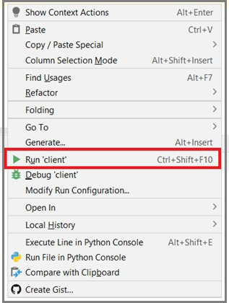

* + Make sure the directory path has been updated on the servers(dirBasePath)

1. Server_A.py-



1. Server_B.py-



* + Run the server B and then server A, followed with Client

# PROGRAM IN EXECUTION

# Run both of the servers, followed with the client.

# As per the lab requirement, lock the file in the directory A and and the same file should is not being updated or modified until the lock is removed.

# Post unlocking, synchronization happens.

# ASSUMPTIONS-

* + Port number for Server_A and Server_B has been hardcoded to be 6621 and 5621.
  + directory_a and directory_b have been placed at

“C:\Users\Saba Ruhee\PycharmProjects\lab3_jagirdar_saj8512”

* + Both of the servers have been placed on the same host(localhost)
  + The created socket object follows IPV4 and TCP
  + File sizes are assumed to be in **bytes**
  + No sub directories included

# REFERENCES-

* + [https://stackoverflow.com/questions/24237524/how-to-split-a-python-string-on-new-line- characters](https://stackoverflow.com/questions/24237524/how-to-split-a-python-string-on-new-line-characters)
  + <https://www.ibm.com/docs/en/i/7.3?topic=programming-how-sockets-work>
  + <https://www.youtube.com/watch?v=Lbfe3-v7yE0>
  + <https://www.youtube.com/watch?v=u4kr7EFxAKk>
  + <https://www.geeksforgeeks.org/python-os-stat-method/>
  + <https://stackoverflow.com/questions/12400256/converting-epoch-time-into-the-datetime>
  + <https://www.geeksforgeeks.org/create-a-watchdog-in-python-to-look-for-filesystem-changes/>
  + <https://pypi.org/project/dirsync/>
  + <https://stackoverflow.com/questions/37227176/how-to-send-a-message-from-client-to-server-in-python>
  + <https://docs.python.org/3/library/argparse.html>
  + <https://realpython.com/command-line-interfaces-python-argparse/>
  + <https://www.kite.com/python/answers/how-to-have-optional-argparse-positional-arguments-in-python>
  + <https://www.geeksforgeeks.org/command-line-arguments-in-python/>
  + <https://docs.python.org/3/library/fcntl.html>
  + <https://pypi.org/project/portalocker/>