

Lab Title:

**Introduction to DBMS and databases**

Submitted to:

**Ma’am Darakhshan**

Submitted by:

**SABA**

Course:

**CS-363L Database Systems**

Semester:

**6th**

Date:

**22ndJanuary, 2022**

**Department of Computer Engineering**

**University of Engineering and Technology, Lahore**

**MongoDB**

**Introduction**

MongoDB is a document database. It stores information in documents. It is different from relational databases. In MongoDB, we have collections instead of tables, documents instead of rows and fields instead of columns. The main advantage of document databases is Flexible schema, meaning that not all documents in a collection need to have the same fields.

**Documents**

“A document is a record in a document database. A document typically stores information about one object and any of its related metadata. Documents store data in field-value pairs. The values can be a variety of types and structures, including strings, numbers, dates, arrays, or objects. Documents can be stored in formats like JSON, BSON, and XML.”

**Collections**

“A collection is a group of documents. Collections typically store documents that have similar contents. Not all documents in a collection are required to have the same fields, because document databases have a flexible schema. Note that some document databases provide schema validation, so the schema can optionally be locked down when needed.”

**Compass-The GUI for MongoDB**

“It is an interactive tool for querying, optimizing, and analyzing MongoDB data.”

**Installation**

1. First go to browser and search for MongoDB community server. And then click on MongoDB Community Download.

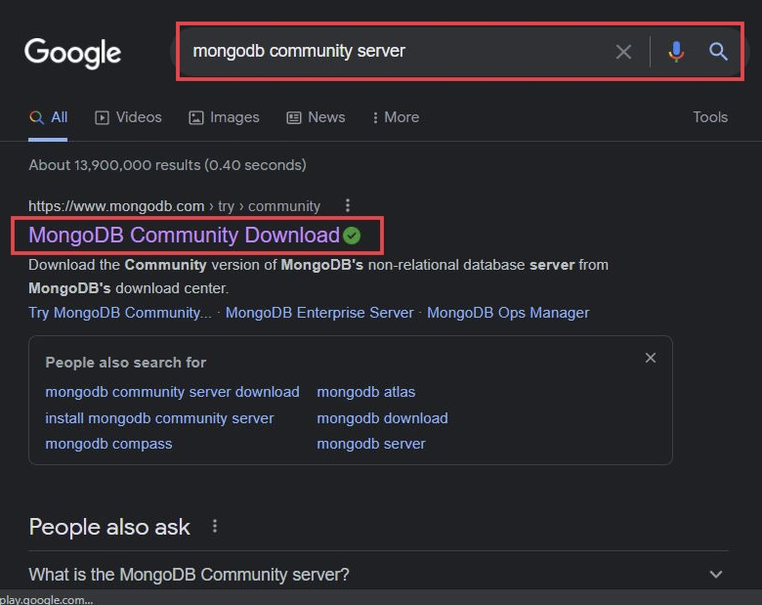

1. Click on Download.

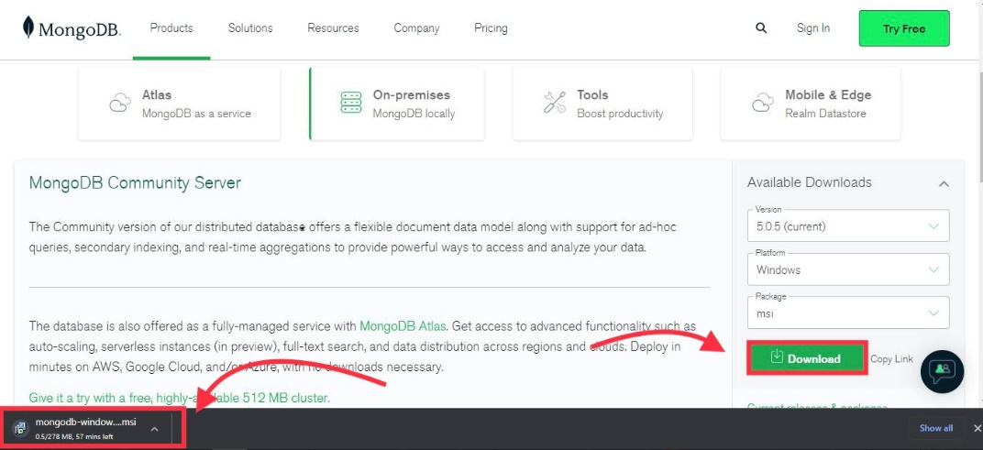

1. Once the downloading is completed, open it and click on next.

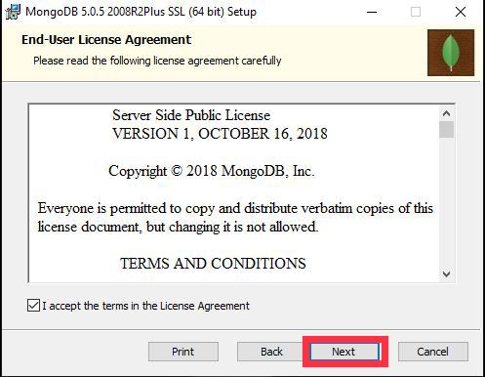

1. Click on Next.

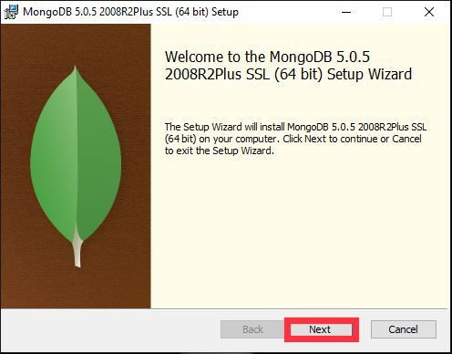

1. Click on Complete.

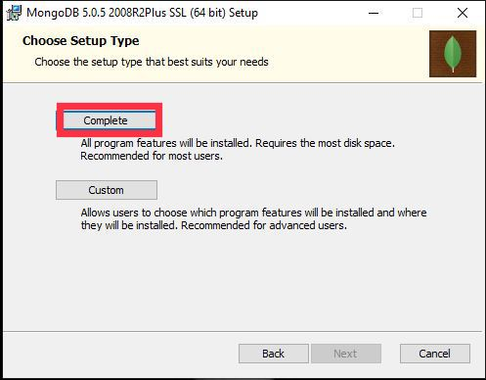

1. Click on Next.

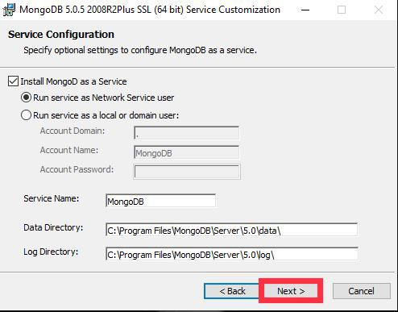

1. Click on Install.

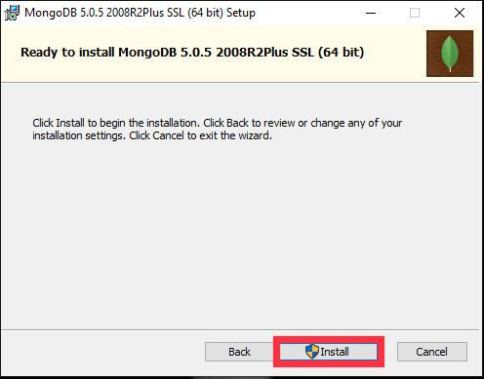

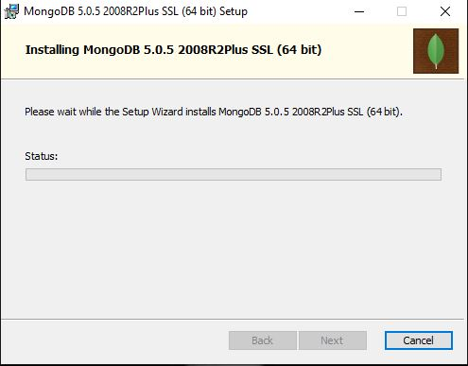

1. MongoDB installed successfully. Click on Finish.

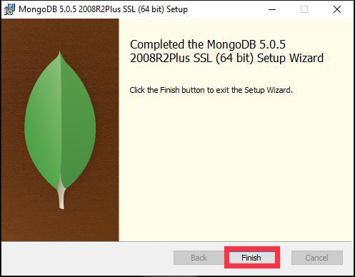

1. Here is the Welcome window.

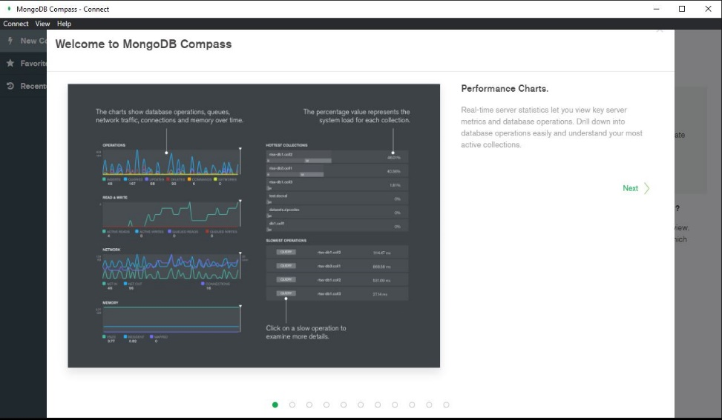

**Connect to MongoDB**

“When we open Compass, an initial connection dialog appears:”

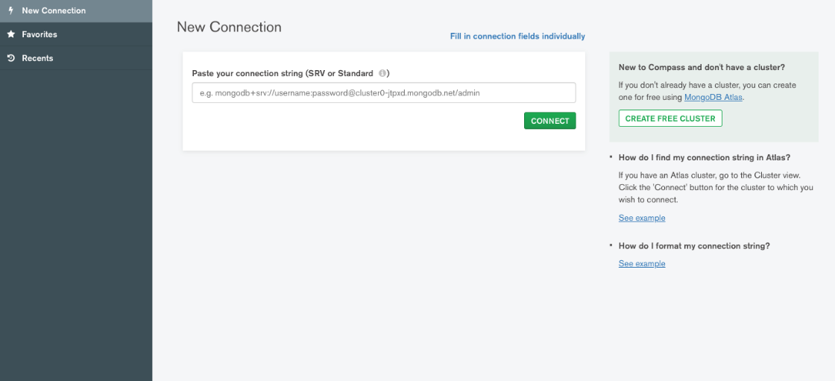

Open mongo.exe. Copy this and paste in above dialog box and click on connect.

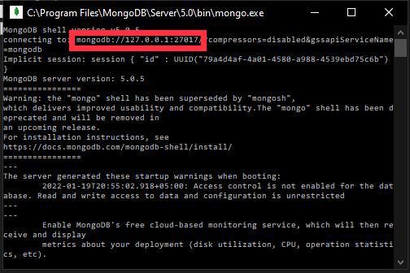

This will connect the compass with our MongoDB.

**How the tool works**

**Create New Database**

1. Click on create database.

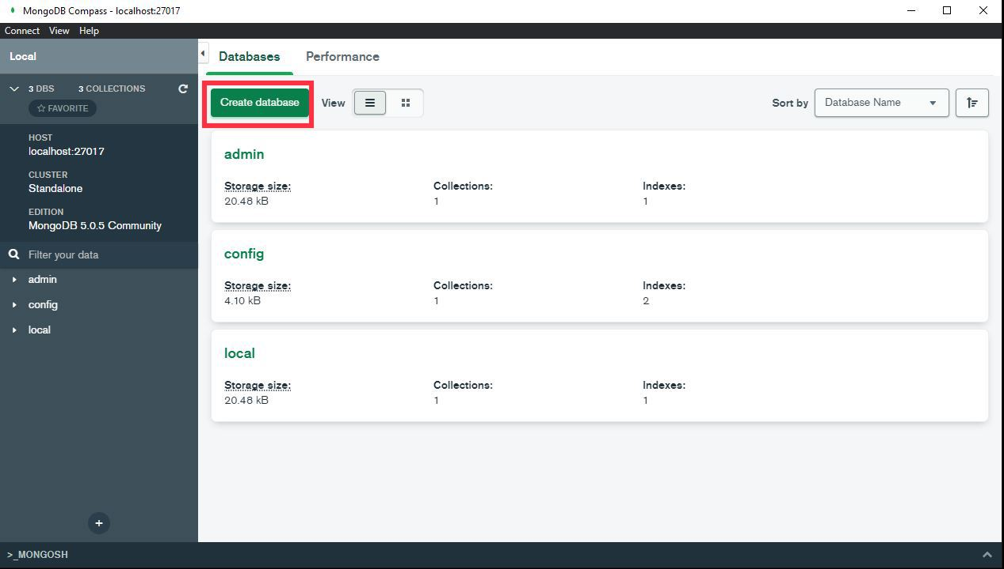

1. Click on create database.

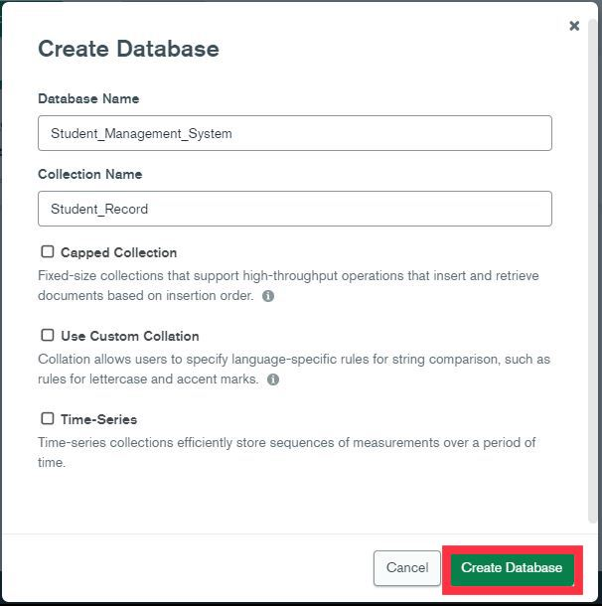

1. Our new database has been created.

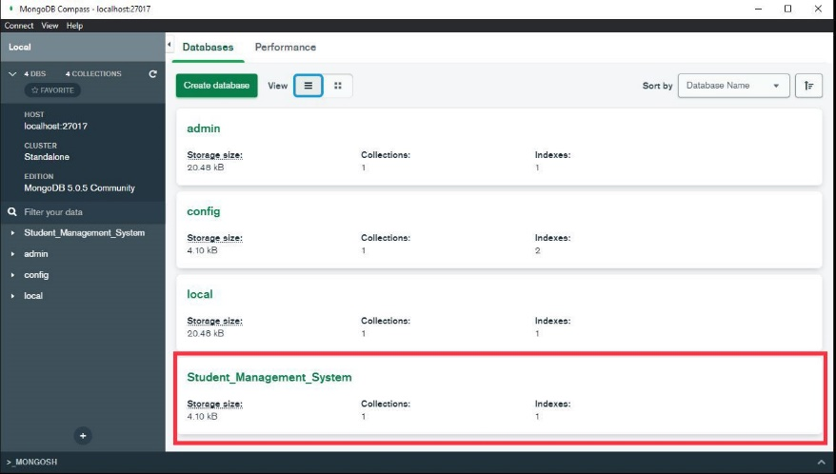

1. Now create collections.

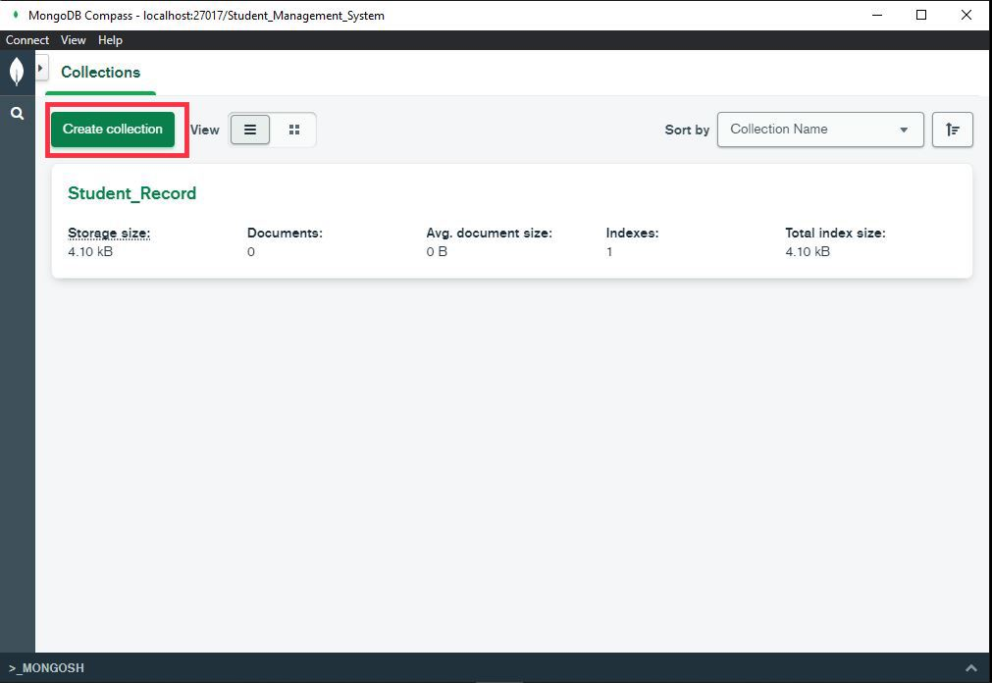

1. Click on Add Data.

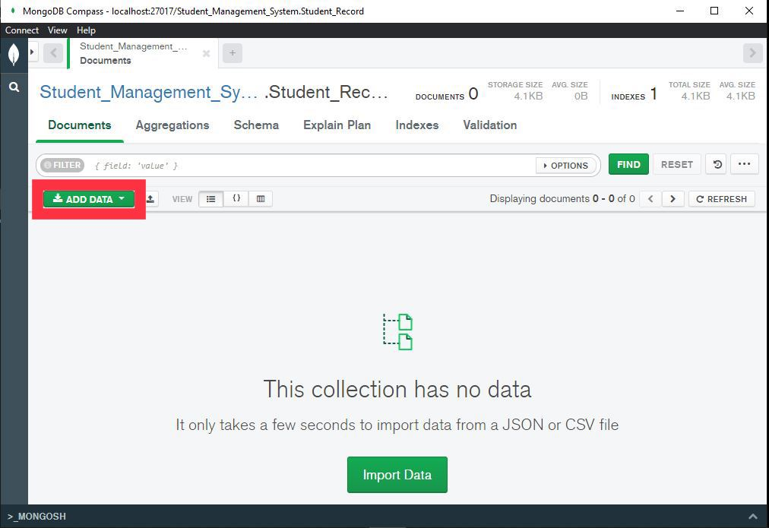

1. Click on Insert.

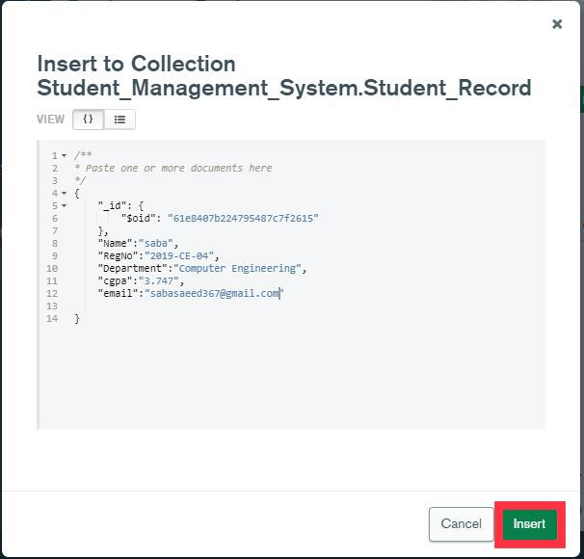

1. Our data has been inserted to collection. We can add multiple documents in the same way.

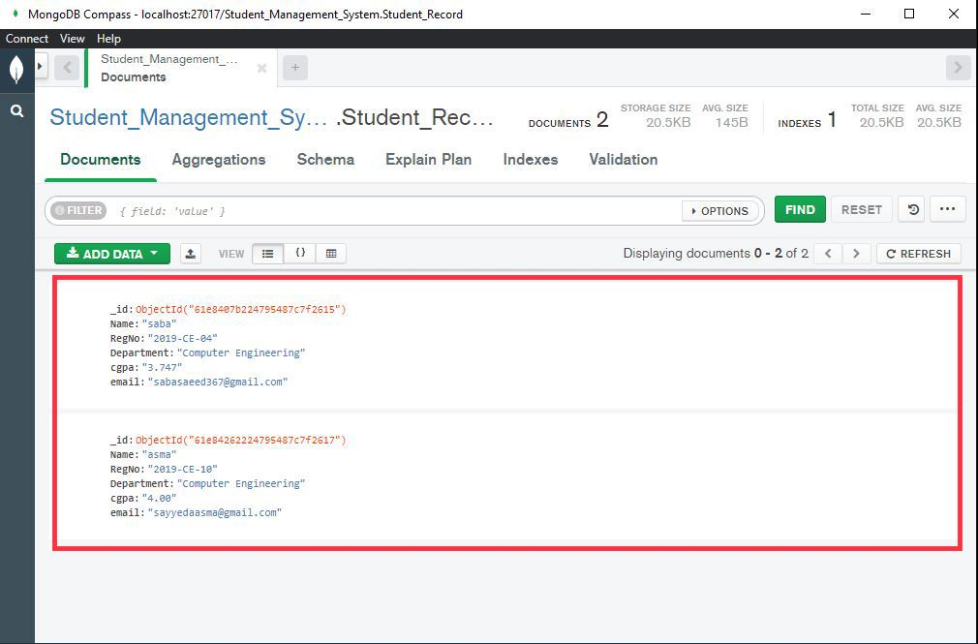

**Mongo shell**

Here is the Mongo shell where we can run commands of MongoDB.

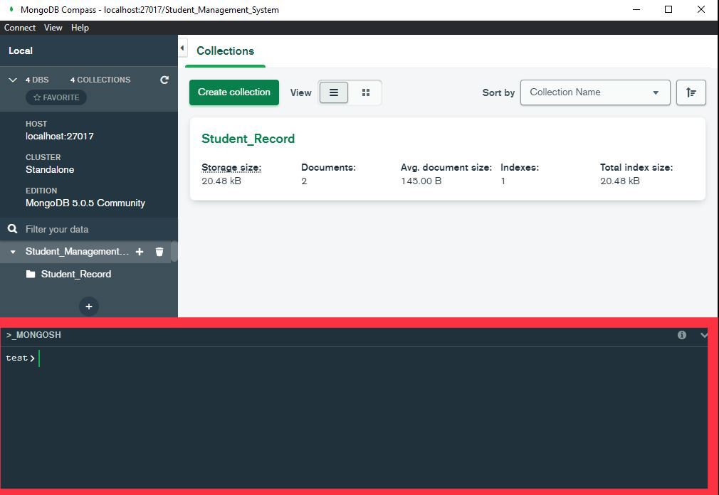

**Import Data**

“We can use MongoDB Compass to import and export data to and from collections. Compass supports import and export for both **JSON**and **CSV** files. To import or export data to or from a collection, navigate to the detailed collection view by either selecting the collection from the Databases tab or clicking the collection in the left-side navigation.”

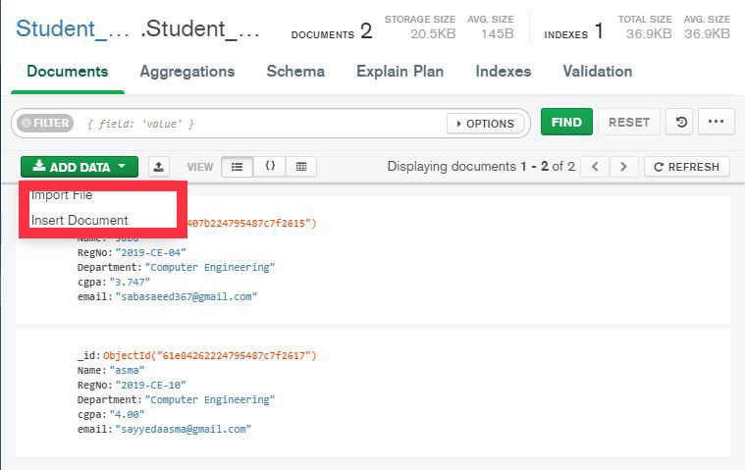

Click on import file and you can import either CSV or JSON file.

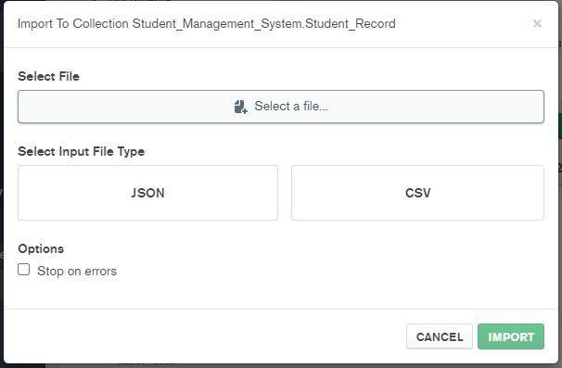

**Export Data**

We can also export our database by using this option.

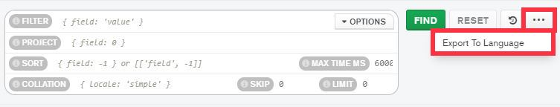

**Export Collection**

We can export collection using this option.

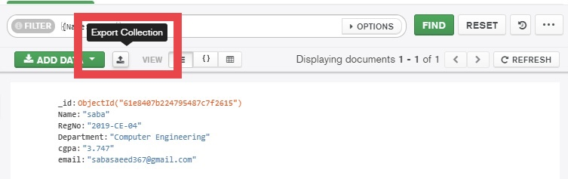

**View Options**

There are three different view option to view our documents.

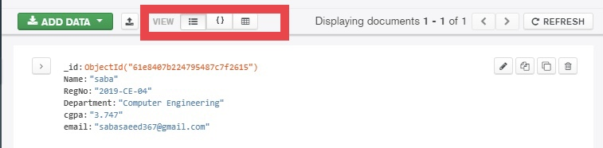

**Versions**

The top left side shows the host, cluster and edition.

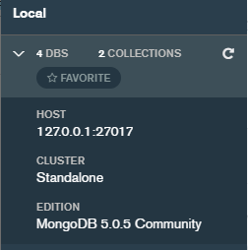

**Search Database**

We can search our desired database using this filter.

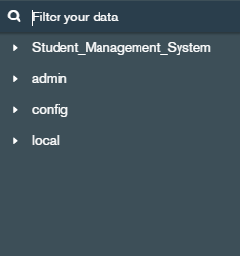

**Create Collection**

We can create new collection by using this option.

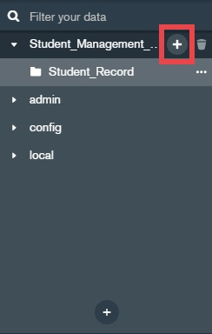

**Drop Collection**

We can drop collection by using this option.

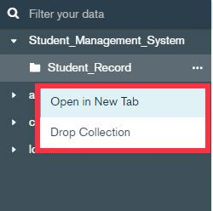

**Drop Database**

We can drop database by using this option.

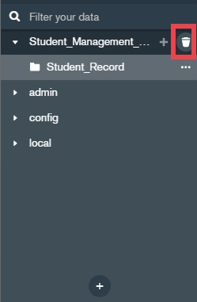

**Search Document**

We can easily find documet using this search bar. Write {field:’value’} or {field:0} or

{field:-1} or [[‘field’,-1]] and click on FIND. Document with your desired field-value pair will be appear. A reset button is used to clear your search box and displays all the documents.

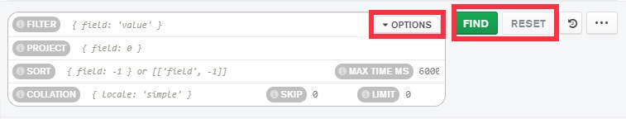

Write any field-value pair and click on Find button. It shows our desired document with this field-value pair.

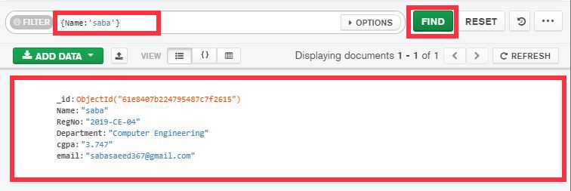

**Edit Document**

We can edit our document using this option. 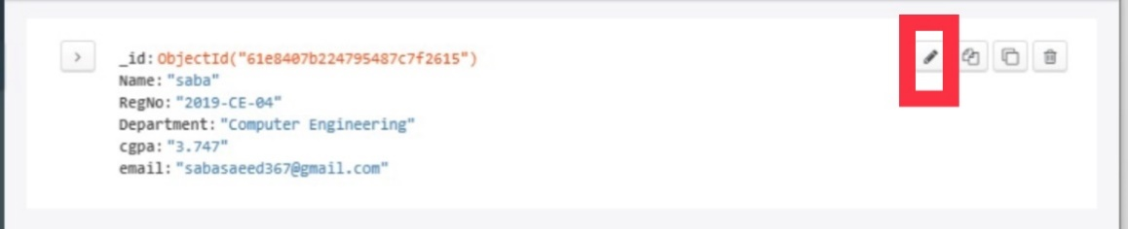

**Copy Document**

We can copy our document using this option.

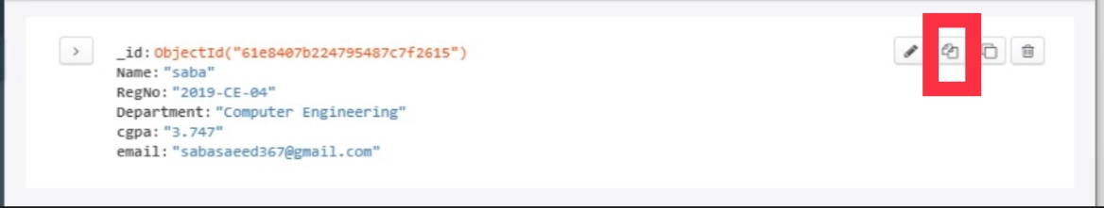

**Clone Document**

We can clone our document using this option. 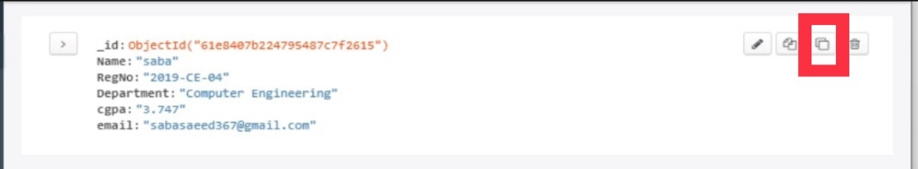

**Delete Document**

We can delete our document using this option.

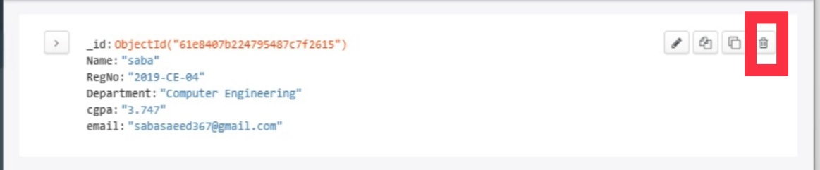

**My Experience**

* “MongoDB is a document database. Data is stored in documents (unlike other databases that store data in structures like tables or graphs).In MongoDB, we have field-value pair. Document databases are considered to be non-relational (or NOSQL) databases. Instead of storing data in fixed rows and columns, document databases use flexible documents. Document databases are the most popular alternative to tabular, relational databases.”
* **“Field-value pairs** can be modeled with fields and values in a document. Any field in a document can be indexed, providing us with additional flexibility in how to query the data.”
* I have learnt how to create a new document database and how to execute the CRUD (create, read, update, and delete) operations. How documents can be created in the database. How documents can be read from the database. How Existing documents can be updated — either in whole or in part. How documents can be deleted from the database.
* I have executed multiple commands of MongoDB in a MongoShell. e.g.
* show dbs– It shows all the databases.
* use dbname– It creates a new database.
* db– It shows the current database.
* db.dropDatabase()– It deletes a database
* show collections– It shows collections
* db.createCollection(‘Records’)– It creates a new collection called Records.
* db.Records.drop()– It drops a collection called ‘Records’.
* db.Records.find()– It shows all the rows in a Collection.
* db.Records.findone({name:’saba’})– It finds the first row matching the object.
* We can easily import and export CSV and JSON files to our database. But we can import only CSV and JSON files because these are also non-relational databases.
* We can search our database using search filter. We can also drop our database.
* We can create and drop our collections
* We can easily find documet using search bar. Write {field:’value’} and click on FIND. Document with this field-value pair will be appear.
* We can edit, copy, clone and delete our document.
* We have different view options to view our documents.
* It is a good facility for developers that they don't have to worry about manually splitting related data across multiple tables when storing it or joining it back together when retrieving it.