ASSIGNMENT No. 3
Complex Computing Problem

Course Title: Data structure & Algorithm Course Code: CSC-221

NAME: SABA SHAHID
ENROLLNMENT: 02-134241-048
CLASS: CS 3-A

Problem
The transportation industry is one of the most popular sectors in terms of technology because customers want to minimize the amount of time and effort spent satisfying their needs. Cab booking is a common kind of transportation provided by several transportation companies in a given city. The majority of individuals rely on cab services for their everyday transportation requirements
Cab Booking/Hiring is a method that may be utilized for a price for a limited of time. People who do not have access to their own personal or do not own one at all can travel around by renting a car.
Cab Services Applications are a modern day tool to solve our day to day transportation related problems. There are a number of issues when it comes to travelling from one place to another, some people don't have their own vehicles, and others don't want to use public transport like buses to travel, independent taxi owners asking for higher fares and many more. Cab service app aims to provide relief to people facing these issues by providing easy to book, cheap and pleasant taxi rides to anyone with access to a smartphone. A Cab Booking System is a service provider that allows users to book a ride from their computer or phone. Users can select the kind of cab they want, enter their pickup and destination, and request a ride. The system will then find a nearby available driver and send the driver to pick up the user. Users can also see the estimated fare and track the cab in real time. A Cab Booking System allows customers to simply schedule trips, check estimated arrival times, and receive ride notifications.
Whizz_cab is one the renowned cab services providing features that includes booking, payment, scheduling trips, location tracking, drivers rating, multiple stop etc.
Whizz_cab wants to enhance the cab service by adding one new feature “On the go pickup”.
Customers can choose “On the go pickup” to get reduced taxi fares. If a customer selects this option, the app will first look for the nearby ongoing rides having a destination same as the destination of the customer and available seats. If it matches, then the customer is added to the same ride at a 50% price, other customers in the cab also get combined 20% discount and the driver earns 20% extra money.
Strategy 1: Passenger requests are processed as they arrive. Customers can specify their maximum number of seats to indicate the remaining number of seats.
Strategy2: “On the go pickup” is implemented with the ongoing rides.

Assumptions
Simulate the process for at least 15 rides per day (with and Without “On the go pickup”). Randomly add customers in the “On the go pickup”. Calculate the amount saved by each passenger and each driver.

Deliverables.
- Create a program in C++ to implement the above problem with appropriate data structure for strategy1 and strategy 2. (CLO4, PLO4, C6)
Strategy 1:
Use a queue or list to process ride requests in the order they arrive.
Track available seats and destinations.
CODE
#include <iostream>
using namespace std;

const int MAX = 20;

struct Ride {
int id;
char destination;
int seats;
};

struct Passenger {
int id;
char destination;
bool onTheGo;
};

void strategy1() {
Ride rides[MAX];
Passenger passengers[MAX];

for (int i = 0; i < 15; i++) {
passengers[i].id = i + 1;
passengers[i].destination = 'A' + (i % 3); // B, C, D
passengers[i].onTheGo = false;

rides[i].id = i + 1;
rides[i].destination = passengers[i].destination;
rides[i].seats = 3; // 1 seat used

cout << "Passenger " << passengers[i].id
<< " assigned Ride " << rides[i].id
<< " to " << rides[i].destination
<< " | Fare: 100\n";
}
}
int main() {

cout << "\n=== Strategy 2 ===\n";
strategy2();

return 0;
}
OUTPUT

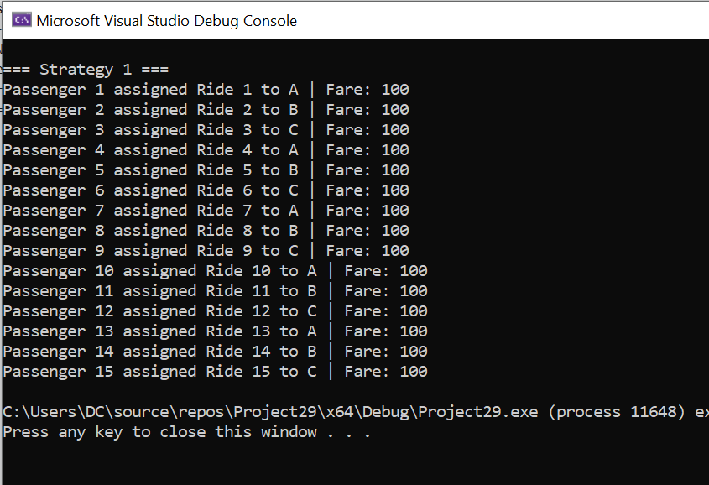
Strategy 2:
Use a hash map or graph to match ongoing rides with new requests based on destination and available seats.
Apply discounts and extra earnings dynamically.
CODE
#include <iostream>
using namespace std;

const int MAX = 20;

struct Ride {
int id;
char destination;
int seats;
};

struct Passenger {
int id;
char destination;
bool onTheGo;
};

void strategy2() {
Ride rides[MAX];
int rideCount = 0;

for (int i = 0; i < 15; i++) {
Passenger p;
p.id = i + 1;
p.destination = 'A' + (i % 3); // B, C, D
p.onTheGo = (i % 2 == 0); // every other uses on-the-go

bool found = false;

if (p.onTheGo) {
for (int j = 0; j < rideCount; j++) {
if (rides[j].destination == p.destination && rides[j].seats > 0) {
rides[j].seats--;
cout << "Passenger " << p.id << " joined Ride " << rides[j].id
<< " to " << rides[j].destination << " | Fare: 50 (on-the-go)\n";
found = true;
break;
}
}
}

if (!found) {
rides[rideCount].id = rideCount + 1;
rides[rideCount].destination = p.destination;
rides[rideCount].seats = 3;
cout << "Passenger " << p.id << " new Ride " << rides[rideCount].id
<< " to " << p.destination << " | Fare: 100\n";
rideCount++;
}
}
}

int main() {

cout << "\n=== Strategy 2 ===\n";
strategy2();

return 0;
}
OUTPUT
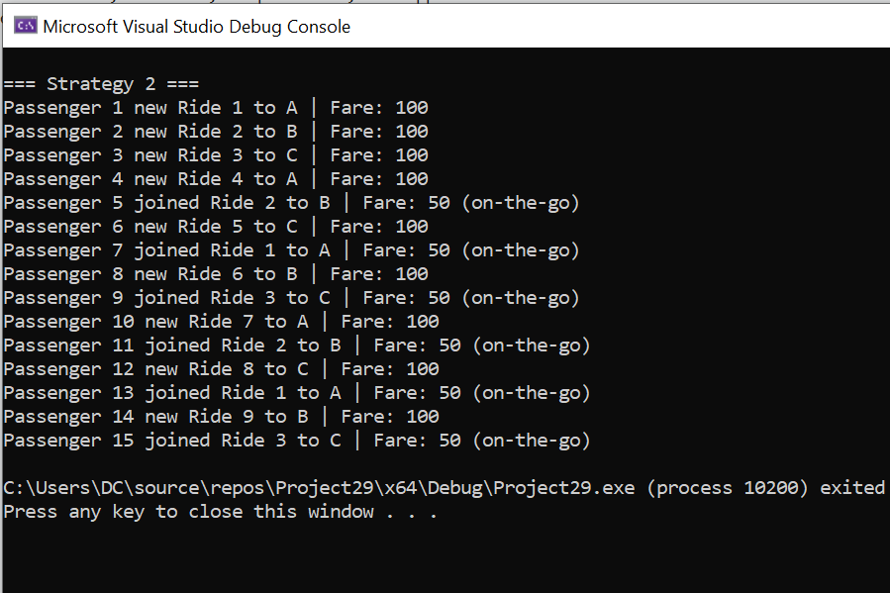

- Design an algorithm other than mentioned strategies.
(CLO4, PLO4, C6)
Strategy 3:
Optimal Matching Based on Maximum Benefit, Algorithm:
Input:
- rides[]: List of ongoing rides (each with destination, available seats, and current passengers)
- passengers[]: List of new passenger requests
Output:
- Assign passengers to the most beneficial ongoing ride or create a new one
Step 1:
For each passenger p in passengers[], do the following:
Step 2:
Set bestRideIndex ← -1
Set maxBenefit ← 0
Step 3:
For each ride r in rides[]:
If r.destination == p.destination and r.availableSeats > 0, then:
Let existingPassengers ← r.totalSeats - r.availableSeats
Let fare ← 100 (or the standard fare)
Let passengerSaving ← fare * 0.5
Let groupSaving ← existingPassengers * fare * 0.2
Let driverBonus ← fare * 0.2
Let totalBenefit ← passengerSaving + groupSaving + driverBonus
If totalBenefit > maxBenefit:
Set bestRideIndex ← index of r
Set maxBenefit ← totalBenefit
Step 4:
If bestRideIndex ≠ -1:
Assign passenger p to rides[bestRideIndex]
Decrease availableSeats by 1
Update total savings and earnings
Else:
Create a new ride for passenger p
Set its destination to p.destination
Set availableSeats = totalSeats - 1
Add ride to rides[]
Step 5:
Repeat for all passengers.

- Analyze the time complexity of your solution. (CLO3, PLO2, C4)
Strategy 1 – FIFO Ride Assignment
- Each passenger is assigned to a new ride in order of arrival.
- No searching or matching is required.
- Time Complexity:
O(1) per passenger
Total: O(n) for n passengers

🚗 Strategy 2 – On-the-Go Ride Matching
- Each passenger searches through existing rides for a match based on destination and available seats.
- Worst-case: passenger checks all rides.
- Time Complexity:
O(m) per passenger, where m = current number of rides
Total: O(n²) in the worst case (if no passengers share rides)

⭐ Strategy 3 – Optimal Matching Based on Benefit
- Each passenger compares all rides to calculate the total benefit (passenger saving + group saving + driver bonus).
- Similar to Strategy 2, but with extra calculations per comparison.
- Time Complexity:
O(m) per passenger for matching
Total: O(n²) in worst case
(Slightly more costly per iteration due to arithmetic operations)

- Explain the use of data structure that you used for all schemes and also provide comparison with calculation of savings. What is your decision whether Smart Cab will launch new feature or not? (CLO1, PLO1, C2)

4. Data Structures Used, Savings Comparison & Recommendation (CLO1, PLO1, C2)
Strategy 1 – Simple Arrays
- Data Structure: Static arrays for rides and passengers.
- Usage: New ride created for every passenger.
- Savings:
- No savings for passengers or drivers.
- Simple but inefficient use of resources.

Strategy 2 – Arrays with Linear Search
- Data Structure: Static arrays; matching based on linear destination check.
- Usage: Passengers can join existing rides if destination matches and seats are available.
- Savings Example (per ride):
- New passenger: 50% fare → saves 50
- Existing passengers: 20% discount each
- Driver earns 20% extra
- Result: Moderate savings for all, better resource use.

Strategy 3 – Arrays with Benefit-Based Matching
- Data Structure: Same as Strategy 2, but with additional benefit evaluation.
- Usage: Chooses the ride offering the maximum combined savings.
- Savings Example (per optimized match):
- Passenger: saves 50
- Existing passengers (e.g., 2): save 40
- Driver bonus: 20
- Total Benefit: 110
- Result: Maximizes savings and earnings across the system.

Note: Single file is required with title page, index page, algorithm, codes with output, calculations and comparisons.

