BAHRIA UNIVERSITY KARACHI CAMPUS
Department of Computer Science

DIGITAL LOGIC DESIGN

LAB EXPERIMENT # 8

Decoder from basic gates

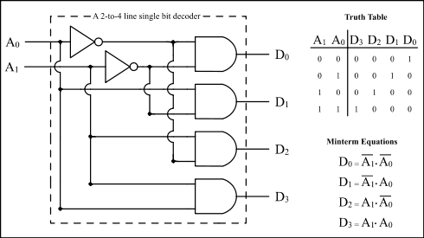

A 2 to 4 line single bit decoder

IN0 | IN1 | Y3 | Y2 | Y1 | Y0
0 | 0 | 0 | 0 | 0 | 1
0 | 1 | 0 | 0 | 1 | 0
1 | 0 | 0 | 1 | 0 | 0
1 | 1 | 1 | 0 | 0 | 0
SCREEN SHOT 01:
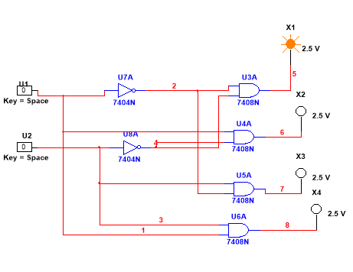

SCREEN SHOT 02:
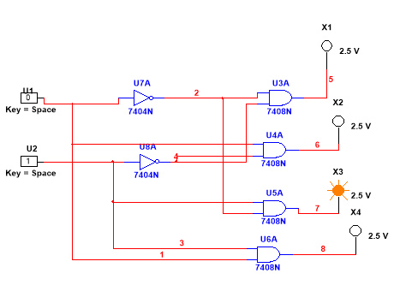

SCREEN SHOT 03:

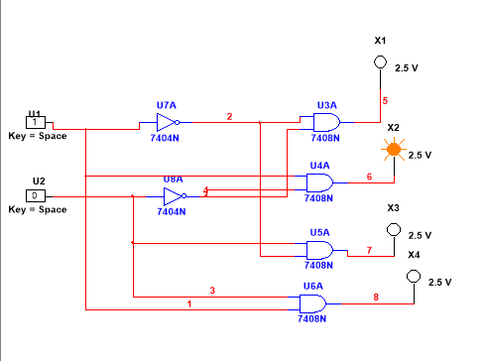

SCREEN SHOT 04:
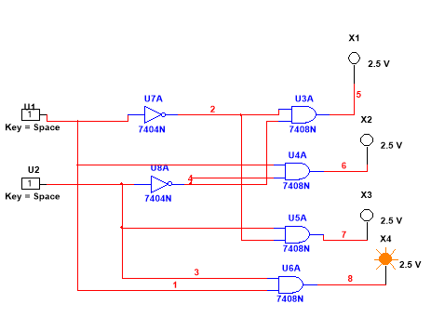

OBSERVATION

- Make the circuit diagram on multisim of 2 x 4 decoder.
- Show the multisim simulation.
- Complete and verify the operation of decoder with the help of a truth table.

Teacher Signature: ________________________

Student Registration No.: 02-134241-048

