ASSIGNMENT No. 3
Problem Based Learning
Course Title: Object-Oriented Programming
Course Code: CSC-210
Class: BS (CS)-2 A/B Submission deadline: 15th December 2024
Course Instructor: Dr. Sameena Javaid Marks: 10
__________________________________________________
Instructions

- Students will perform this assignment individually.
- Assignment should be done only on A4 size paper and will also be uploaded on LMS
- Deadline will not be extended for any reason.
- Copied assignments will be marked zero.
- Name, class, section, and enrollment number on the sheets must be mentioned correctly
- Make a single PDF file as both soft and hard copies are mandatory. Submit softcopy on LMS and hardcopy to CR (CR will submit hardcopies to faculty on the due date)

Evaluate the given scenario and provide the requirements given after the case:

Case Study / Scenario

The proposed system is an E-Commerce Order Management platform designed to facilitate seamless transactions between customers and the online store. It encompasses various components and functionalities to ensure efficient order processing, inventory management, and customer interaction.

At its core, the system comprises three primary components: Orders, Products, and Customers. The Orders component handles the order placement process by allowing customers to add items, specify details, calculate total prices, cancel orders, and generate invoices. Concurrently, the Products component manages inventory by updating stock quantities whenever orders are placed. The system provides distinct interfaces catering to different user roles. Customers access an interface enabling them to place orders and access their order history. Staff members and administrators, on the other hand, utilize an administrative interface to manage orders, monitor inventory levels, and update customer information. Robust error handling mechanisms are embedded within the system to address potential issues such as out-of-stock products, invalid customer information, and system failures. A key feature involves the use of a robust data storage system (such as a database) to securely persist order, customer, and product information. Security measures are integrated to ensure data protection and system integrity. Authentication and authorization mechanisms are implemented to safeguard customer data and regulate access to sensitive information. The system is designed to handle high volumes of orders efficiently. It incorporates performance optimizations and scalable architecture to accommodate increasing demands without compromising performance. Logging functionalities are put in place to track system events comprehensively. These logs facilitate the generation of reports on order history, customer data, and inventory levels. Additionally, a comprehensive testing suite is developed to validate the system's functionality, ensuring its reliability and robustness. Comprehensive documentation, including class diagrams, flowcharts, and user manuals, is maintained to aid in understanding and maintaining the system. This documentation serves as a valuable resource for both developers and users, facilitating system comprehension and maintenance.

Overall, the system aims to create a seamless and secure environment for managing e-commerce operations. Its emphasis on error handling, scalability, security, and technical documentation ensures a reliable platform for efficient order management and customer satisfaction.

Assumptions:

- Operations and Methods:
- Place Order: A method within the Order class that allows a customer to place an order by adding items to the order and specifying the customer details.
- Calculate Total Price: A method within the Order class that calculates the total price of the order, considering the prices and quantities of the ordered items.
- Update Stock: A method within the Product class that updates the stock quantity when an order is placed.
- Cancel Order: A method within the Order class that allows customers to cancel an order, which will update the stock and remove the order from the system.
- Generate Invoice: A method within the Order class that generates an invoice with details of the order for the customer.
- User Interfaces:
- The system may have user interfaces for customers to place orders and view their order history.
- An administrative interface for staff to manage orders, view inventory, and update customer information.
- Error Handling:
- Implement robust error handling to manage issues like out-of-stock products, invalid customer information, or system failures.
- Data Persistence:
- Implement a data storage component (such as a database or file system) to persist order, customer, and product information.
- Security:
- Ensure that the system is secure, with proper authentication and authorization mechanisms to protect customer data and system integrity.
- Scalability and Performance:
- Design the system to handle a large number of orders efficiently, taking into account performance optimizations and scalability options.
- Logging and Reporting:
- Implement a logging system to track system events and generate reports on order history, customer data, and inventory levels.
- Testing:
- Develop a comprehensive testing suite to validate the system's functionality and robustness.
- Documentation:
- Maintain thorough documentation for the system, including class diagrams, flowcharts, and user manuals.

Deliverables / Questions:

Question 01 (CLO4, PLO4, C5) (5 Marks)
- Determine the class relationships. Make UML with proper relations among classes.

ANSWER:

Class Relationships
1. OrderManagementSystem → (uses) Customer and Staff.
2. Customer → (uses) Inventory.
3. Staff → (uses) Inventory.

4. Inventory is independent and shared by Staff and Customer class.

UML

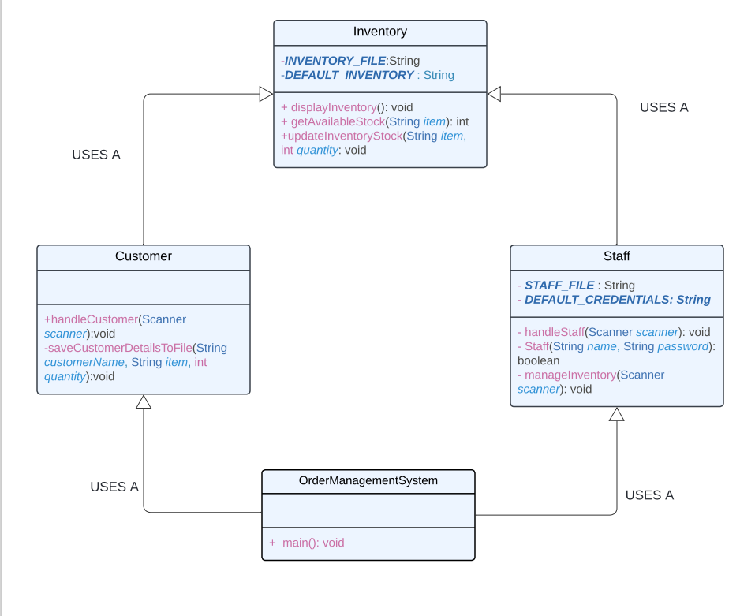
- Recommend 2 more classes to enhance the vertical scope of the project. With complete justification.

ANSWER:
- Payment class:
public class Payment {
private double paymentAmount;
private String paymentStatus;
public Payment() {
this.paymentStatus = "Pending";
}
public boolean processPayment(double amount) {
this.paymentAmount = amount;
// Simulate payment processing (could be extended for actual payment gateway integration)
if (amount > 0) {
this.paymentStatus = "Successful";
System.out.println("Payment of $" + amount + " processed successfully.");
return true;
} else {
this.paymentStatus = "Failed";
System.out.println("Payment failed. Invalid amount.");
return false;
}
}
public String getPaymentStatus() {
return paymentStatus;
}
public double getPaymentAmount() {
return paymentAmount;
}
}

2. Shipping class:
public class Shipping {
private String shippingAddress;
private String shippingStatus;
public Shipping() {
this.shippingStatus = "Not Shipped";
}
public double calculateShippingFee(double orderAmount) {
// Assume shipping fee is a percentage of the order amount (e.g., 5%)
return orderAmount * 0.05;
}
public String trackShipment(String orderId) {
return "Tracking info for Order ID " + orderId + ": Shipment is in transit.";
}
public void updateShippingStatus(String status) {
this.shippingStatus = status;
System.out.println("Shipping status updated to: " + status);
}
public String getShippingStatus() {
return shippingStatus;
}
public String getShippingAddress() {
return shippingAddress;
}
public void setShippingAddress(String shippingAddress) {
this.shippingAddress = shippingAddress;
}
}

Justification and use:

The Payment and Shipping classes can be integrated with the Customer class and the handleCustomer method in the Customer class can be modified to interact with these new classes:

For example:
- After the customer places an order, the Payment class will be invoked to process the payment.
- Then, the Shipping class will be used to calculate shipping fees and track shipments.

Question 02 (CLO3, PLO4, C4) (5 Marks)
- Make inferences using JAVA code of all classes of your modified UML with proper class relationships.
CLASS | FUNCTIONALITY | RELATIONSHIP WITH OTHER CLASSES
OrderManagementSystem | - Main entry point of the system.  - Prompts the user to choose a role (Customer or Staff).  - Handles user input and delegates to the corresponding role handler. | - Uses-a (uses Staff and Customer to manage different roles)
Staff | - Authenticates staff using credentials stored in staff.txt.  - Allows inventory management.  - Can add new staff credentials. | - Used-by (used by OrderManagementSystem to manage staff operations)  - Uses-a (uses Inventory for stock management)  - Has-a (manages Staff File for authentication)
Inventory | Displays and updates stock items.  - Manages stock quantity.  - Reads and writes to the inventory.txt file. | - Used-by (used by Staff for stock management)  - Used-by (used by Customer for browsing products)  - Used-by (used by Order to verify stock
Customer | - Allows customers to place orders.  - Displays available items from the Inventory.  - Saves order information to a customer file.  - Manages payment and shipping. | - Used-by (used by OrderManagementSystem for customer actions)  - Uses-a (uses Inventory for product browsing)  - Uses-a (uses Order to place orders)  - Uses-a (uses Payment to process payments)  - Uses-a (uses Shipping for shipping information)
Payment | Processes the payment of an order.  - Updates payment status (successful/failed).  - Calculates payment amount based on order | - Used-by (used by Customer to make payments)  - Used-by (used by Order to process payments after order confirmation)
Shipping | -Calculates shipping fees based on order amount.  -Tracks and updates shipment status.  -Provides tracking information. | - Used-by (used by Customer for shipping information)  - Used-by (used by Order for shipment tracking and delivery)

- Analyze your project by Application Class. Making 2 objects of each class used. Provide Outputs as well.
Application class:
import java.util.Scanner;
public class OrderManagementSystem {
public static void main(String[] args) {
Scanner scanner = new Scanner(System.in);
Staff staffHandler = new Staff();
Customer customerHandler = new Customer();
while (true) {
System.out.println("Choose what you want to be:");
System.out.println("1. Customer");
System.out.println("2. Staff");
System.out.println("3. Exit");
System.out.println("(Enter 'staff', 'customer', or 'exit')");
String role = scanner.nextLine();
if (role.equals("exit")) {
System.out.println("Exiting the system. Goodbye!");
break;
} else if (role.equals("staff")) {
staffHandler.handleStaff(scanner);
} else if (role.equals("customer")) {
customerHandler.handleCustomer(scanner);
} else {
System.out.println("Invalid input. Please enter 'staff', 'customer', or 'exit'.");
}
}
scanner.close();
}
}
Output:
1.Staff login:
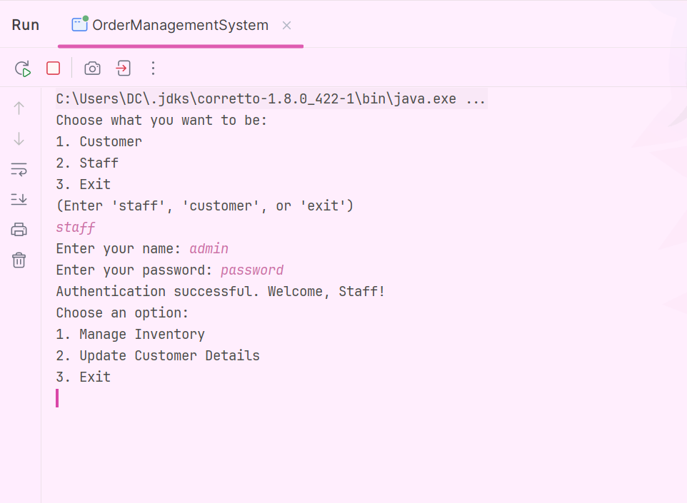

2. Staff Features:
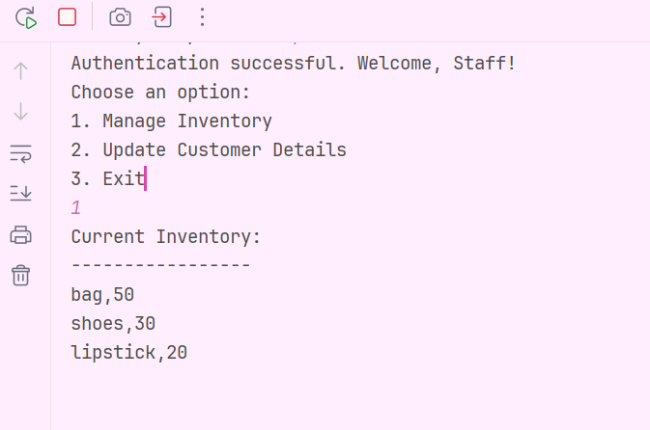
3.Customer Features:
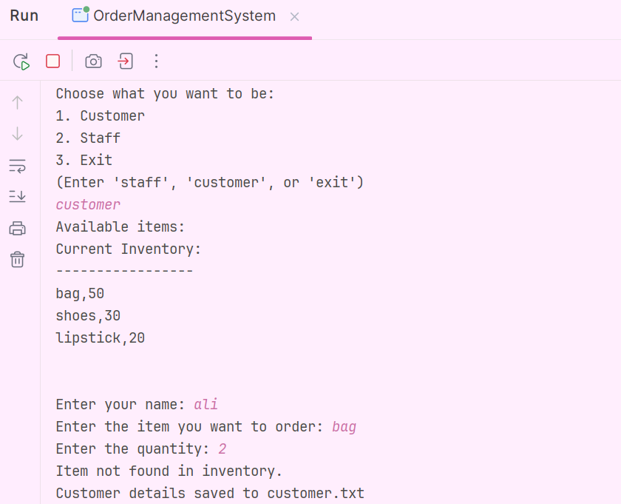
4.Staff.txt(for authentication):
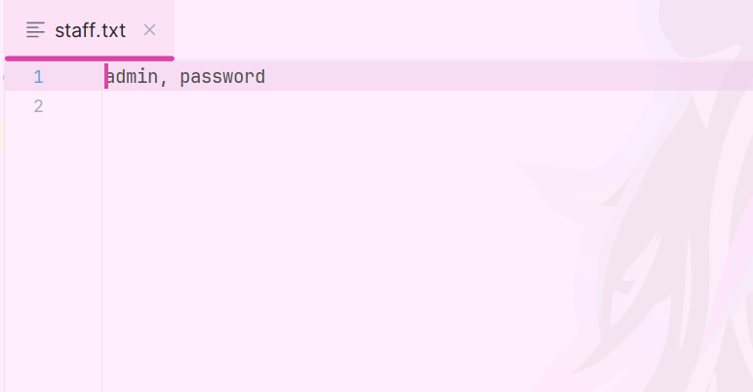

5.Customer.txt:
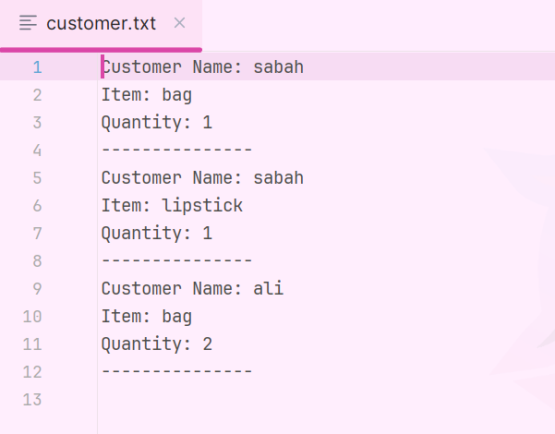
6.Inventory.txt:
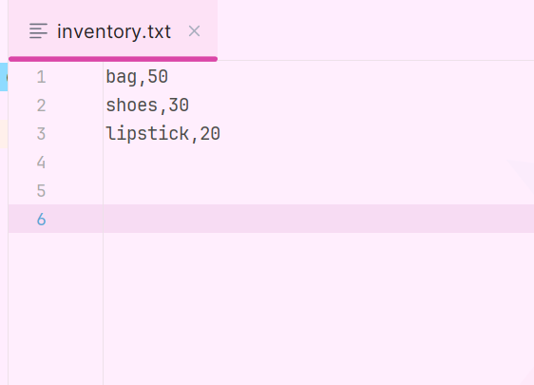

Note:

Kindly provide a zip folder containing following requirements
- Java Code (.java file)
- Proper justification / technical documentation is mandatory.
- Outputs with 2 cases at least (.docx / .pdf file)
- UML diagram (.docx / .pdf / any other third party software generated image file)

*******************

