BAHRIA UNIVERSITY KARACHI CAMPUS
Department of Computer Science

DIGITAL DESIGN

LAB EXPERIMENT # 1

QUESTIONS: -

- How will you implement the given circuit in Figure No. 1 on breadboard?

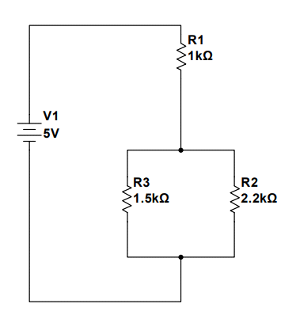
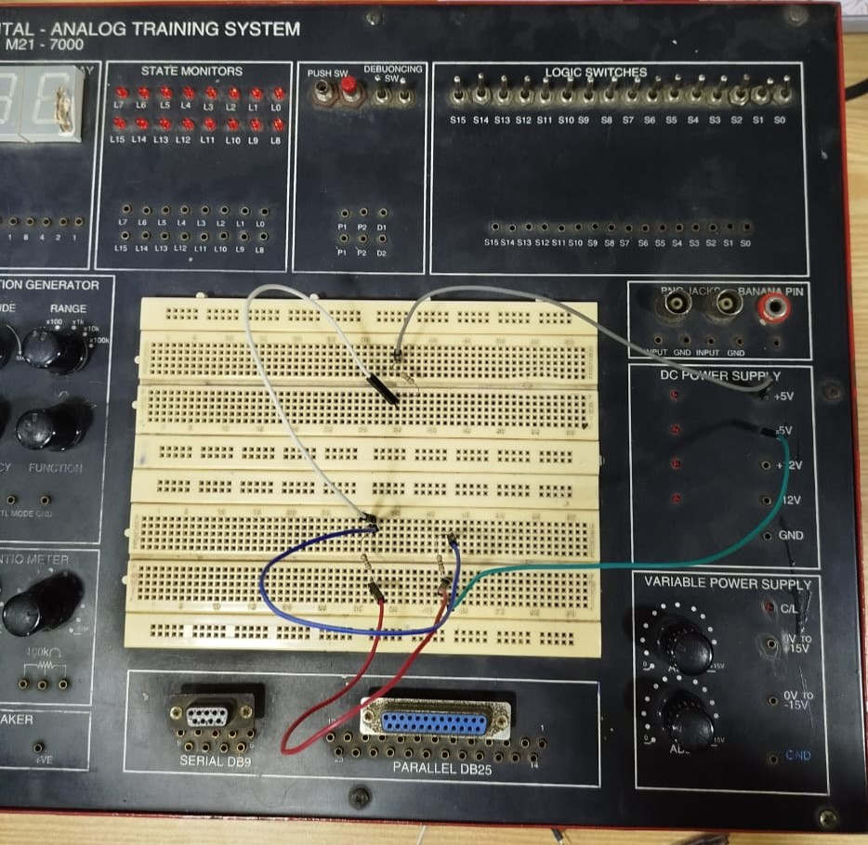

- Briefly describe the working of Logic Probe.

A logic probe is a handheld device used to test and troubleshoot digital circuits by detecting and indicating the logic levels at specific points. It shows whether a point in a circuit is at a high voltage (logic "1"), low voltage (logic "0"), or toggling between the two states (pulsing).

- Explain the working of Digital Analog Trainer.

A Digital Analog Trainer is an educational tool commonly used in electronics labs to help students and professionals design, test, and analyze both analog and digital circuits. It combines various components and instruments into a single platform, allowing users to experiment with different electronic configurations without needing a full suite of lab equipment.

- Explain the clock waveform in Digital Electronics.

In digital electronics, the clock waveform is a periodic signal used to synchronize operations within a digital system. It serves as the timing reference for various digital circuits, ensuring that operations occur in a coordinated manner. This waveform typically alternates between two voltage levels: high (1) and low (0).

Teacher Signature: ________________________

Student Registration No.: 02-134241-048

STUDENT MANUAL FORMAT

DIGITAL LOGIC DESIGN (3+1)

CEL-120

LAB MANUAL



Department Of Computer Science

Bahria University, Karachi Campus

DIGITAL LOGIC DESIGN
CEL-120

Student Name: SABA SHAHID

Registration Number: 02-134241-048

Class & Section: CS 2 A

Semester: 2nd

Fall / spring: fall

Year: 2024

Lab Day & Time: day 1/2:30 to 5:30

Course Teacher: Mr. Junaid Yawar

Lab Engineer: _____________________________

