Assignment # 02
NAME: SABA SHAHID
ENROLLNMENT: 02-134241-048
CLASS: BS (CS) 3-A
CLO-2 PLO-2 (BT level- C3)

Circuit switching is a mechanism in which the communication path is dedicated. In contrast, packet switching mechanism allows the sharing of communication path among users. Keeping conventional and Next Generation Networks (NGN) in mind, as mentioned below, answer the followings:

- Conventional Communication Networks: develop a packet switching network and apply any real time data services application (for example voice) on it. Demonstrate whether it is a good idea to use the real time data services over packet switching network? Support your answer with detail discussion, examples and limitations (if any).
ANSWER

  - Packet Switching Network Development:
  - Conceptual Design:
- Nodes and Links:
  - We'll create a simplified network with a few nodes (routers) connected by links (communication channels).
  - Each node will have routing capabilities to forward packets.
- Packet Structure:
  - Define a packet structure with:
    - Header: Source/destination addresses, sequence number, timestamp (for real-time), and payload length.
    - Payload: The actual voice data.
- Routing Algorithm:
  - Implement a basic routing algorithm like distance vector or link-state to determine the best path for packets.
- Buffering and Queuing:
  - Implement buffers at each node to store packets temporarily.
  - Use queuing mechanisms (e.g., FIFO) to manage packet flow.
- Voice Application Simulation:
  - Simulate a voice application by dividing voice data into packets.
  - Introduce delays and jitter to mimic real-world network conditions.
  - Implement a simple voice reconstruction at the receiving end.

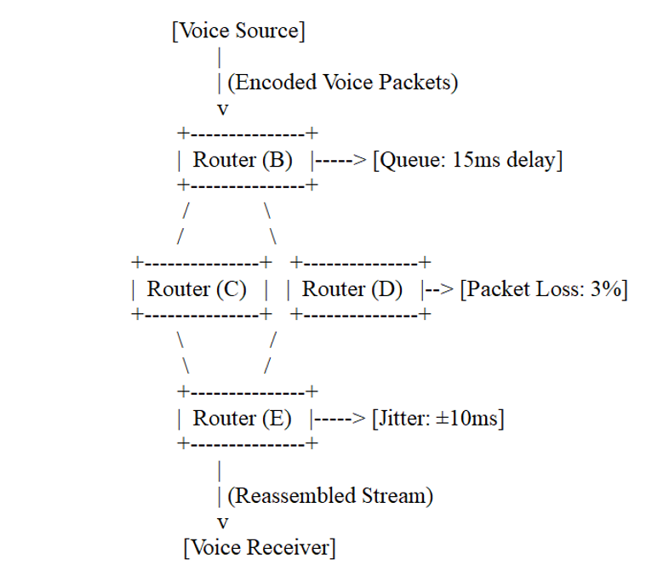
    - Example Scenario:
Imagine a network with nodes A, B, C, and D. Node A sends voice packets to node D. The routing algorithm determines the path (e.g., A -> B -> C -> D). Packets might experience different delays at each node due to queuing.

  - Suitability of Real-Time Data Services (Voice) Over Packet Switching:
  - Arguments for Suitability:
- Efficiency:
  - Packet switching is efficient in utilizing network bandwidth. It only sends data when needed, unlike circuit switching, which reserves bandwidth even during silence.
- Flexibility:
  - Packet switching can dynamically adapt to changing network conditions. If a link fails, packets can be rerouted.
- Scalability:
  - Packet switching networks can easily scale to accommodate a large number of users.
- Integration:
  - Packet switching allows voice to be integrated with other data services (e.g., video, text) on the same network.
  - Arguments Against Suitability:
- Delay and Jitter:
  - Packet switching introduces variable delays and jitter (variations in delay), which can degrade voice quality.
  - Packets may arrive out of order, requiring reassembly.
- Packet Loss:
  - Packets can be lost due to network congestion or errors, resulting in gaps in the voice signal.
- Quality of Service (QoS):
  - Packet switching networks do not inherently guarantee QoS. Real-time services like voice require low latency and minimal jitter, which can be challenging to achieve.
  - These mechanisms help ensure that voice packets receive preferential treatment.
  - Examples:
1. Voice over IP (VoIP):
  - VoIP uses packet switching to transmit voice over the internet.
  - It has become a widely used technology for telephone calls.
  - VoIP applications use protocols like RTP (Real-time Transport Protocol) and SIP (Session Initiation Protocol) to manage voice communication.
- Video conferencing:
  - Video conferencing also uses packet switching.
  - It is even more sensitive to delay and jitter than voice calls.
  - Conclusion:
While packet switching offers efficiency and flexibility, it presents challenges for real-time services like voice due to delay, jitter, and packet loss. With proper QoS mechanisms and careful network design, it is possible to achieve acceptable voice quality over packet switching networks. The internet is based on packet switching, and real time services are performed on it every day. Therefore, it is possible, but needs careful engineering.

- Next Generation Networks, Infer/Predict whether all types of data (real time/ non real time) should be transported by using the circuit switching or packet switching networks? Support your answer with discussion and examples.

ANSWER:
- Why Packet Switching Dominates in NGNs

- Bandwidth Efficiency
  - Dynamically allocates resources only when needed
  - Eliminates wasted capacity during idle periods (unlike circuit switching)
- Service Convergence
  - Single infrastructure handles voice, video, and data
  - Enables innovative services like IoT and cloud gaming
- Advanced QoS Capabilities
  - Traffic prioritization (DiffServ)
  - Resource reservation (RSVP)
  - Jitter compensation buffers
- 5G Enhancements
  - URLLC (Ultra-Reliable Low Latency Communications)
  - Network slicing for customized service quality

- Circuit Switching in Modern Networks
- Remaining Use Cases:
- Legacy emergency systems
- Critical infrastructure control
- Ultra-high reliability applications (<1ms latency requirements)
- Technical Comparison:
Feature | Packet Switching | Circuit Switching
Latency | Variable (QOS-managed) | Fixed, predictable
Bandwidth Usage | Efficient | Dedicated
Service Support | All types | Primarily voice
Cost | Lower | Higher

- Implementation Examples
- VoIP: Uses packet switching with RTP/RTCP protocols
- 4K Streaming: Adaptive bitrate over packet networks
- Smart Factories: Hybrid approaches using TSN (Time-Sensitive Networking)
- Conclusion
While packet switching is clearly superior for most NGN applications due to its flexibility and efficiency, circuit switching retains value for specialized use cases requiring guaranteed performance. Modern NGNs increasingly achieve the "best of both worlds" through:
- Advanced QoS implementations
- Network virtualization
- Protocol innovations like 5G URLLC
The future lies in packet-based networks that can emulate circuit-switched characteristics when absolutely necessary.

Deadline: 5th April, 2025

Important Instructions:
  - Use Standard Font (Arial), Line Spacing of 1.15,
  - Proper Justified, Page Margins 1’’from all four sides.
  - Text Font Size = 12 Heading Font Size = 14
  - Late assignment submission will not be marked
  - Copied Assignment will be given ZERO and no resubmission will be accepted
  - Maximum Marks= 05

