BAHRIA UNIVERSITY KARACHI CAMPUS
Department of Computer Science

DIGITAL DESIGN

LAB EXPERIMENT # 2

OBSERVATION/RESULTS and DISCUSSION:-

Input: A | Input: B | 7400  NAND | 7402  NOR | A●B  7408  AND | A+B  7432  OR
0 | 0 | 1 | 1 | 0 | 0
0 | 1 | 1 | 0 | 0 | 1
1 | 0 | 1 | 0 | 0 | 1
1 | 1 | 0 | 0 | 1 | 1
0 | Not Connected | 1 | 0 | 0 | 0
1 | Not Connected | 0 | 0 | 0 | 1
Not Connected | 0 | 1 | 0 | 0 | 0
Not Connected | 1 | 0 | 0 | 0 | 1
Not Connected | Not Connected | 0 | 0 | 0 | 0

QUESTIONS:-

- Draw the circuit of Logic Gates drawn on Multisim IDE.
1. AND Gate
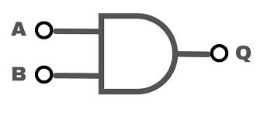
Definition:

The AND gate performs a logical multiplication of its inputs. It outputs 1 (true) only if all of its inputs are 1 (true). Otherwise, it outputs 0 (false).
Key Functions:

Logical Multiplication: Combines inputs and only provides a positive result (1) when all inputs are positive.
Common Use: Used in conditions where all criteria must be satisfied (e.g., if both conditions A and B are true, then activate an output).
Example: In safety systems, an AND gate ensures that all required safety conditions are met before allowing a machine to operate.
Truth Table:

Screenshots of Multi-Sim:

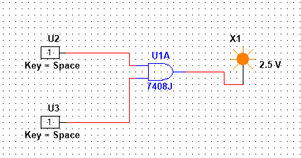

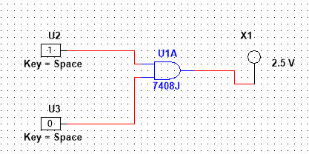
Truth table

Input: A | Input: B | A+B  7432  OR
0 | 0 | 0
0 | 1 | 1
1 | 0 | 1
1 | 1 | 1
0 | Not Connected | 0
1 | Not Connected | 1
Not Connected | 0 | 0
Not Connected | 1 | 1
Not Connected | Not Connected | 0

- OR Gate
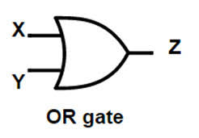
Definition:

The OR gate performs a logical addition of its inputs. It outputs 1 if at least one of its inputs is 1. It outputs 0 only when all inputs are 0.

Key Functions:

Logical Addition: Gives a positive result (1) when one or more inputs are positive.
Common Use: Used when at least one of several conditions needs to be true to trigger an output (e.g., in a control system, if either sensor A or sensor B detects a condition, then trigger a response).
Example: In alarm systems, an OR gate can be used to trigger an alarm if any one of several sensors detects a problem.
Screenshots of Multi-Sim:
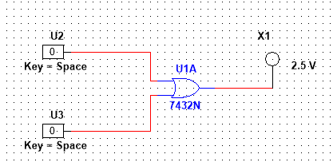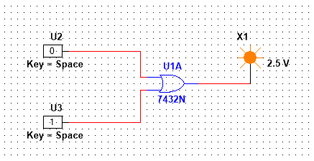

Truth Table:
Input: A | Input: B | 7400  NAND
0 | 0 | 1
0 | 1 | 1
1 | 0 | 1
1 | 1 | 0
0 | Not Connected | 1
1 | Not Connected | 1
Not Connected | 0 | 1
Not Connected | 1 | 1
Not Connected | Not Connected | 1

- NOR Gate
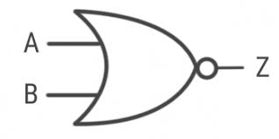
Definition:

A NOR gate is the negation (NOT) of the OR gate. It outputs 1 only if all inputs are 0. If any input is 1, it outputs 0.

Key Functions:

Negation of OR: Used in systems where an output must be active only when none of the inputs are active.
Common Use: Used in conditions where all signals must be inactive to trigger an output.
Example: NOR gates are often used in memory elements, such as SR latches, to maintain a specific state unless triggered.
Screenshots of Multi-Sim:
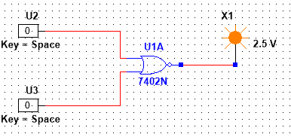
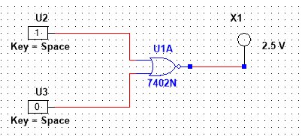

Truth Table:

Input: A | Input: B | 7402  NOR
0 | 0 | 1
0 | 1 | 0
1 | 0 | 0
1 | 1 | 0
0 | Not Connected | 0
1 | Not Connected | 0
Not Connected | 0 | 0
Not Connected | 1 | 0
Not Connected | Not Connected | 1

- NAND Gate
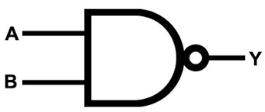
Definition:

A NAND gate is the negation (NOT) of the AND gate. It outputs 0 only if all inputs are 1. If any input is 0, it outputs 1.

Key Functions:

Negation of AND: Outputs true (1) except when all inputs are true.
Common Use: Often used in combination with other gates in circuit design to simplify logic (many logic functions can be built using only NAND gates, making it a universal gate).
Example: NAND gates are used in memory storage devices and control circuits, and are the foundation of many flip-flop designs.
Screenshots of Multi-Sim:
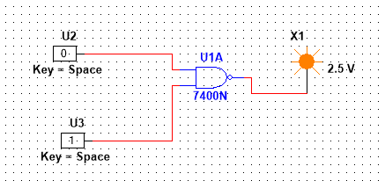
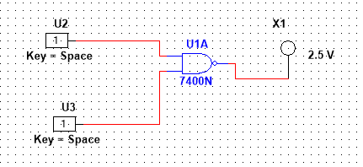

Truth Table:

Input: A | Input: B | 7400  NAND
0 | 0 | 1
0 | 1 | 1
1 | 0 | 1
1 | 1 | 0
0 | Not Connected | 1
1 | Not Connected | 1
Not Connected | 0 | 1
Not Connected | 1 | 1
Not Connected | Not Connected | 1

2. How do these gate treat when inputs are unconnected (low or high)? Briefly explain why?

- AND Gate: Unconnected inputs can lead to unpredictable results, but they may be interpreted as high (logic 1) in some configurations, resulting in the output being influenced accordingly.
- OR Gate: Similar to AND, floating inputs might be treated as high, potentially making the output high if any connected input is also high.
- NAND Gate: Unconnected inputs may be treated as high, leading the output to be low if all inputs are high (which is unlikely with floating inputs).
- NOR Gate: Unconnected inputs can also float high, causing the output to be low if any input is high.

3. Do swapping A and B make any difference?

- AND Gate: No difference; output is the same regardless of input order.
- OR Gate: No difference; output remains the same.
- NAND Gate: No difference; output is the same.
- NOR Gate: No difference; output remains the same.

- What is difference between a Inverter and a NOT gate?

- Inverter: Generally, refers to a device or configuration that produces the opposite logic level of its input.
- NOT Gate: Specifically refers to a single-input logic gate that outputs the inverse of the input. In practical terms, they are effectively the same when referring to a basic inverter.

- How can you make an inverter using a NOR gate?

An inverter is a logic gate that produces the opposite output of its input. A NOR gate, on the other hand, produces a 1 only when both inputs are 0.
To create an inverter using a NOR gate, we simply connect both inputs of the NOR gate together. This way, the input to the NOR gate will always be the same as both of its inputs.

- How can you make an inverter using a NAND gate?

To create an inverter using a NAND gate, connect both inputs of the NAND gate together.
A NAND gate produces a 1 only when both inputs are 0. By connecting both inputs together, the input becomes the same as both inputs. This effectively inverts the input, creating an inverter.

CONCLUSION:-

- The output of AND Gate is only high when all inputs are high.
- The output of OR Gate is low when all inputs are low.
- The output of NOT Gate is inverse of input.
- The output of NAND Gate is low when all inputs are high.
- The output of NOR Gate is high when all inputs are low.

Teacher Signature: ________________________

Student Registration No.: 02-134241-048

