DSA LAB 10
QUESTION 01
CODE
//SABA SHAHID
//02-134241-048
// CS 3-A

#include<iostream>
#include<string>
using namespace std;

//QUESTION 01

struct node {
int bookID;
struct node* left;
struct node* right;
};
struct node* CreateNode(int data) {
struct node* newNode = new node;
newNode->bookID = data;
newNode->left = NULL;
newNode->right = NULL;
return newNode;
}

// Insert
struct node* insert(struct node* root, int key) {
if (root == NULL) {
return CreateNode(key);
}

if (key < root->bookID) {
root->left = insert(root->left, key);
}
else {
root->right = insert(root->right, key);
}
return root;
}

// Pre-order
void preorder(struct node* root) {
if (root != NULL) {
cout << root->bookID << " ";
preorder(root->left);
preorder(root->right);
}
}

// In-order
void inorder(struct node* root) {
if (root != NULL) {
inorder(root->left);
cout << root->bookID << " ";
inorder(root->right);
}
}

// Post-order
void postorder(struct node* root) {
if (root != NULL) {
postorder(root->left);
postorder(root->right);
cout << root->bookID << " ";
}
}

void search(struct node* root, int key) {
if (root == NULL) {
cout << "Not found\n";
return;
}
if (root->bookID == key) {
cout << "Found\n";
}
else if (key < root->bookID) {
search(root->left, key);
}
else {
search(root->right, key);
}
}

// Right subtree me minimum bookID find
struct node* minValueNode(struct node* node) {
struct node* current = node;
while (current && current->left != NULL)
current = current->left;
return current;//last left return krdein ge
}

// bookID ko delete karnein ge
struct node* deleteNode(struct node* root, int key) {
if (root == NULL)
return root;

if (key < root->bookID) {
root->left = deleteNode(root->left, key);
}
else if (key > root->bookID) {
root->right = deleteNode(root->right, key);
}
else {
//leaf
if (root->left == NULL && root->right == NULL) {
delete root;
return NULL;
}
//agar 1 child
if (root->left == NULL) {
struct node* temp = root->right;
cout << "Book ID " << root->bookID << " deleted\n";
delete root;
return temp;
}
else if (root->right == NULL) {
struct node* temp = root->left;
cout << "Book ID " << root->bookID << " deleted!\n";
delete root;
return temp;
}

//agar 2 childern hain
struct node* temp = minValueNode(root->right);
//copying min of the right subtree node mai
root->bookID = temp->bookID; // Changed from price to bookID
//delete kr rae hain min ko right se
root->right = deleteNode(root->right, temp->bookID); // Changed from price to bookID
}
return root;
}

int main() {
int bookIDs[] = { 25, 17, 38, 12, 22, 45, 32, 9, 50, 19, 28, 40 };
int n = sizeof(bookIDs) / sizeof(bookIDs[0]);
struct node* root = NULL;

for (int i = 0; i < n; i++) {
root = insert(root, bookIDs[i]);
}

cout << "\n------------------------ " << endl;
cout << "Pre-order Traversal: " << endl;
preorder(root);
cout << "\n------------------------ " << endl;
cout << "In-order Traversal: " << endl;
inorder(root);
cout << "\n------------------------ " << endl;
cout << "Post-order Traversal: " << endl;
postorder(root);
cout << "\n------------------------ " << endl;

int searchID;
cout << "Enter book ID to search: " << endl;
cin >> searchID;
search(root, searchID);

int delID;
cout << "\n------------------------ " << endl;
cout << "Enter book ID to delete: " << endl;
cin >> delID;
root = deleteNode(root, delID);

cout << "\n------------------------ " << endl;
cout << "In-order after deletion: " << endl;
inorder(root);
cout << endl;
}
OUTPUT
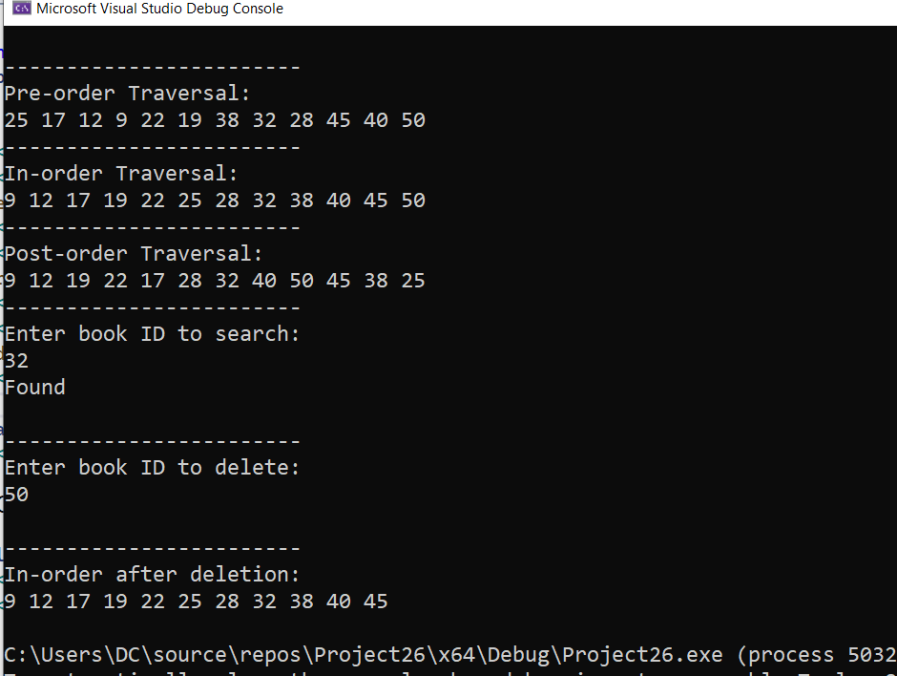
QUESTION 02
CODE
//SABA SHAHID
//02-134241-048
// CS 3-A

#include<iostream>
#include<string>
using namespace std;

//QUESTION 02

struct node {
string word;
struct node* left;
struct node* right;
};

struct node* CreateNode(string data) {
struct node* newNode = new node;
newNode->word = data;
newNode->left = NULL;
newNode->right = NULL;
return newNode;
}

// Insert
struct node* insert(struct node* root, string key) {
if (root == NULL) {
return CreateNode(key);
}

if (key < root->word) { // comparing strings
root->left = insert(root->left, key);
}
else {
root->right = insert(root->right, key);
}
return root;
}

// Pre-order
void preorder(struct node* root) {
if (root != NULL) {
cout << root->word << " ";
preorder(root->left);
preorder(root->right);
}
}

// In-order
void inorder(struct node* root) {
if (root != NULL) {
inorder(root->left);
cout << root->word << " ";
inorder(root->right);
}
}

// Post-order
void postorder(struct node* root) {
if (root != NULL) {
postorder(root->left);
postorder(root->right);
cout << root->word << " ";
}
}

void search(struct node* root, string key) {
if (root == NULL) {
cout << "Not found\n";
return;
}
if (root->word == key) {
cout << "Found\n";
}
else if (key < root->word) {
search(root->left, key);
}
else {
search(root->right, key);
}
}

// Right subtree me minimum word find
struct node* minValueNode(struct node* node) {
struct node* current = node;
while (current && current->left != NULL)
current = current->left;
return current;
}

// word ko delete karnein ge
struct node* deleteNode(struct node* root, string key) {
if (root == NULL)
return root;

if (key < root->word) {
root->left = deleteNode(root->left, key);
}
else if (key > root->word) {
root->right = deleteNode(root->right, key);
}
else {
//leaf
if (root->left == NULL && root->right == NULL) {
delete root;
return NULL;
}
//agar 1 child
if (root->left == NULL) {
struct node* temp = root->right;
cout << "Word '" << root->word << "' deleted\n";
delete root;
return temp;
}
else if (root->right == NULL) {
struct node* temp = root->left;
cout << "Word '" << root->word << "' deleted!\n";
delete root;
return temp;
}

//agar 2 childern hain
struct node* temp = minValueNode(root->right);
//copying min of the right subtree node mai
root->word = temp->word;
//delete kr rae hain min ko right se
root->right = deleteNode(root->right, temp->word);
}
return root;
}
//word lenght
void word_length(struct node* root, string key) {
if (root == NULL) {
cout << "Word not found\n";
return;
}
if (root->word == key) {
cout << "Length of '" << key << "' is: " << key.length() << endl;
}
else if (key < root->word) {
word_length(root->left, key);
}
else {
word_length(root->right, key);
}
}

int main() {
string words[] = { "kiwi", "dog", "banana", "apple", "cat", "grape", "peach",
"lemon", "orange", "raspberry", "strawberry", "zebra" };
int n = sizeof(words) / sizeof(words[0]);
struct node* root = NULL;
for (int i = 0; i < n; i++) {
root = insert(root, words[i]);
}

cout << "\n------------------------ " << endl;
cout << "Pre-order Traversal: " << endl;
preorder(root);
cout << "\n------------------------ " << endl;
cout << "In-order Traversal: " << endl;
inorder(root);
cout << "\n------------------------ " << endl;
cout << "Post-order Traversal: " << endl;
postorder(root);
cout << "\n------------------------ " << endl;

string searchWord;
cout << "Enter word to search: ";
cin >> searchWord;
search(root, searchWord);

string delWord;
cout << "\n------------------------ " << endl;
cout << "Enter word to delete: ";
cin >> delWord;
root = deleteNode(root, delWord);

cout << "\n------------------------ " << endl;
cout << "In-order after deletion: " << endl;
inorder(root);
cout << endl;

string lengthWord;
cout << "\n------------------------ " << endl;
cout << "Enter word to find its length: ";
cin >> lengthWord;
word_length(root, lengthWord);
cout << "\n------------------------ " << endl;
}
OUTPUT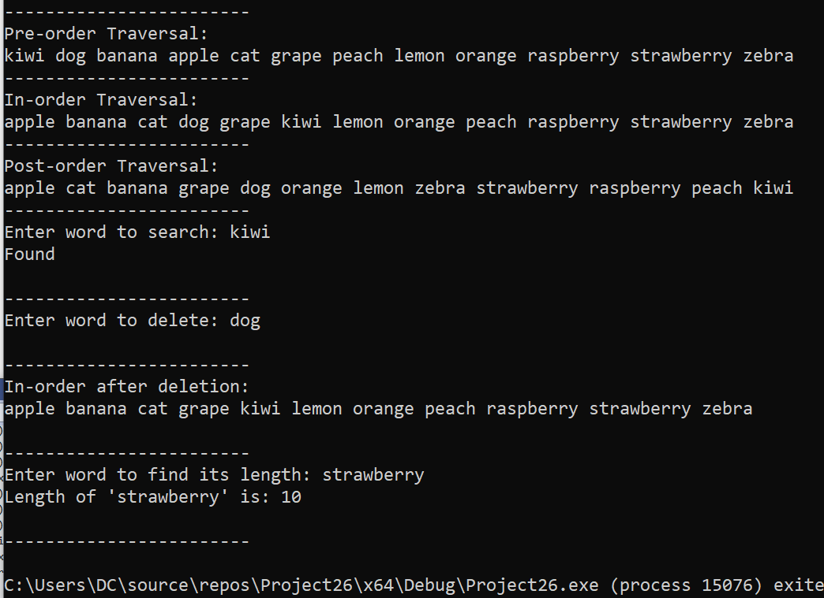

QUESTION 03
CODE
//SABA SHAHID
//02-134241-048
// CS 3-A

#include<iostream>
#include<string>
using namespace std;

//QUESTION 03

struct node {
double price;
struct node* left;
struct node* right;
};
struct node* CreateNode(double data) {
struct node* newNode = new node;
newNode->price = data;
newNode->left = NULL;
newNode->right = NULL;
return newNode;
}

// Insert
struct node* insert(struct node* root, double key) {
if (root == NULL) {
return CreateNode(key);
}

if (key < root->price) {
root->left = insert(root->left, key);
}
else {

root->right = insert(root->right, key);
}
return root;
}

// In-order
void inorder(struct node* root) {
if (root != NULL) {
inorder(root->left);
cout << root->price << " ";
inorder(root->right);
}
}

void search(struct node* root, double key) {
if (root == NULL) {
cout << " not found :(\n";
return;
}
if (root->price == key) {
cout << key << " found :)\n";
}
else if (key < root->price) {
search(root->left, key);
}
else {
search(root->right, key);
}
}

// Right subtree me minimum price find
struct node* minValueNode(struct node* node) {
struct node* current = node;
while (current && current->left != NULL)
current = current->left;
return current;//last left return krdein ge
}

// Price ko delete karnein ge
struct node* deleteNode(struct node* root, double key) {
if (root == NULL)
return root;

if (key < root->price) {
root->left = deleteNode(root->left, key);
}

else if (key > root->price) {
root->right = deleteNode(root->right, key);
}
else {
//leaf
if (root->left == NULL && root->right == NULL) {
delete root;
return NULL;
}
//agar 1 chid
if (root->left == NULL) {
struct node* temp = root->right;
cout << "Value " << root->price << " deleted\n";
delete root;
return temp;
}

else if (root->right == NULL) {
struct node* temp = root->left;
cout << "Value " << root->price << " deleted!\n";
delete root;
return temp;
}

//agar 2 childern hain
struct node* temp = minValueNode(root->right);
//copying min of the right subtree node mai
root->price = temp->price;
//delete kr rae hain min ko right se
root->right = deleteNode(root->right, temp->price);
}
return root;
}

// count karta hai kitni items average price se zyada hain
int countAboveAverage(struct node* root, double average) {
if (root == NULL) {
return 0;
}
//hardcode ki hui valuse se camparing aur counting
int count = 0;
if (root->price > average) {
count = 1;
}
return count + countAboveAverage(root->left, average) + countAboveAverage(root->right, average);
}

// count karta hai kitni items average price se kam hain
int countBelowAverage(struct node* root, double average) {
if (root == NULL) {
return 0;
}
int count = 0;
if (root->price < average) {
count = 1;
}
return count + countBelowAverage(root->left, average) + countBelowAverage(root->right, average);
}

// highest price find karta hai (rightmost node)
double findHighestPrice(struct node* root) {
while (root && root->right != NULL) {
root = root->right;
}
return root->price;

}

// lowest price find karta hai (leftmost node)
double findLowestPrice(struct node* root) {
while (root && root->left != NULL) {
root = root->left;
}
return root->price; //agar empty hai tree
}

int main() {
double prices[] = { 11.0, 13.5, 9.5, 12.5, 14.0, 15.5, 8.0, 10.5, 11.5, 13.0, 15.5, 18.0, 17.5, 19.0, 17.0 };
int n = sizeof(prices) / sizeof(prices[0]);
struct node* root = NULL;

for (int i = 0; i < n; i++) {
root = insert(root, prices[i]);
}

double average = 13.73;

cout << "\n------------------------ " << endl;
cout << "Inorder Traversal: " << endl;
inorder(root);
cout << "\n------------------------ " << endl;
cout << "number of items above the average price of 13.73: " << countAboveAverage(root, average) << endl;
cout << "number of items below the average price of 13.73: " << countBelowAverage(root, average) << endl;

cout << "highest price: " << findHighestPrice(root) << endl;
cout << "lowest price: " << findLowestPrice(root) << endl;

double searchPrice;
cout << "Enter price to search: " << endl;
cin >> searchPrice;
search(root, searchPrice);

double delPrice;
cout << "\n------------------------ " << endl;
cout << "Enter price to delete: " << endl;
cin >> delPrice;
root = deleteNode(root, delPrice);

cout << "\n------------------------ " << endl;
cout << "Inorder after deletion: " << endl;
inorder(root);
cout<< endl;
}

OUTPUT
