Lab 5: Implementation of Stack CLO1, PLO3, P3

Objective(s): Upon completion of this lab session, students will be able to:
Implement the concept of stack

Exercise 1: Utility Bill Stack Organizer

In a household, you are tasked with managing the stack of utility bills that need to be paid. Each bill (such as electricity, water, and gas bills) is placed in a stack as they arrive. The stack has a maximum capacity of ten bills. Your program should include the following functions: addBill(), removeBill(), and displayBills(). Implement the following functions and test your program for given procedures.
- addBill():If the stack is not full, add the bill to the stack. Display the name or type of the bill added (e.g., "Electricity Bill").If the stack is full, print "Stack is full; cannot add more bills."
- removeBill(): If the stack is not empty, remove a bill from the stack and display that the bill is paid. If the stack is empty, print "Stack is empty; no bills to pay."
- displayBills(): This function displays the details of all the current bills in the stack.

Test Your Program Using the Following Procedure:
  - Call addBill("Electricity Bill")
  - Call addBill("Water Bill")
  - Call addBill("Gas Bill")
  - Call addBill("Internet Bill")
  - Call addBill("Phone Bill")
  - Call addBill("Cable Bill")
  - Call addBill("Trash Collection Bill")
  - Call addBill("Insurance Bill")
  - Call addBill("Property Tax Bill")
  - Call addBill("Credit Card Bill")
  - Call addBill("Loan Repayment Bill")
  - Display all bills in the stack.
  - Call removeBill()
  - Display all bills in the updated stack.

CODE
// Saba Shahid
// 02-134241-048
// CS 3-A

// question 01
#include<iostream>
#include<string>
using namespace std;

//max values for the stack
int MAX = 10;
// array to store bills
string bills[10];
int top = -1; // stack pointer, iniallaizing it to be empty

void addBill(string bill) {
if (top >= MAX - 1) {
cout << "cannot add more bills" << endl;
}
else {
top++;
bills[top] = bill;
cout << bill << " added " << endl;
}
}

void removeBill() {
if (top < 0) {
cout << "no bills availible" << endl;
}
else {
cout << bills[top] << " paid and removed from the stack " << endl;
top--;
}
}

void displayBills() {
if (top < 0) {
cout << "no bills availible" << endl;
}
else {
cout << "current bills :" << endl;
for (int i = top; i >= 0; i--) {
cout << bills[i] << endl;
}
}
}
int main() {
int option;
string bill;
while(true){
cout << "select an option:" << endl;
cout << "1. add bill" << endl;
cout << "2. remove bill" << endl;
cout << "3. display bills" << endl;
cout << "4. exit" << endl;
cin >> option;

switch (option) {
case 1:
cout << "Enter bill name: ";
cin.ignore();
getline(cin, bill);
addBill(bill);
break;
case 2:
removeBill();
break;
case 3:
displayBills();
case 4:
return 0;
default:
break;
}
}
}

OUTPUT

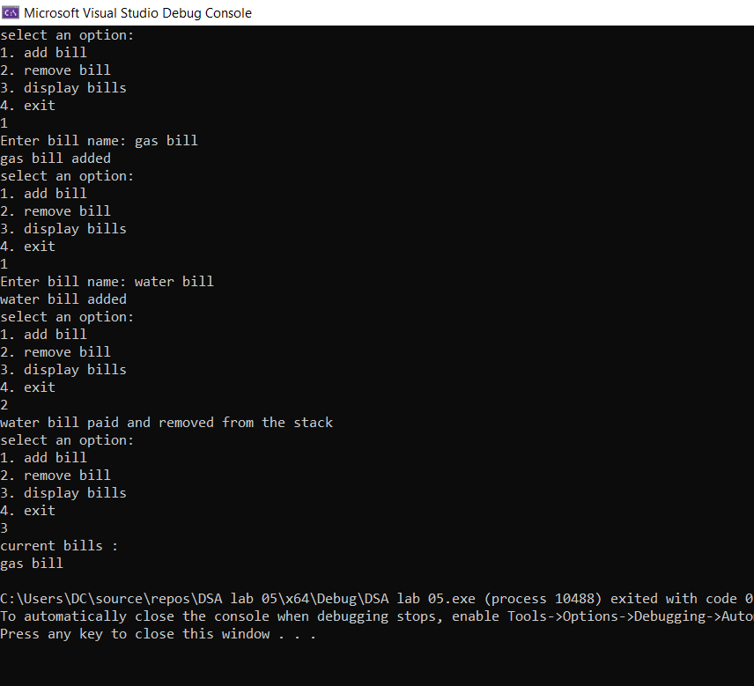

Exercise 2: Syntax Checker

Consider that you are building a compiler. Implement a C++ program that uses a stack to check whether a given expression has balanced parentheses, square brackets, and curly braces. Provide meaningful error messages for unbalanced cases.
Some Sample Inputs:
- {{[[(())]]}}
- ((()))
- ((){}[])
- {[(])}
- {[}
CODE
//saba shahid
// //02-134241-048
// CS 3-A

// question 02
#include <iostream>
#include <string>
using namespace std;

const int MAX = 20;
char Stack[MAX];
int top = -1;

//top of the stack ko manage krne ke liye
bool isEmpty() {
return top < 0;
}
bool isFull() {
return top >= MAX - 1;
}

void push(char item) {
if (!isFull()) Stack[++top] = item;
}

void pop() {
if (!isEmpty()) top--;
}

bool isMatching(char a, char b) {
return (a == '(' && b == ')') || (a == '{' && b == '}') || (a == '[' && b == ']');
}

//ty to w3schools learned :)
bool checkBalancedParentheses(string exp) {
for (char brk : exp) {
if (brk == '(' || brk == '{' || brk == '[') {
push(brk);
}
else if (brk == ')' || brk == '}' || brk == ']') {
//stack top function top ka track rakhta hai to check the expected expression and match it
if (isEmpty() || !isMatching(Stack [top], brk))
return false;
pop();
}
}
return isEmpty();
}

int main() {
string exp;
char choice;
do {
cout << "enter an expression: ";
getline(cin, exp);

cout << (checkBalancedParentheses(exp) ? "balanced expression \n"
: " unbalanced expression \n");

cout << " want to continue? (y/n): ";
cin >> choice;
cin.ignore(); // input buffer
} while (choice == 'y' || choice == 'Y');

return 0;
}
OUTPUT
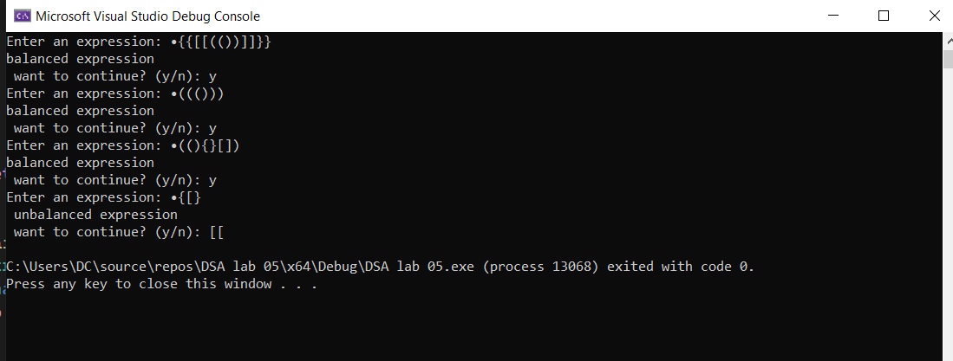

Exercise 3: Postfix Expression Evaluator

In a software development team building a calculator app, they decide to add a feature that evaluates mathematical expressions in postfix notation, which makes it easier to read without needing parentheses. The program uses a stack to keep track of numbers. When it encounters a number, it pushes it onto the stack. When it sees an operator like + or -, it pops the last two numbers off the stack, performs the operation, and pushes the result back on. The app can handle basic math operations and checks for errors, like dividing by zero or not having enough numbers to perform an operation.
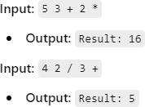

CODE
// saba shahid
// 02-134241-048
// CS 3-A

//question 03
#include <iostream>
using namespace std;

const int MAX = 20;
double Stack[MAX];
int top = -1;

bool isEmpty() {
return top < 0;
}

bool isFull() {
return top >= MAX - 1;
}

void push(double num) {
if (!isFull()) Stack[++top] = num;
}

double pop() {
if (!isEmpty()) return Stack[top--];
cout << "stack underflow!\n";
return -1;
}

// check karein ge if character is an operator
bool isOperator(char ch) {
return ch == '+' || ch == '-' || ch == '*' || ch == '/';
}

// arithmetic operations
double performOperation(double a, double b, char op) {
if (op == '+') return a + b;
if (op == '-') return a - b;
if (op == '*') return a * b;
if (op == '/') {
return a / b;
}
return 0;
}

// postfix expressions
double evaluatePostfix(string exp) {
for (int i = 0; i < exp.length(); i++) {
char ch = exp[i];

// if character is a number pushin to stack
if (ch >= '0' && ch <= '9') {
push(ch - '0'); // Convert char to int
}

// ifff character is an operator pop 2 values perform operationnn push result ezz
else if (isOperator(ch)) {
if (top < 1) {
cout << "not enough operands!\n";
return -1;
}
double num2 = pop();
double num1 = pop();
double result = performOperation(num1, num2, ch);
push(result);
}
else {
cout << "invalid character '" << ch << "'\n";
return -1;
}
}

if (top != 0) {
cout << "invalid expression!\n";
return -1;
}

return pop();
}

int main() {
string exp;
char choice;

do {
cout << "enter a postfix expression (for eg 10+): ";
cin >> exp;

double result = evaluatePostfix(exp);
if (result != -1) {
cout << "result: " << result << endl;
}

cout << "want to continue? (y/n): ";
cin >> choice;
} while (choice == 'y' || choice == 'Y');

return 0;
}

OUTPUT
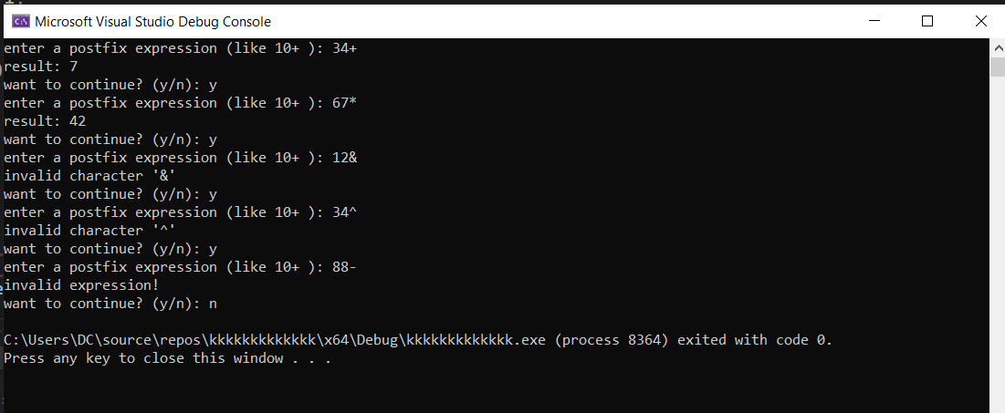

Exercise 4: Image Editing

A photographer is editing a lawn shoot picture for a clothing brand. The photographer performs several edit operations on the image, and he needs the ability to undo some of the operations if he decides they weren't suitable for the final picture. Each edit will be stored in a stack. Design a C++ program using a stack to perform editing on the image, with a maximum of 10 edits allowed. Implement an undo feature that allows the photographer to revert to a previous edit step. The program should store each edit operation in the stack, and the user should be able to perform edits, view the current image state, and undo edits as needed.

The editing options he might use are:

- Brightness adjustment (increase or decrease brightness).
- Cropping (cutting a portion of the image).
- Applying filters (e.g., grayscale, sepia).
- Rotating the image (clockwise or counter-clockwise).

Sample Output:
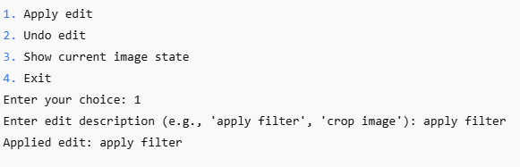
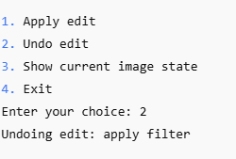

CODE

// saba shahid
// 02-134241-048
// CS 3-A

//question 04
#include <iostream>
#include <string>
using namespace std;

const int MAX_EDITS = 10;
string editStack[MAX_EDITS];
int top = -1;

bool isEmpty() {
return top == -1;
}
bool isFull() {
return top == MAX_EDITS - 1;
}
void addEdit(const string& edit) {
if (isFull()) {
cout << "max number of edits reached " << endl;
}
else {
editStack[++top] = edit;
cout << edit << " added to the stack" << endl;
}
}
void undoEdit() {
if (isEmpty()) {
cout << "no edits to undo" << endl;
}
else {
cout << "undoing edit: " << editStack[top] << endl;
top--;
}
}
void displayImageState() {
cout << "displaying image" << endl;
}

void editMenu() {
int choice;

do {
cout << "\nenter your choice for edit:\n";
cout << "1. brightness\n";
cout << "2. crop\n";
cout << "3. apply filter\n";
cout << "4. rotate\n";
cout << "5. back to main menu\n";
cout << "enter choice: ";
cin >> choice;
cin.ignore();

switch (choice) {
case 1:
cout << "brightness done" << endl;
addEdit("brightness done");
break;

case 2:
cout << "crop done" << endl;
addEdit("crop done");
break;

case 3:
cout << "filter applied" << endl;
addEdit("filter applied");
break;

case 4:
cout << "rotation done" << endl;
addEdit("rotation done");
break;

case 5:
cout << "returning to main menu\n";
break;

default:
cout << "invalid choice\n";
}

} while (choice != 5);
}

int main() {
int choice;

do {
cout << "1. edit\n";
cout << "2. undo last edit\n";
cout << "3. display edits\n";
cout << "4. exit\n";
cout << "enter your choice: ";
cin >> choice;
cin.ignore();

switch (choice) {
case 1:
editMenu();
break;

case 2:
undoEdit();
break;

case 3:
cout << "\n all edits made so far:\n";
for (int i = 0; i <= top; i++) {
cout << editStack[i] << endl;
}
break;

case 4:
cout << "exiting\n";
break;

default:
cout << "invalid choice\n";
}

} while (choice != 4);

return 0;
}

OUTPUT

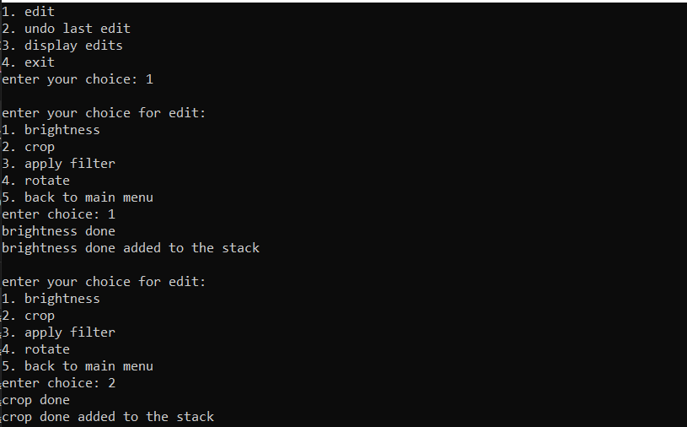

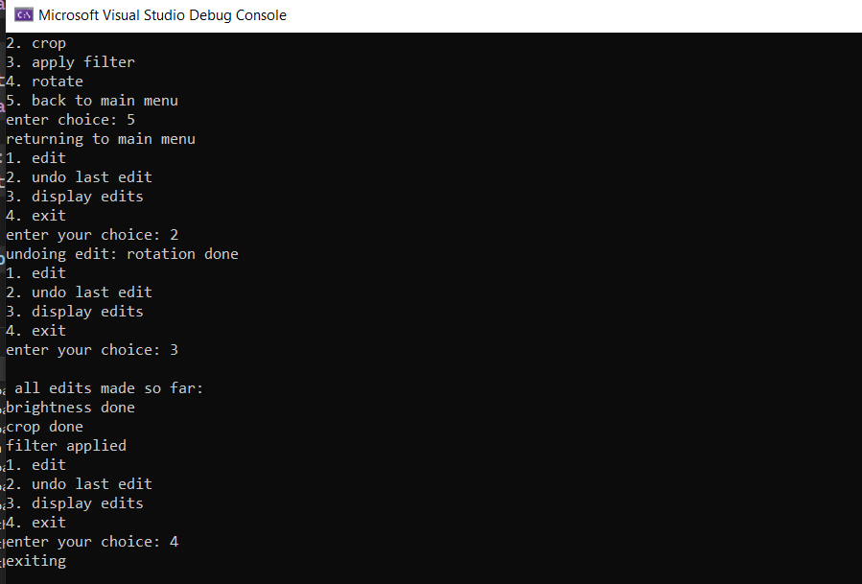

Exercise 5: Fruit Stack Frenzy

Design a small game that uses 4 arrays functioning as stacks to manage the arrangement of fruits in different containers. Each container has a capacity of 3 fruits Apple, Kiwi and orange. Initially, fruits are randomly placed in 3 jars and 4th jar will be empty. The objective is to organize the containers such that any 3 jars will have similar fruits only. The game allows players to push fruits into the containers and pop them out, with the constraint that only fruits of the same type can be placed on top of each other in a container.
Sample: Initial Jars

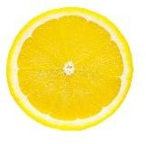
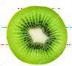

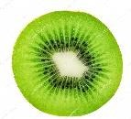





Jar 1 Jar 2 Jar 3 Jar 4







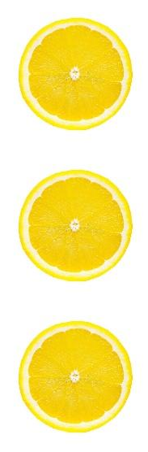
Goal:
CODE
// saba shahid
// 02-134241-048
// CS 3-A

//question 05
#include <iostream>
#include <string>
using namespace std;

const int MAX_CAPACITY = 3;
string jars[4][MAX_CAPACITY];
int top[4] = { -1, -1, -1, -1 };

bool isEmpty(int jar) {
return top[jar] == -1;
}
bool isFull(int jar) {
return top[jar] == MAX_CAPACITY - 1;
}
void push(int jar, string fruit) {
if (!isFull(jar)) {
jars[jar][++top[jar]] = fruit;
}
}
void pop(int jar) {
if (!isEmpty(jar)) {
top[jar]--;
}
}
void displayJars() {
for (int i = 0; i < 4; i++) {
cout << "jar " << i + 1 << ": ";
if (isEmpty(i)) cout << "empty";
else for (int j = 0; j <= top[i]; j++) cout << jars[i][j] << " ";
cout << endl;
}
}
bool isGoalAchieved() {
int appleCount = 0, kiwiCount = 0, orangeCount = 0;
for (int i = 0; i < 4; i++) {
for (int j = 0; j <= top[i]; j++) {
if (jars[i][j] == "apple") appleCount++;
else if (jars[i][j] == "kiwi") kiwiCount++;
else if (jars[i][j] == "orange") orangeCount++;
}
}
return appleCount == 3 || kiwiCount == 3 || orangeCount == 3;
}

int main() {
int choice, jar;
string fruit;

// fruit placement k liye
push(0, "apple");
push(0, "kiwi");
push(0, "orange");

push(1, "apple");
push(1, "orange");
push(1, "kiwi");

push(2, "orange");
push(2, "kiwi");
push(2, "apple");

// main game loop
do {
cout << "\n1. push fruit\n2. pop fruit\n3. display jars\n4. check goal\n5. exit\n";
cout << "choose option: ";
cin >> choice;

switch (choice) {
case 1:
cout << "enter fruit (apple, kiwi, orange): ";
cin >> fruit;
cout << "enter jar (1-4): ";
cin >> jar;
jar -= 1; // adjust for 0-based index
if (fruit == "apple" || fruit == "kiwi" || fruit == "orange") {
push(jar, fruit);
}
else {
cout << "invalid fruit" << endl;
}
break;

case 2:
cout << "enter jar (1-4): ";
cin >> jar;
jar -= 1;
pop(jar);
break;

case 3:
displayJars();
break;

case 4:
if (isGoalAchieved()) {
cout << "goal achieved" << endl;
}
else {
cout << "goal not achieved" << endl;
}
break;

case 5:
cout << "exiting" << endl;
break;

default:
cout << "invalid choice" << endl;
}
} while (choice != 5);

return 0;
}
OUTPUT
