Lab 6: Implementation of Queue CLO1,PLO3,P3

Objective(s): Upon completion of this lab session, students will be able to:
Implement the concepts of Queue according to application domain
Lab Exercises

Exercise 1: Petrol refueling

Write a program in C++ that implements a car refueling system using a queue data structure that simulate the process of vehicle arriving at petrol pump station and the order in which they arrive. Each car has unique number, amount of petrol require to refuel and amount paid for petrol. Assume that cost of one liter petrol is 256 rupees. Your program must have following functionalities.

- Add a car in the queue.
- Display all cars in the queue
- Remove the car from Queue after refueling
- Calculate the fuel cost
CODE
//saba shahid
//02-134241-048
//CS 3-A

//question 01

#include <iostream>
using namespace std;

const int COST_PER_LITER = 256;
const int MAX_CARS = 100;

struct Car {
int carNumber;
int petrolRequired;
int amountPaid;
};

Car queue[MAX_CARS];
int start = 0, rear = 0;

void addCar() {
if (rear == MAX_CARS) {
cout << "queue full!\n";
}
else {
cout << "enter car number: ";
cin >> queue[rear].carNumber;
cout << "enter petrol required: ";
cin >> queue[rear].petrolRequired;
//queue[end].amountPaid mai store krwa rae hain calculated value
queue[rear].amountPaid = queue[rear].petrolRequired * COST_PER_LITER;
rear++;
cout << "car added \n";
}
}

void display() {
if (start == rear) {
cout << "no cars in queue \n";
return;
}
cout << "cars in queue:\n";
for (int i = start; i < rear; i++) {
cout << "car " << queue[i].carNumber << "\t" << " Petrol: " << queue[i].petrolRequired << "\t" << "Paid: " << queue[i].amountPaid << " rupees\n";
}
}

void removeCar() {
if (start == rear) {
cout << "no cars in queue\n";
return;
}
cout << "car " << queue[start].carNumber << " removed \n";
start++;
}

void calculatePrice() {
if (start == rear) {
cout << "no cars in queue \n";
return;
}
cout << "car: " << queue[start].carNumber << "\t" << " Petrol: " << queue[start].petrolRequired << "\t" << "Paid: " << queue[start].amountPaid << " rupees\n";
}

int main() {
int choice;
do {
cout << "\n1. add Car\n2. display Cars\n3. remove Car\n4. calculate price\n5. exit\n";
cin >> choice;
switch (choice) {
case 1: addCar();
break;
case 2: display();
break;
case 3: removeCar();
break;
case 4: calculatePrice();
break;
case 5: cout << "exiting...\n";
break;
default: cout << "invalid choice.\n";
}
} while (choice != 5);

return 0;
}
OUTPUT
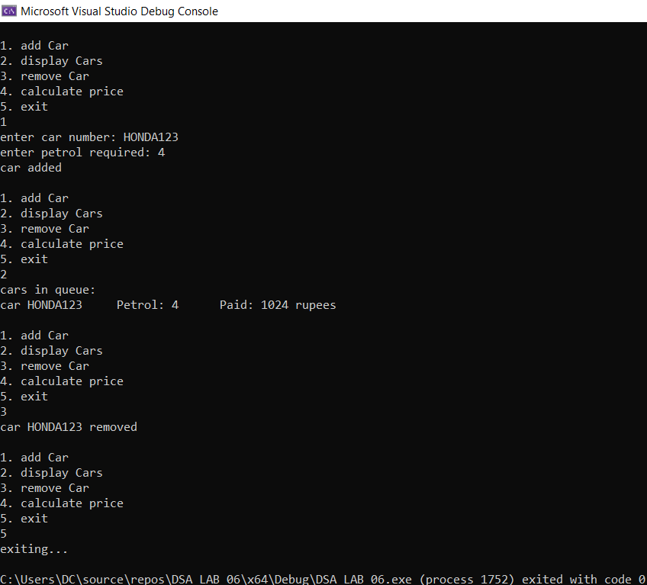

Exercise 1: Efficient Package Management: Emily's Logistics Queue System

Emily is a manager at a small logistics company that specializes in delivering packages to local businesses. To streamline the package handling process, Emily decides to develop a C++ program using a QUEUE data structure with a maximum capacity of 6 packages.

The program will include three key functions:

  - enQueue() to add packages to the delivery queue,
  - deQueue() to remove packages once they are delivered, and
  - Display() to show the current status of the delivery queue.
Emily plans to test the program with a series of procedures based on the company's typical operations:

- Initially, Emily calls enQueue(10) to add a package labeled as "Package 10" to the delivery queue.
- Following that, she adds more packages by calling enQueue(7), enQueue(4), enQueue(8), enQueue(2), and enQueue(15), each time specifying the package number.
- Curious to see the current status of the delivery queue, Emily calls the Display() function.

- As more packages arrive at the warehouse, Emily decides to add one more by calling enQueue(25).
- Once the delivery drivers start their routes, Emily begins removing packages from the queue by calling deQueue() twice to signify that the first two packages have been deliveredsuccessfully.
- To ensure that everything is running smoothly, Emily calls Display() again to check the updated status of the delivery queue after the deliveries.
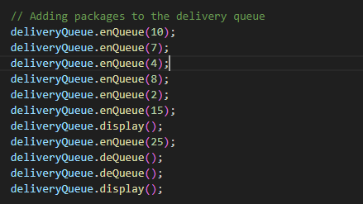
CODE

// saba shahid
// 02-134241-048
// CS 3-A

// question 02

#include <iostream>
using namespace std;

const int MAX_PACKAGES = 6;

struct Package {
int packageNumber;
};

Package queue[MAX_PACKAGES];
int start = 0, rear = 0;

void addPackage(int packageNumber) {
if (rear == MAX_PACKAGES) {
cout << "Queue full!\n";
}
else {
queue[rear].packageNumber = packageNumber;
rear++;
cout << "Package " << packageNumber << " added\n";
}
}

void removePackage() {
if (start == rear) {
cout << "No packages in queue\n";
return;
}
cout << "Package " << queue[start].packageNumber << " removed\n";
start++;
}

void display() {
if (start == rear) {
cout << "No packages in queue\n";
return;
}
cout << "Packages in queue:\n";
for (int i = start; i < rear; i++) {
cout << "Package " << queue[i].packageNumber << "\n";
}
}

int main() {

addPackage(10);
addPackage(7);
addPackage(4);
addPackage(8);
addPackage(2);
addPackage(15);
display();
addPackage(25);
removePackage();
removePackage();
display();
}
OUTPUT
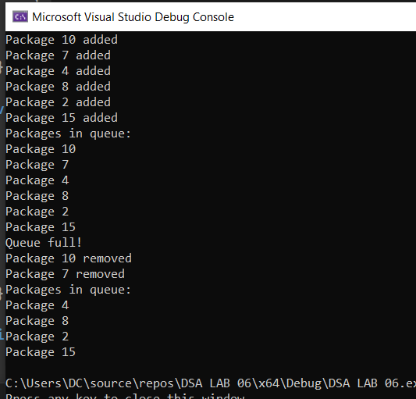

Exercise 3: Streamlining Café Orders: Sara's Token System Implementation

Sara's café has gained immense popularity in the neighborhood for its delicious food and cozy ambiance. Recently, she introduced a token system to streamline the ordering process. The system works like this: when a customer enters the café, they take a token indicating their order and wait for their turn. As soon as their order is ready, they approach the food counter, display their token, collect their food, and pay the bill.

Now, Sara wants to implement a program to manage this token system efficiently. She wants to use a Circular Queue data structure to store the token numbers, with a maximum capacity of 10 tokens at any given time.

Your task is to write a C++ program that simulates this token system for Sara's café. The program should include the following functionalities:

  - A function to add tokens to the circular queue when a customer arrives at the café.
  - A function to remove tokens from the circular queue when a customer's order is ready.
  - Ensure that the circular queue maintains a maximum capacity of 10 tokens at all times.
  - Display appropriate messages to inform customers when they can collect their food.
  - Display an error message if the queue is empty and a customer tries to collect their food.

CODE
// saba shahid
// 02-134241-048
// CS 3-A

// question 03
#include <iostream>
using namespace std;

struct Token {
string tokenNumber;
};

const int MAX_TOKENS = 10;
Token queue[MAX_TOKENS];
int start = -1;
int rear = -1;

void addToken() {
if (rear == MAX_TOKENS - 1) {
cout << "The queue is full\n";
}
else {
cout << "Enter your token number\n";
rear++;
cin >> queue[rear].tokenNumber;

// start ko ab index 0 pr laein ge
if (start == -1) {
start = 0;
}
}
}
void removeToken() {
if (start == -1) {
cout << "The queue is empty\n";
}
else {
cout << "Your order for token number: " << queue[start].tokenNumber << " is ready\n";
if (start == rear) {
start = rear = -1;
}
else {
start = (start + 1) % MAX_TOKENS; // moving start to next position
}
}
}

void displayTokens() {
if (start == -1) {
cout << "The queue is empty\n";
}
else {
cout << "Tokens in the queue are:\n";
int i = start;
while (i != rear) {
cout << queue[i].tokenNumber << endl;
i = (i + 1) % MAX_TOKENS;
}
cout << queue[rear].tokenNumber << endl;
}
}

int main() {
int choice;

do {
cout << "\n WELCOME TO EMILY'S CAFE\n";
cout << "1. Add a Token\n";
cout << "2. Remove a Token\n";
cout << "3. Display Tokens\n";
cout << "4. Exit\n";
cout << "Enter your choice: ";
cin >> choice;

switch (choice) {
case 1:
addToken();
break;
case 2:
removeToken();
break;
case 3:
displayTokens();
break;
case 4:
cout << "exiting...\n";
break;
default:
cout << "invalid choice, please try again.\n";
}
} while (choice != 4);

return 0;
}

OUTPUT

