DSA LAB -07
QUESTION O1
CODE
// saba shahid
// 02-134241-048
// CS 3-A

// question 01
#include <iostream>
#include <string>

using namespace std;

struct Node {
string content;
string time;
Node* next;
};
Node* head = NULL;

void addPost(string content, string time) {
Node* temp = new Node();
temp->content = content;
temp->time = time;
temp->next = NULL;

if (head == NULL) {
head = temp;
return;
}

Node* ptr = head;
while (ptr->next != NULL) {
ptr = ptr->next;
}
ptr->next = temp;
}

void removePost(string content) {
Node* temp = head;
Node* prev = NULL;
bool found = false;

while (temp != NULL) {
if (temp->content == content) {
found = true;
Node* toDelete = temp;

if (prev == NULL) { // If deleting head
head = temp->next;
}
else {
prev->next = temp->next;
}

delete toDelete; // Free memory
cout << "Post removed successfully.\n";
return; // Stop after removing the first match
}

prev = temp;
temp = temp->next;
}

if (!found) {
cout << "Post not found.\n";
}
}

void displayPosts() {
Node* temp = head;
while (temp != NULL) {
cout << "Post: " << temp->content << " (" << temp->time << ")\n";
temp = temp->next;
}
}

int totalCount() {
int count = 0;
Node* temp = head;
while (temp != NULL) {
count++;
temp = temp->next;
}
return count;
}

void searchPosts(string content) {
Node* temp = head;
int position = 1;

while (temp != NULL) {
string tempContent = temp->content;

if (tempContent == content) {
cout << "Post found at position: " << position << endl;
return;
}

temp = temp->next;
position++;
}
cout << "Post not found.\n";
}

int main() { // Corrected main() declaration
cout << "Adding posts...\n";
addPost("travel blog", "10:00 AM");
addPost("cafe visit", "10:30 AM");
addPost("college trip", "11:00 AM");
addPost("shopping", "11:30 AM");
addPost("friends hangout", "12:00 PM");
addPost("ramazan posting", "12:30 PM");
addPost("food recipe", "1:00 PM");
cout << "Posts added.\n";
displayPosts();

string toRemove, toSearch;

cin.ignore(); // preventing input skipping loll
cout << "Enter post content to remove: ";
getline(cin, toRemove);
removePost(toRemove);

cout << "Enter another post content to remove: ";
getline(cin, toRemove);
removePost(toRemove);

displayPosts();

cout << "Total Posts: " << totalCount() << endl;

cout << "Enter post content to search: ";
getline(cin, toSearch);
searchPosts(toSearch);

return 0;
}
OUTPUT
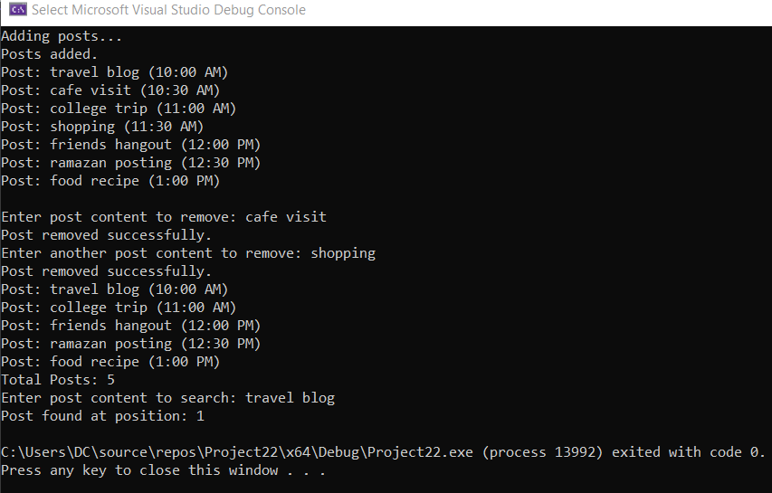
QUESTION 02
CODE
// saba shahid
// 02-134241-048
// CS 3-A

// question 02
#include <iostream>
#include <string>

using namespace std;

struct Node {
string title;
string genre;
string timeRead;
Node* next;
};

Node* head = NULL;

void addBook(string title, string genre, string timeRead) {
Node* temp = new Node();
temp->title = title;
temp->genre = genre;
temp->timeRead = timeRead;
temp->next = NULL;

if (head == NULL) {
head = temp;
return;
}

Node* ptr = head;
while (ptr->next != NULL) {
ptr = ptr->next;
}
ptr->next = temp;
}

void removeBook(string title) {
Node* temp = head;
Node* prev = NULL;
bool found = false;

while (temp != NULL) {
if (temp->title == title) {
found = true;
Node* toDelete = temp;

if (prev == NULL) {
head = temp->next;
}
else {
prev->next = temp->next;
}

delete toDelete;
cout << "Book removed.\n";
return;
}

prev = temp;
temp = temp->next;
}

if (!found) {
cout << "Couldn’t find that book.\n";
}
}

void displayBooks() {
Node* temp = head;
if (temp == NULL) {
cout << "No books to show.\n";
return;
}
while (temp != NULL) {
cout << "Title: " << temp->title << " | Genre: " << temp->genre << " | Read at: " << temp->timeRead << "\n";
temp = temp->next;
}
}

int totalBooks() {
int count = 0;
Node* temp = head;
while (temp != NULL) {
count++;
temp = temp->next;
}
return count;
}

void searchBook(string title) {
Node* temp = head;
int position = 1;
while (temp != NULL) {
if (temp->title == title) {
cout << "Found at position: " << position << "\n";
return;
}
temp = temp->next;
position++;
}
cout << "Not in the list.\n";
}

int main() {
cout << "Adding books...\n";
addBook("The Great Gatsby", "Classic", "10:00 AM");
addBook("To Kill a Mockingbird", "Fiction", "11:30 AM");
addBook("1984", "Dystopian", "1:00 PM");
addBook("Harry Potter", "Fantasy", "3:00 PM");
addBook("The Hobbit", "Adventure", "5:00 PM");
cout << "Books added!\n";
displayBooks();

string toRemove, toSearch;

cout << "Enter book title to remove: ";
getline(cin, toRemove);
removeBook(toRemove);

displayBooks();

cout << "Total books: " << totalBooks() << endl;

cout << "Enter book title to search: ";
getline(cin, toSearch);
searchBook(toSearch);

return 0;
}
OUTPUT
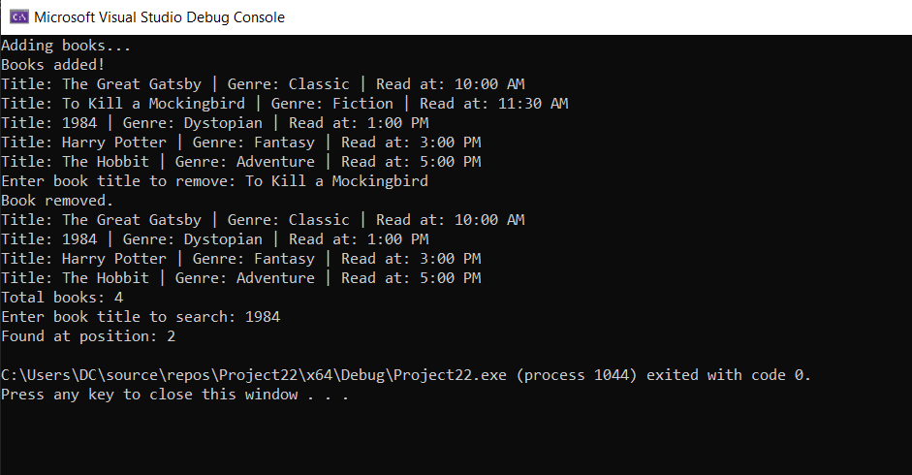
QUESTION 03
CODE
// saba shahid
// 02-134241-048
// CS 3-A

// question 03
#include <iostream>
#include <string>

using namespace std;

struct Order {
int orderNumber;
string drinkType;
string customizations;
Order* next;
};

Order* front = NULL;
Order* rear = NULL;
int orderCount = 1;

void placeOrder(string drinkType, string customizations) {
Order* temp = new Order();
temp->orderNumber = orderCount++;
temp->drinkType = drinkType;
temp->customizations = customizations;
temp->next = NULL;

if (rear == NULL) {
front = rear = temp;
return;
}

rear->next = temp;
rear = temp;
}

void serveOrder() {
if (front == NULL) {
cout << "no orders in the queue" << endl;
return;
}

Order* temp = front;
front = front->next;

if (front == NULL) {
rear = NULL;
}

cout << "serving order number" << temp->orderNumber << " - " << temp->drinkType <<
" customizations: " << temp->customizations << endl;
delete temp;
}

void displayQueue() {
if (front == NULL) {
cout << "no pending orders" << endl;
return;
}

Order* temp = front;
cout << "current orders in queue:" << endl;
while (temp != NULL) {
cout << "order number " << temp->orderNumber << " Drink: " << temp->drinkType <<
" customizations: " << temp->customizations << endl;
temp = temp->next;
}
}

void displayOrderDetails(int orderNumber) {
Order* temp = front;
while (temp != NULL) {
if (temp->orderNumber == orderNumber) {
cout << "order number" << temp->orderNumber << " " << temp->drinkType <<
" Customizations: " << temp->customizations << endl;
return;
}
temp = temp->next;
}
cout << "order not found." << endl;
}

int main() {

int choice;
string drinkType, customizations;
int orderNumber;

do {
cout << "\n1. Place Order\n2. Serve Order\n3. Display Queue\n4. Display Order Details\n5. Exit\nEnter your choice: ";
cin >> choice;
cin.ignore();

switch (choice) {
case 1:
cout << "enter drink type: ";
getline(cin, drinkType);
cout << "enter customizations: ";
getline(cin, customizations);
placeOrder(drinkType, customizations);
break;
case 2:
serveOrder();
break;
case 3:
displayQueue();
break;
case 4:
cout << "enter order number: ";
cin >> orderNumber;
displayOrderDetails(orderNumber);
break;
case 5:
cout << "exiting..." << endl;
break;
default:
cout << "invalid choice :(" << endl;
}
} while (choice != 5);

return 0;
}
OUTPUT
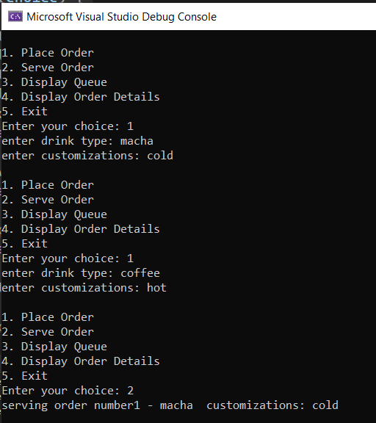 | 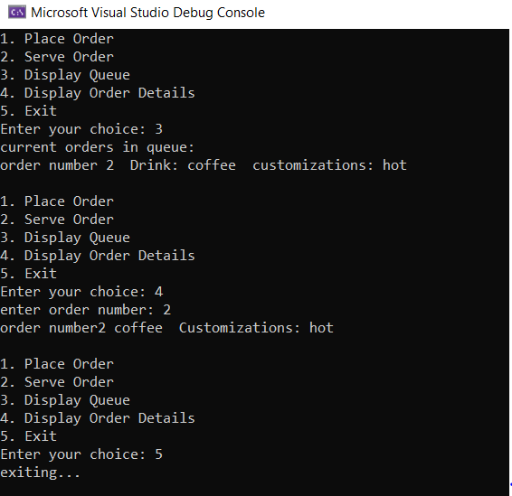

QUESTION 04
CODE
// saba shahid
// 02-134241-048
// CS 3-A

// question 04
#include <iostream>
#include <string>

using namespace std;

struct Station {
string name;
Station* next;
};

Station* head = NULL;

void addStation(string name) {
Station* newStation = new Station();
newStation->name = name;
if (head == NULL) {
head = newStation;
newStation->next = head;
}
else {
Station* temp = head;
while (temp->next != head) {
temp = temp->next;
}
temp->next = newStation;
newStation->next = head;
}
}

void displayRoute() {
if (head == NULL) {
cout << "no stations in the route." << endl;
return;
}
Station* temp = head;
cout << "train Route: " << endl;
do {
cout << temp->name << " -> ";
temp = temp->next;
} while (temp != head);
cout << "back to startt" << endl;
}

int main() {
int choice;
string stationName;

do {
cout << "\n1. Add Station\n2. Display Route\n3. Exit\nEnter your choice: ";
cin >> choice;
cin.ignore();

switch (choice) {
case 1:
cout << "enter station name: ";
getline(cin, stationName);
addStation(stationName);
break;
case 2:
displayRoute();
break;
case 3:
cout << "exiting..." << endl;
break;
default:
cout << "invalid choice." << endl;
}
} while (choice != 3);

return 0;
}
OUTPUT
