Lab 3:Implementation of Sorting algorithms CLO1, PLO3, P3
Objective(s): Upon completion of this lab session, students will be able to:
Implement following sorting algorithms
- Bubble sort
- Selection sort
- Insertion sort

Exercise 1: Analyzing Sales Data

Consider we have the sales data of the last quarter of XYZ Company. The dataset represents the total sales (in dollars) generated by 10 different salespeople, and the company needs to sort this data in ascending order for analysis and reporting. Sorting this data will help identify the top and bottom performers and provide insights to improve overall sales strategies.
Sales ➔ {1250, 970, 880, 1020, 1340, 710, 980, 1150, 1230, 1050}
Your task is to develop a C++ program that implements three sorting algorithms (Bubble Sort, Selection Sort, and Insertion Sort) to sort the sales data in ascending order.
The program should:
- Print each pass of the algorithm, showing the array after each iteration.
- Display the total number of passes and comparisons made during the sorting process.
- Show the final sorted result of the sales data.

CODE:
//saba shahid
//02-134241-048
//CS 3-A

//QUESTION 01

#include<iostream>
using namespace std;

// BUBBLE SORT
void bubbleSort( ) {

int sales[] = { 1250, 970, 880, 1020, 1340, 710, 980, 1150, 1230, 1050 };

int n = sizeof(sales) / sizeof(sales[0]);

int passes = 0;
int comparisons = 0;
// phla loop is going to perform the passes
for (int i = 0; i < n - 1; i++) {
passes++; // Increment passes
// second loop compare aur sort karay ga
for (int j = 0; j < n - i - 1; j++) {
comparisons++; // Increment comparisons
if (sales[j] > sales[j + 1]) {
int temp = sales[j];
sales[j] = sales[j + 1];
sales[j + 1] = temp;
}
}
// Print the array after each pass
cout << " after pass " << passes << ": ";
for (int k = 0; k < n; k++) {
cout << sales[k] << " ";
}
cout << endl;
}
cout << "sorted array with bubble sort: ";
for (int i = 0; i < n; i++) {
cout << sales[i] << " ";
}
cout << endl;
cout << "number of passes: " << passes << endl;
cout << "comparisons made: " << comparisons << endl;
cout << endl;
}

// INSERTION SORT
void insertionSort() {

int sales[] = { 1250, 970, 880, 1020, 1340, 710, 980, 1150, 1230, 1050 };

int n = sizeof(sales) / sizeof(sales[0]);

int passes = 0;
int comparisons = 0;

for (int i = 1; i < n; i++) {
// element to insert
int key = sales[i];
int j = i - 1;
// counting the passes
passes++;

// Shift elements of sales[0..i-1], that are greater than key, to one position ahead
while (j >= 0 && sales[j] > key) {
comparisons++; // Increment the comparison counter for each inner loop iteration
sales[j + 1] = sales[j];
j = j - 1;
}
sales[j + 1] = key;

// Print the array after each pass
cout << "after pass " << passes << ": ";
for (int k = 0; k < n; k++) {
cout << sales[k] << " ";
}
cout << endl;
}

cout << "sorted array using insertion sort: ";
for (int i = 0; i < n; i++) {
cout << sales[i] << " ";
}
cout << endl;
cout << "number of passes: " << passes << endl;
cout << "comparisons made: " << comparisons << endl;
cout << endl;
}

// SELECTION SORT
void selectionSort() {

int sales[] = { 1250, 970, 880, 1020, 1340, 710, 980, 1150, 1230, 1050 };

int n = sizeof(sales) / sizeof(sales[0]);

int passes = 0;
int comparisons = 0;

for (int i = 0; i < n - 1; i++) {
// assuming that current index wala element is min
int minIndex = i;
// counting passes
passes++;
// Finding the new min
for (int j = i + 1; j < n; j++) {
// increasing comparisons
comparisons++;

// updating the min wala index
if (sales[j] < sales[minIndex]) {
minIndex = j;
}
}

// Swapping found min with the first element of original array
if (minIndex != i) {
int temp = sales[i];
sales[i] = sales[minIndex];
sales[minIndex] = temp;
}

// Print the array after each pass
cout << "after pass " << passes << ": ";
for (int k = 0; k < n; k++) {
cout << sales[k] << " ";
}
cout << endl;
}
cout << "Sorted array using selection sort: ";
for (int i = 0; i < n; i++) {
cout << sales[i] << " ";
}
cout << endl;
cout << "number of passes: " << passes << endl;
cout << "comparisons made: " << comparisons << endl;
cout << endl;
}

int main() {
bubbleSort();
selectionSort();
insertionSort();
return 0;
}
OUTPUT:
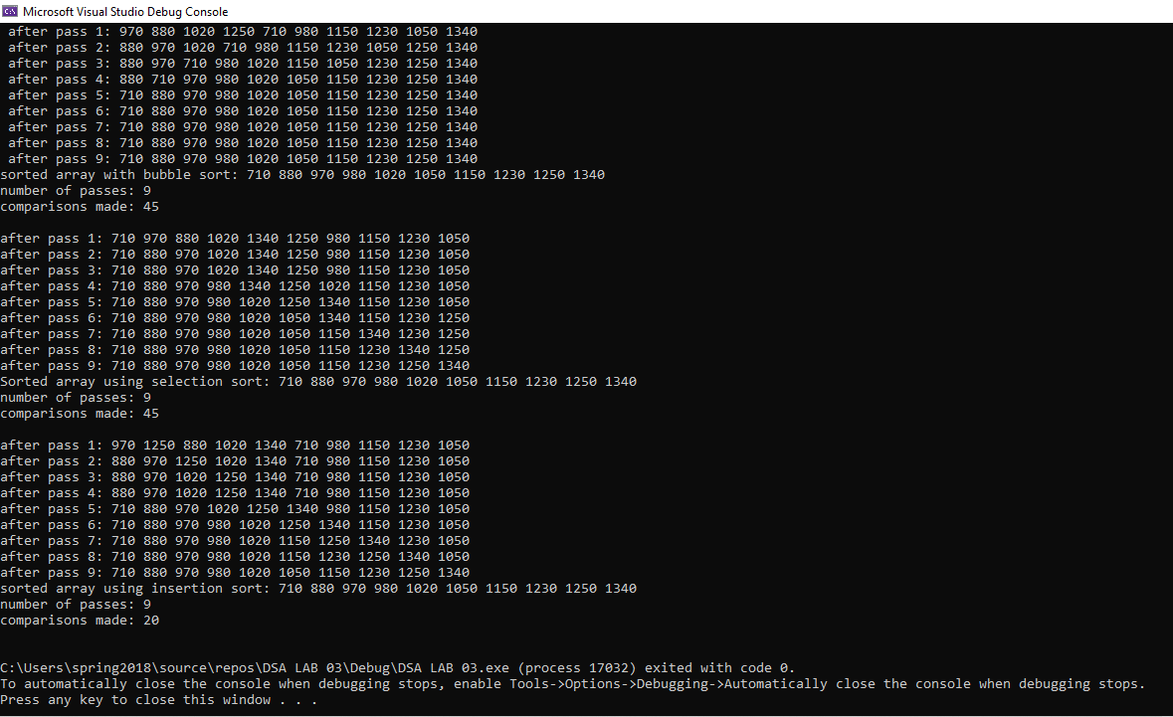

Exercise 2: File Management

Consider a simple file management system that display a list of files in a directory, with each file represented by a string containing its name. Design a program that uses the bubble sort algorithm to sort these file names in ascending alphabetical order.
Sample Output:

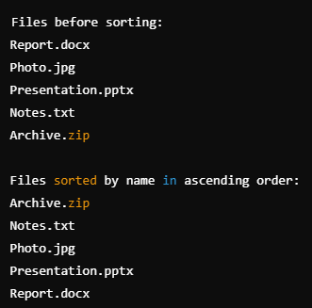

CODE
//saba shahid
//02-134241-048
// cs 3-A

//question 02
#include<iostream>
using namespace std;

void bubbleSort(string files[], int n) {
for (int i = 0; i < n - 1; i++) {
for (int j = 0; j < n - i - 1; j++) {
if (files[j] > files[j + 1]) {
swap(files[j], files[j + 1]);
//easy question ;p
}
}
}
}

void main() {
string files[] = { "files.doc", "pics.jpg", "presentation.pptx", "notes.txt", "project.zip" };
int n = sizeof(files) / sizeof(files[0]);

//before sorting
cout << "the files before sorting:\n";
for (int i = 0; i < n; i++) {
cout << files[i] << endl;
}

bubbleSort(files, n);

// after sorting
cout << endl;
cout << "the files after sorting:\n";
for (int i = 0; i < n; i++) {
cout << files[i] << endl;
}

}
OUTPUT

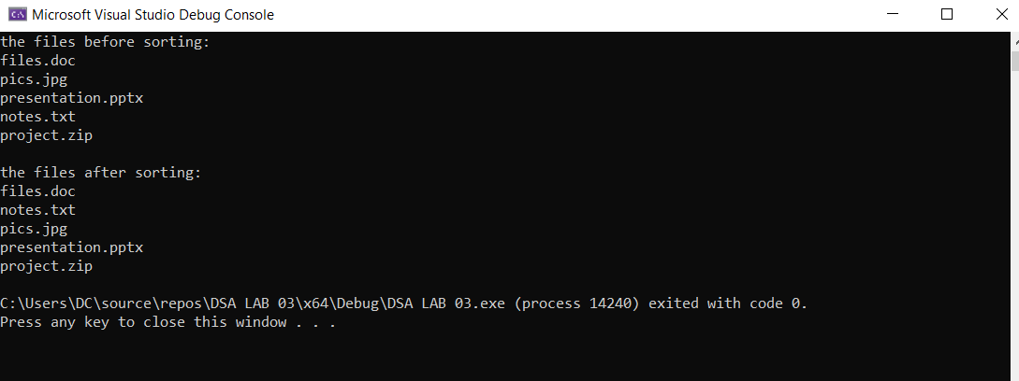

Exercise 3: Laundry Clothes Sorting

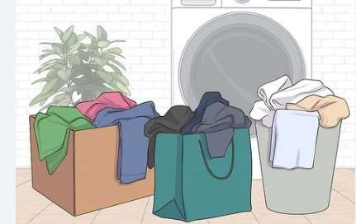
Imagine you're about to do your laundry at home and you have a pile of clothes ready to be washed. To ensure your clothes come out looking fresh and vibrant, you need to sort them properly before tossing them into the washing machine. Your need to go through the pile and separate the clothes into different groups based on their color—such as whites, darks, and colors—so that each group can be washed without risking color bleeding onto lighter items. Your task is to implement an Insertion Sort algorithm to sort the clothes based on their color. The goal is to sort this list such that all the white clothes appear first, followed by the dark clothes, and then the colored clothes. [Assume there are total 15 clothes for laundry today]

Sample Output:
Input Array:
C D W D C W C
Output:
W W D D C C C

CODE
//saba shahid
// //02-134241-048
// //cs 3-A

//question 03

#include <iostream>
using namespace std;

// insertion Sort
void insertionSort(char colors[], int n) {
for (int i = 1; i < n; i++) {
char key = colors[i]; // picking the current element
int j = i - 1;

//shifting elements that are greater than key to the right
while (j >= 0 && colors[j] > key) {
colors[j + 1] = colors[j];
j--;
}
colors[j + 1] = key;
}
}

// display
void displayColors(char colors[], int n) {
for (int i = 0; i < n; i++) {
cout << colors[i] << " ";
}
cout << endl;
}

void main() {

char colors[] = { 'C', 'D', 'W', 'D', 'C', 'W', 'C','W' };
int n = sizeof(colors) / sizeof(colors[0]);

cout << "Before Sorting: ";
displayColors(colors, n);
insertionSort(colors, n);
cout << "After Sorting: ";
displayColors(colors, n);
}

OUTPUT

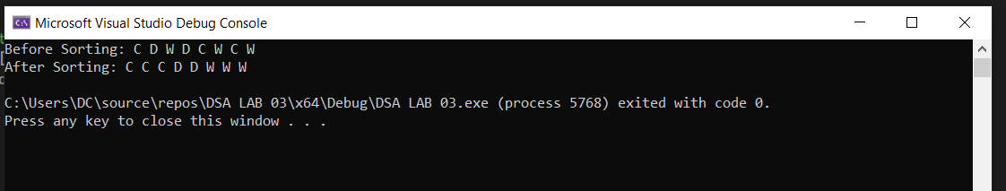

Exercise 4: Optimizing Delivery Routes

You are a logistics coordinator at a local delivery company, tasked with optimizing delivery routes by sorting a list of delivery locations based on their distance from the warehouse. You are given an array of locations, each associated with its distance from the warehouse (in miles). Your task is to implement a C++ program that uses Selection Sort to sort the locations in ascending order of their distance.

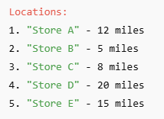
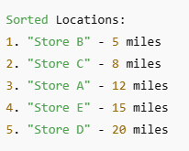

CODE

//saba shahid
// //02-134241-048
// //cs 3-A

//question 04
#include <iostream>
using namespace std;

struct Store {
string name;
int distance;
};

// selection Sort
void selectionSort(Store stores[], int n) {
for (int i = 0; i < n - 1; i++) {
int minIndex = i;
// Find the min index
for (int j = i + 1; j < n; j++) {
if (stores[j].distance < stores[minIndex].distance) {
minIndex = j;
}}
// swap found min with the 1st
if (minIndex != i) {
Store temp = stores[i];
stores[i] = stores[minIndex];
stores[minIndex] = temp;
}
}
}

//display
void displayStores(Store stores[], int n, string title) {
cout << title << endl;
for (int i = 0; i < n; i++) {
cout << stores[i].name << " - " << stores[i].distance << " miles" << endl;
}
cout << endl;
}

int main() {
Store stores[] = {{"grocery store", 12},{"book store", 5},{"clothing store ", 8},{"snacks arena", 20},{"hair sylon", 15}};

int n = sizeof(stores) / sizeof(stores[0]);

displayStores(stores, n, "locations:");
selectionSort(stores, n);
displayStores(stores, n, "sorted Locations:");

return 0;
}
OUTPUT
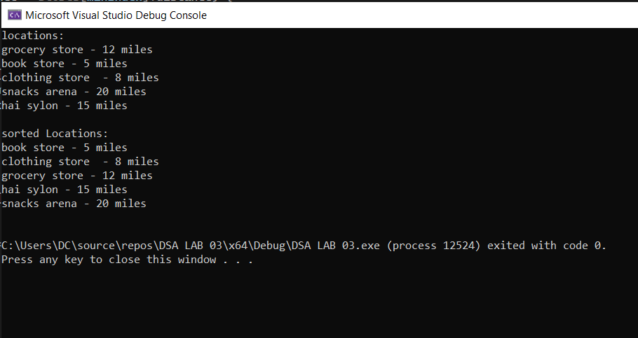

Exercise 5: Organizing Cars by Type and Price

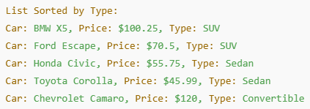
Assume that you are developing a Car Rental Service Application that displays a list of available cars. Each car is represented by properties such as the car's name, rental price per day, and type (e.g., sedan, SUV, convertible) Your task is to implement a Selection Sort algorithm with two functions: one that sorts the cars by their type, grouping them into categories such as sedans, SUVs, and convertibles, and another that sorts the cars by price in ascending order, from the least expensive to the most expensiv
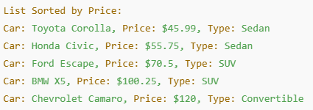
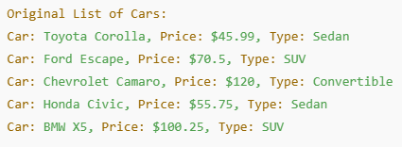

CODE
//saba shahid
//02-134241-048
//cs 3-a

//question 05
#include<iostream>
#include<string>
using namespace std;

struct car {
string name;
string type;
double price;
};

// print
void printcars(car cars[], int n) {
for (int i = 0; i < n; i++) {
cout << cars[i].name << " " << cars[i].type << " " << cars[i].price << "/day" << endl;
}
cout << endl;
}

// sort cars type using selection sort
void sortbytype(car cars[], int n) {
for (int i = 0; i < n - 1; i++) {
int minindex = i;
for (int j = i + 1; j < n; j++) {
if (cars[j].type < cars[minindex].type) {
minindex = j;
}
}
// swap if smaller type is found
if (minindex != i) {
car temp = cars[i];
cars[i] = cars[minindex];
cars[minindex] = temp;
}
}
}

// function to sort cars by their price (ascending order, using selection sort)
void sortbyprice(car cars[], int n) {
for (int i = 0; i < n - 1; i++) {
int minindex = i;
for (int j = i + 1; j < n; j++) {
if (cars[j].price < cars[minindex].price) {
minindex = j;
}
}
// swap if a cheaper car is found
if (minindex != i) {
car temp = cars[i];
cars[i] = cars[minindex];
cars[minindex] = temp;
}
}
}

int main() {

car cars[] =
{{"toyota camry", "sedan", 45.0},{"ford mustang", "convertible", 75.0},
{"honda", "suv", 60.0},{"chevrolet malibu", "sedan", 50.0},
{"bmw x5", "suv", 120.0},{"mazda mx-5", "convertible", 85.0}};

int n = sizeof(cars) / sizeof(cars[0]);

// display original list of cars

cout << "original list of cars:\n";
printcars(cars, n);

// sort by type and display

sortbytype(cars, n);
cout << "cars sorted by type:\n";
printcars(cars, n);

// sort by price and display

sortbyprice(cars, n);
cout << "cars sorted by price:\n";
printcars(cars, n);

return 0;
}

OUTPUT:
