Lab 4: Algorithm Analysis CLO1, PLO3, P3
Objective(s): Upon completion of this lab session, students will be able to:
Study the experimental ways to analyze the time complexity of different algorithms.

Exercise 1: Library Books sorting

You've been assigned to analyze sorting algorithms for organizing a cluttered stack of computer science books in the library based on their titles alphabetically. Write a C++ program to sort the clutter of books by applying bubble sort, insertion sort and selection sort algorithms and analyze their time complexity in arranging the books. Write a C++ program to implement these algorithms and assess their performance. Cluttered stack of books is given below:
{ Introduction to the Theory of Computation, Code: The Hidden Language of Computer Hardware and Software, Clean Code: A Handbook of Agile Software Craftsmanship, The Pragmatic Programmer, Structure and Interpretation of Computer Programs, Design Patterns: Elements of Reusable Object-Oriented Software, Algorithms, Compilers: Principles, Techniques, and Tools, Artificial Intelligence: A Modern Approach, Cracking the Coding Interview, The Art of Computer Programming, Operating Systems: Three Easy Pieces, Computer Systems: A Programmer's Perspective, Introduction to Algorithms, The Mythical Man-Month: Essays on Software Engineering, Refactoring: Improving the Design of Existing Code, The C Programming Language, The Elements of Computing Systems: Building a Modern Computer from First Principles, You Don’t Know JS: Scope & Closures, Effective Java, JavaScript: The Good Parts, Programming Pearls, The Design of Everyday Things, The Algorithm Design Manual, Python Crash Course, Effective C++: 55 Specific Ways to Improve Your Programs and Designs, Deep Learning, Head First Design Patterns, The Computer Science Handbook, The Little Schemer, Programming in Haskell, Essentials of Programming Languages, Programming Rust, Computer Architecture: A Quantitative Approach, Machine Learning Yearning, Hackers: Heroes of the Computer Revolution, }

CODE

//saba shahid
// 02-134241-048
// CS 3-A

//question 01
#include <iostream>
#include <chrono>

using namespace std;
using namespace std::chrono;

// bubble sort
void bubbleSort(string arr[], int n, double& execTime) {
auto start = high_resolution_clock::now();
for (int i = 0; i < n - 1; i++) {
for (int j = 0; j < n - i - 1; j++) {
if (arr[j] > arr[j + 1]) {
swap(arr[j], arr[j + 1]);
}
}
}
auto stop = high_resolution_clock::now();
execTime = duration<double, micro>(stop - start).count();
}

// selection sort
void selectionSort(string arr[], int n, double& execTime) {
auto start = high_resolution_clock::now();
for (int i = 0; i < n - 1; i++) {
int minIndex = i;
for (int j = i + 1; j < n; j++) {
if (arr[j] < arr[minIndex]) {
minIndex = j;
}
}
swap(arr[i], arr[minIndex]);
}
auto stop = high_resolution_clock::now();
execTime = duration<double, micro>(stop - start).count();
}

// insertion sort
void insertionSort(string arr[], int n, double& execTime) {
auto start = high_resolution_clock::now();
for (int i = 1; i < n; i++) {
string key = arr[i];
int j = i - 1;
while (j >= 0 && arr[j] > key) {
arr[j + 1] = arr[j];
j--;
}
arr[j + 1] = key;
}
auto stop = high_resolution_clock::now();
execTime = duration<double, micro>(stop - start).count();
}

int main() {
string books[] = {
"Introduction to the Theory of Computation", "Code: The Hidden Language of Computer Hardware and Software",
"Clean Code: A Handbook of Agile Software Craftsmanship", "The Pragmatic Programmer",
"Structure and Interpretation of Computer Programs", "Design Patterns: Elements of Reusable Object-Oriented Software",
"Algorithms", "Compilers: Principles, Techniques, and Tools",
"Artificial Intelligence: A Modern Approach", "Cracking the Coding Interview",
"The Art of Computer Programming", "Operating Systems: Three Easy Pieces",
"Computer Systems: A Programmer's Perspective", "Introduction to Algorithms",
"The Mythical Man-Month: Essays on Software Engineering", "Refactoring: Improving the Design of Existing Code",
"The C Programming Language", "The Elements of Computing Systems: Building a Modern Computer from First Principles",
"You Don’t Know JS: Scope & Closures", "Effective Java", "JavaScript: The Good Parts",
"Programming Pearls", "The Design of Everyday Things", "The Algorithm Design Manual",
"Python Crash Course", "Effective C++: 55 Specific Ways to Improve Your Programs and Designs",
"Deep Learning", "Head First Design Patterns", "The Computer Science Handbook",
"The Little Schemer", "Programming in Haskell", "Essentials of Programming Languages",
"Programming Rust", "Computer Architecture: A Quantitative Approach",
"Machine Learning Yearning", "Hackers: Heroes of the Computer Revolution"
};

const int n = sizeof(books) / sizeof(books[0]);
//for bubble sort
double execTime = 0;
string bubbleSorted[n];
for (int i = 0; i < n; i++)
bubbleSorted[i] = books[i];
bubbleSort(bubbleSorted, n, execTime);
cout << " " << endl;
cout << "bubble sort execution time: " << execTime << " microseconds" << endl;
cout << "Sorted books by bubble sort:";
for (int i = 0; i < n; i++) {
cout << bubbleSorted[i] << " ";
}
cout << " " << endl;
//for selection sort
execTime = 0;
string selectionSorted[n];
for (int i = 0; i < n; i++)
selectionSorted[i] = books[i];
selectionSort(selectionSorted, n, execTime);
cout << " " << endl;
cout << "selection sort execution time: " << execTime << " microseconds" << endl;
cout << "sorted books by selection sort:";
for (int i = 0; i < n; i++) {
cout << selectionSorted[i] << " ";
}
cout << " " << endl;

// for insertion sortp
execTime = 0;
string insertionSorted[n];
for (int i = 0; i < n; i++)
insertionSorted[i] = books[i];
insertionSort(insertionSorted, n, execTime);
cout << " " << endl;
cout << "Insertion Sort Execution Time: " << execTime << " microseconds" << endl;
cout << "Sorted Books (Insertion Sort):";
for (int i = 0; i < n; i++) {
cout << insertionSorted[i] << " ";
}
cout << " " << endl;
return 0;
}

OUTPUT
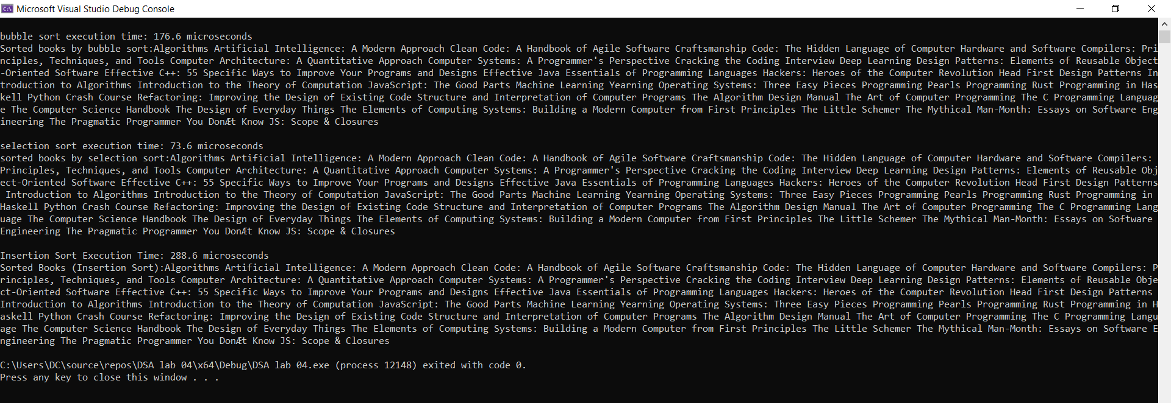

Exercise 2: Searching Employee id
Consider the following employee id of 100 employees of Xyz Company. Write a program that finds the time taken to search given employee ids by applying linear search and binary search algorithms.
Emp_id=1335 Emp_id=1289

1231 | 1232 | 1233 | 1234 | 1235 | 1236
1237 | 1238 | 1239 | 1240 | 1241 | 1242
1243 | 1244 | 1245 | 1246 | 1247 | 1248
1249 | 1250 | 1251 | 1252 | 1253 | 1254
1255 | 1256 | 1257 | 1258 | 1259 | 1260
1261 | 1262 | 1263 | 1264 | 1265 | 1266
1267 | 1268 | 1269 | 1270 | 1271 | 1272
1273 | 1274 | 1275 | 1276 | 1277 | 1278
1279 | 1280 | 1281 | 1282 | 1283 | 1284
1285 | 1286 | 1287 | 1288 | 1289 | 1290
1291 | 1292 | 1293 | 1294 | 1295 | 1296
1297 | 1298 | 1299 | 1300 | 1301 | 1302
1303 | 1304 | 1305 | 1306 | 1307 | 1308
1309 | 1310 | 1311 | 1312 | 1313 | 1314
1315 | 1316 | 1317 | 1318 | 1319 | 1320
1321 | 1322 | 1323 | 1324 | 1325 | 1326
1327 | 1328 | 1329 | 1330

CODE

//saba shahid
// 02-134241-048
// CS 3-A

//question 02
#include <iostream>
#include <chrono>

using namespace std;
using namespace std::chrono;

// Linear search
bool linearSearch(int arr[], int n, int target, double& execTime) {
auto start = high_resolution_clock::now();
for (int i = 0; i < n; i++) {
if (arr[i] == target) {
auto stop = high_resolution_clock::now();
execTime = duration<double, micro>(stop - start).count();
return true;
}
}
auto stop = high_resolution_clock::now();
execTime = duration<double, micro>(stop - start).count();
return false;
}

// binary search
bool binarySearch(int arr[], int left, int right, int target, double& execTime) {
auto start = high_resolution_clock::now();
while (left <= right) {
int mid = left + (right - left) / 2;
if (arr[mid] == target) {
auto stop = high_resolution_clock::now();
execTime = duration<double, micro>(stop - start).count();
return true;
}
if (arr[mid] < target)
left = mid + 1;
else
right = mid - 1;
}
auto stop = high_resolution_clock::now();
execTime = duration<double, micro>(stop - start).count();
return false;
}

int main() {
int employeeIDs[] = {
1231, 1232, 1233, 1234, 1235, 1236, 1237, 1238, 1239, 1240,
1241, 1242, 1243, 1244, 1245, 1246, 1247, 1248, 1249, 1250,
1251, 1252, 1253, 1254, 1255, 1256, 1257, 1258, 1259, 1260,
1261, 1262, 1263, 1264, 1265, 1266, 1267, 1268, 1269, 1270,
1271, 1272, 1273, 1274, 1275, 1276, 1277, 1278, 1279, 1280,
1281, 1282, 1283, 1284, 1285, 1286, 1287, 1288, 1289, 1290,
1291, 1292, 1293, 1294, 1295, 1296, 1297, 1298, 1299, 1300,
1301, 1302, 1303, 1304, 1305, 1306, 1307, 1308, 1309, 1310,
1311, 1312, 1313, 1314, 1315, 1316, 1317, 1318, 1319, 1320,
1321, 1322, 1323, 1324, 1325, 1326, 1327, 1328, 1329, 1330,
1335
};
int n = sizeof(employeeIDs) / sizeof(employeeIDs[0]);
int targets[] = { 1335, 1289 };

for (int target : targets) {
double execTime = 0;
bool foundLinear = linearSearch(employeeIDs, n, target, execTime);
cout << "Linear Search for " << target << (foundLinear ? " found" : " not found")<< " in " << execTime << " microseconds" << endl;
execTime = 0;
bool foundBinary = binarySearch(employeeIDs, 0, n - 1, target, execTime);

cout << "Binary Search for " << target << (foundBinary ? " found" : " not found") << " in " << execTime << " microseconds" << endl;
cout << "--------------------------------------------" << endl;

/* "foundLinear" is a boolean variable that stores whether the target employee ID was found
If "foundLinear" is true the message "found" is printed; otherwise, "not found" is printed.
The execution time in microseconds is also displayed */
// foundBinary works the same way as foundLinear

//learned from w3 schools :pp
}

return 0;
}

OUTPUT

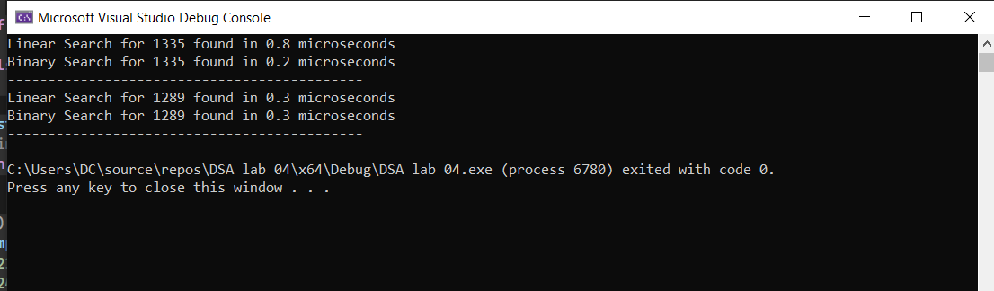

Exercise 3: Star Pyramid
Consider the following code that prints the pyramid of star by N rows. Write a program that analyze the time taken to print the star pyramid with following values of N.
#include <iostream> using namespace std; int main()
{
// Number of rows int N = 5;

// Outer loop runs N times, once for each row for (int i = 1; i <= N; i++) {
// Inner loop prints 'N - i' spaces for (int j = 1; j <= N - i; j++) {
cout << " ";
}
// Inner loop prints '2 * i - 1' stars for (int j = 1; j <= 2 * i - 1; j++) {
cout << "*";}
// Move to the next line cout << "\n";}
return 0;}

CODE
//saba shahid
// 02-134241-048
// CS 3-A

//question 03
#include <iostream>
#include <chrono>

using namespace std;
using namespace std::chrono;

//pyramid
void printStarPyramid(int n, double& execTime) {
auto start = high_resolution_clock::now();

for (int i = 1; i <= n; i++) {
for (int j = 1; j <= n - i; j++) {
cout << " ";
}
for (int j = 1; j <= 2 * i - 1; j++) {
cout << "*";
}
cout << endl;
}

auto stop = high_resolution_clock::now();
execTime = duration<double, micro>(stop - start).count();
}

int main() {
int values[] = { 5, 10, 15, 20, 25 }; //for valus of n

for (int n : values) {
double execTime = 0;
cout << "pyramid for n: " << n << endl;
printStarPyramid(n, execTime);
cout << "execution time: " << execTime << " microseconds\n";

}

return 0;
}

OUTPUT
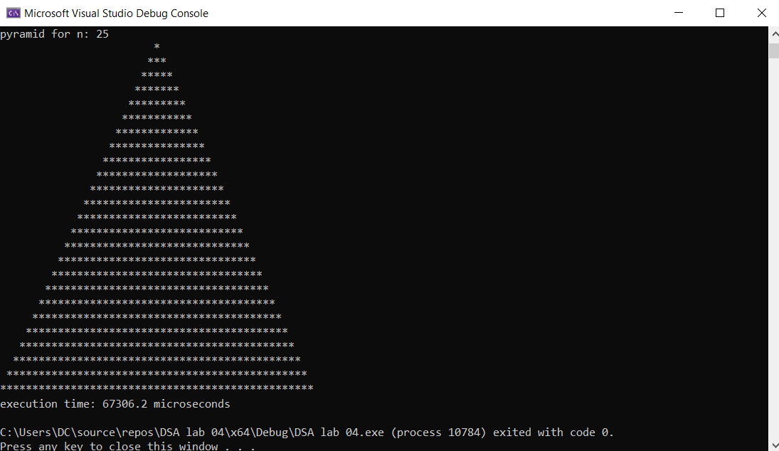

Exercise 4: Recursion VS Iteration

Write programs for following two different algorithms for calculating the factorial of a given number. Also determine the time taken by both algorithms
Frist Algorithm Second Algorithm

if n == 0 or n == 1 return 1
else
return n * factorial_recursive(n - 1)
result=1
for i ← 2 to n result = result * i
return result

Calculate times taken by these programs for given values and conclude which algorithm is better than other
- n = 10
- n = 50
- n= 100
- n=150
- n = 200
- n= 250
- n=300
Plot graphs for time of execution vs. “n”, for all the values of n given .Use excel for plotting graph.
CODE
//saba shahid
//02-134241-048
//cs 3-A

//question 04

#include <iostream>
#include <chrono>
using namespace std;
using namespace chrono;

long long factorial_recursive(int n, double& time) {
auto c_start = high_resolution_clock::now();
long long result = (n == 0 || n == 1) ? 1 : n * factorial_recursive(n - 1, time);

auto c_end = high_resolution_clock::now();
time = duration<double, micro>(c_end - c_start).count();

return result;
}

long long factorial_iterative(int n, double& time) {
auto c_start = high_resolution_clock::now();

long long result = 1;
for (int i = 2; i <= n; ++i)
result *= i;

auto c_end = high_resolution_clock::now();
time = duration<double, micro>(c_end - c_start).count();

return result;
}

int main() {
int values[] = { 10, 50, 100, 150, 200, 250, 300 };

for (int n : values) {
double timeRecursive = 0,
double timeIterative = 0;

factorial_recursive(n, timeRecursive);
factorial_iterative(n, timeIterative);

cout << "For n = " << n << ":\n";
cout << "Recursive Time: " << timeRecursive << " microseconds" << endl;
cout << "Iterative Time: " << timeIterative << " microseconds" << endl;
cout << "----------------------------------------" << endl;
}

return 0;
}
OUTPUT
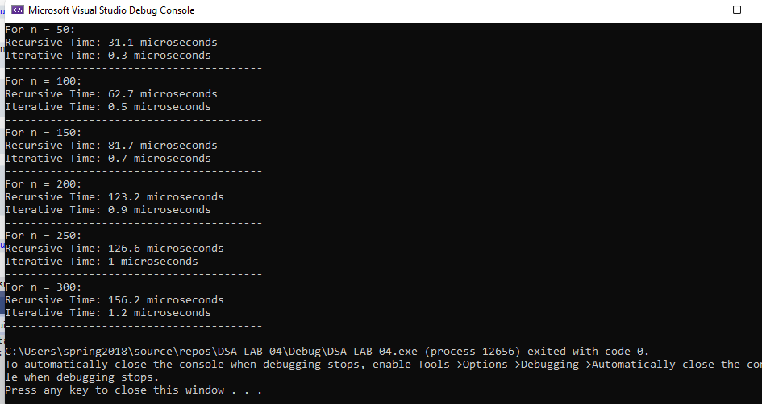

GRAPH
