

BAHRIA UNIVERSITY (Karachi Campus)
Department of Computer Science ASSIGNMENT 01 SPRING 2025
Course Title: | Data Structures & Algorithms | Start Date: | 18-3-25
Course Code: | CSC-221 | End Date: | 24-3-25
Semester: | BS(CS)-3A | Max. Marks: | 5
Course Instructor(s): Lubna Siddiqui

Instructions:
- This is an individual assignment; you must solve it by yourself.
- Any assignment submitted after the cutoff time will receive zero.
- Copied /plagiarized assignment will be marked zero

QUESTION NO. 1 [CLO4, PLO4 , C6] (Marks=3)

When a share of common stock of some company is sold, the capital gain (or, sometimes, loss) is the difference between the share’s selling price and the price originally paid to buy it. This rule is easy to understand for a single share, but if we sell multiple shares of stock bought over a long period of time, then we must identify the shares actually being sold. A standard accounting principle for identifying which shares of a stock were sold in such a case is to use a FIFO protocol—the shares sold are the ones that have been held the longest (indeed, this is the default method built into several personal finance software packages). For example, suppose we buy 100 shares at $20 each on day 1, 20 shares at $24 on day 2, 200 shares at $36 on day 3, and then sell 150 shares on day 4 at $30 each. Then applying the FIFO protocol means that of the 150 shares sold, 100 were bought on day 1, 20 were bought on day 2, and 30 were bought on day 3. The capital gain in this case would therefore be 100·10+20·6+30·(−6), or $940. Write a program that takes as input a sequence of transactions of the form “buy x share(s) at $y each” or “sell x share(s) at $y each, “assuming that the transactions occur on consecutive days and the values x and y are integers. Given this input sequence, the output should be the total capital gain (or loss) for the entire sequence, using the FIFO protocol to identify share

Design a program in C++ for the above scenario by applying appropriate data structure.

CODE
// SABA SHAHID
//02-134241-048

//FIFO stock manager
#include <iostream>
using namespace std;

const int MAX_SHARES = 100;

struct Stock {
int quantity;
int price;
};

Stock queue[MAX_SHARES];
int start = 0;
int rear = 0;
int totalCapitalGain = 0;

// for buying shares
void buyShares() {
if (rear == MAX_SHARES) {
cout << "queue is full! cannot buy more shares :(\n";
return;
}
cout << "enter number of shares to buy: ";
cin >> queue[rear].quantity;
cout << "enter purchase price per share: ";
cin >> queue[rear].price;
rear++;
cout << "shares purchased successfully:)\n";
}

// for selling shares
void sellShares() {
if (start == rear) {
cout << "no shares available to sell:(";
return;
}
int sharesToSell, sellPrice;
cout << "enter number of shares to sell: ";
cin >> sharesToSell;
cout << "enter selling price per share: ";
cin >> sellPrice;

int remaining = sharesToSell;//so we can update the shares to sell now

while (remaining > 0 && start < rear) {
if (queue[start].quantity <= remaining) {
// calculating the gain and loss for all shares in queue
int gainLoss = queue[start].quantity * (sellPrice - queue[start].price);
totalCapitalGain += gainLoss;
cout << "sold " << queue[start].quantity << " shares( bought per share for $" <<
queue[start].price << ") \nGain/Loss: $" << gainLoss << endl;
remaining -= queue[start].quantity;
start++; //moving to next
}
else {
// now if they are partially sell from the current batch
int gainLoss = remaining * (sellPrice - queue[start].price);
totalCapitalGain += gainLoss;
cout << "sold " << remaining << " shares (bought per share for $" << queue[start].price
<< ")\n Gain/Loss: $" << gainLoss << endl;

queue[start].quantity -= remaining;
remaining = 0;
}
}

if (remaining > 0) {
cout << "not enough shares available to sell:(\n";
}
}

// For remaining shares
void displayShares() {
if (start == rear) {
cout << "no shares in availible currently :(\n";
return;
}
cout << "Current shares in the portfolio are :\n";
for (int i = start; i < rear; i++) {
cout << queue[i].quantity << " per share for $" << queue[i].price << "\n";
}
}

// total capital gain/loss
void displayCapitalGain() {
cout << "Total Capital Gain/Loss is: $" << totalCapitalGain << endl;
}

int main() {
int choice;
do {
cout << "\n1. Buy Shares\n2. Sell Shares\n3. Display Portfolio\n4. View Capital Gain/Loss\n5. Exit\n";
cin >> choice;
switch (choice) {
case 1:
buyShares();
break;
case 2:
sellShares();
break;
case 3:
displayShares();
break;
case 4:
displayCapitalGain();
break;
case 5:
cout << "exiting program...\n";
break;
default:
cout << "invalid choice.\n";
}
} while (choice != 5);

return 0;
}
OUTPUT
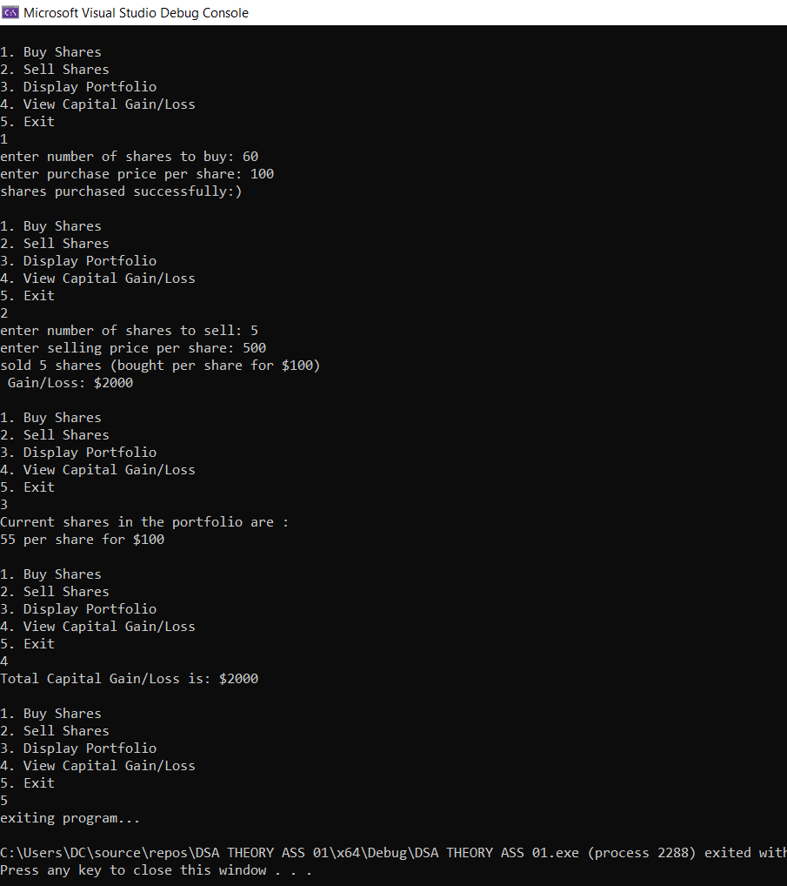

QUESTION NO. 2 [CLO4, PLO4, C6] (Marks=2)

A basketball coach organizes a passing and shooting drill for a group of kids. The drill focuses on improving their passing accuracy, decision-making, and shooting skills. The basketball coach decided to train each player by giving turns so every kid gets a fair chance to participate. Assume that there are 7 players and 5 turns are given to each player for their practice

Create a program in C++ for the above scenario by applying appropriate data structure.

CODE
//SABA SHAHID
//02-134241-048

// Basketball drill

#include <iostream>
#include <string>
using namespace std;

const int MAX_PLAYERS = 5;
const int MAX_TURNS = 5;

struct Player {
string name;
int turnsLeft;
};

Player queue[MAX_PLAYERS * MAX_TURNS];
int start = -1, rear = -1;

bool isFull() {
return (rear + 1) % (MAX_PLAYERS * MAX_TURNS) == start;
}

bool isEmpty() {
return start == -1;
}

void addPlayer(string name) {
if (isFull()) {
cout << "queue is full, cannot add more players\n";
return;
}

for (int i = 0; i < MAX_TURNS; i++) { // giving each player 5 turns
rear = (rear + 1) % (MAX_PLAYERS * MAX_TURNS);
queue[rear] = { name, MAX_TURNS - i };
if (start == -1) start = 0;
}
}

void removePlayer() {
if (isEmpty()) {
cout << "no players in queue!\n";
return;
}

cout << "Player " << queue[start].name <<
" is practicing(Turns left: " << queue[start].turnsLeft << ")\n";
if (start == rear) {
start = rear = -1;
}
else {
start = (start + 1) % (MAX_PLAYERS * MAX_TURNS);
}
}

void displayQueue() {
if (isEmpty()) {
cout << "no players in the queue\n";
return;
}
cout << "players in the queue: \n";
int i = start;
while (i != rear) {
cout << "player " << queue[i].name << " - turns left: " << queue[i].turnsLeft << "\n";
i = (i + 1) % (MAX_PLAYERS * MAX_TURNS);
}
cout << "player " << queue[rear].name << " - turns left: " << queue[rear].turnsLeft << "\n";
}

int main() {
cout << "enter the names of 5 players: \n";
for (int i = 1; i <= MAX_PLAYERS; i++) {
string name;
cout << "Enter name for Player " << i << ": ";
cin >> name;
addPlayer(name);
}

int choice;
do {
cout << "\nBasketball Training Drill\n";
cout << "1. Next Player Turn\n";
cout << "2. Display Queue\n";
cout << "3. Exit\n";
cout << "Enter your choice: ";
cin >> choice;

switch (choice) {
case 1:
removePlayer();
break;
case 2:
displayQueue();
break;
case 3:
cout << "Exiting...\n";
break;
default:
cout << "invalid choice \n";
}
} while (choice != 3);

return 0;
}
OUTPUT
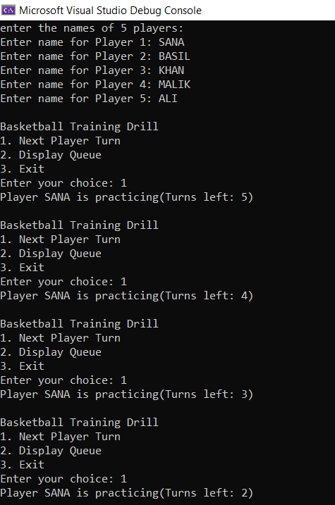 | 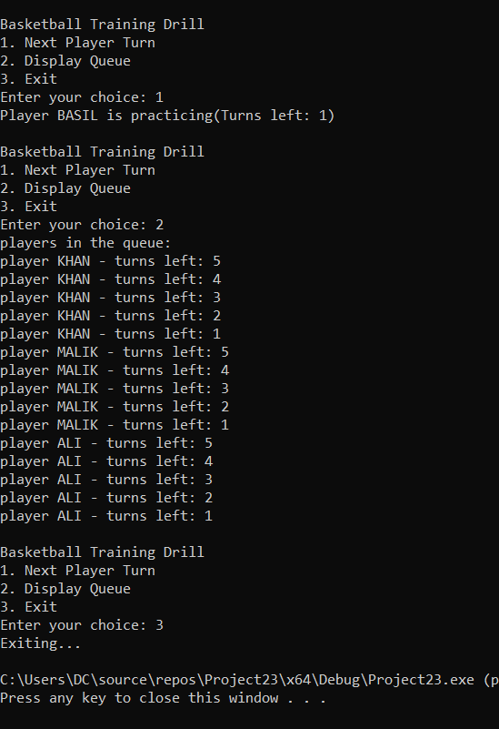

1 | P a g e

